APEXPLANET
Cybersecurity & Ethical Hacking Internship
TASK 2: NETWORK SECURITY & SCANNING
Prepared by: Pawan Kumar
Platform: Kali Linux | Tools: Greenbone/OpenVAS, iptables
Evidence date: 11 October 2026

1. Objective
Practice network-security assessment in a controlled lab, inspect local firewall rules, document GVM/OpenVAS setup evidence, and review the supplied scan report.

2. Tools and Environment
- Kali Linux terminal
- Greenbone Vulnerability Management (GVM) / OpenVAS
- iptables for local firewall-rule inspection

3. Firewall Rules Check (Day 21)
The supplied screenshot shows `sudo iptables -L -n -v` and `sudo iptables -S`. The INPUT, FORWARD, and OUTPUT chains show ACCEPT policies, with no additional rules displayed. This describes the visible iptables output only; it does not verify every other firewall framework or network control.
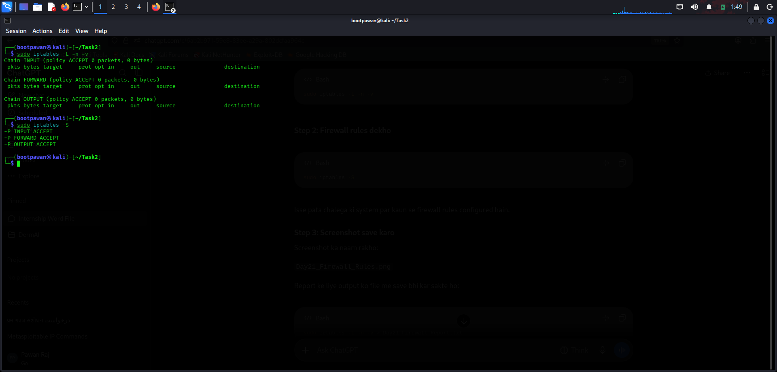
Figure 1. Local iptables rules output.

4. OpenVAS Setup Evidence (Day 22)
The supplied screenshot records PostgreSQL/GVM setup commands, a database listing, the GVM database setup script, and a PostgreSQL version query. This is setup evidence, not proof of a successful vulnerability scan.
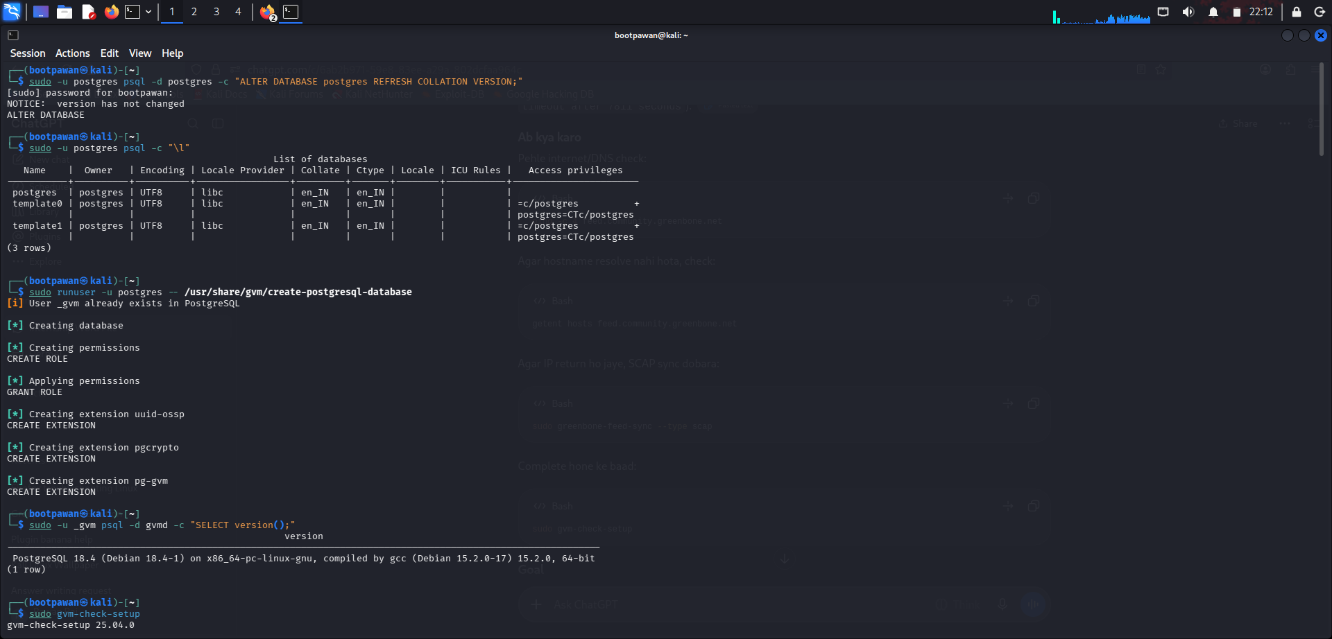
Figure 2. GVM/PostgreSQL setup terminal evidence.

5. OpenVAS Scan Report (supplied XML)
Target label: <b>PAWAN</b>
Reported scan status: Stopped
Hosts found: 0
Vulnerabilities listed: 0
Results listed: 0
Scanner-reported errors: 0
Report timestamp (UTC): 2026-10-11T14:22:20Z
Report end time (UTC): 2026-10-11T14:23:43Z
Important interpretation: The XML report status is “Stopped,” with zero hosts, zero vulnerabilities, zero results, and zero scanner-reported errors. Since no hosts or results were recorded, this is not proof that the target has no vulnerabilities. Run the scan again against a reachable, authorized lab target.

6. Recommended Follow-up
- Confirm the target IP belongs to your own lab or a system you have explicit permission to test.
- Verify that the target is powered on and reachable from Kali.
- In Greenbone, check the target address and port list, select an available scan configuration such as Full and Fast, and start a new task.
- Wait for the task to finish and export the completed report. Record actual findings only; do not invent vulnerabilities.

7. Conclusion
The evidence documents basic firewall-rule inspection and the GVM/PostgreSQL setup process. The supplied OpenVAS scan is incomplete because its task was stopped before any hosts or results were recorded. A successful repeat scan and its exported report are needed to complete the vulnerability-assessment portion.

Evidence Files
- Task20_Day21_Firewall_Rules.png
- Task2_Day15_OpenVAS_Setup.png
- Supplied OpenVAS XML report (status: Stopped)

