MLOps Assignment 01
Heart Disease UCI Dataset - End-to-End ML System
Machine Learning Operations (MLOps) - AIMLCZG523
Student: __________________________
GitHub Repository: __________________________
Date: __________________________
This report describes a reproducible machine learning pipeline covering data acquisition, EDA, model development, MLflow tracking, testing, CI/CD, Docker, Kubernetes deployment, and monitoring.

1. Objective and Problem Statement
The objective is to build a cloud-ready machine learningclassifier that predicts the risk of heart disease frompatient health information. The solution follows an MLOpsworkflow so that the model can be reproduced, tested,packaged, deployed, and monitored.
The implementation uses the Heart Disease UCI Clevelanddataset. The original target contains values from 0 to 4.For binary classification, target 0 is mapped to nodisease and values greater than 0 are mapped to disease.
The system is designed as a learning-orientedproduction-style pipeline rather than a medical diagnostictool. Predictions are for educational use only and mustnot be treated as medical advice.
- Reproducible preprocessing using a scikit-learnColumnTransformer and Pipeline.
- Two baseline classification approaches: LogisticRegression and Random Forest.
- Five-fold stratified cross-validation for Random Forest tuning.
- MLflow for experiment tracking.
- FastAPI for model serving and Prometheus-compatible metrics.
- GitHub Actions for automated linting, testing, training,and Docker build.
- Docker and Kubernetes for deployment.

2. Data Acquisition and EDA
The data acquisition script downloads the Cleveland subsetfrom the UCI Machine Learning Repository. The raw file isstored under data/raw. Missing values represented by thecharacter '?' are converted to missing values and handledlater by the preprocessing pipeline.
The EDA script creates a class-balance chart, numerichistograms, a correlation heatmap, and anage-versus-maximum-heart-rate scatter plot. Thesevisualizations are saved under reports/figures.
For the final submission, the student should insert theactual EDA screenshots generated by their own run. Thisavoids claiming results that were not executed in thestudent's environment.
- Class balance: inspect whether the target classes arereasonably represented.
- Numeric distributions: inspect age, resting bloodpressure, cholesterol, maximum heart rate, and oldpeak.
- Correlation: inspect relationships among numerical variables.
- Missing values: confirm the raw UCI representation andverify that the preprocessing pipeline handles them.

3. Feature Engineering and Model Development
The preprocessing design separates numerical andcategorical/discrete variables. Numerical variables aremedian-imputed and standardized. Categorical/discretevariables are imputed using the most frequent value andone-hot encoded.
The transformations are inside the model pipeline. Thismeans the same transformations are automatically appliedat training and inference time, reducing the risk ofinconsistent preprocessing.
Logistic Regression is used as a simple baseline becauseit is easy to explain. Random Forest is used as a secondmodel because it can capture nonlinear relationships andinteractions without requiring manual featuretransformations.
Random Forest is tuned with GridSearchCV using five-foldStratifiedKFold cross-validation and ROC-AUC as theoptimization metric. The final model is then retrained onthe complete dataset before packaging.
- Train/test split: 80% / 20% with stratification.
- Random state: 42 for repeatability.
- Evaluation metrics: accuracy, precision, recall, and ROC-AUC.
- Selected model: tuned Random Forest pipeline.

4. Experimental Results
The training script generates the actual results afterexecution. The table below is populated automatically whensrc/generate_report.py is run after training.
Model | Accuracy | Precision | Recall | ROC-AUC
Logistic Regression | 0.8852 | 0.8387 | 0.9286 | 0.9665
Random Forest Tuned | 0.8852 | 0.8387 | 0.9286 | 0.9545
Random Forest | 0.8689 | 0.8125 | 0.9286 | 0.9426
The final report should discuss which model performed bestand why ROC-AUC, precision, and recall matter for thisclassification problem. The discussion must use thestudent's actual results rather than invented values.

5. MLflow Experiment Tracking and Reproducibility
MLflow is configured with a local file-based trackingstore under mlruns. Each major training run records themodel name, split configuration, random state, metrics,and evaluation plots. The tuned Random Forest run alsorecords its best hyperparameters and cross-validationscore.
The model is saved with joblib. The saved object containsthe full preprocessing and model pipeline, so theinference API does not need a separate preprocessingimplementation.
The requirements.txt file defines the Python dependencies.The Dockerfile creates an isolated environment containingthe same application dependencies and the packaged model.
- MLflow experiment: heart-disease-classification.
- Artifacts: ROC curves, confusion matrices, and model comparison CSV.
- Reusable model: models/heart_disease_model.joblib.
- Metadata: models/model_metadata.json.

6. Testing and CI/CD
Unit tests are implemented with pytest. One test verifiesthat the preprocessing pipeline can handle missing values.API tests verify the health endpoint and the predictionresponse using a small dummy model, so the tests do notdepend on a trained model file.
The GitHub Actions workflow performs linting, downloadsthe dataset, runs tests, trains the model, builds theDocker image, and uploads the generated machine learningartifacts. The workflow is designed to stop when lintingor tests fail.
For the final submission, a screenshot of the successfulGitHub Actions run should be inserted here.
- pytest -q
- flake8 src tests --max-line-length=100
- python -m src.data
- python -m src.train
- docker build -t heart-disease-api:ci .

7. Containerization and API
The model is exposed through FastAPI. The /predictendpoint accepts patient data as JSON and returns a binaryprediction, a human-readable label, confidence, and thedisease probability. The /health endpoint reports servicehealth and whether the model has been loaded.
The Docker image uses Python 3.11, installs requirements,copies the application and model, and starts Uvicorn onport 8000. Docker Compose is also supplied for aone-command local deployment.
Swagger UI at /docs provides an easy way to demonstratethe API during the video recording.
- Local API: http://127.0.0.1:8000/docs
- Health: http://127.0.0.1:8000/health
- Metrics: http://127.0.0.1:8000/metrics
- Prediction: POST /predict

8. Kubernetes Deployment and Monitoring
The Kubernetes manifest creates a Deployment with tworeplicas and a LoadBalancer Service. Readiness andliveness probes call the /health endpoint. Resourcerequests and limits are included to make the deploymentmore production-oriented.
The API logs prediction requests to standard output. Theselogs can be inspected using docker logs or kubectl logs.Prometheus-compatible HTTP metrics are exposed at /metricsusing prometheus-fastapi-instrumentator.
For a local demonstration, Docker Desktop Kubernetes orMinikube can be used. For a cloud deployment, the imageshould be pushed to a container registry and theKubernetes image reference changed accordingly.
- kubectl apply -f k8s/deployment.yaml
- kubectl get pods
- kubectl get service heart-disease-api
- kubectl logs deployment/heart-disease-api
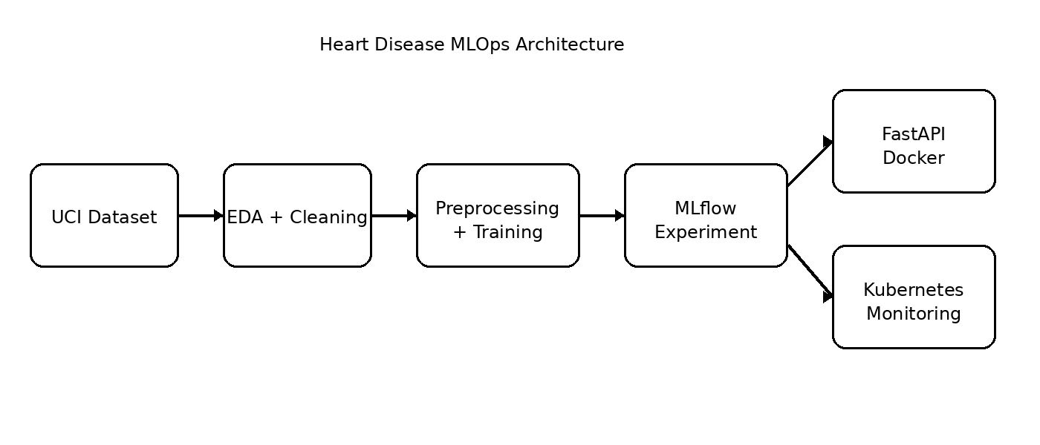

9. Conclusion, Limitations and Submission Checklist
This implementation demonstrates the complete lifecyclerequested by the assignment: data acquisition, EDA,reproducible preprocessing, model comparison and tuning,experiment tracking, automated tests, CI/CD,containerization, Kubernetes deployment, API logging, andmetrics.
A key limitation is that the dataset is relatively smalland the solution is intended for academic demonstration.The prediction must not be used as a medical diagnosis.Additional clinical validation, external validation data,calibration, fairness analysis, security controls, andmedical governance would be required for a real clinicalsystem.
Before submission, replace the report placeholders withyour actual model metrics and screenshots. Add your GitHubrepository URL and record the required short demonstrationvideo.
- Dataset downloaded and EDA completed.
- Two models trained and compared.
- Cross-validation and tuning completed.
- MLflow screenshots captured.
- Unit tests and linting pass.
- Docker build and API test completed.
- Kubernetes deployment and service verified.
- Monitoring/logging demonstrated.
- GitHub Actions run is successful.
- Final report, screenshots, repository URL, and video are ready.

