NAME : PAWAN MAHADU SARULE

ROLL NO : 92 CLASS : FYBCA(Sci)

QUESTION : 13 DATE : 11 Dec 2020

* Q13. Using Word write a letter to your friend informing him about paint. Discuss various options of paint its usage and application. Insert an image created by you using paint to support your sayings.

C5-507, Xrbia Township,

Hinjewadi,

Pune 411033

Date: 11 Dec 2020

Dear Karan,

I hope you are doing well during this Pandemic. This year we had ample of time, so I decided to surf my Laptop without using internet! Yes, without internet for a change. While surfing my Laptop I found the most satisfying application which is now being ignored but it was a sensational app while we were young. Yes, I am taking about the Microsoft Paint. The usage and the application are mind blowing so I want you to use MS Paint once while I am attaching you the activity I have done. It helps in Image Resizing, Precision editing with grid, etc.

Below example is of Image resizing, please write back and Let me know what activity you did.

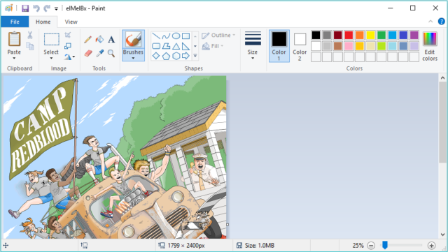

Your lovingly!

Pawan Sarule