NAME : PAWAN MAHADU SARULE

ROLL NO : 92 CLASS : FYBCA(Sci)

QUESTION : 5 DATE : 11 Dec 2020

* Q5. Create Word document for advertisement of different types of Laptops. Make a use of Bullets for displaying details of Laptops. Use Auto shape Banner for creating advertisement.

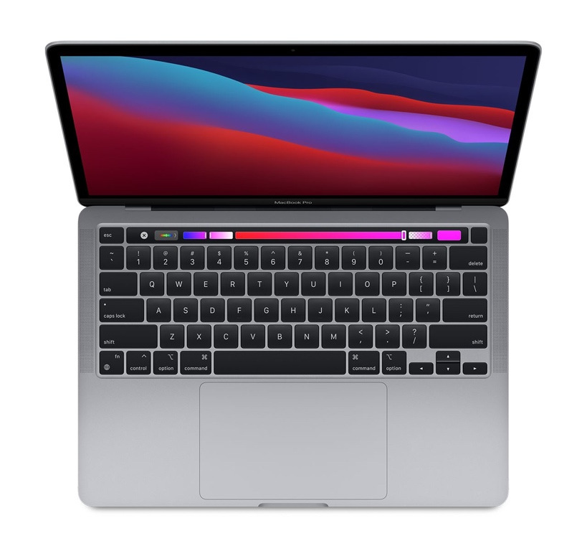

**13-inch MacBook Pro-**

**Space Grey**

* Apple M1 chip with 8‑core CPU, 8‑core GPU and 16‑core Neural Engine
* 8GB unified memory
* 256GB SSD storage
* 13-inch Retina display with True Tone
* Backlit Magic Keyboard - US English
* Touch Bar and Touch ID
* Two Thunderbolt / USB 4 ports

**₹1,22,900**  **(incl. of all taxes)**

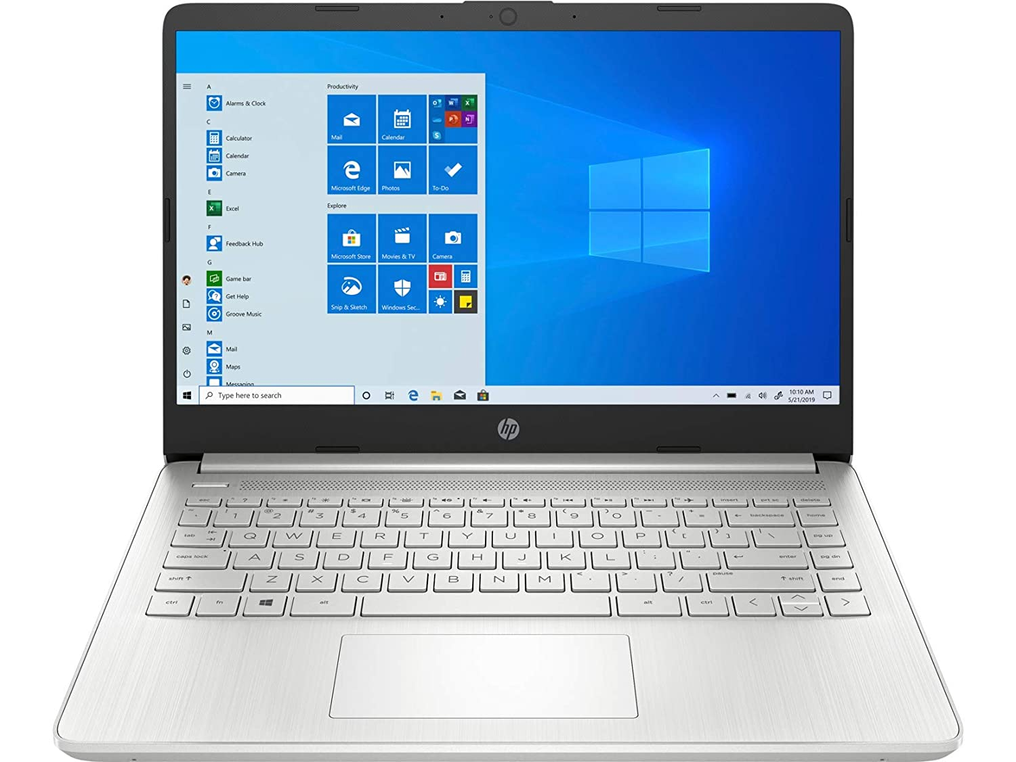

**HP Laptop 14s-er0003TU**

* 10th Generation Intel® Core™ i5 processor
* Windows 10 Home Single Language 64 Plus
* Intel® UHD Graphics
* 8 GB DDR4-2666 SDRAM (1 x 8 GB)
* Starting at 1.49 kg
* Included:
* 1 Year On-site Warranty

**₹65,900**  **(incl. of all taxes)**

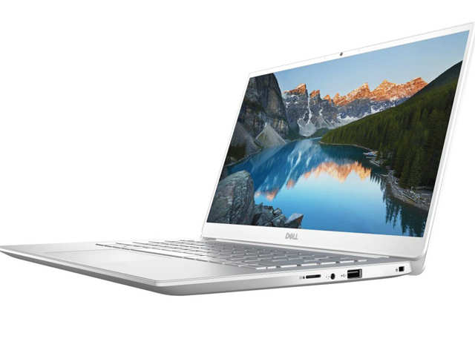

**Inspiron 14 5490 Laptop**

* 10th Generation Intel® Core™ i5-10210U Processor (6MB Cache, up to 4.2 GHz)
* Windows 10 Home Single Language, English
* NVIDIA® GeForce® MX250 with 2GB GDDR5 graphics memory
* 8GB,4Gx1 + 4G onboard, DDR4, 2666MHz
* 512GB M.2 PCIe NVMe Solid State Drive
* LCD Back Cover for Non-touch Display with Backlit Silver Keyboard- Platinum Silver (ICC)

**₹73,490**  **(incl. of all taxes)**