Data Visualization

#Import Sales Data set:

Sales_data<-read.csv("SalesData.csv")  
head(Sales_data,5)

## AccountId AccountName Region Division City State Tier Month Sales2015  
## 1 1116 Account1 West DIAMONDBACK PHOENIX W AZ Low Aug 0.00  
## 2 1116 Account1 West DIAMONDBACK PHOENIX W AZ Low Oct 10500.78  
## 3 2391 Account2 East MINUTEMEN HARTFORD CT Med Jun 0.00  
## 4 2391 Account2 East MINUTEMEN HARTFORD CT Med Mar 19881.00  
## 5 2397 Account3 East MINUTEMEN WORCESTER MA Med Sep 3684.48  
## Sales2016 Units2015 Units2016 TargetAchevied2015 TargetAchevied2016  
## 1 13208.52 0 4 0.70 1.53  
## 2 23114.91 3 7 0.84 1.31  
## 3 6627.00 0 3 1.15 1.29  
## 4 13254.00 9 6 1.33 1.17  
## 5 0.00 1 0 1.02 1.53

#Structure of the data set

str(Sales_data)

## 'data.frame': 3709 obs. of 14 variables:  
## $ AccountId : int 1116 1116 2391 2391 2397 2400 2400 2404 2406 2408 ...  
## $ AccountName : chr "Account1" "Account1" "Account2" "Account2" ...  
## $ Region : chr "West" "West" "East" "East" ...  
## $ Division : chr "DIAMONDBACK" "DIAMONDBACK" "MINUTEMEN" "MINUTEMEN" ...  
## $ City : chr "PHOENIX W" "PHOENIX W" "HARTFORD" "HARTFORD" ...  
## $ State : chr "AZ" "AZ" "CT" "CT" ...  
## $ Tier : chr "Low" "Low" "Med" "Med" ...  
## $ Month : chr "Aug" "Oct" "Jun" "Mar" ...  
## $ Sales2015 : num 0 10501 0 19881 3684 ...  
## $ Sales2016 : num 13209 23115 6627 13254 0 ...  
## $ Units2015 : num 0 3 0 9 1 0 1 1 0 0 ...  
## $ Units2016 : num 4 7 3 6 0 4 17 1 2 4 ...  
## $ TargetAchevied2015: num 0.7 0.84 1.15 1.33 1.02 1.03 1.08 0.79 1.12 1.11 ...  
## $ TargetAchevied2016: num 1.53 1.31 1.29 1.17 1.53 1.45 0.99 1.46 1.02 1.54 ...

#Importing useful library

library(dplyr)

## Warning: package 'dplyr' was built under R version 4.0.5

##   
## Attaching package: 'dplyr'

## The following objects are masked from 'package:stats':  
##   
## filter, lag

## The following objects are masked from 'package:base':  
##   
## intersect, setdiff, setequal, union

library(ggplot2)

## Warning: package 'ggplot2' was built under R version 4.0.4

# Q(1): Compare Sales by region for 2016 with 2015 using bar chart

regional_totalsales<-Sales_data%>%select(Region, Sales2015, Sales2016)%>%group_by(Region)%>%summarise(Total_sales2015=sum(Sales2015), Total_sales2016=sum(Sales2016))  
  
#Create data Frame  
df<-data.frame(Region=c("Central","East","West","Central","East","West"),  
 Sales=c(7891729,9512916,5349745,9787809,12667230,7209689),   
 Year=c("Total_sales2015","Total_sales2015","Total_sales2015","Total_sales2016","Total_sales2016","Total_sales2016"))  
df

## Region Sales Year  
## 1 Central 7891729 Total_sales2015  
## 2 East 9512916 Total_sales2015  
## 3 West 5349745 Total_sales2015  
## 4 Central 9787809 Total_sales2016  
## 5 East 12667230 Total_sales2016  
## 6 West 7209689 Total_sales2016

ggplot(df,aes(x=Region,y=Sales, fill=Year))+geom_bar(position="dodge", stat="identity")+geom_text(aes(label=Sales),size=3.2, hjust=0.7)+theme_update(plot.title = element_text(hjust = ))+ggtitle("Compare Sales by Region for 2015 with 2016")

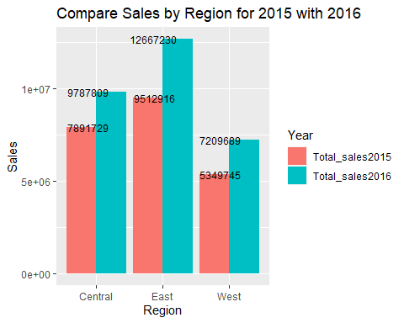

# Q(2): Pie Chart for Sales of each Region in 2016

totalsales2016<-Sales_data%>%select(Region, Sales2016)%>%group_by(Region)%>%summarise(Total_sales2016=sum(Sales2016))  
totalsales2016

## # A tibble: 3 x 2  
## Region Total_sales2016  
## <chr> <dbl>  
## 1 Central 9787809.  
## 2 East 12667230.  
## 3 West 7209689.

pie(totalsales2016$Total_sales2016,totalsales2016$Region, main="Region Pie Chart")

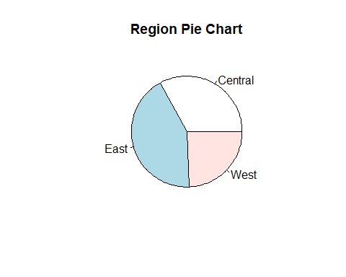

pct<-round(totalsales2016$Total_sales2016/sum(totalsales2016$Total_sales2016)*100,1)  
pct

## [1] 33.0 42.7 24.3

lbs=paste(pct,"%",":",c("Central","East","West"))  
lbs

## [1] "33 % : Central" "42.7 % : East" "24.3 % : West"

pie(totalsales2016$Total_sales2016, labels =lbs, main = "Region Wise Sales2016",  
 col = rainbow(length(totalsales2016$Total_sales2016)))

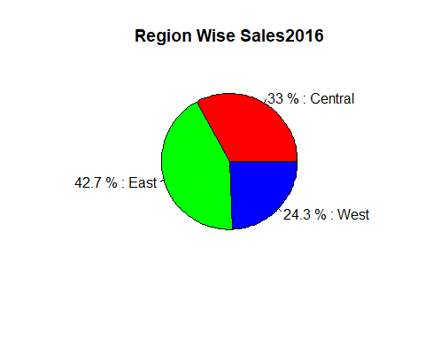

#3D Pie Chart  
#install.packages("plotrix")  
library(plotrix)  
  
pie3D(totalsales2016$Total_sales2016, labels = lbs, main = "Region Wise Sales2016 3D Pie Chart",  
 col = rainbow(length(totalsales2016$Total_sales2016)),explode = 0.05)

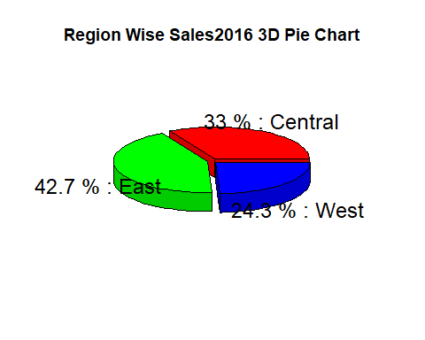

# Q(3): Compare sales of 2015 and 2016 with region and Tier

totalsales_2015<-Sales_data%>%select(Region, Tier,Sales2015)%>%group_by(Region, Tier)%>%summarise(Total_sales2015=sum(Sales2015))

## `summarise()` has grouped output by 'Region'. You can override using the `.groups` argument.

totalsales_2015

## # A tibble: 12 x 3  
## # Groups: Region [3]  
## Region Tier Total_sales2015  
## <chr> <chr> <dbl>  
## 1 Central High 4798698.  
## 2 Central Low 943440.  
## 3 Central Med 2068226.  
## 4 Central Out 81365.  
## 5 East High 6102946.  
## 6 East Low 901666.  
## 7 East Med 2470998.  
## 8 East Out 37307.  
## 9 West High 2944789.  
## 10 West Low 671064.  
## 11 West Med 1718476.  
## 12 West Out 15415.

totalsales_2016<-Sales_data%>%select(Region, Tier,Sales2016)%>%group_by(Region, Tier)%>%summarise(Total_sales2016=sum(Sales2016))

## `summarise()` has grouped output by 'Region'. You can override using the `.groups` argument.

totalsales_2016

## # A tibble: 12 x 3  
## # Groups: Region [3]  
## Region Tier Total_sales2016  
## <chr> <chr> <dbl>  
## 1 Central High 6026043.  
## 2 Central Low 1132833.  
## 3 Central Med 2632181.  
## 4 Central Out -3249.  
## 5 East High 7817151.  
## 6 East Low 1144930.  
## 7 East Med 3705150.  
## 8 East Out 0   
## 9 West High 3768038.  
## 10 West Low 1099502.  
## 11 West Med 2342149.  
## 12 West Out 0

library(dplyr)  
  
total_sales<-full_join(totalsales_2015,totalsales_2016)

## Joining, by = c("Region", "Tier")

total_sales

## # A tibble: 12 x 4  
## # Groups: Region [3]  
## Region Tier Total_sales2015 Total_sales2016  
## <chr> <chr> <dbl> <dbl>  
## 1 Central High 4798698. 6026043.  
## 2 Central Low 943440. 1132833.  
## 3 Central Med 2068226. 2632181.  
## 4 Central Out 81365. -3249.  
## 5 East High 6102946. 7817151.  
## 6 East Low 901666. 1144930.  
## 7 East Med 2470998. 3705150.  
## 8 East Out 37307. 0   
## 9 West High 2944789. 3768038.  
## 10 West Low 671064. 1099502.  
## 11 West Med 1718476. 2342149.  
## 12 West Out 15415. 0

df<-data.frame(Region=c("Central","Central","Central","Central","Central","Central","Central","Central","East","East","East","East","East","East","East","East","West","West","West","West","West","West","West","West"), Tier=c("High","High","Low","Low","Med","Med","out","out","High","High","Low","Low","Med","Med","out","out","High","High","Low","Low","Med","Med","out","out"),  
 Year=c("Total_sales2015","Total_sales2016","Total_sales2015","Total_sales2016","Total_sales2015","Total_sales2016","Total_sales2015","Total_sales2016","Total_sales2015","Total_sales2016","Total_sales2015","Total_sales2016","Total_sales2015","Total_sales2016","Total_sales2015","Total_sales2016","Total_sales2015","Total_sales2016","Total_sales2015","Total_sales2016","Total_sales2015","Total_sales2016","Total_sales2015","Total_sales2016"),  
 Sales=c(4798698, 6026043,943440,1132833,2068226,2632181,81365,-3249,6102946,7817151,901666,1144930,2470998,3705150,37307,0,2944789,3768038,671064,1099502,1718476,2342149,15415,0))  
df

## Region Tier Year Sales  
## 1 Central High Total_sales2015 4798698  
## 2 Central High Total_sales2016 6026043  
## 3 Central Low Total_sales2015 943440  
## 4 Central Low Total_sales2016 1132833  
## 5 Central Med Total_sales2015 2068226  
## 6 Central Med Total_sales2016 2632181  
## 7 Central out Total_sales2015 81365  
## 8 Central out Total_sales2016 -3249  
## 9 East High Total_sales2015 6102946  
## 10 East High Total_sales2016 7817151  
## 11 East Low Total_sales2015 901666  
## 12 East Low Total_sales2016 1144930  
## 13 East Med Total_sales2015 2470998  
## 14 East Med Total_sales2016 3705150  
## 15 East out Total_sales2015 37307  
## 16 East out Total_sales2016 0  
## 17 West High Total_sales2015 2944789  
## 18 West High Total_sales2016 3768038  
## 19 West Low Total_sales2015 671064  
## 20 West Low Total_sales2016 1099502  
## 21 West Med Total_sales2015 1718476  
## 22 West Med Total_sales2016 2342149  
## 23 West out Total_sales2015 15415  
## 24 West out Total_sales2016 0

ggplot(df,aes(x=Tier,y=Sales, fill=Year))+geom_bar(position="dodge", stat="identity")+geom_text(aes(label=Sales),size=3.2, hjust=0.7)+theme_update(plot.title = element_text(hjust = ))+ggtitle("Compare sales of 2015 and 2016 with Region and Tier")+facet_grid(~Region)

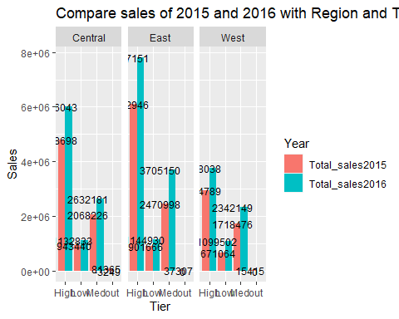

# Q(4):In East region, Which state registered a decline in 2016 as compared to 2015

totalsales_2015 = Sales_data%>%select(Region,State,Sales2015)%>%filter(Region=="East")%>%group_by(State)%>%summarise(totalsales_2015=sum(Sales2015))  
totalsales_2016 = Sales_data%>%select(Region,State,Sales2016)%>%filter(Region=="East")%>%group_by(State)%>%summarise(totalsales_2016=sum(Sales2016))  
  
total_sales<-full_join(totalsales_2015,totalsales_2016)

## Joining, by = "State"

total_sales

## # A tibble: 16 x 3  
## State totalsales_2015 totalsales_2016  
## <chr> <dbl> <dbl>  
## 1 CT 197203. 323502.  
## 2 DC 216724. 257422.  
## 3 FL 1660162 2508232.  
## 4 GA 681546. 946920.  
## 5 MA 419279. 687096.  
## 6 MD 527309. 750009.  
## 7 ME 77426. 183673.  
## 8 NC 1292802. 1610521   
## 9 NH 136419. 144718.  
## 10 NJ 520419. 782289.  
## 11 NY 1725415. 1703136.  
## 12 PA 785093. 894319.  
## 13 RI 156312. 162455.  
## 14 SC 247812. 463414.  
## 15 TN 49677 70109.  
## 16 VA 819319. 1179415.

df<-data.frame(State=c("CT","CT","DC","DC","FL","FL","GA","GA","MA","MA","MD","MD","ME","ME","NC","NC","NH","NH","NJ","NJ","NY","NY","PA","PA","RI","RI","SC","SC","TN","TN","VA","VA"),   
 Year=c("Total_sales2015","Total_sales2016","Total_sales2015","Total_sales2016","Total_sales2015","Total_sales2016","Total_sales2015","Total_sales2016","Total_sales2015","Total_sales2016","Total_sales2015","Total_sales2016","Total_sales2015","Total_sales2016","Total_sales2015","Total_sales2016","Total_sales2015","Total_sales2016","Total_sales2015","Total_sales2016","Total_sales2015","Total_sales2016","Total_sales2015","Total_sales2016","Total_sales2015","Total_sales2016","Total_sales2015","Total_sales2016","Total_sales2015","Total_sales2016","Total_sales2015","Total_sales2016"),  
 Sales=c(197203,323502,216724,257422,1660162,2508232,681546,946920,419279,687096,527309,750009,77426,183673,1292802,1610521,136419,144718,520419,782289,1725415,1703136,785093,894319,156312,162455,247812,463414,49677,70109,819319,1179415))  
df

## State Year Sales  
## 1 CT Total_sales2015 197203  
## 2 CT Total_sales2016 323502  
## 3 DC Total_sales2015 216724  
## 4 DC Total_sales2016 257422  
## 5 FL Total_sales2015 1660162  
## 6 FL Total_sales2016 2508232  
## 7 GA Total_sales2015 681546  
## 8 GA Total_sales2016 946920  
## 9 MA Total_sales2015 419279  
## 10 MA Total_sales2016 687096  
## 11 MD Total_sales2015 527309  
## 12 MD Total_sales2016 750009  
## 13 ME Total_sales2015 77426  
## 14 ME Total_sales2016 183673  
## 15 NC Total_sales2015 1292802  
## 16 NC Total_sales2016 1610521  
## 17 NH Total_sales2015 136419  
## 18 NH Total_sales2016 144718  
## 19 NJ Total_sales2015 520419  
## 20 NJ Total_sales2016 782289  
## 21 NY Total_sales2015 1725415  
## 22 NY Total_sales2016 1703136  
## 23 PA Total_sales2015 785093  
## 24 PA Total_sales2016 894319  
## 25 RI Total_sales2015 156312  
## 26 RI Total_sales2016 162455  
## 27 SC Total_sales2015 247812  
## 28 SC Total_sales2016 463414  
## 29 TN Total_sales2015 49677  
## 30 TN Total_sales2016 70109  
## 31 VA Total_sales2015 819319  
## 32 VA Total_sales2016 1179415

ggplot(df,aes(x=State,y=Sales, fill=Year))+geom_bar(position="dodge", stat="identity")+geom_text(aes(label=Sales),size=3.2, hjust=0.7)+theme_update(plot.title = element_text(hjust = ))+ggtitle("In East Region, NY registered a decline in sales in 2016")

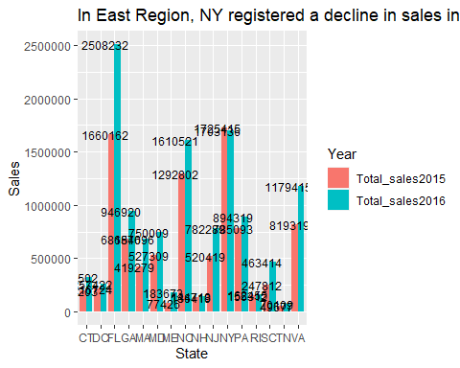 # Q(5):In all the high tier, which Division saw a decline in number of units sold in 2016 compared to 2015?

total_units = Sales_data %>%select(Division, Tier, Units2015,Units2016)%>%filter(Tier=="High")%>%group_by(Division)%>%summarise(TotalUnits_2015=sum(Units2015),TotalUnits_2016=sum(Units2016))  
head(total_units,5)

## # A tibble: 5 x 3  
## Division TotalUnits_2015 TotalUnits_2016  
## <chr> <dbl> <dbl>  
## 1 BIG APPLE 181. 231   
## 2 CHARGERS 124. 164.  
## 3 CONGRESSIONAL 165. 205   
## 4 DIAMONDBACK 153. 177.  
## 5 EMPIRE 414. 449.

#Save "total_units into csv

write.csv(total_units,"total_units.csv")

#Import modified “total_units_data.csv” file

total_units=read.csv("total_units_data.csv")  
total_units

## ï..X Division Units Year  
## 1 1 BIG APPLE 180.8330 TotalUnits_2015  
## 2 2 CHARGERS 123.6666 TotalUnits_2015  
## 3 3 CONGRESSIONAL 164.5003 TotalUnits_2015  
## 4 4 DIAMONDBACK 153.3334 TotalUnits_2015  
## 5 5 EMPIRE 414.3332 TotalUnits_2015  
## 6 6 GRIDIRON 213.6673 TotalUnits_2015  
## 7 7 GULF STREAM 185.0000 TotalUnits_2015  
## 8 8 HAILSTORM 187.8338 TotalUnits_2015  
## 9 9 KINETIC 214.3334 TotalUnits_2015  
## 10 10 MINUTEMEN 215.0000 TotalUnits_2015  
## 11 11 MUDDY WATERS 150.6666 TotalUnits_2015  
## 12 12 NORDIC 210.1675 TotalUnits_2015  
## 13 13 NORTHWEST 135.5008 TotalUnits_2015  
## 14 14 ORION 175.8334 TotalUnits_2015  
## 15 15 RACEWAY 178.3338 TotalUnits_2015  
## 16 16 REVOLUTION 205.8335 TotalUnits_2015  
## 17 17 RIPTIDE 147.5002 TotalUnits_2015  
## 18 18 SOUTHERN STAR 230.0000 TotalUnits_2015  
## 19 19 STAMPEDE 192.4999 TotalUnits_2015  
## 20 20 SYNERGY 322.6666 TotalUnits_2015  
## 21 21 THE CAROLINAS 258.8335 TotalUnits_2015  
## 22 22 TORNADO VALLEY 128.3331 TotalUnits_2015  
## 23 23 VICTORY 174.5005 TotalUnits_2015  
## 24 24 WAVE RIDER 173.4996 TotalUnits_2015  
## 25 25 WOLVERINE 122.0002 TotalUnits_2015  
## 26 26 WRANGLER 206.1666 TotalUnits_2015  
## 27 27 BIG APPLE 231.0000 TotalUnits_2016  
## 28 28 CHARGERS 164.4999 TotalUnits_2016  
## 29 29 CONGRESSIONAL 205.0000 TotalUnits_2016  
## 30 30 DIAMONDBACK 176.6667 TotalUnits_2016  
## 31 31 EMPIRE 449.3332 TotalUnits_2016  
## 32 32 GRIDIRON 246.1675 TotalUnits_2016  
## 33 33 GULF STREAM 301.0009 TotalUnits_2016  
## 34 34 HAILSTORM 247.0003 TotalUnits_2016  
## 35 35 KINETIC 244.5001 TotalUnits_2016  
## 36 36 MINUTEMEN 267.5000 TotalUnits_2016  
## 37 37 MUDDY WATERS 211.5004 TotalUnits_2016  
## 38 38 NORDIC 225.8334 TotalUnits_2016  
## 39 39 NORTHWEST 163.6669 TotalUnits_2016  
## 40 40 ORION 276.0000 TotalUnits_2016  
## 41 41 RACEWAY 297.0000 TotalUnits_2016  
## 42 42 REVOLUTION 226.8334 TotalUnits_2016  
## 43 43 RIPTIDE 183.8336 TotalUnits_2016  
## 44 44 SOUTHERN STAR 274.1665 TotalUnits_2016  
## 45 45 STAMPEDE 246.8333 TotalUnits_2016  
## 46 46 SYNERGY 428.3334 TotalUnits_2016  
## 47 47 THE CAROLINAS 345.0000 TotalUnits_2016  
## 48 48 TORNADO VALLEY 181.0004 TotalUnits_2016  
## 49 49 VICTORY 221.1669 TotalUnits_2016  
## 50 50 WAVE RIDER 223.3332 TotalUnits_2016  
## 51 51 WOLVERINE 143.0000 TotalUnits_2016  
## 52 52 WRANGLER 259.6666 TotalUnits_2016

#Plot

ggplot(total_units,aes(x=Division,y=Units, fill=Year))+geom_bar(position="dodge", stat="identity")+geom_text(aes(label=Units),size=3.2, hjust=0.7)+theme_update(plot.title = element_text(hjust = ))+ggtitle("Division wise Units Comparison for Each Year")+coord_flip()

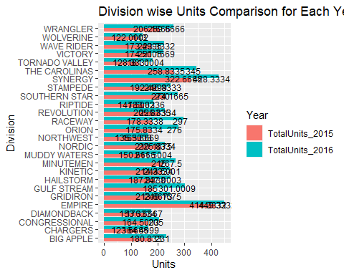

##From the above graph, we can easily see that there is no decline number of units sold in 2016 as compared to 2015.

# Q(6): Create a new column Qtr-

#Jan-Mar: Q1  
#Apr-Jan: Q2  
#Jul-Sep: Q3  
#Oct-Dec: Q4  
  
#Calculating Quartiles  
Q1<-Sales_data%>%select(Month, Sales2015,Sales2016)%>%filter(Month==c("Jan","Feb","Mar"))%>%summarise(sum(Sales2015),sum(Sales2016))

## Warning in Month == c("Jan", "Feb", "Mar"): longer object length is not a  
## multiple of shorter object length

Q1

## sum(Sales2015) sum(Sales2016)  
## 1 2064545 2427928

Q2<-Sales_data%>%select(Month, Sales2015,Sales2016)%>%filter(Month==c("Apr","May","Jun"))%>%summarise(sum(Sales2015),sum(Sales2016))

## Warning in Month == c("Apr", "May", "Jun"): longer object length is not a  
## multiple of shorter object length

Q2

## sum(Sales2015) sum(Sales2016)  
## 1 1690440 2493748

Q3<-Sales_data%>%select(Month, Sales2015,Sales2016)%>%filter(Month==c("Jul","Aug","Sep"))%>%summarise(sum(Sales2015),sum(Sales2016))

## Warning in Month == c("Jul", "Aug", "Sep"): longer object length is not a  
## multiple of shorter object length

Q3

## sum(Sales2015) sum(Sales2016)  
## 1 2192199 2832778

Q4<-Sales_data%>%select(Month, Sales2015,Sales2016)%>%filter(Month==c("Oct","Nov","Dec"))%>%summarise(sum(Sales2015),sum(Sales2016))

## Warning in Month == c("Oct", "Nov", "Dec"): longer object length is not a  
## multiple of shorter object length

Q4

## sum(Sales2015) sum(Sales2016)  
## 1 1889045 2663758

#Preparing data frame   
df<-data.frame(Year=c("TotalSales2015","TotalSales2016","TotalSales2015","TotalSales2016","TotalSales2015","TotalSales2016","TotalSales2015","TotalSales2016"),  
   
 Qty=c("Q1","Q1","Q2","Q2","Q3","Q3","Q4","Q4"),Sales=c(2064545,2427928,1690440,2493748,2192199,2832778,1889045,2663758))  
View(df)

# Q(7):Compare Qtr wise sales in 2015 and 2016 in a bar plot

#Dodge Graph  
ggplot(df, aes(x=Qty,y=Sales, fill=Year))+geom_bar(position="dodge", stat="identity")+geom_text(aes(label=Sales),size=3.2, hjust=0.7)+theme_update(plot.title = element_text(hjust = ))+ggtitle("Division wise Units Comparison for Each Year")

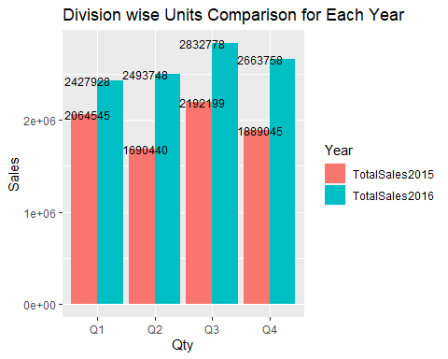

# Q(8): Determine the composition of Qtr wise sales in and 2015 with regards to all the Tiers in Pie Chart.

#Calculating Quartiles  
par(mfrow=c(2,2))  
Q1<-Sales_data%>%select(Month,Tier, Sales2015)%>%filter(Month==c("Jan","Feb","Mar"))%>%group_by(Tier)%>%summarise(Total_Sales=sum(Sales2015))

## Warning in Month == c("Jan", "Feb", "Mar"): longer object length is not a  
## multiple of shorter object length

Q1

## # A tibble: 4 x 2  
## Tier Total_Sales  
## <chr> <dbl>  
## 1 High 1269962.  
## 2 Low 275479.  
## 3 Med 518623.  
## 4 Out 481.

pie(Q1$Total_Sales,Q1$Tier, main="Qtr1")  
  
Q2<-Sales_data%>%select(Month,Tier, Sales2015)%>%filter(Month==c("Apr","May","Jun"))%>%group_by(Tier)%>%summarise(Total_Sales=sum(Sales2015))

## Warning in Month == c("Apr", "May", "Jun"): longer object length is not a  
## multiple of shorter object length

Q2

## # A tibble: 4 x 2  
## Tier Total_Sales  
## <chr> <dbl>  
## 1 High 1029616.  
## 2 Low 206932.  
## 3 Med 440134.  
## 4 Out 13758.

pie(Q2$Total_Sales,Q2$Tier, main="Qtr2")  
  
Q3<-Sales_data%>%select(Month, Tier, Sales2015)%>%filter(Month==c("Jul","Aug","Sep"))%>%group_by(Tier)%>%summarise(Total_Sales=sum(Sales2015))

## Warning in Month == c("Jul", "Aug", "Sep"): longer object length is not a  
## multiple of shorter object length

Q3

## # A tibble: 4 x 2  
## Tier Total_Sales  
## <chr> <dbl>  
## 1 High 1319837.  
## 2 Low 183892.  
## 3 Med 677504.  
## 4 Out 10966.

pie(Q3$Total_Sales,Q3$Tier, main="Qtr3")  
  
Q4<-Sales_data%>%select(Month,Tier, Sales2015)%>%filter(Month==c("Oct","Nov","Dec"))%>%group_by(Tier)%>%summarise(Total_Sales=sum(Sales2015))

## Warning in Month == c("Oct", "Nov", "Dec"): longer object length is not a  
## multiple of shorter object length

Q4

## # A tibble: 4 x 2  
## Tier Total_Sales  
## <chr> <dbl>  
## 1 High 1254390.  
## 2 Low 140425.  
## 3 Med 488248.  
## 4 Out 5982.

pie(Q4$Total_Sales,Q4$Tier, main="Qtr4")

