Retail Case Study

#Import CSV Data Files

getwd()

## [1] "C:/Users/Pawan Sharma/Desktop/AnalytixLabs/Case Studies/R case study/Retail data analysis/R - Retail Case study/R case study 1 (Retail)/Customer Analysis for Retail"

customer<-read.csv("Customer.csv")  
View(customer)  
  
prod_cat_info<-read.csv("prod_cat_info.csv")  
View(prod_cat_info)  
  
Transactions<-read.csv("Transactions.csv")  
View(Transactions)

#Q(1) ## (a) Merge the data set with the help of the merge()

customer_df<-merge(customer, Transactions,by.x="customer_Id",by.y="cust_id")  
View(customer_df)  
  
Customer_Final<-merge(customer_df,prod_cat_info, by.x="prod_subcat_code",by.y = "prod_sub_cat_code")  
View(Customer_Final)  
  
head(Customer_Final,3)

## prod_subcat_code customer_Id DOB Gender city_code transaction_id  
## 1 1 275166 05-11-1970 M 10 31795262740  
## 2 1 275166 05-11-1970 M 10 31795262740  
## 3 1 275166 05-11-1970 M 10 31795262740  
## tran_date prod_cat_code.x Qty Rate Tax total_amt Store_type  
## 1 1/2/2011 4 4 531 223.02 2347.02 e-Shop  
## 2 1/2/2011 4 4 531 223.02 2347.02 e-Shop  
## 3 1/2/2011 4 4 531 223.02 2347.02 e-Shop  
## prod_cat_code.y prod_cat prod_subcat  
## 1 2 Footwear Mens  
## 2 1 Clothing Women  
## 3 4 Bags Mens

##(b) Merge the data set with the help of dplyr package

library(dplyr)

## Warning: package 'dplyr' was built under R version 4.0.5

##   
## Attaching package: 'dplyr'

## The following objects are masked from 'package:stats':  
##   
## filter, lag

## The following objects are masked from 'package:base':  
##   
## intersect, setdiff, setequal, union

customer_df<-inner_join(customer,Transactions, by=c("customer_Id"="cust_id"))  
View(customer_df)  
  
Customer_Final<-inner_join(customer_df,prod_cat_info,by=c("prod_subcat_code"="prod_sub_cat_code"))  
View(Customer_Final)  
  
head(Customer_Final,3)

## customer_Id DOB Gender city_code transaction_id tran_date  
## 1 268408 02-01-1970 M 4 87243835584 13-01-2014  
## 2 268408 02-01-1970 M 4 16197868036 16-12-2013  
## 3 268408 02-01-1970 M 4 16197868036 16-12-2013  
## prod_subcat_code prod_cat_code.x Qty Rate Tax total_amt Store_type  
## 1 7 5 5 187 98.175 1033.175 TeleShop  
## 2 1 4 -5 -210 110.250 -1160.250 Flagship store  
## 3 1 4 -5 -210 110.250 -1160.250 Flagship store  
## prod_cat_code.y prod_cat prod_subcat  
## 1 5 Books Fiction  
## 2 1 Clothing Women  
## 3 2 Footwear Mens

#Q(2) Prepare a summary report for the marged data set. ##(a) Get the column names and their corresponding data types.

colnames(Customer_Final)

## [1] "customer_Id" "DOB" "Gender" "city_code"   
## [5] "transaction_id" "tran_date" "prod_subcat_code" "prod_cat_code.x"   
## [9] "Qty" "Rate" "Tax" "total_amt"   
## [13] "Store_type" "prod_cat_code.y" "prod_cat" "prod_subcat"

#OR  
names(Customer_Final)

## [1] "customer_Id" "DOB" "Gender" "city_code"   
## [5] "transaction_id" "tran_date" "prod_subcat_code" "prod_cat_code.x"   
## [9] "Qty" "Rate" "Tax" "total_amt"   
## [13] "Store_type" "prod_cat_code.y" "prod_cat" "prod_subcat"

##(b)Top/Bottom 10 observations

head(Customer_Final,10)

## customer_Id DOB Gender city_code transaction_id tran_date  
## 1 268408 02-01-1970 M 4 87243835584 13-01-2014  
## 2 268408 02-01-1970 M 4 16197868036 16-12-2013  
## 3 268408 02-01-1970 M 4 16197868036 16-12-2013  
## 4 268408 02-01-1970 M 4 16197868036 16-12-2013  
## 5 268408 02-01-1970 M 4 16197868036 12/12/2013  
## 6 268408 02-01-1970 M 4 16197868036 12/12/2013  
## 7 268408 02-01-1970 M 4 16197868036 12/12/2013  
## 8 268408 02-01-1970 M 4 28810141075 2/9/2013  
## 9 268408 02-01-1970 M 4 28810141075 2/9/2013  
## 10 268408 02-01-1970 M 4 28810141075 2/9/2013  
## prod_subcat_code prod_cat_code.x Qty Rate Tax total_amt Store_type  
## 1 7 5 5 187 98.175 1033.175 TeleShop  
## 2 1 4 -5 -210 110.250 -1160.250 Flagship store  
## 3 1 4 -5 -210 110.250 -1160.250 Flagship store  
## 4 1 4 -5 -210 110.250 -1160.250 Flagship store  
## 5 1 4 5 210 110.250 1160.250 Flagship store  
## 6 1 4 5 210 110.250 1160.250 Flagship store  
## 7 1 4 5 210 110.250 1160.250 Flagship store  
## 8 10 6 2 813 170.730 1796.730 TeleShop  
## 9 10 6 2 813 170.730 1796.730 TeleShop  
## 10 10 6 2 813 170.730 1796.730 TeleShop  
## prod_cat_code.y prod_cat prod_subcat  
## 1 5 Books Fiction  
## 2 1 Clothing Women  
## 3 2 Footwear Mens  
## 4 4 Bags Mens  
## 5 1 Clothing Women  
## 6 2 Footwear Mens  
## 7 4 Bags Mens  
## 8 3 Electronics Audio and video  
## 9 5 Books Non-Fiction  
## 10 6 Home and kitchen Kitchen

tail(Customer_Final,10)

## customer_Id DOB Gender city_code transaction_id tran_date  
## 57157 269626 27-12-1992 F 5 94134051896 7/7/2011  
## 57158 269626 27-12-1992 F 5 94134051896 7/7/2011  
## 57159 274308 29-12-1992 F 5 26208690928 22-10-2012  
## 57160 274308 29-12-1992 F 5 26208690928 22-10-2012  
## 57161 274308 29-12-1992 F 5 26208690928 22-10-2012  
## 57162 274308 29-12-1992 F 5 57358822237 5/9/2012  
## 57163 274308 29-12-1992 F 5 57358822237 5/9/2012  
## 57164 274308 29-12-1992 F 5 57358822237 5/9/2012  
## 57165 274308 29-12-1992 F 5 58160544337 4/7/2012  
## 57166 274308 29-12-1992 F 5 58160544337 4/7/2012  
## prod_subcat_code prod_cat_code.x Qty Rate Tax total_amt Store_type  
## 57157 3 1 3 1078 339.57 3573.57 MBR  
## 57158 3 1 3 1078 339.57 3573.57 MBR  
## 57159 1 2 2 898 188.58 1984.58 MBR  
## 57160 1 2 2 898 188.58 1984.58 MBR  
## 57161 1 2 2 898 188.58 1984.58 MBR  
## 57162 1 2 4 876 367.92 3871.92 e-Shop  
## 57163 1 2 4 876 367.92 3871.92 e-Shop  
## 57164 1 2 4 876 367.92 3871.92 e-Shop  
## 57165 12 5 5 588 308.70 3248.70 e-Shop  
## 57166 12 5 5 588 308.70 3248.70 e-Shop  
## prod_cat_code.y prod_cat prod_subcat  
## 57157 2 Footwear Women  
## 57158 5 Books Comics  
## 57159 1 Clothing Women  
## 57160 2 Footwear Mens  
## 57161 4 Bags Mens  
## 57162 1 Clothing Women  
## 57163 2 Footwear Mens  
## 57164 4 Bags Mens  
## 57165 5 Books Academic  
## 57166 6 Home and kitchen Tools

##(c) “Five-Number summary”, for continuous variables.

Customer_Final %>% select(Qty, Rate,Tax, total_amt)%>%summary()

## Qty Rate Tax total_amt   
## Min. :-5.00 Min. :-1499 Min. : 7.35 Min. :-8270.9   
## 1st Qu.: 1.00 1st Qu.: 312 1st Qu.: 98.49 1st Qu.: 764.7   
## Median : 3.00 Median : 709 Median :199.34 Median : 1759.2   
## Mean : 2.43 Mean : 635 Mean :248.97 Mean : 2102.1   
## 3rd Qu.: 4.00 3rd Qu.: 1109 3rd Qu.:364.98 3rd Qu.: 3553.7   
## Max. : 5.00 Max. : 1500 Max. :787.50 Max. : 8287.5

#OR  
summary(Customer_Final$Qty)

## Min. 1st Qu. Median Mean 3rd Qu. Max.   
## -5.00 1.00 3.00 2.43 4.00 5.00

summary(Customer_Final$Rate)

## Min. 1st Qu. Median Mean 3rd Qu. Max.   
## -1499 312 709 635 1109 1500

summary(Customer_Final$Tax)

## Min. 1st Qu. Median Mean 3rd Qu. Max.   
## 7.35 98.49 199.34 248.97 364.98 787.50

summary(Customer_Final$total_amt)

## Min. 1st Qu. Median Mean 3rd Qu. Max.   
## -8270.9 764.7 1759.2 2102.1 3553.7 8287.5

##(d) Frequency tables for all the categorical variables.

data.frame(table(Customer_Final$Gender))

## Var1 Freq  
## 1 F 27953  
## 2 M 29213

data.frame(table(Customer_Final$city_code))

## Var1 Freq  
## 1 1 5582  
## 2 2 5616  
## 3 3 5886  
## 4 4 5961  
## 5 5 5941  
## 6 6 5295  
## 7 7 5761  
## 8 8 5771  
## 9 9 5538  
## 10 10 5800

data.frame(table(Customer_Final$prod_subcat_code))

## Var1 Freq  
## 1 1 8850  
## 2 2 1007  
## 3 3 9201  
## 4 4 16008  
## 5 5 958  
## 6 6 989  
## 7 7 1043  
## 8 8 972  
## 9 9 985  
## 10 10 8979  
## 11 11 4116  
## 12 12 4058

data.frame(table(Customer_Final$prod_cat_code.x))

## Var1 Freq  
## 1 1 9847  
## 2 2 10006  
## 3 3 9895  
## 4 4 6989  
## 5 5 12141  
## 6 6 8288

data.frame(table(Customer_Final$Store_type))

## Var1 Freq  
## 1 e-Shop 23087  
## 2 Flagship store 11324  
## 3 MBR 11644  
## 4 TeleShop 11111

data.frame(table(Customer_Final$prod_cat_code.y))

## Var1 Freq  
## 1 1 10019  
## 2 2 10019  
## 3 3 9910  
## 4 4 6952  
## 5 5 12179  
## 6 6 8087

data.frame(table(Customer_Final$prod_cat))

## Var1 Freq  
## 1 Bags 6952  
## 2 Books 12179  
## 3 Clothing 10019  
## 4 Electronics 9910  
## 5 Footwear 10019  
## 6 Home and kitchen 8087

data.frame(table(Customer_Final$prod_subcat))

## Var1 Freq  
## 1 Academic 2029  
## 2 Audio and video 2993  
## 3 Bath 2058  
## 4 Cameras 985  
## 5 Children 2058  
## 6 Comics 3067  
## 7 Computers 958  
## 8 DIY 989  
## 9 Fiction 1043  
## 10 Furnishing 1007  
## 11 Kids 7069  
## 12 Kitchen 2993  
## 13 Mens 9902  
## 14 Mobiles 4002  
## 15 Non-Fiction 2993  
## 16 Personal Appliances 972  
## 17 Tools 2029  
## 18 Women 10019

#Q(3) Generate Histogram for all the continuous Variables and frequency bars for categorical variables.

hist(Customer_Final$Qty, xlab = "Qty", ylab = "Frequency", main = "Histogram for Qty")

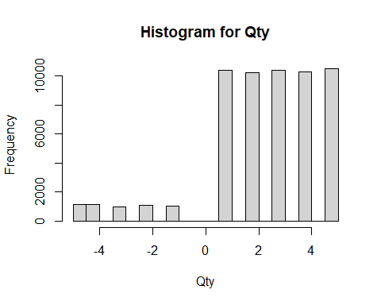

hist(Customer_Final$Rate,xlab = "Rate", ylab = "Frequency", main = "Histogram for Rate")

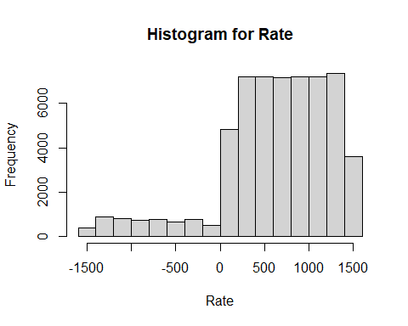

hist(Customer_Final$Tax,xlab = "Tax", ylab = "Frequency", main = "Histogram for Tax")

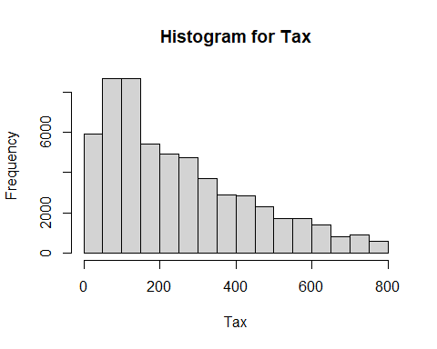

hist(Customer_Final$total_amt,xlab = "total_amt", ylab = "Frequency", main = "Histogram for tital_amt")

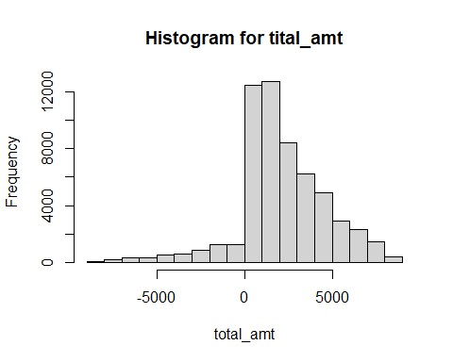

#barplot(data.frame(table(Customer_Final$Gender)))  
barplot(table(Customer_Final$city_code))

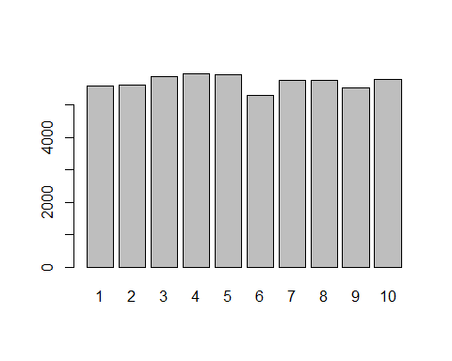

barplot(table(Customer_Final$prod_subcat_code))

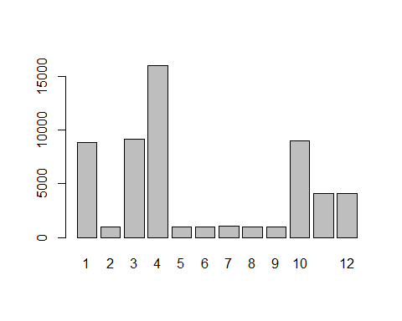

barplot(table(Customer_Final$prod_cat_code.x))

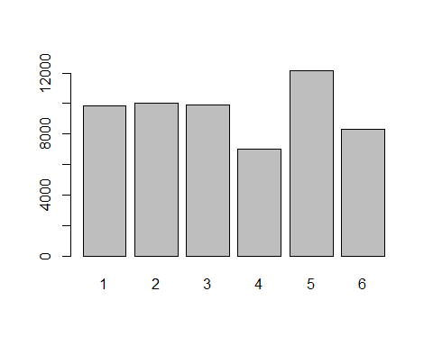

barplot(table(Customer_Final$Store_type))

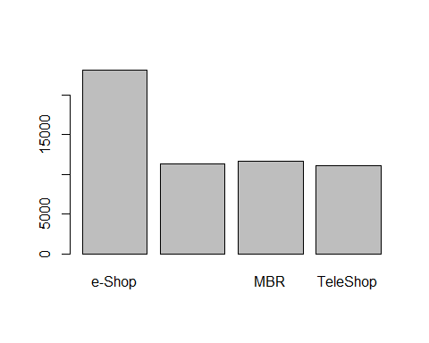

barplot(table(Customer_Final$prod_cat_code.y))

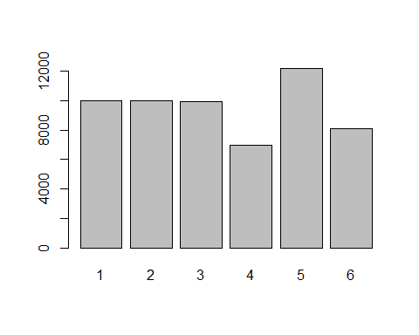

barplot(table(Customer_Final$prod_cat))

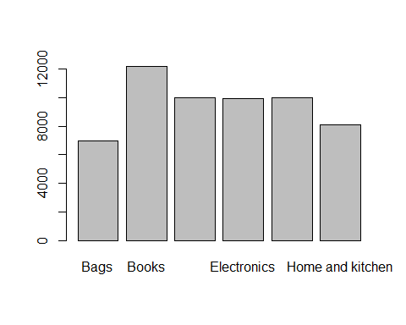

barplot(table(Customer_Final$prod_subcat))

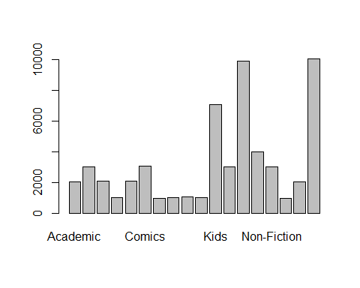

#Q(4) Calculate the following information using the merged dataset

library(lubridate)

## Warning: package 'lubridate' was built under R version 4.0.5

##   
## Attaching package: 'lubridate'

## The following objects are masked from 'package:base':  
##   
## date, intersect, setdiff, union

df<-distinct(select(Customer_Final, transaction_id,tran_date))  
dmy=dmy(df$tran_date)  
head(dmy,20)

## [1] "2014-01-13" "2013-12-16" "2013-12-12" "2013-09-02" "2013-05-06"  
## [6] "2013-01-30" "2012-10-14" "2012-09-07" "2012-08-14" "2012-04-26"  
## [11] "2011-07-12" "2012-04-15" "2012-04-08" "2011-09-18" "2013-10-03"  
## [16] "2013-03-31" "2013-01-30" "2012-12-24" "2012-07-20" "2012-02-06"

mdy=mdy(df$tran_date)

## Warning: 13918 failed to parse.

head(mdy,20)

## [1] NA NA "2013-12-12" "2013-02-09" "2013-06-05"  
## [6] NA NA "2012-07-09" NA NA   
## [11] "2011-12-07" NA "2012-08-04" NA "2013-03-10"  
## [16] NA NA NA NA "2012-06-02"

mdy[is.na(mdy)]<-dmy[is.na(mdy)]  
df$tran_date<-mdy  
head(df,5)

## transaction_id tran_date  
## 1 87243835584 2014-01-13  
## 2 16197868036 2013-12-16  
## 3 16197868036 2013-12-12  
## 4 28810141075 2013-02-09  
## 5 64633435931 2013-06-05

#Time Period  
years<-year(max(df$tran_date))-year(min(df$tran_date))  
years

## [1] 3

months<-month(max(df$tran_date))-month(min(df$tran_date))  
months

## [1] 11

day<-day(max(df$tran_date))-month(min(df$tran_date))  
day

## [1] 1

##(b) Count the transactions where the total amount of transaction was negative.

Customer_Final%>%select(transaction_id,total_amt)%>%filter(total_amt<0)%>%count(transaction_id)%>%head()

## transaction_id n  
## 1 87125650 3  
## 2 95570369 2  
## 3 156697409 2  
## 4 265535637 3  
## 5 268218855 4  
## 6 277893283 3

#Q(5) Analyze which product categories are more popular among females vs male customers.

Customer_Final%>%select(prod_cat, Gender)%>%group_by(prod_cat)%>%count(Gender)%>%arrange(desc(n))

## # A tibble: 12 x 3  
## # Groups: prod_cat [6]  
## prod_cat Gender n  
## <chr> <chr> <int>  
## 1 Books M 6175  
## 2 Books F 6004  
## 3 Electronics M 5115  
## 4 Clothing M 5103  
## 5 Footwear M 5103  
## 6 Clothing F 4916  
## 7 Footwear F 4916  
## 8 Electronics F 4795  
## 9 Home and kitchen M 4128  
## 10 Home and kitchen F 3959  
## 11 Bags M 3589  
## 12 Bags F 3363

prod_cat “Books” is more popular among females and male.

#Q(6) Which City code has the maximum customers and what was the percentage of customers from the city?

max_cust<-Customer_Final%>%select(customer_Id,city_code)%>%distinct()%>%count(city_code)  
max_cust

## city_code n  
## 1 1 535  
## 2 2 546  
## 3 3 576  
## 4 4 569  
## 5 5 570  
## 6 6 516  
## 7 7 563  
## 8 8 551  
## 9 9 532  
## 10 10 546  
## 11 NA 2

#Identify NA's.  
which(is.na(Customer_Final$city_code))

## [1] 1145 1146 1147 1148 1149 1150 1151 1152 1153 1154 1155 1547 1548 1549 1550

#Replace NA's with city code 3.  
Customer_Final$city_code[is.na(Customer_Final$city_code)]<-3  
  
#City code wise Maximum customers.  
max_cust<-Customer_Final%>%select(customer_Id,city_code)%>%distinct()%>%count(city_code)%>%arrange(desc(n))  
max_cust

## city_code n  
## 1 3 578  
## 2 5 570  
## 3 4 569  
## 4 7 563  
## 5 8 551  
## 6 2 546  
## 7 10 546  
## 8 1 535  
## 9 9 532  
## 10 6 516

City code 3 has maximum customers.

#Percentage of the customers of each city.  
max_cust$Percentage<-round((max_cust$n/sum(max_cust$n))*100,2)  
max_cust

## city_code n Percentage  
## 1 3 578 10.50  
## 2 5 570 10.35  
## 3 4 569 10.33  
## 4 7 563 10.23  
## 5 8 551 10.01  
## 6 2 546 9.92  
## 7 10 546 9.92  
## 8 1 535 9.72  
## 9 9 532 9.66  
## 10 6 516 9.37

#Q(7)Which store type sells the maximum products by value and by quantity?

Customer_Final%>% select(Store_type,total_amt,Qty)%>%group_by(Store_type)%>%summarise(Grand_sales=sum(total_amt),Grand_Qty=sum(Qty))%>%arrange(desc(Grand_Qty))

## # A tibble: 4 x 3  
## Store_type Grand_sales Grand_Qty  
## <chr> <dbl> <int>  
## 1 e-Shop 49096589. 56372  
## 2 MBR 24018167. 27869  
## 3 Flagship store 24072659. 27600  
## 4 TeleShop 22980349. 27059

Store type “e-shope” sells the maximum products by value and by quantity.

#Q(8) What was the total amount earned from the “Electronics” and “Clothing” categories from Flagship stores?

Customer_Final%>%select(Store_type,prod_cat, total_amt)%>%filter(Store_type=="Flagship store",prod_cat==c("Electronics","Clothing"))%>%group_by(prod_cat)%>%summarise(Grand_Total=sum(total_amt))

## # A tibble: 2 x 2  
## prod_cat Grand_Total  
## <chr> <dbl>  
## 1 Clothing 2149593.  
## 2 Electronics 2011226.

#Q(9) What was the total amount earned from “Male” customers under the “Electronic” category?

Customer_Final %>% select(prod_cat,Gender,total_amt)%>%filter(Gender=="M",prod_cat=="Electronics")%>%summarise(prod_cat="Electronics",Gender="M",Grand_Total=sum(total_amt))

## prod_cat Gender Grand_Total  
## 1 Electronics M 10953414

#Q(10) How many customers have more than 10 unique transactions, after removing all the transaction which have any negative amounts?

Customer_Final%>% select(transaction_id,customer_Id,total_amt)%>%filter(total_amt>0)%>%distinct(transaction_id, customer_Id)%>%group_by(customer_Id)%>%count(customer_Id)%>%arrange(desc(n))%>%filter(n > 10)

## # A tibble: 6 x 2  
## # Groups: customer_Id [6]  
## customer_Id n  
## <int> <int>  
## 1 266794 11  
## 2 270535 11  
## 3 270803 11  
## 4 272741 11  
## 5 273014 11  
## 6 274227 11

There are six customers having more than 10 unique transactions, after removing all the transaction which have any negative amounts.

#Q(11) For all customers aged between 25 - 35, find out: ##(a) What was the total amount spent for “Electronics” and “Books” product categories?

#Changing DOB Date format %Y-%m-%d as the R standard.  
Customer_Final$DOB<-strptime(as.character(Customer_Final$DOB),"%d-%m-%Y")  
Customer_Final$DOB<-format(Customer_Final$DOB,"%Y-%m-%d")  
  
#Adding Age column.  
Customer_Final$Age<-year(Sys.Date())-year(Customer_Final$DOB)  
  
Customer_Final%>%select(prod_cat,Age,total_amt)%>%filter(prod_cat==c("Electronics","Books"), Age==25:35)%>%group_by(prod_cat)%>%summarise(sum(total_amt))

## Warning in Age == 25:35: longer object length is not a multiple of shorter  
## object length

## # A tibble: 2 x 2  
## prod_cat `sum(total_amt)`  
## <chr> <dbl>  
## 1 Books 363547.  
## 2 Electronics 295582.

#Q(b) What was the total amount spent by these customers between 1st Jan,2014 to 1st Mar, 2014?

#Converting the date format of tran_date into the same format.  
library(lubridate)  
dmy=dmy(Customer_Final$tran_date)  
head(dmy,20)

## [1] "2014-01-13" "2013-12-16" "2013-12-16" "2013-12-16" "2013-12-12"  
## [6] "2013-12-12" "2013-12-12" "2013-09-02" "2013-09-02" "2013-09-02"  
## [11] "2013-05-06" "2013-05-06" "2013-05-06" "2013-05-06" "2013-01-30"  
## [16] "2012-10-14" "2012-10-14" "2012-10-14" "2012-09-07" "2012-09-07"

mdy=mdy(Customer_Final$tran_date)

## Warning: 34590 failed to parse.

head(mdy,20)

## [1] NA NA NA NA "2013-12-12"  
## [6] "2013-12-12" "2013-12-12" "2013-02-09" "2013-02-09" "2013-02-09"  
## [11] "2013-06-05" "2013-06-05" "2013-06-05" "2013-06-05" NA   
## [16] NA NA NA "2012-07-09" "2012-07-09"

mdy[is.na(mdy)]<-dmy[is.na(mdy)]  
Customer_Final$tran_date<-mdy  
  
#Calculating total amount.   
Customer_Final%>%select(Age,tran_date,total_amt)%>%filter(Age==25:35,tran_date>="2014-01-01" & tran_date <= "2014-03-01" )%>%arrange(tran_date) %>%summarise(sum(total_amt))

## Warning in Age == 25:35: longer object length is not a multiple of shorter  
## object length

## sum(total_amt)  
## 1 96515.12