**SQL PROJECT- PIZZA SALES DATA ANALYSIS**

# 1. Retrieve the total number of orders placed.

select count(order_id) as total_orders from orders

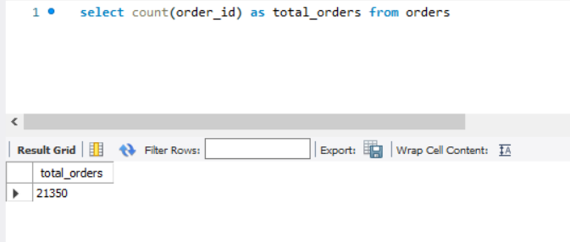

# 2. Calculate the total revenue generated from pizza sales.

select round(sum(price*quantity),2) as total_revenue from pizzas

join order_details

on pizzas.pizza_id = order_details.pizza_id

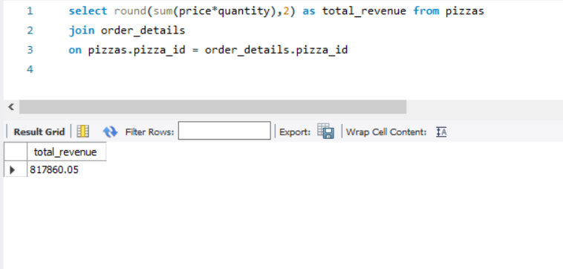

# 3. Identify the highest-priced pizza.

select pizza_types.name, pizzas.price from pizzas

join pizza_types

on pizzas.pizza_type_id = pizza_types.pizza_type_id

order by pizzas.price desc

limit 1

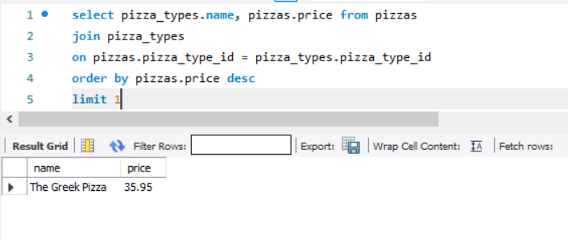

# 4. Identify the most common pizza size ordered.

select pizzas.size, count(order_details.order_details_id) as order_count

from pizzas

join order_details

on pizzas.pizza_id = order_details.pizza_id

group by pizzas.size

order by order_count desc

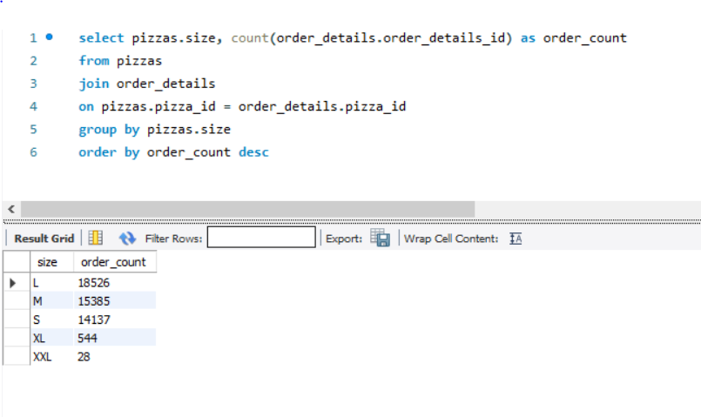

# 5. List the top 5 most ordered pizza types along with their quantities.

select pizza_types.name, sum(order_details.quantity) as order_quantity

from pizzas

join pizza_types

on pizzas.pizza_type_id = pizza_types.pizza_type_id

join order_details

on pizzas.pizza_id = order_details.pizza_id

group by pizza_types.name

order by order_quantity desc

limit 5

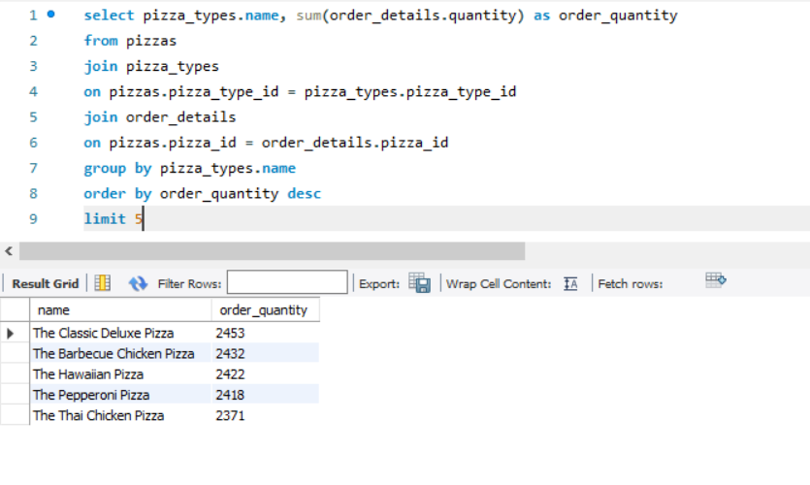

# 6. Join the necessary tables to find the total quantity of each pizza category ordered.

select pizza_types.category, sum(order_details.quantity) as order_quantity

from pizzas

join pizza_types

on pizzas.pizza_type_id = pizza_types.pizza_type_id

join order_details

on pizzas.pizza_id = order_details.pizza_id

group by pizza_types.category

order by order_quantity desc

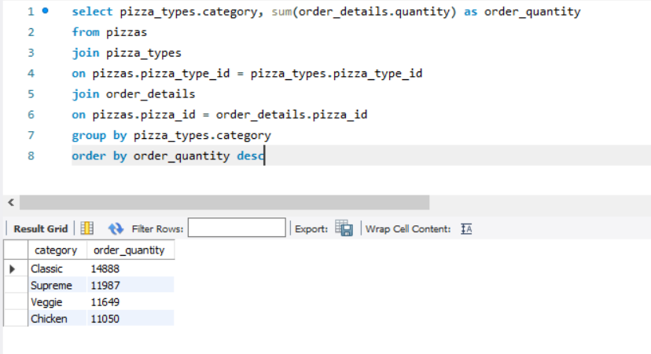

# 7. Determine the distribution of orders by hour of the day.

select hour(order_time), count(order_id) 'No._of_order' from orders

group by hour(order_time)

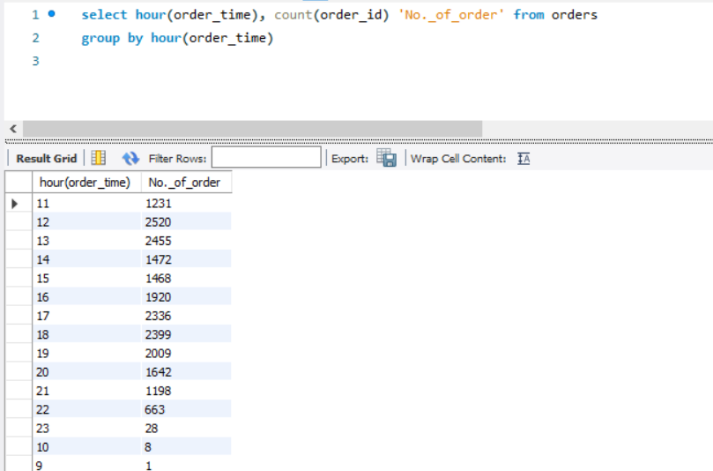

# 8. Join relevant tables to find the category-wise distribution of pizzas.

select category, count(name) as count from pizza_types

group by category

order by count desc

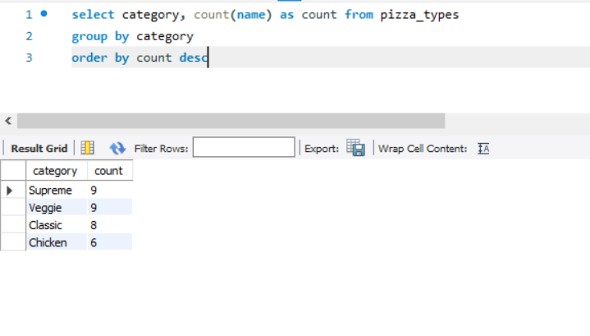

# 9. Group the orders by date and calculate the average number of pizzas ordered per day.

select Round(avg(total_order_quantity),0) from

(select orders.order_date, sum(order_details.quantity) as total_order_quantity

from orders

join order_details

on orders.order_id = order_details.order_id

group by orders.order_date)

as order_per_day

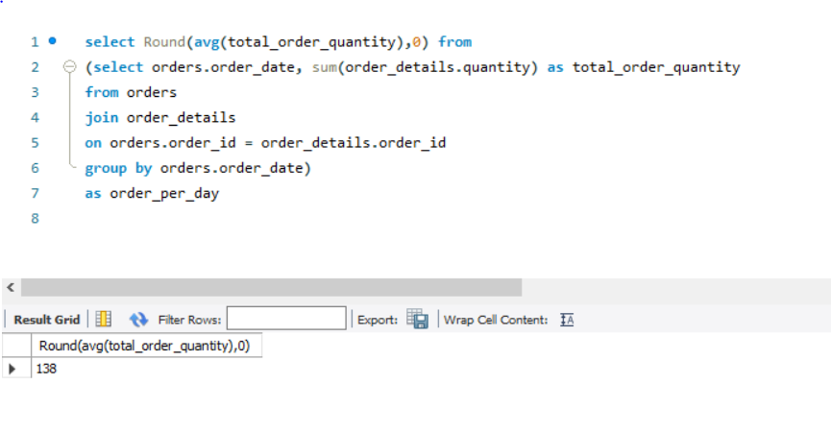

# 10. Determine the top 5 most ordered pizza types based on revenue.

select pizza_types.name, sum(order_details.quantity*pizzas.price) as revenue

from pizzas

join pizza_types

on pizzas.pizza_type_id = pizza_types.pizza_type_id

join order_details

on pizzas.pizza_id = order_details.pizza_id

group by pizza_types.name

order by revenue desc

limit 5

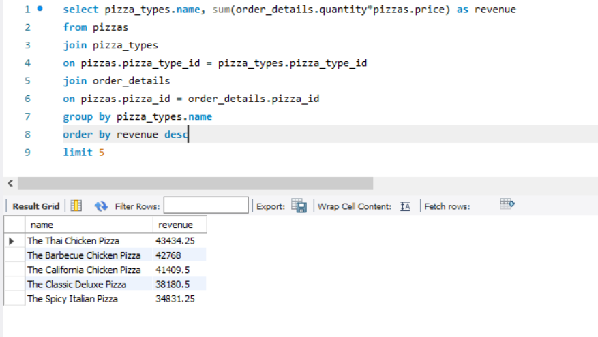

# 11.Calculate the percentage contribution of each pizza type to total revenue.

select pizza_types.category,

round(sum(order_details.quantity*pizzas.price) / (select round(sum(order_details.quantity*pizzas.price),2) as total_sales

from order_details

join pizzas

on pizzas.pizza_id = order_details.pizza_id) * 100,2) as revenue

from pizzas

join pizza_types

on pizzas.pizza_type_id = pizza_types.pizza_type_id

join order_details

on pizzas.pizza_id = order_details.pizza_id

group by pizza_types.category

order by revenue desc

# 

# 12. Analyze the cumulative revenue generated over time.

select order_date, sum(revenue) over(order by order_date) as cum_revenue

from

(select orders.order_date, sum(order_details.quantity * pizzas.price) as revenue

from order_details

join pizzas

on pizzas.pizza_id = order_details.pizza_id

join orders

on orders.order_id = order_details.order_id

group by orders.order_date) as sales

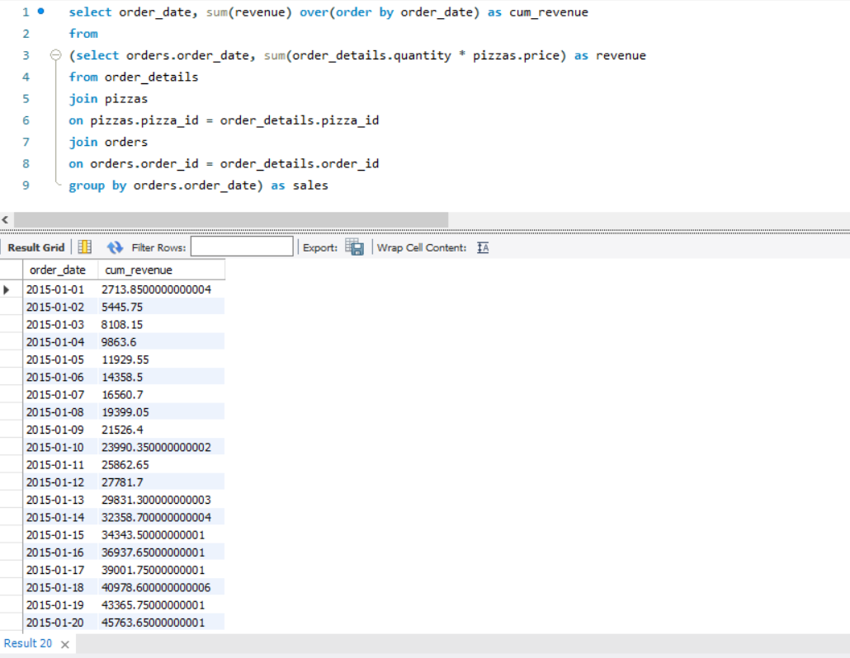

# 13. Determine the top 3 most ordered pizza types based on revenue for each pizza category.

select name, revenue, ranking_by_category from

(select name, category, revenue,

rank() over(partition by category order by revenue desc) as ranking_by_category

from

(

select pizza_types.name, pizza_types.category, sum((order_details.quantity) * pizzas.price) as revenue

from pizza_types

join pizzas

on pizza_types.pizza_type_id = pizzas.pizza_type_id

join order_details

on order_details.pizza_id = pizzas.pizza_id

group by pizza_types.category, pizza_types.name

) as order_table ) as b

where ranking_by_category <=3

