1. 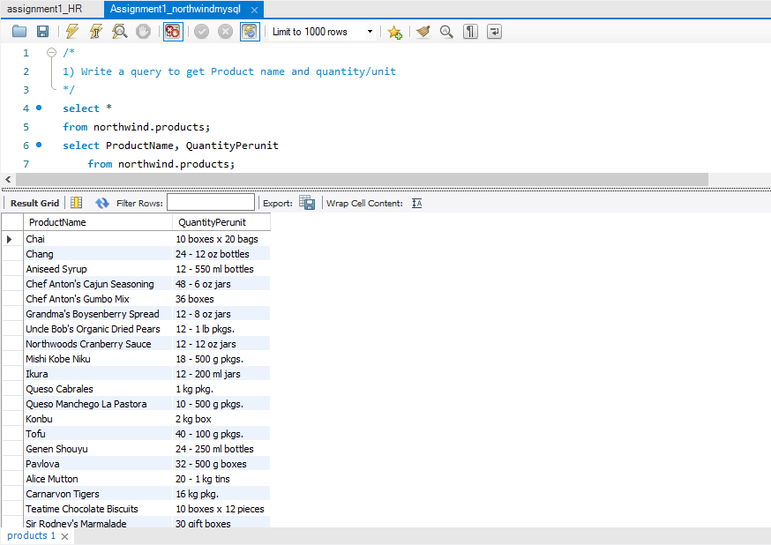Write a query to get Product name and quantity/unit
2. Write a query to get current Product list (Product ID and name)

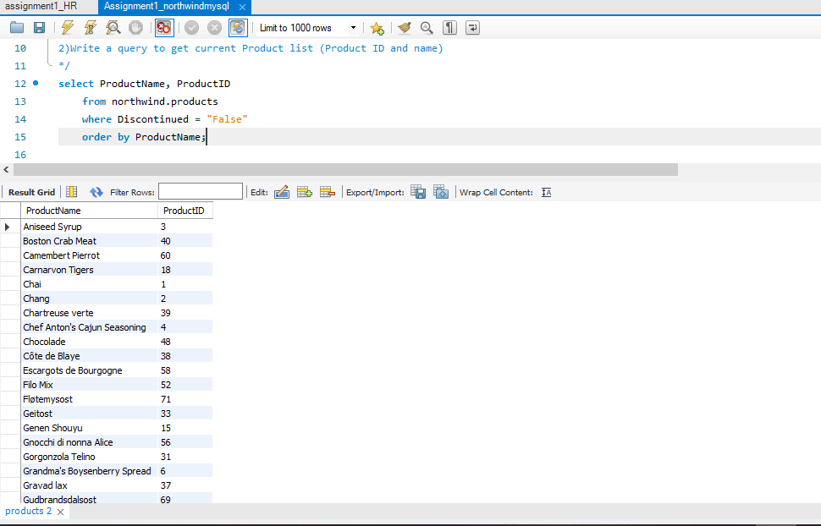

1. Write a query to get discontinued Product list (Product ID and name)

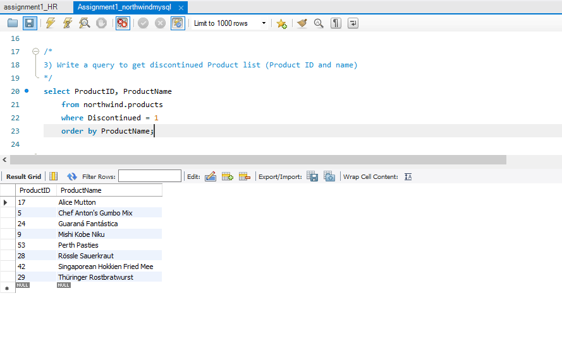

1. Write a query to get most expense and least expensive Product list (name and unit price)

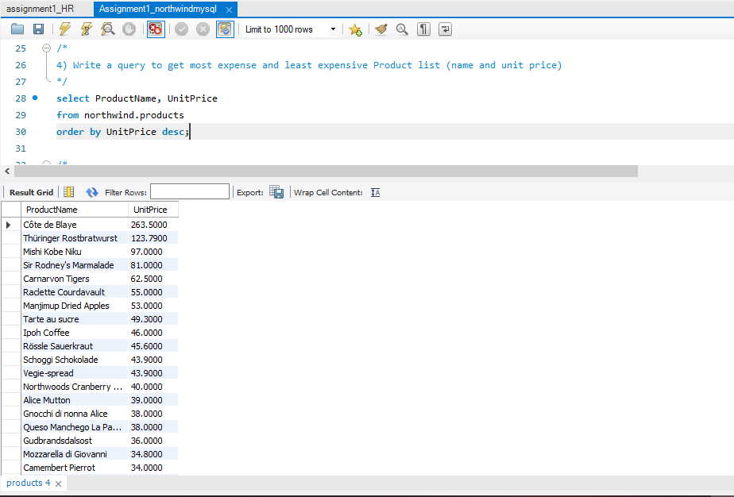

1. Write a query to get Product list (id, name, unit price) where current products cost less than $20

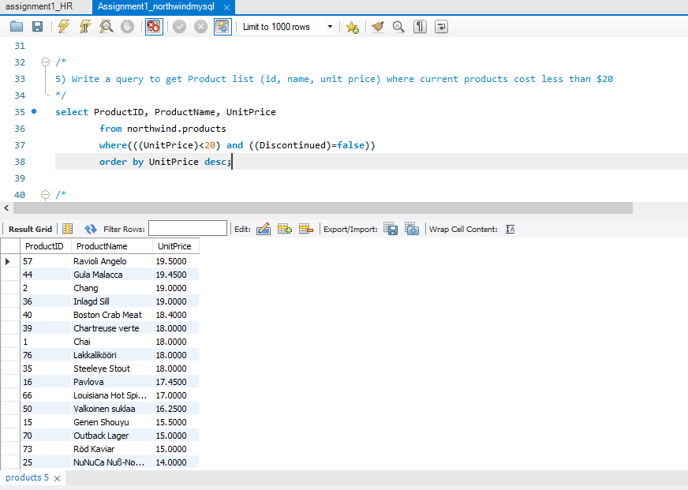

1. Write a query to get Product list (id, name, unit price) where products cost between $15 and $25

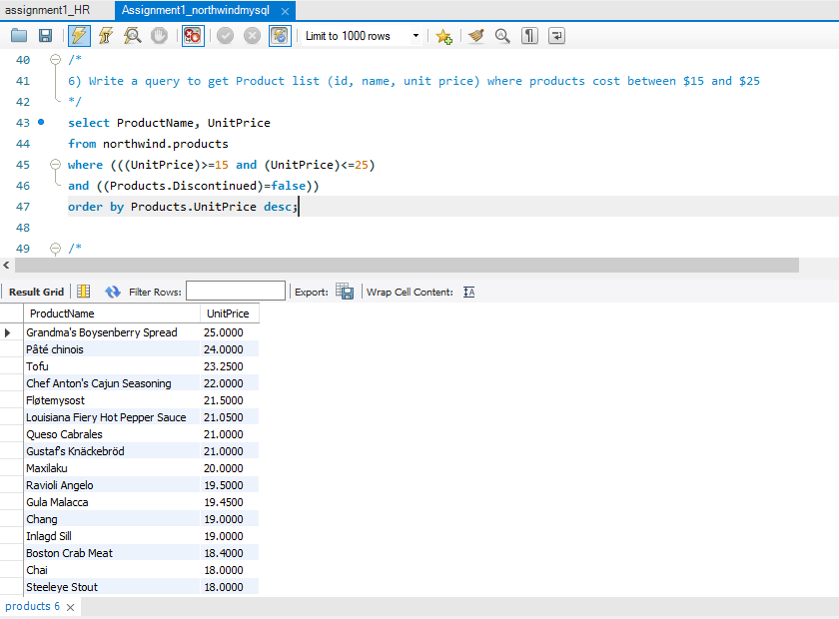

1. Write a query to get Product list (name, unit price) of above average price

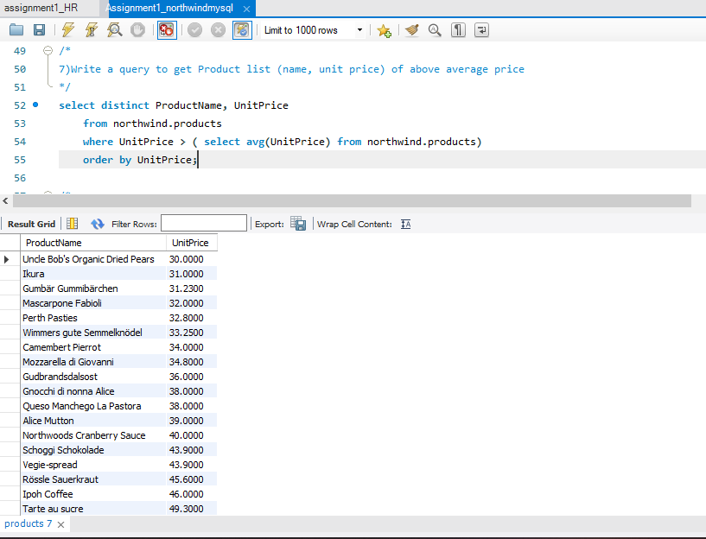

8. Write a query to get Product list (name, unit price) of ten most expensive products

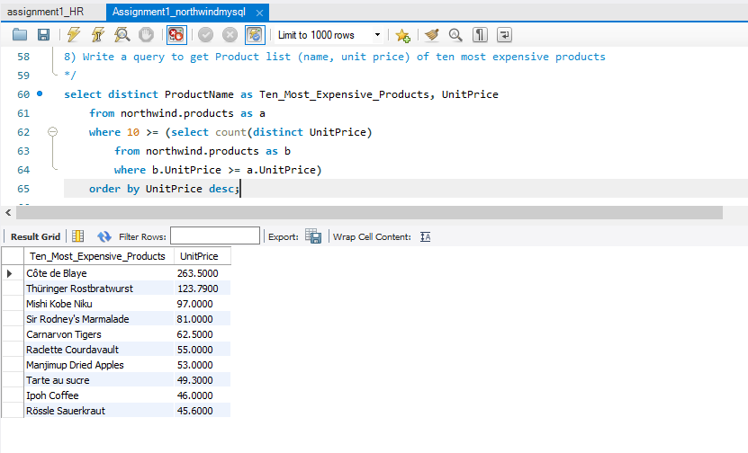

1. Write a query to count current and discontinued products

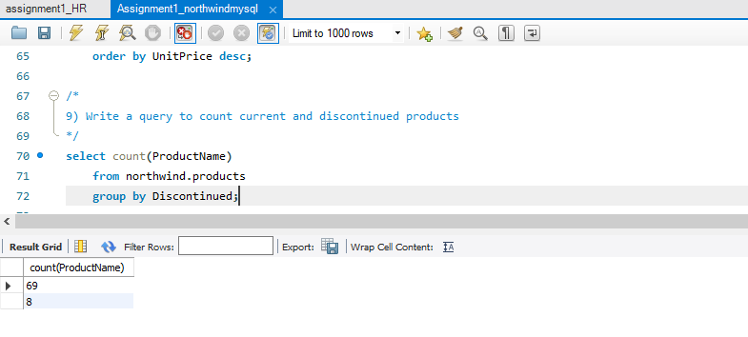

10. Write a query to get Product list (name, units on order , units in stock) of stock is less than the quantity on order

