1. Write a query to display the names (first_name, last_name) using alias name “First Name", "Last Name"

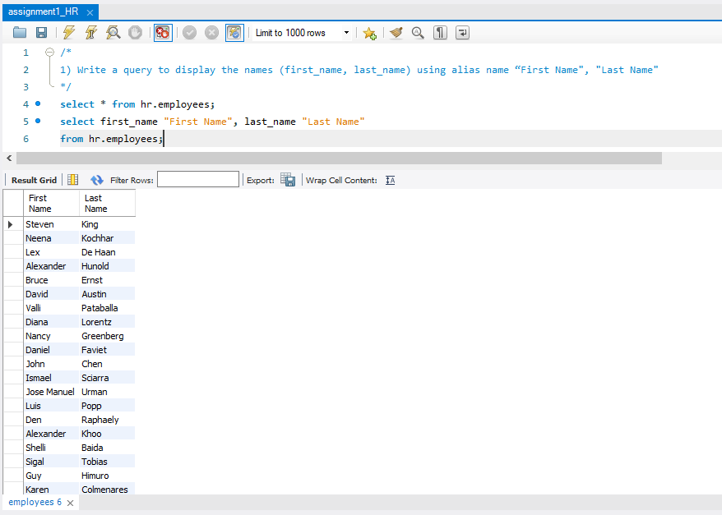

2. Write a query to get unique department ID from employee table

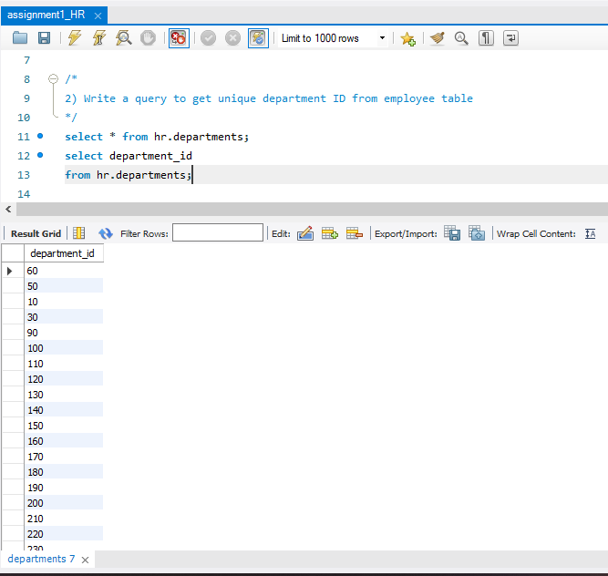

3. Write a query to get all employee details from the employee table order by first name, descending

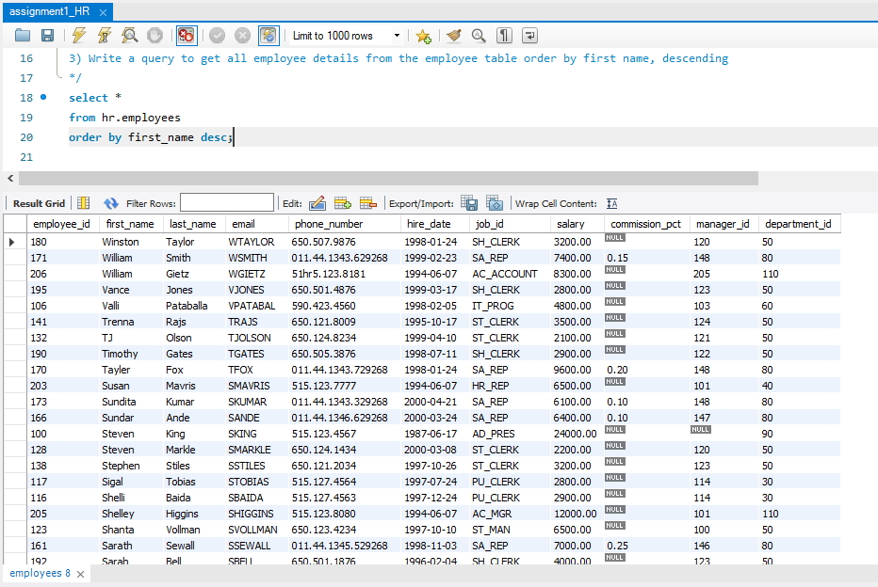

4. Write a query to get the names (first_name, last_name), salary, PF of all the employees (PF is calculated as 15% of salary)

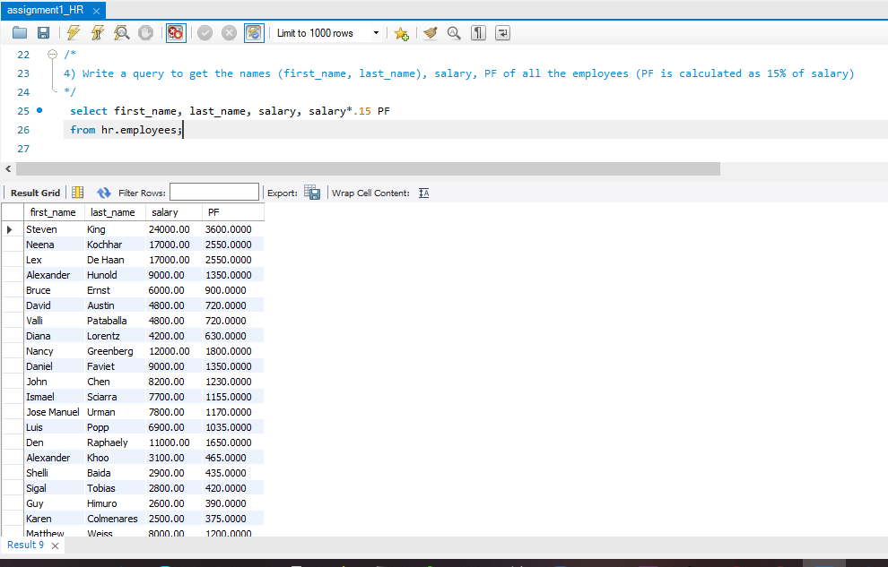

5. Write a query to get the employee ID, names (first_name, last_name), salary in ascending order of salary

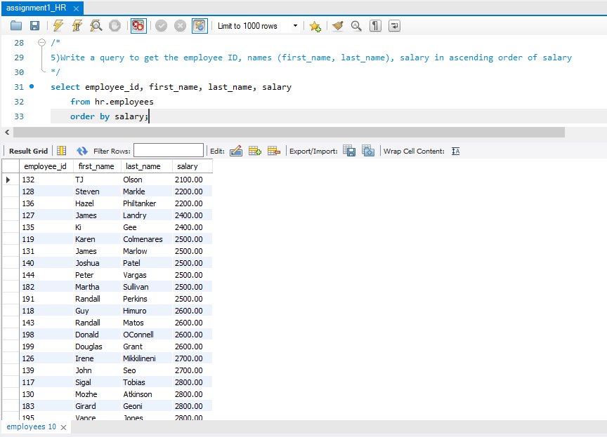

6. Write a query to get the total salaries payable to employees

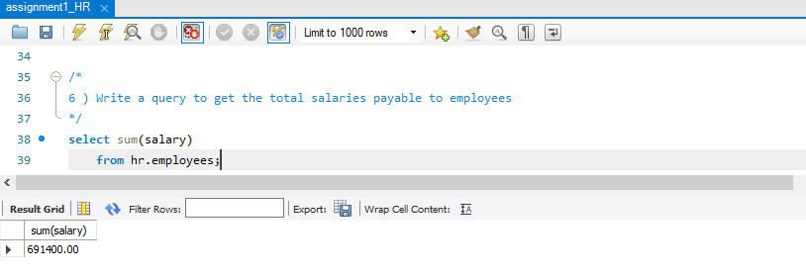

7. Write a query to get the maximum and minimum salary from employees table

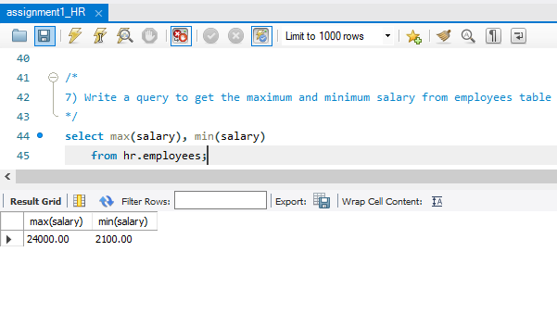

8. Write a query to get the average salary and number of employees in the employees table

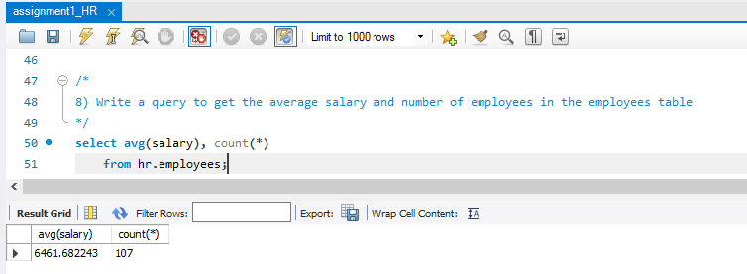

9. Write a query to get the number of employees working with the company

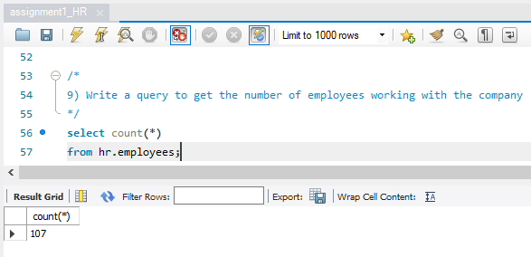

10. Write a query to get the number of jobs available in the employees table

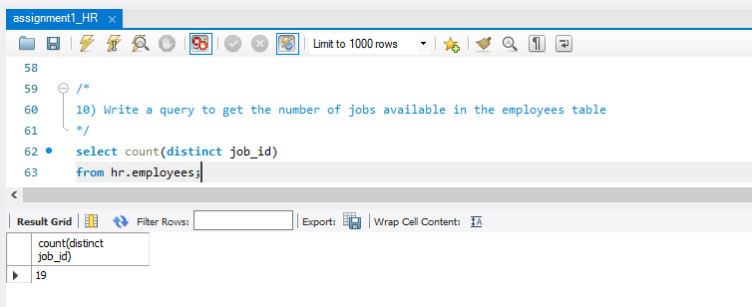

11. Write a query get all first name from employees table in upper case

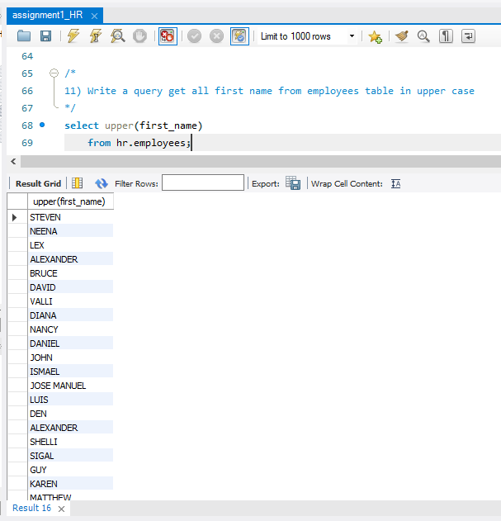

12. Write a query to get the first 3 characters of first name from employees table

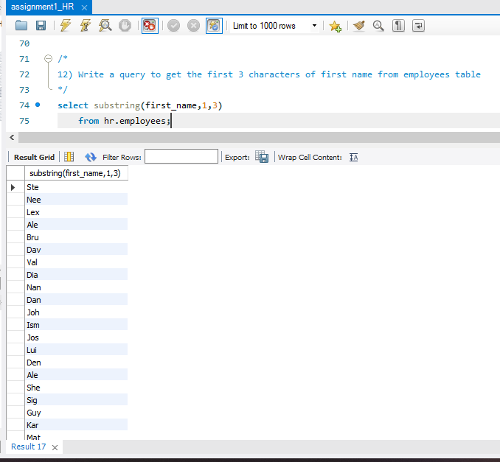

13. Write a query to get first name from employees table after removing white spaces from both side

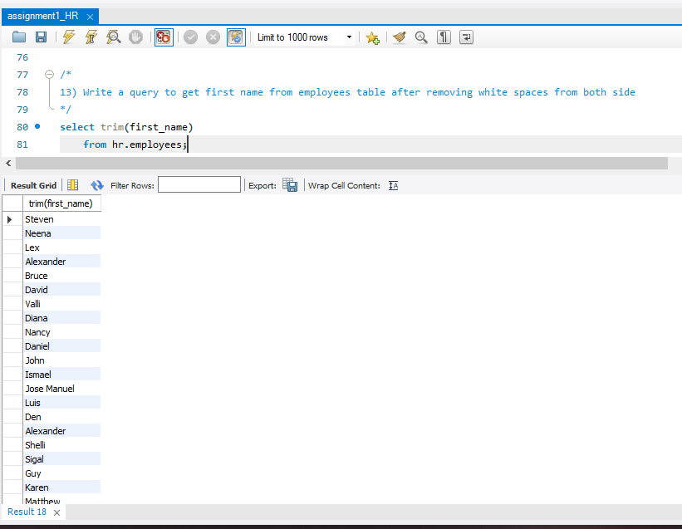

14. Write a query to get the length of the employee names (first_name, last_name) from employees table

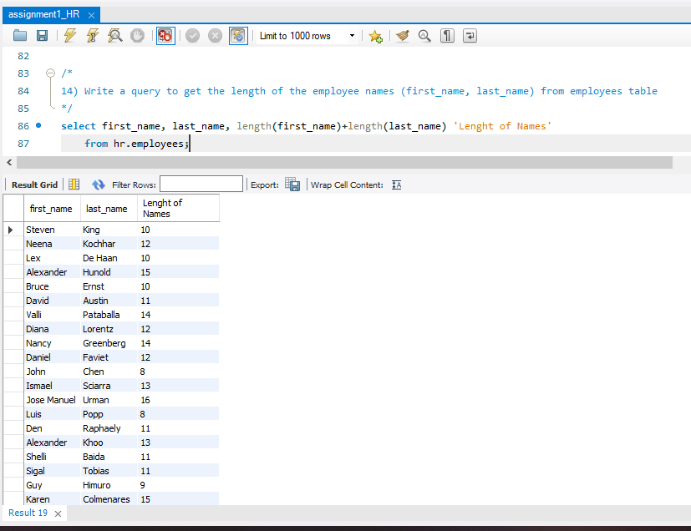

15. Write a query to check if the first_name fields of the employees table contains numbers

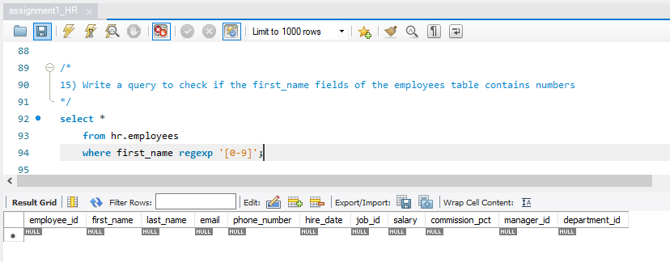

16. Write a query to display the name (first_name, last_name) and salary for all employees whose salary is not in the range $10,000 through $15,000

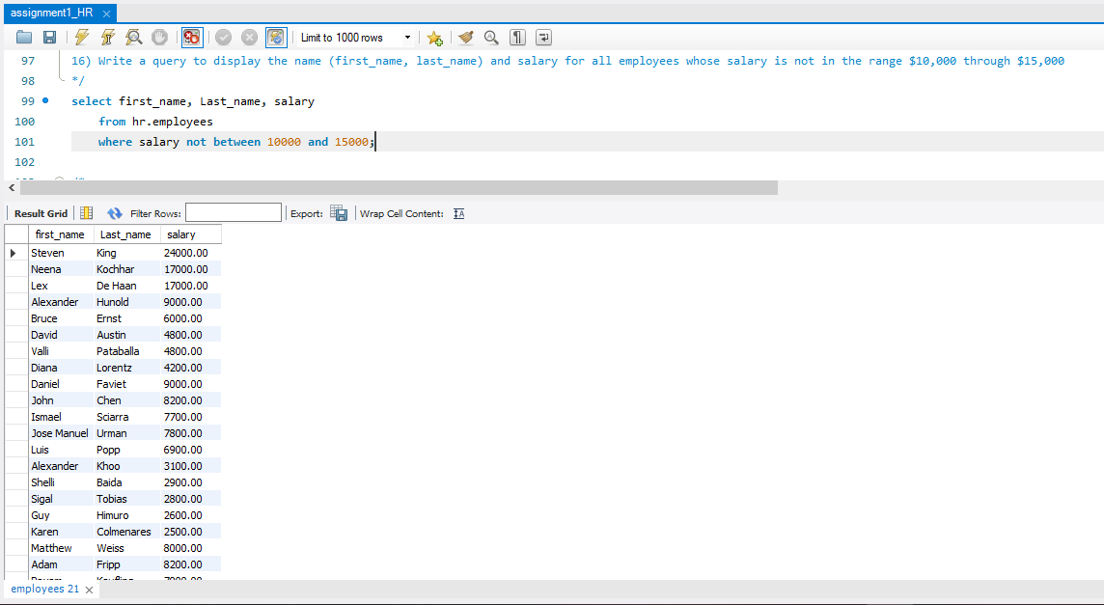

17. Write a query to display the name (first_name, last_name) and department ID of all employees in departments 30 or 100 in ascending order

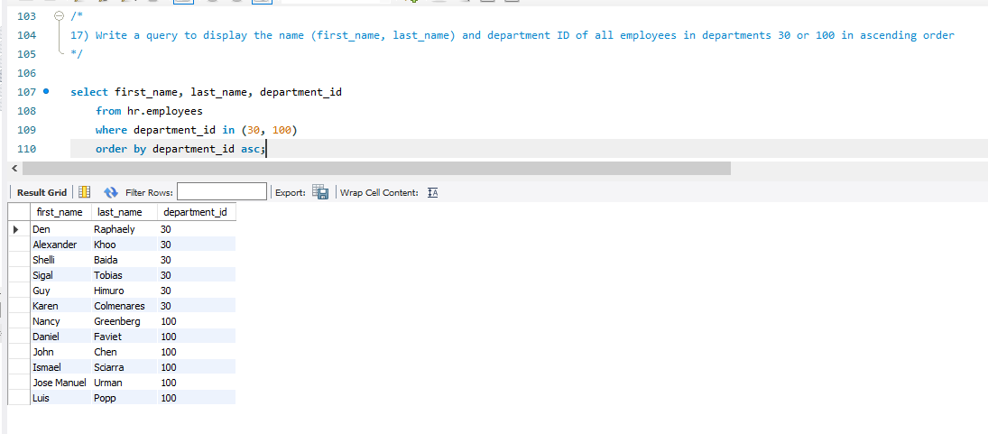

18. Write a query to display the name (first_name, last_name) and salary for all employees whose salary is not in the range $10,000 through $15,000 and are in department 30 or 100

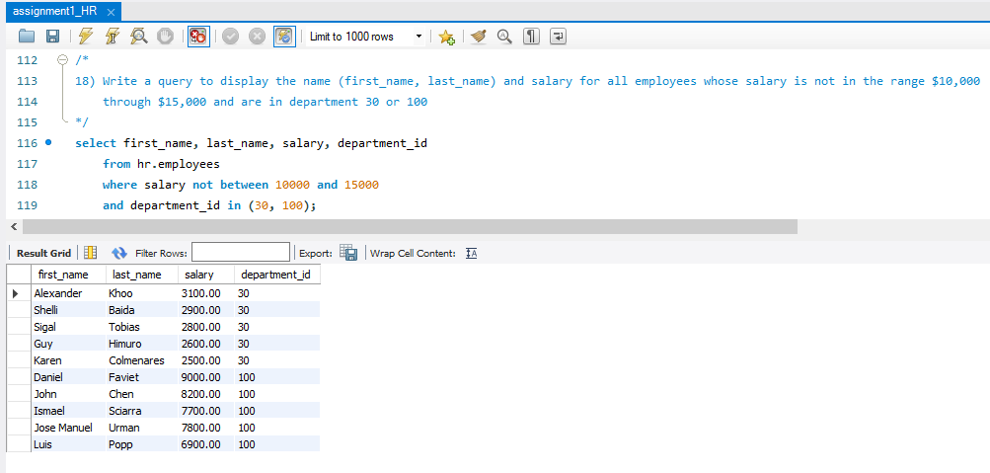

19. Write a query to display the name (first_name, last_name) and hire date for all employees who were hired in 1987

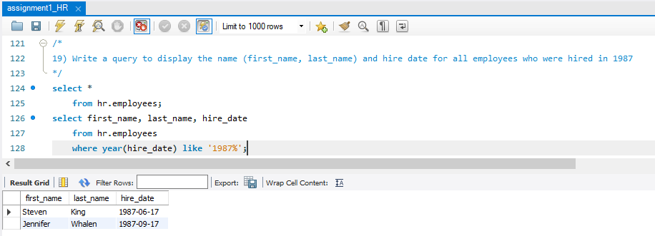

20. Write a query to display the first_name of all employees who have both "b" and "c" in their first name

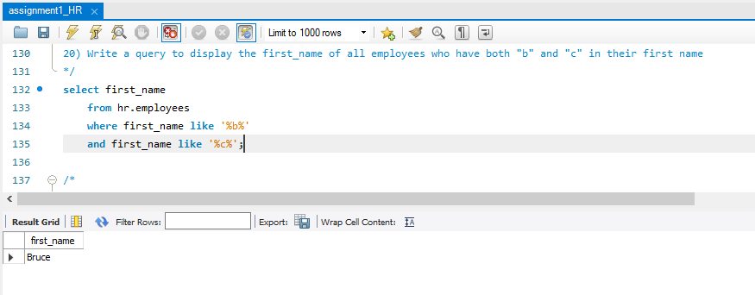

21. Write a query to display the last name, job, and salary for all employees whose job is that of a Programmer or a Shipping Clerk, and whose salary is not equal to $4,500, $10,000, or $15,000

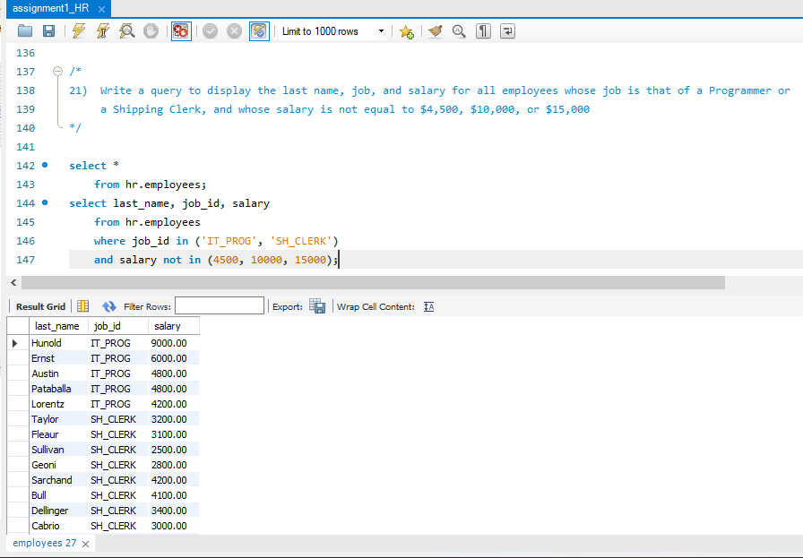

22. Write a query to display the last name of employees whose names have exactly 6 characters

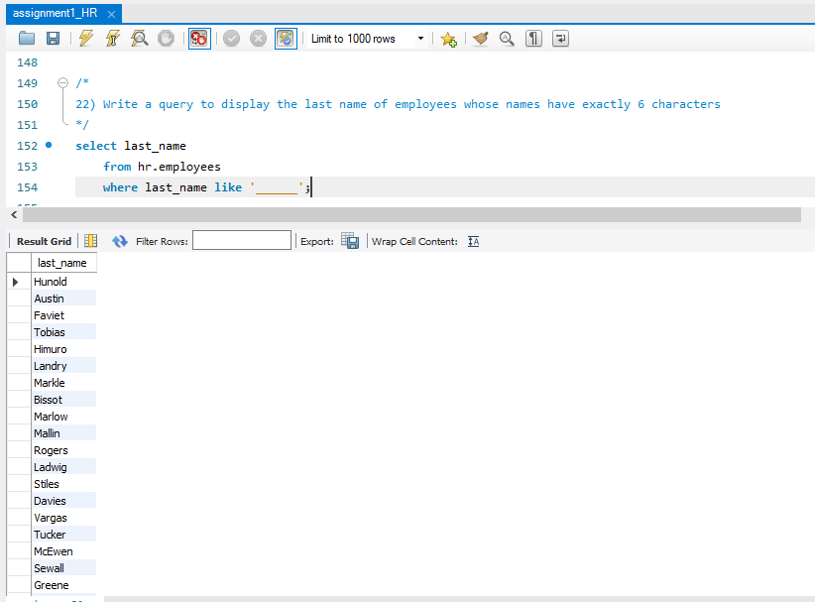

23. Write a query to display the last name of employees having 'e' as the third character

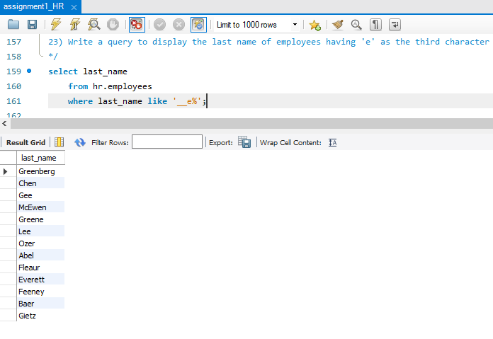

24. Write a query to get the job_id and related employee's id

|  |  |
| --- | --- |
| Partial output of the query : job_id | Employees ID |
| AC_ACCOUNT | 206 |
| AC_MGR | 205 |
| AD_ASST | 200 |
| AD_PRES | 100 |
| AD_VP | 101 ,102 |
| FI_ACCOUNT | 110 ,113 ,111 ,109 ,112 |

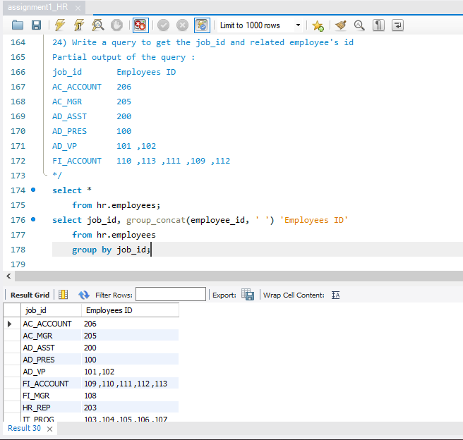

25. Write a query to update the portion of the phone_number in the employees table, within the phone number the substring '124' will be replaced by '999'

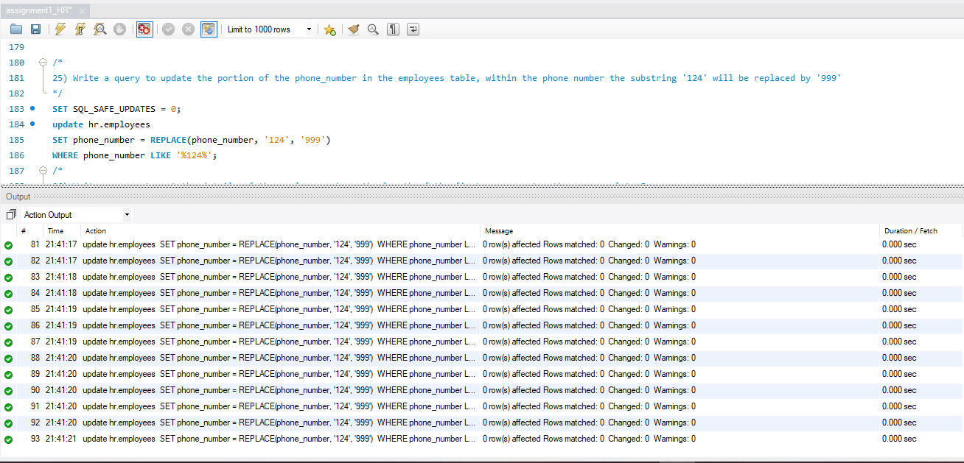

26. Write a query to get the details of the employees where the length of the first name greater than or equal to 8

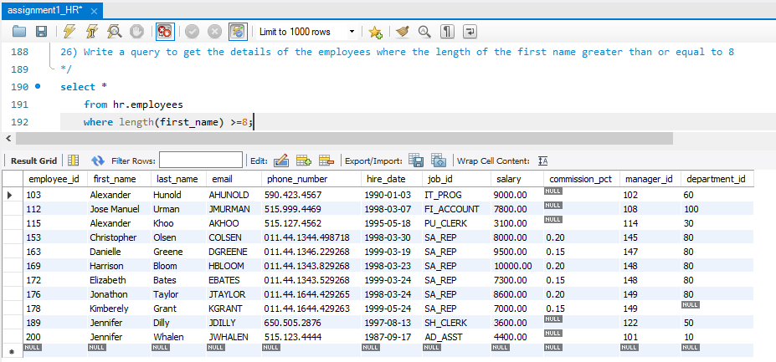

27. Write a query to append '@example.com' to email field

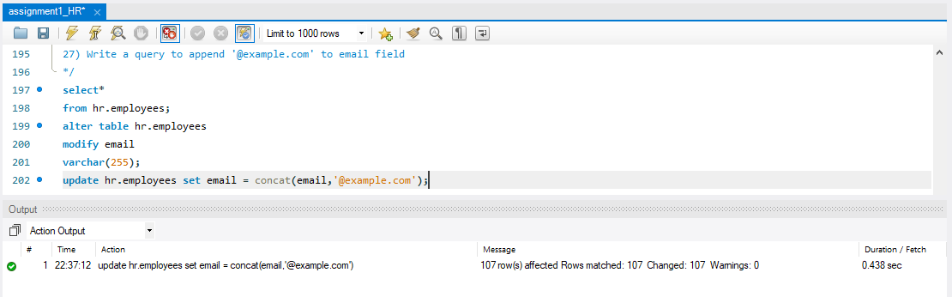

28. Write a query to extract the last 4 character of phone numbers

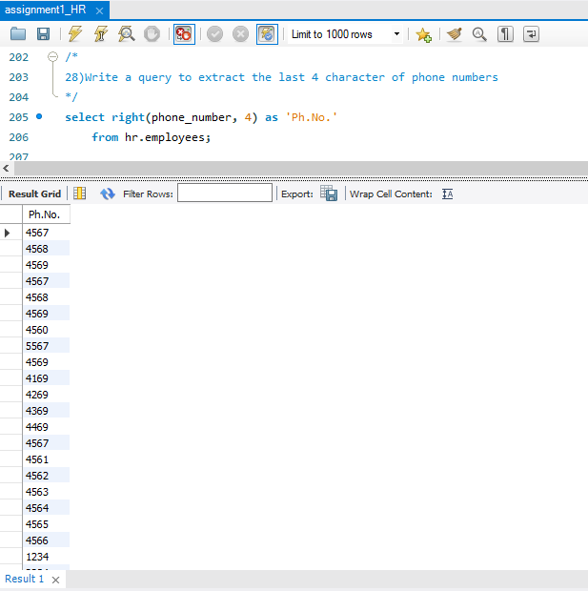

29. Write a query to get the last word of the street address

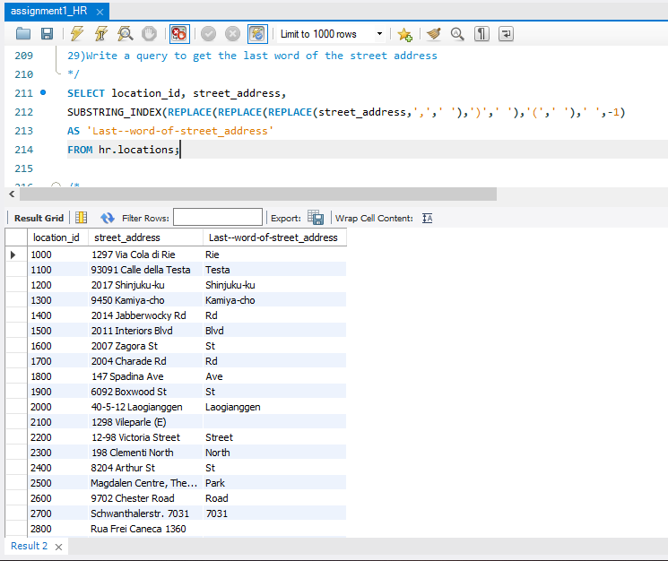

30. Write a query to get the locations that have minimum street length

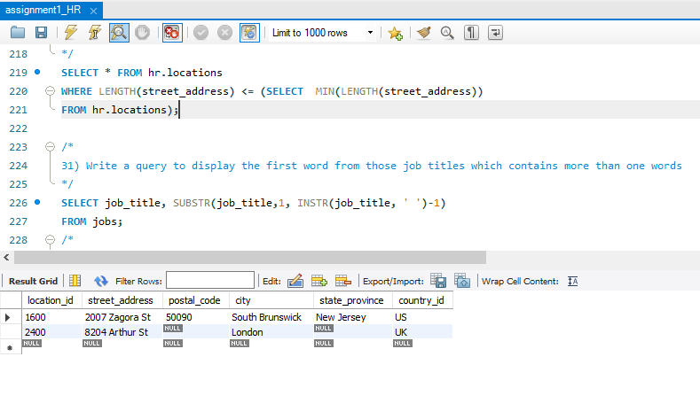

31. Write a query to display the first word from those job titles which contains more than one words

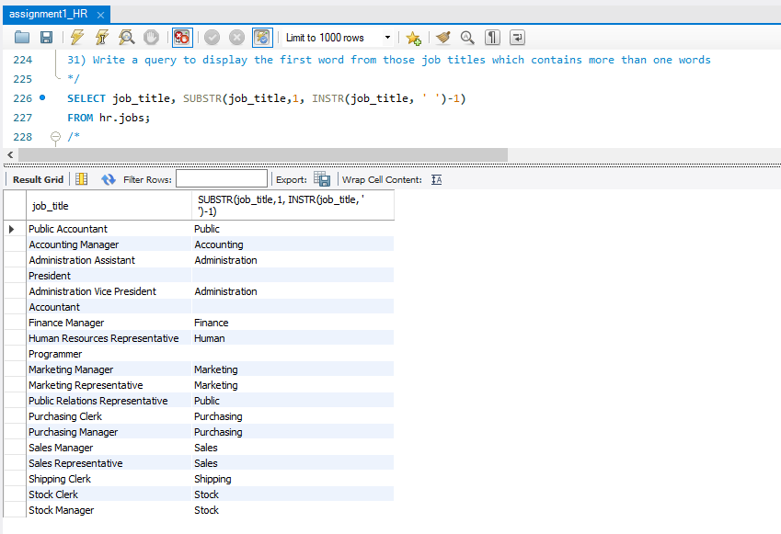

32. Write a query to display the length of first name for employees where last name contain character 'c' after 2nd position

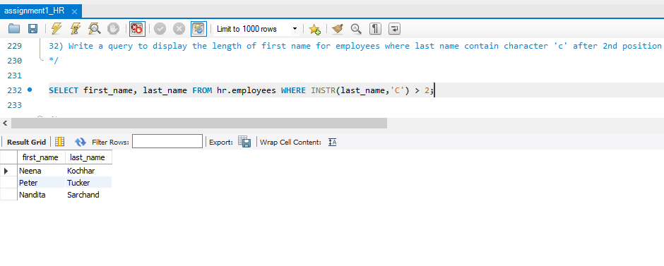

33. Write a query that displays the first name and the length of the first name for all employees whose name starts with the letters 'A', 'J' or 'M'. Give each column an appropriate label. Sort the results by the employees' first names

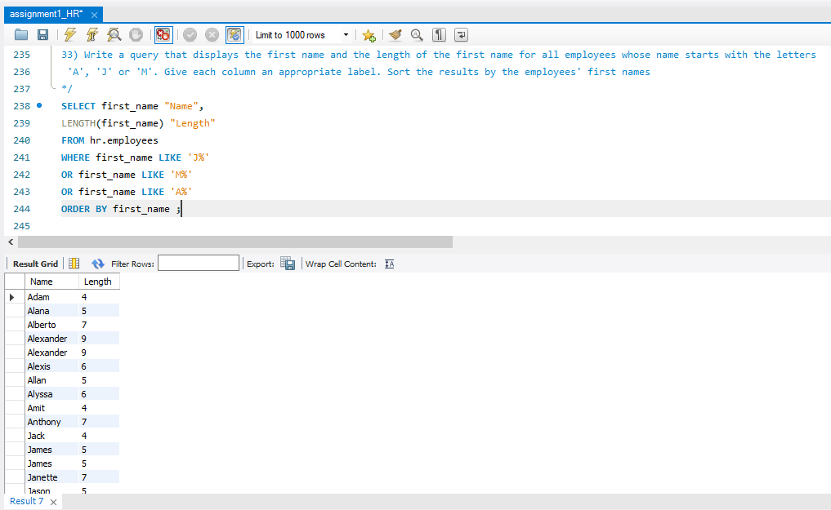

34. Write a query to display the first name and salary for all employees. Format the salary to be 10 characters long, left-padded with the $ symbol. Label the column SALARY

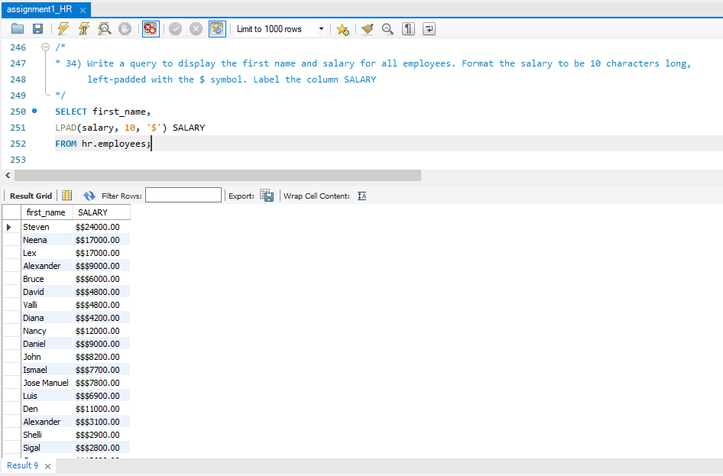

35. Write a query to display the first eight characters of the employees' first names and indicates the amounts of their salaries with '$' sign. Each '$' sign signifies a thousand dollars. Sort the data in descending order of salary

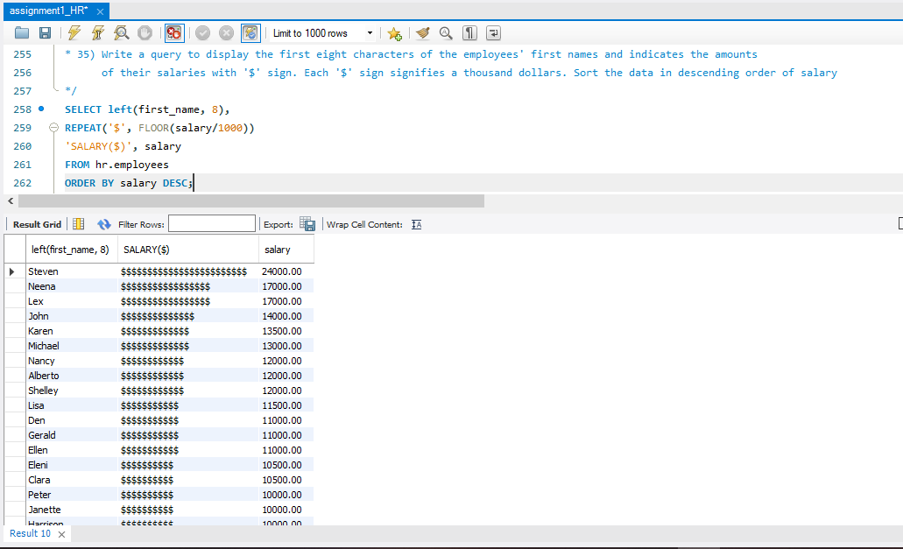

36. Write a query to display the employees with their code, first name, last name and hire date who hired either on seventh day of any month or seventh month in any year

