1. 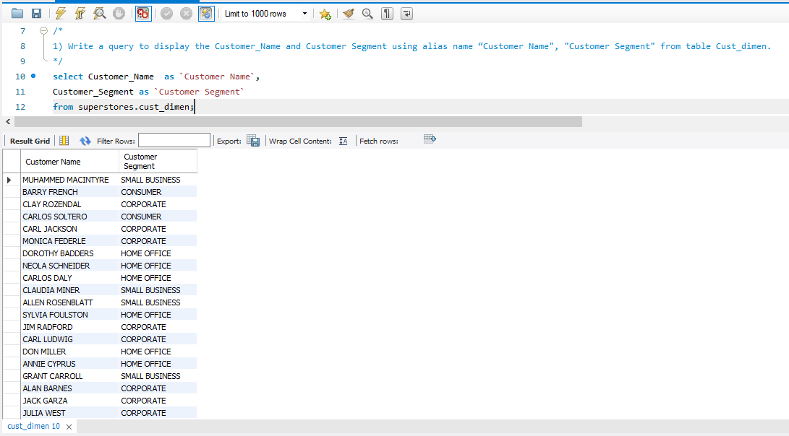**Write a query to display the Customer_Name and Customer Segment using alias name “Customer Name", "Customer Segment" from table Cust_dimen.**
2. **Write a query to find all the details of the customer from the table cust_dimen order by desc.**

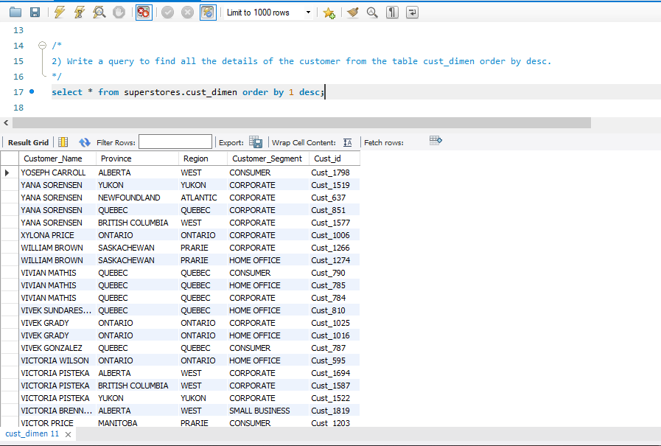

1. **Write a query to get the Order ID, Order date from table orders_dimen where ‘Order Priority’ is high.**

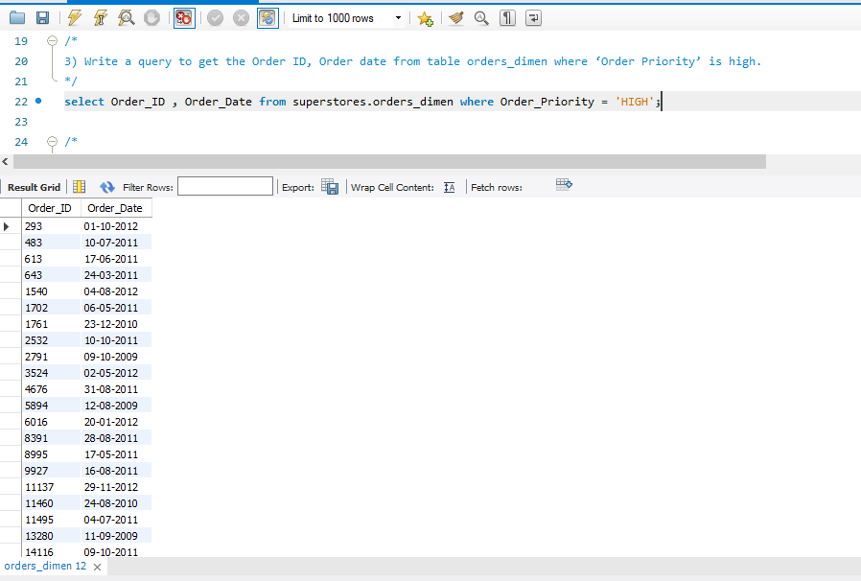

1. **Find the total and the average sales (display total_sales and avg_sales)**

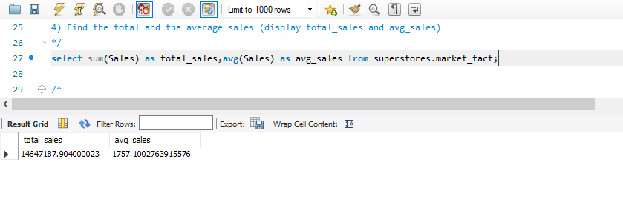

1. **Write a query to get the maximum and minimum sales from maket_fact table**

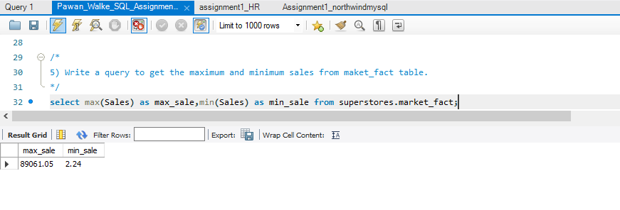

1. **Display the number of customers in each region in decreasing order of no_of_customers. The result should contain columns Region, no_of_customers.**

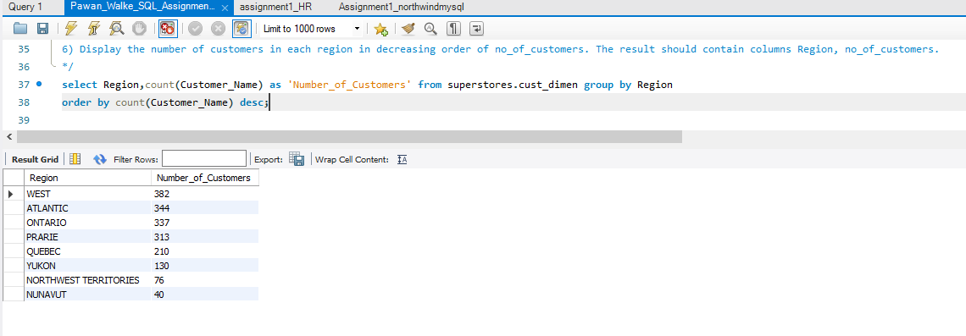

1. **Find the region having maximum customers (display the region name and max(no_of_customers)**

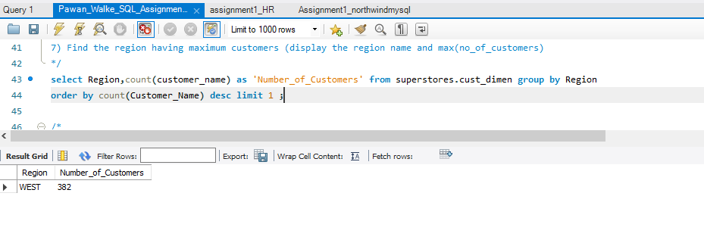

1. **Find all the customers from Atlantic region who have ever purchased ‘TABLES’ and the number of tables purchased (display the customer name, no_of_tables purchased)**

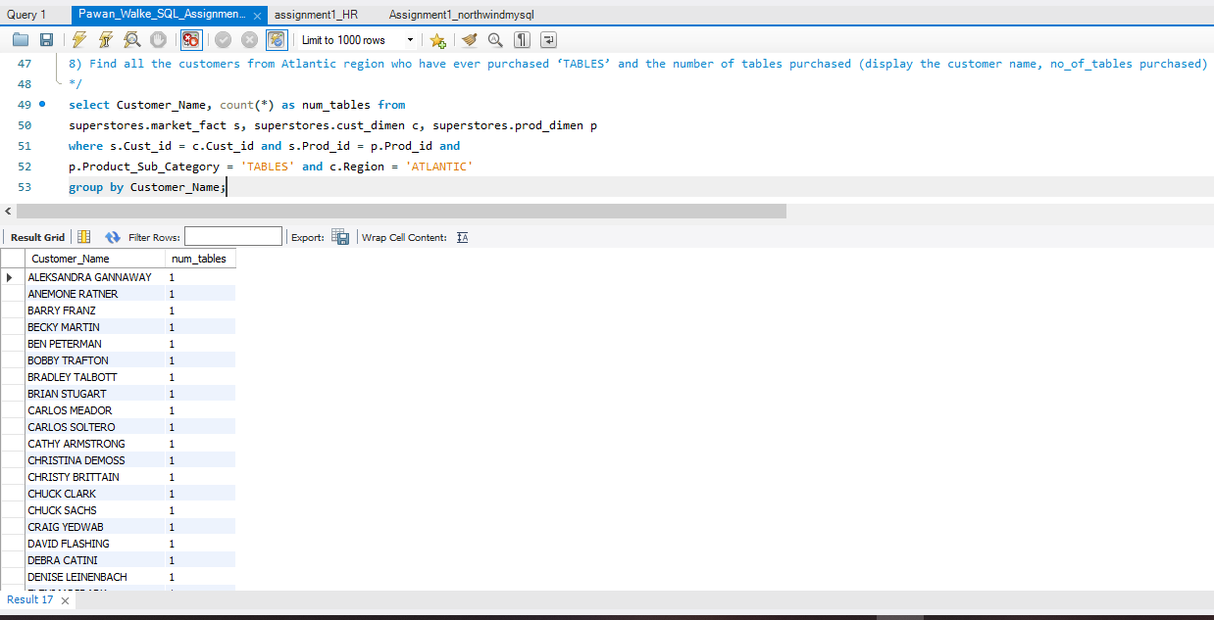

1. **Find all the customers from Ontario province who own Small Business. (display the customer name, no of small business owners)**

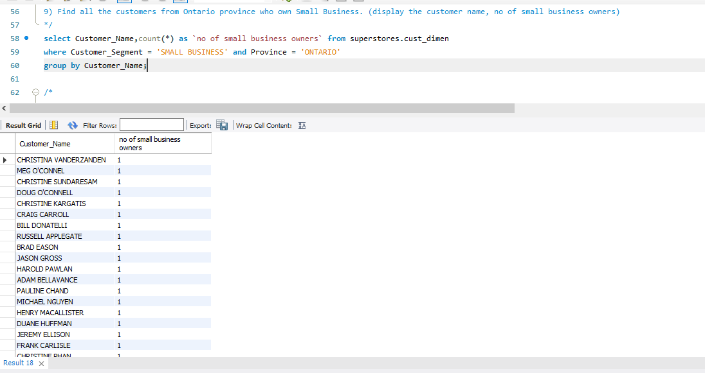

1. **Find the number and id of products sold in decreasing order of products sold (display product id, no_of_products sold)**

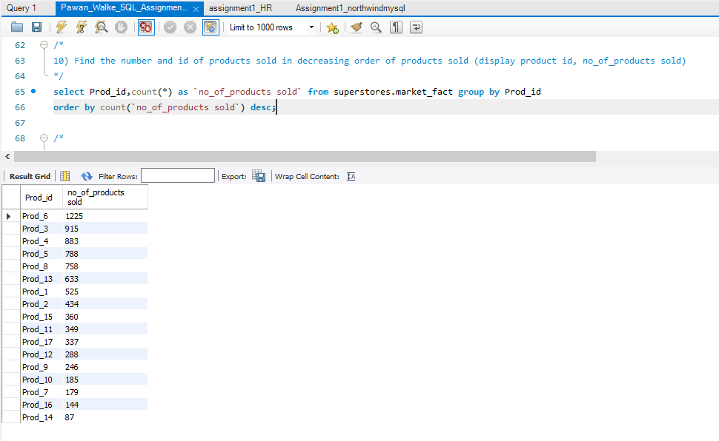

1. **Display product Id and product sub category whose produt category belongs to Furniture and Technlogy. The result should contain columns product id, product sub category.**

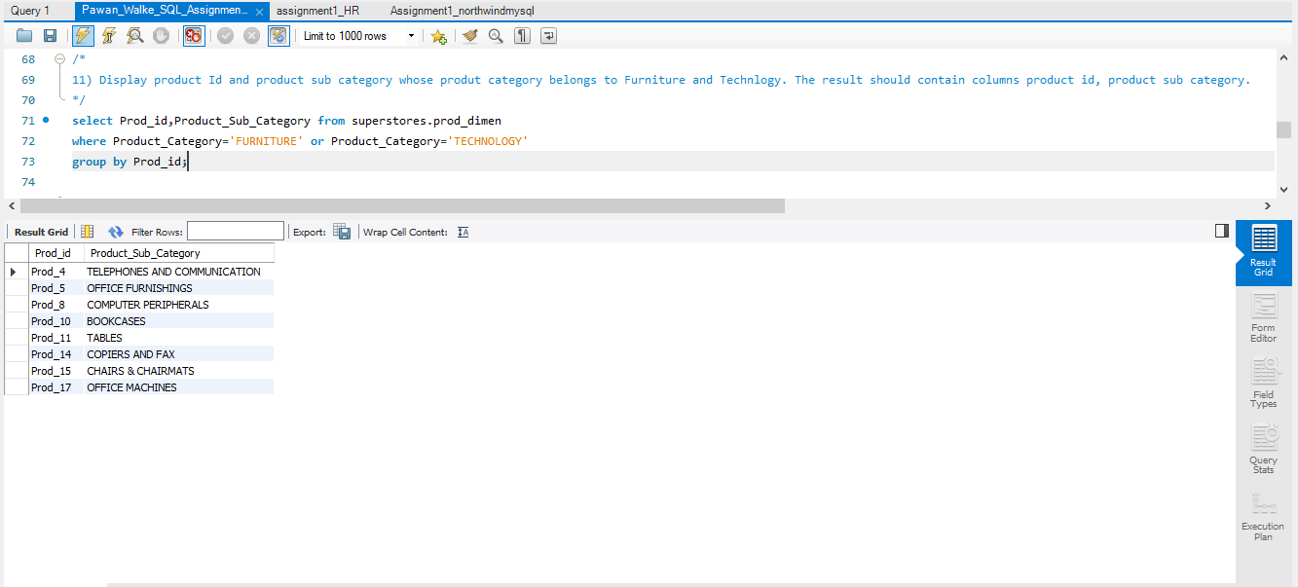

1. **Display the product categories in descending order of profits (display the product category wise profits i.e. product_category, profits)?**

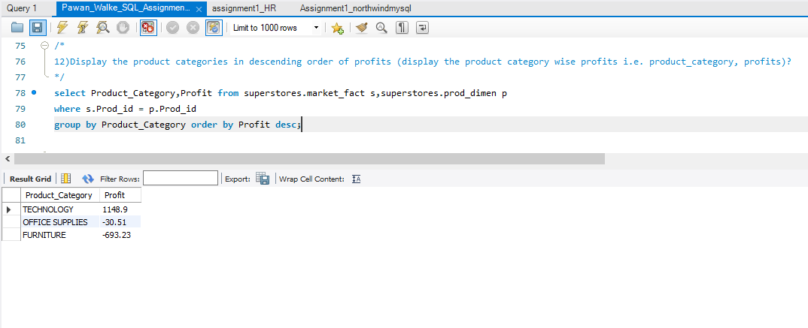

1. **Display the product category, product sub-category and the profit within each subcategory in three columns.**

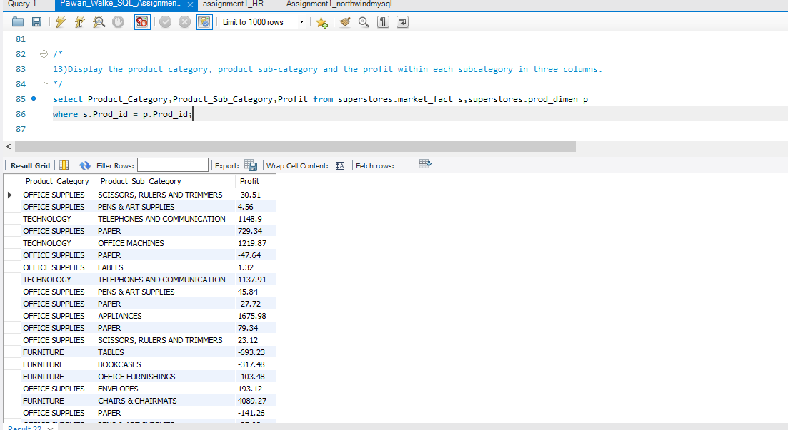

1. **Display the order date, order quantity and the sales for the order.**

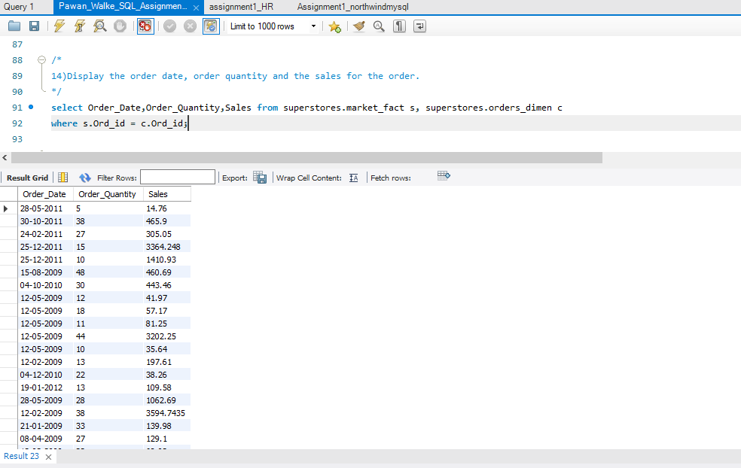

1. **Display the names of the customers whose name contains the**

**i) Second letter as ‘R’**

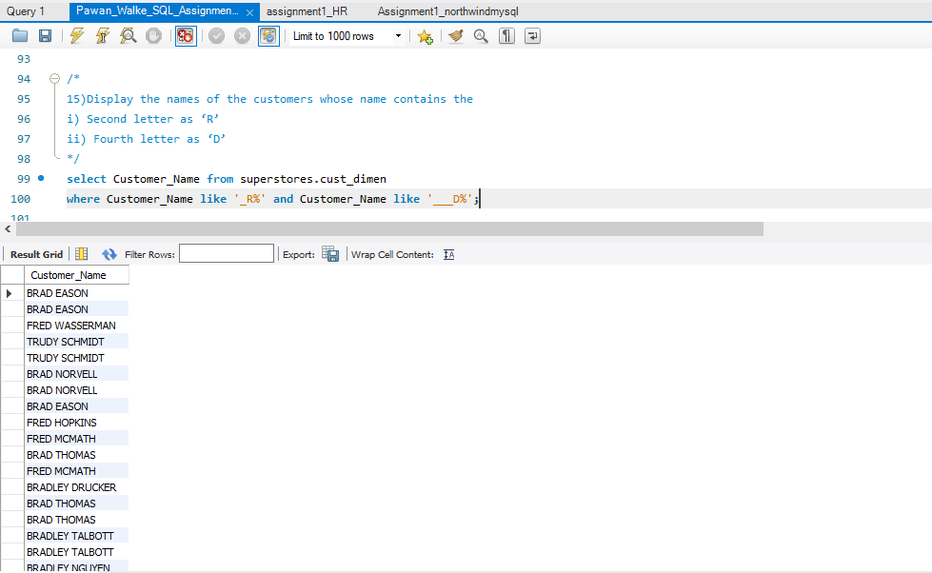**ii) Fourth letter as ‘D’**

1. **Write a SQL query to to make a list with Cust_Id, Sales, Customer Name and their region where sales are between 1000 and 5000.**

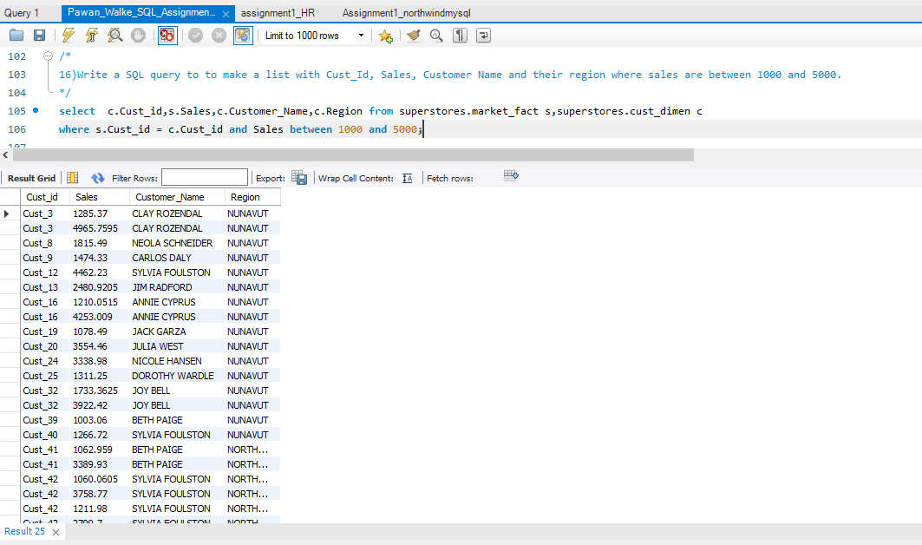

1. **Write a SQL query to find the 3rd highest sales.**

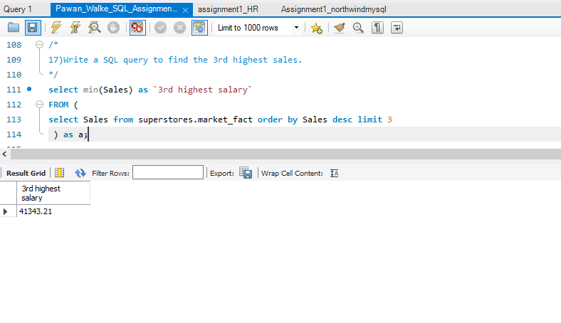

1. **Where is the least profitable product subcategory shipped the most? For the least profitable product sub-category, display the region-wise no_of_shipments and the profit made in each region in decreasing order of profits (i.e. region, no_of_shipments, profit_in_each_region) → Note: You can hardcode the name of the least profitable product subcategory**

