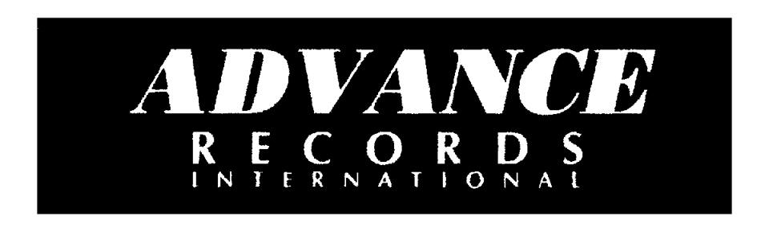

**CONSIGNMENT AGREEMENT**

***THIS CONSIGNMENT AGREEMENT*** ("Agreement") is entered into on by and between ("Consignors")

***Advance Records international*** located at 7486 Old Alexandria Ferry Road Clinton, MD 20735,and ("Consignees")___________________________, located at _________________________________________,

AGREEMENT TO SELL

In accordance with this Agreement, the Consignor grants an exclusive right to display and sell the mutually agreed upon item(s), pursuant to the terms of this Agreement.

Agrees to place on display the mutually agreed upon item(s) in a prominent area within the store premises.

The sale price of all items and terms of said sale shall be determined by mutual agreement. Sale Price:_____________

PROCEEDS AND TERMS OF SALES

The Consignee, shall be entitled to retain 55% of all proceeds from the sale of each item consigned, PayPal, Cash app, Cash, Cash Certified Check Money Order.

The Consignee shall submit a payment for the full amount of the sale price, less the aforementioned agreed upon 55%, to the Consignor within 30 business days of receipt of the sale. The Consignor shall be retaining their portion of the proceeds, 45% of the sale price.

Both the Consignee and the Consignor agree that payments shall be made in the form of.

The Consignee agrees to maintain the agreed upon selling price for each item consigned and will accept nothing less unless otherwise agreed upon in writing and signed by both parties.

The Consignee shall maintain insurance for the premises and all contents thereof against any damage or theft that may occur to any item(s) left with the Consignee to sell.

The Consignee shall retain possession and control of the consigned merchandise for a minimum period of180 days, beginning on the aforementioned agreement date.

Prior to or upon delivery of the merchandise, the Consignor shall provide a complete and accurate inventory list of the merchandise items that have been consigned to be sold. This list must include a description of each item, the quantity of each item, the agreed upon price of each item, and it must be signed by both the Consignor and Consignee upon acceptance.

The Consignee shall only accept clean, quality merchandise in good condition.

All consigned merchandise shall remain at the aforementioned Consignee address and shall not be moved to another location without prior written notice to the Consignor.

Any merchandise that is not sold at the end of the consignment period shall be evaluated by both the Consignee and the Consignor. In the event that the Consignor decides to remove their merchandise, the Consignor shall assume all responsibility for retrieving and removing the unsold merchandise or arrange for the pick-up and all costs associated with said removal of merchandise.

MERCHANDISE RECORDS

It shall be the responsibility of the Consignee to maintain all records of consignments and ensure accurate record keeping of each item, quantity and what was sold. The Consignor shall have the right to inspect all records related to their account.

**MERCHANDISE OWNERSHIP**

The Consignor shall retain ownership of any and all consigned merchandise until such time as the merchandise is sold.

BREACH OF AGREEMENT

In the event that the Consignee fails to perform and/or adhere to the terms and obligations contained herein this Agreement, the Consignor shall be afforded the opportunity to cancel this Agreement by providing days advance written notice to the Consignee.

However, the Consignor shall in turn afford the Consignee the opportunity to take corrective action prior to the deadline stated in the aforementioned advance written notice to avert cancellation of this Agreement.

TERMINATION OF CONSIGNMENT AGREEMENT

The Consignee may terminate this Agreement at any time and for any reason by providing days advance written notice and by returning to the Consignor all the unsold merchandise that is the subject of this Agreement. The Consignor may terminate this