**Assignment – 4 (WQUPC)**

Name: Aashay Pawar

NUID: 002134382

***Step1:***

**(a)**

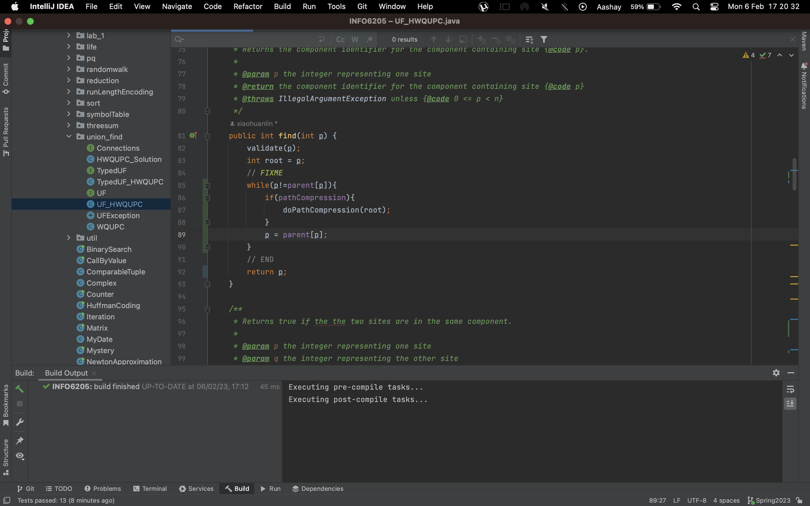

***(b)***

***Step2:***

***UFClient.java class:***

***Output:***





***Report from the Output:***

|  |  |  |
| --- | --- | --- |
| **Number of Objects (m)** | **Number of Pairs (n)** | **m*Ln(m)/2** |
| 1000 | 3715 | 3453.877639 |
| 2000 | 8416 | 7600.90246 |
| 4000 | 17573 | 16588.09928 |
| 8000 | 38371 | 35948.78728 |
| 16000 | 83580 | 77442.75201 |
| 32000 | 170177 | 165975.8589 |
| 64000 | 377227 | 354132.4276 |
| 128000 | 786114 | 752626.2747 |
| 256000 | 1675967 | 1593975.389 |
| 512000 | 3505085 | 3365396.455 |

***Conclusion:***

I observed that the value of n is very close to half the product of m and logarithmic value of m, equation as follows:

We already know that the number of pairs is directly dependent on the number of objects i.e.,

Meaning,

where c is unique constant

To find c, in the demonstrated code, the for loop runs through **i*=2** iterations. So O(n) here is **Ln(n)** because of which the unique constant c is equal to: