https://www.kaggle.com/competitions/gemini-3/writeups

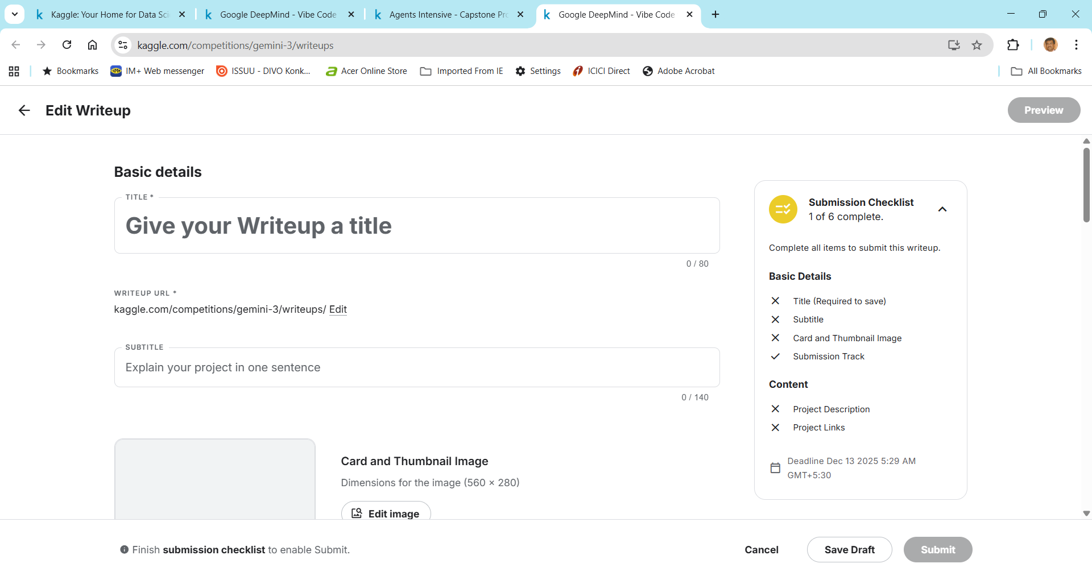

Basic details
Customer Centric Application Agent to assist customers with shopping , answer queries and solve issues , Generate reports for Admin + customers , Voice support enabled feature
Writeup URL *
kaggle.com/competitions/gemini-3/writeups/
SubTitle
Customer Centric Application Agent
Card and Thumbnail Image
Refer 3 images generated by Gemini , OpenAI , Perplexity for Customer Centric Application Agent
Project Description
1.Assist customer to make purchases like clothing and electronic goods , feature to place order via the application.
2.Suggest customer with additional purchases to complete the range of shopping
3.Support Multilingual mode both English and French
4.Assist with voice support chat for specific categories of customers unable to write text
5.Ability of the application to create new products (only by administrator) and modify prices of the product (only by administrator)
6.Maintain history of the chat for a particular customer (memory storage)
7.The application would provide reports for both customer and administrator.The reports should help you identify how app is performing. You should be able to see data around:
The total number of chats they’ve received
The total number of valid chats
The total number of invalid chats
An overview of the three metrics discussed above
How engaging your visitors found them on the customer support app
For customer user it should have customer satisfaction survey before the conversation ends

Attachments
Add links to code, demos and Kaggle files that will help judges understand your project. You can also upload files like code or model weights that are part of your project.
Project links
Deployed public project link add here

Files
Upload files to your Writeup (max. 100MB). For larger files, consider creating a Kaggle Dataset, Model, or link a GitHub repo.

