Long Term Dynamics of Markovian System:

What is a Markov System?

A Markov system (or Markov process or Markov chain) is a system that can be in one of several (numbered) states, and can pass from one state to another each time step according to fixed probabilities.

If a Markov system is in state i, there is a fixed probability, pij, of it going into state j the next time step, and pij is called a transition probability.

We can demonstrate a Markovian system using a transition diagram that shows all the nodes, their states and the probabilities of transition.

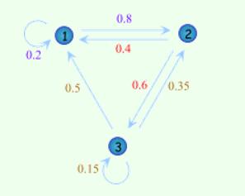

**Matrix:**

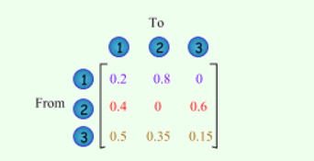

Page Rank Algorithm:

The Page rank of a web page is decided by the number of Page Rank metric of all the pages linked to it. The page rank of a web page **u** can be expressed as:

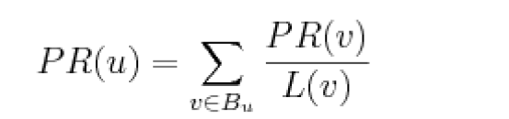

It can be understood as a **Markov Chain** process in which the states are pages and the transitions are all probable (with different probabilities) and are the links between pages. With Markovian analysis, we can say that Page rank of a page is the probability of being at that page after number of clicks.

In page rank algorithm, change of states takes place in the form of number of iterations till we get a converged solution.

At each step, following computations takes place:

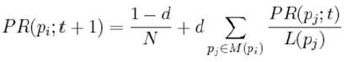

This will give the page rank of that particular web page.

* Where 1-d is the dampening factor that handles the probability of user browsing a page on a new URL apart from following the different page route
* M (Pi) is the set of all pages linking to pi.
* PR (pjt) defines the aggregation of all the page ranks of the in link pages.

In this way, we have analyzed the page rank algorithm. Based on the Markov chain formulation of this algorithm, we use the Markov chain aggregation as a tool to analyze the properties of page rank. The page rank algorithm converges rapidly for any web sized graph until we get a constant page rank.

A Markov model is created for a sample Web graph and the PageRank

calculation is shown for the Markov model.