
A PROJECT REPORT
ON

EMOTION BASED AUDIO PLAYER

SUBMITTED TO THE
SAVITRIBAI PHULE PUNE UNIVERSITY, PUNE

IN THE PARTIAL FULFILLMENT OF THE REQUIREMENTS
FOR THE AWARD OF THE DEGREE OF
BACHELOR OF ENGINEERING
(ELECTRONICS AND TELECOMMUNICATION)

SUBMITTED BY

RAHUL GAJANAN KATORE
[Exam No. 72159205J]
UNDER THE GUIDANCE OF

MRS. NIKITA CHAVAN



DEPARTMENT OF ELECTRONICS AND TELECOMMUNICATION

DR. D.Y. PATIL INSTITUTE OF ENGINEERING, MANAGEMENT & RESEARCH
AKURDI, PUNE 411044

2023-2024



CERTIFICATE

This is to certify that the project report entitles

“EMOTION BASED AUDIO PLAYER”

Submitted by
Rahul Gajanan Katore [Exam No. 72159205J]
Is being submitted by Group number: 28 is a record of bonafide work carried out by him/her under the supervision and guidance of Mrs. Nikita Chavan in partial fulfillment of the requirement for Bachelor of Engineering ((E&TC Engineering) – 2019 course of Savitribai Phule Pune University, Pune in the academic year 2023-2024.

Mrs. Nikita Chavan | Mrs. D. N. Hire | Dr. Priya Charles
Guide | Project coordinators | Head
Department of E&TC  Engineering | Department of E&TC Engineering | Department of E&TC Engineering

Dr. Anupama V. Patil
Principal,
Dr. D.Y. Patil Institute of Engineering, Management & Research Akurdi Pune

Place: Pune
Date:
DECLARATION

We hereby declare that the entire project work entitled “EMOTION BASED AUDIO PLAYER” is a project report of original work done by us and to the best of my knowledge and belief. No part of it has been submitted for any degree or diploma of any Institution previously. This Project work is submitted to Savitribai Phule Pune University, Pune in the Dr. D.Y. Patil Institute of Engineering, Management and Research, Akurdi, Pune during the academic year 2022-2023.

Place: Signature of Students
Date: 1. Rahul Katore

ACKNOWLEDGEMENT

We express our sincere gratitude towards the faculty members who made this project work successful.
We would like to express our thanks to our guide Mrs. Nikita Chavan for his/her wholehearted co-operation and valuable suggestions, technical guidance throughout the project work.
Special thanks to our H.O.D. Dr. Priya Charles for her kind official support and encouragement. We are also thankful to our project coordinators Mrs. D. N. Hire for their valuable guidance.
Finally, we would like to thank all our staff members in the E&TC Department who helped us directly or indirectly to complete this work successfully.

Rahul Katore 72159205J
(BE E&TC Engineering)

ABSTRACT

Current research has confirmed that individuals respond significantly to music, with a profound impact on their cognitive activity. The average Indian dedicates up to four hours daily to listening to songs, often choosing music based on their mood and interests. This project focuses on developing an application to recommend songs to users based on their mood, leveraging facial expressions as a form of nonverbal communication.
Computer vision, an interdisciplinary field, facilitates a high-level understanding of digital images or videos by computer systems. In this application, computer vision components are employed to discern the user's emotion through facial expressions. Once the emotion is identified, the system suggests a playlist tailored to that emotion, saving users considerable time compared to manual song selection.
The emotion-based music player also keeps track of user details, including the play count for each song, categorizes songs based on genre and interest level, and dynamically reorganizes the playlist. Furthermore, the system notifies users about songs that have never been played, allowing for potential deletion or modification.
This holistic approach aims to enhance the user experience by providing personalized music recommendations while efficiently managing and organizing their music preferences based on facial expressions and usage patterns

Contents

CERTIFICATE…………………………………………………………………………………………2
DECLARATION……………………………………………………………………………………….3
ACKNOWLEDGEMENT……………………………………………………………………………...3
ABSTRACT………………………………………………………………………………………….…4
CHAPTER 1 INTRODUCTION 8
1.1 INTODUCTION 8
1.2 GOALS & OBJECTIVES / SCOPE 8
1.3 MOTIVATION 9
1.4 PROBLEM STATEMENT 9
CHAPTER 2 LITERATURE SURVEY 10
2.1 LITERATURE SERVEY 10
2.2 DESCRIPTION 10
CHAPTER 3 PROPOSED SOLUTION 12
3.1 INTRODUCTION 12
3.2 SYSTEM OVERVIEW 13
3.3 SYSTEM REQUIREMENTS 14
CHAPTER 4 PROPOSED METHODOLOGY 15
4.1 PROPOSED MODEL 15
4.2 ALGORITHM 16
CHAPTER 5 SYSTEM RCHITECTURE 19
CHAPTER 6 DESIGN 20
6.1 As-Is-System 20
6.2 To-Be-System 21
6.3 UML DIAGRAM 21
6.3.1 CLASS DIAGRAM 22
6.3.2 SEQUENCE DIAGRAM 23
CHAPTER 7 FUTURE SCOPE 24
7.1 FUTURE SCOPE 24
CHAPTER 8 CONCLUSION 25
CHAPTER 9 REFERENCES 26

LIST OF FIGURES
Figure 3. 1 System Architecture of Emotion-Based Music Player 12
Figure 3. 2 System Flow of Emotion-Based Music Player 13

Figure 4. 1Working of The Proposed Model……………………………………………………….15

Figure 5. 1 The prototype model of the system shows the activity of creating of prototypes of applications, that is, incomplete versions of the product being developed……………………….19

Figure 6. 1 The As-Is user process flowchart………………………………………………………20
Figure 6. 2 The To-Be user process flowchart 21
Figure 6. 3 Class Diagram 22
Figure 6. 4 Sequence Diagram 23

LIST OF TABLES
Table 2. 1 Overview of literature survey 10

CHAPTER 1 INTRODUCTION

1.1 INTODUCTION
Emotions encompass the physical sensations linked to one's mood, temperament, character, or individuality. Paul Ekman, in 1972, classified basic emotions as anger, disgust, fear, happiness, sadness, and surprise.
Facial expressions manifest through movements, actions, or positions of facial muscles, conveying an individual's emotional state. While facial expressions can be voluntary, with a person controlling facial features to convey a specific emotion, they are primarily involuntary, tightly linked to genuine emotions. For example, an individual might furrow their eyebrows and frown to express irritation or intentionally relax facial muscles to appear unaffected.
Despite efforts to conceal current emotions, facial expressions often reveal them involuntarily, typically within the first few microseconds before returning to a neutral expression. Since Darwin's work in 1872, behavioral scientists have actively researched and analyzed facial expression detection, making significant progress in developing computer systems for understanding and interpreting individuals' facial expressions in communication.
The "Emotion-based Music Player" is a tool designed to detect an individual's emotion and play a curated list of tunes accordingly. Initially, the person expresses their emotion through facial expression, which the device then detects, analyzes, and interprets. Subsequently, the music player selects songs that align with the detected emotion. The focus of the system is on analyzing facial expressions without considering head or face movements

1.2 GOALS & OBJECTIVES / SCOPE
- The emotion-based music player is a valuable application tailored for music enthusiasts possessing a smartphone and internet connectivity. This user-friendly software is accessible to anyone who establishes a profile on the platform. The application is strategically crafted to meet the following user requirements:
- Account Creation or Registration, Sign-Up, and Sign-In for System Reliability
- Song Management: Addition, Deletion, and Updates
- Personalized Playlist Creation
- Music Recommendations
- Emotion Capture through Camera Functionality
- Users can seamlessly navigate and engage with the application, ensuring a tailored and enjoyable music listening experience.

1.3 MOTIVATION
As an avid music enthusiast, I have consistently believed that music players should offer more than just playing songs and allowing users to curate playlists. A music player should exhibit intelligence and adapt to the user's preferences, aiding in the seamless organization and automated playback of songs without requiring extensive user effort. The Emotion-based music player establishes an enhanced platform for all music enthusiasts, ensuring the automated selection and regular updating of playlists. This feature empowers users to effortlessly organize and play songs in accordance with their moods. Moreover, the player provides on-the-go suggestions for users to modify songs, utilizing the EMO algorithm to calculate song weight, thereby facilitating a more personalized and well-organized playlist experience.

1.4 PROBLEM STATEMENT
The impact of music on an individual's emotions is widely acknowledged. Whether for primitive or modern man, after a day of toil and hard work, the soothing melody of music provides a means to relax and unwind. Research even supports the notion that the rhythm itself acts as a powerful tranquilizer.
However, the challenge for many lies in the selection of music, particularly finding songs that align with one's current emotional state. Confronted with lengthy, unorganized music lists, individuals often feel demotivated to sift through and locate specific songs. Consequently, they may resort to randomly choosing songs within the music folder, leading to a mismatch with their current emotions. For instance, someone feeling sad might prefer heavy rock music to channel their emotions, but the arduous task of manually searching through a vast playlist proves impractical. As a result, individuals often opt to play songs randomly or select the "play all" option for their entire collection.
This conventional approach to searching and selecting songs has been in practice for several years, causing people to grow weary of its limitations. The need for a more efficient and personalized method of music selection has become increasingly apparent over time.

CHAPTER 2 LITERATURE SURVEY
A literature survey is gathering information on previous work done related to your project. It contains the research study year, researchers name, technologies used and drawbacks of the system.

2.1 LITERATURE SERVEY
Table 2. 1 Overview of literature survey
Sr. No. | Topic | Author and Year | Summary/Details
01 | Music stands as one of the most universally embraced cultures and languages, transcending boundaries and appealing to people of all backgrounds and types. | Barbara Raskauskas,  Oct 2009 | Music provides enjoyment and communicates with us, irrespective of whether it contains lyrics or not.
02 | Individuals are drawn to music for similar reasons that attract them to substances, gambling, and delectable food, as indicated by recent research. | Emily Sohn, Sept-  Oct 2011 | The research demonstrated that when individuals listen to harmonious or melodic elements that resonate with them, the human brain releases dopamine, a chemical associated with addiction and motivation.
03 | Detecting facial expressions in an individual can be achieved by comparing them with similar expressions.. | Mary Duenwald,  Mar 2005 | Scientists have conducted numerous studies and research, revealing that facial expressions globally tend to fall roughly into seven categories.

2.2 DESCRIPTION
In 2009, Barbara Raskauskas published an article asserting that music serves as a universally accepted culture and language, embraced by people of all kinds. Raskauskas emphasized the ability of music to fill silence, convey cultural upbringing, and provide pleasure, asserting its universality as a source of enjoyment even for individuals with hearing impairments. She stated that finding joy in music is a universal experience.
According to Emily Sohn in 2011, people's love for music shares similarities with their attraction to drugs, gambling, and delectable food, as indicated by recent research. Sohn highlighted the study's findings, demonstrating that listening to harmonious or melodic elements induces the release of dopamine in the human brain, contributing to feelings of addiction and motivation.
Detecting facial expressions in individuals involves comparing them with similar expressions, as highlighted in a 2005 article by Mary Duenwald. Duenwald summarized various studies revealing that facial expressions worldwide can be broadly categorized into seven distinct categories.

CHAPTER 3 PROPOSED SOLUTION
The device architecture of the Emotion-based music player is illustrated in Figure 3.1. The application is constructed employing the architectural model-view-controller pattern, a widely utilized framework in architecture. In this context, the application is divided into three primary logical components: the model, the view, and the controller

3.1 INTRODUCTION
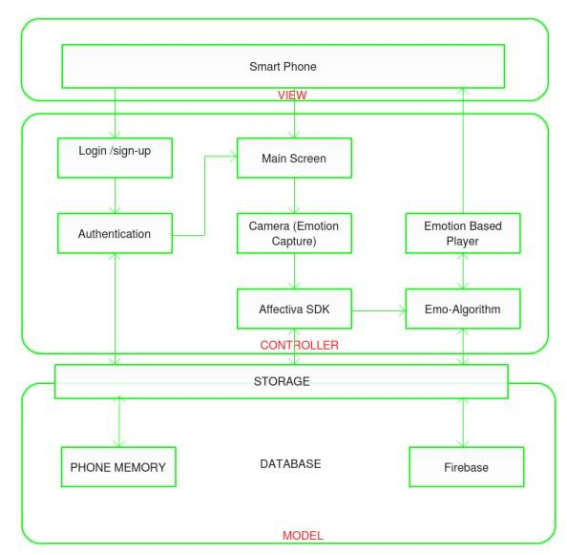
Figure 3. 1 System Architecture of Emotion-Based Music Player

View: The topmost layer is where the end-user engages with the software by clicking buttons, entering details, accessing the camera, selecting a radio button, uploading songs, etc. This layer is responsible for displaying all information or a portion of data to the user based on the application's requirements. Additionally, it acts as a bridge facilitating communication between the user and the application.
Controller: Positioned in the middle layer of the application, the controller houses the business logic and core functionality. When the user interacts with the application, this layer processes the response. From login procedures to displaying playlists, all background functions belong to this layer. It encompasses functions and the EMO algorithm crucial for song segregation and sending output to the view layer.
Model: This component is responsible for maintaining user data. The Emotion-based music player utilizes Google Firebase for storing user data, providing a useful repository for user profiles and preferences. The application also stores certain temporary data on the device.

3.2 SYSTEM OVERVIEW
This section delineates the design and functional aspects of the application. The Emotion-Based music player is installed on a mobile device, allowing users to access their customized playlists and play songs based on their emotions. Figure 3.2 provides an overview of the application.
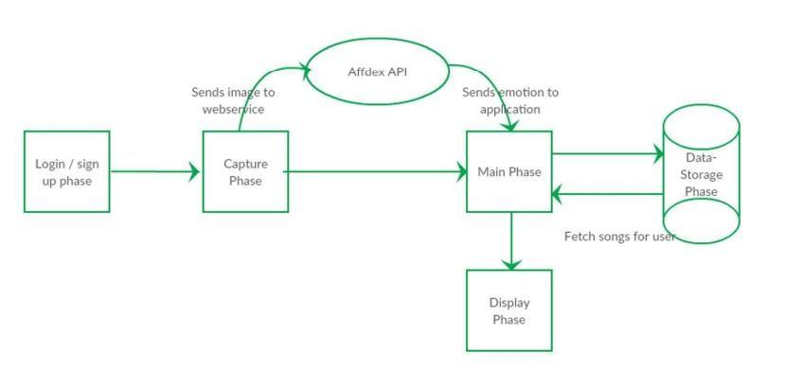
Figure 3. 2 System Flow of Emotion-Based Music Player
Login/Sign-Up Phase: Users are required to create a profile to store personal data. If the user already has an account, they can log in to access personalized playlists and songs. Upon login, the user's profile is saved until manual logout. User-added songs and their details, such as category and interest level, are recorded by the system.
Emotion Capture Phase: After authentication, the application seeks the user's permission to access media and photos, capturing the user's image via the camera.
Affdex API: The captured image is sent to the Affdex SDK for processing. The SDK analyzes the image, and the image comments are relayed back to the application.
Emo-Phase: In this stage, the application receives image data and identifies the emotion based on a predefined threshold. This emotion is then sent to the database to retrieve the emotion-based playlist.
Display Phase: Songs are organized using the EMO algorithm, and the user can play any song from the displayed list. Users can add, remove, and modify songs, as well as adjust the category and interest level at any time. The application includes a recommendation tab, notifying users of seldom-played songs.

3.3 SYSTEM REQUIREMENTS
The minimum requirements for developing this application are as follows:

Hardware Requirements:
Processor: 2 GHz
RAM: 1 GB
Browser Compatibility:

Chrome 51 or higher
Firefox 47 or higher
Opera 37
Edge 10586
Database:

Firebase
NoSQL
API:

Affective Emotion Recognition API

CHAPTER 4 PROPOSED METHODOLOGY
This chapter introduce us regarding the example model (GUI) within which it renowned us however project seem like and implementation detail of first module.

4.1 PROPOSED MODEL
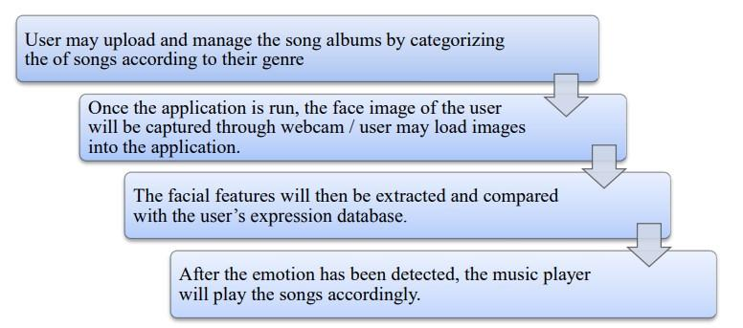
Figure 4. 1Working of The Proposed Model

From the developer side, as for this FYP, the proposed version may be focusing on two primary capabilities, first is expression detection and second the list of songs played for each class of emotion. As for expression detection, the machine is designed specially to hit upon the 4 main expressions, which might be happy, unhappy, normal and surprised. Alternatively, there might be songs ready available in every category. After the emotion of the person is detected, the machine will play ten songs through the music player.
Except, there can be units of nevertheless photos with the four special expressions available in the database of facial features detection. It will likely be used for contrast functions. After the photo of the person is loaded, the capabilities (lip and eyes) of the user may be extracted by using the system. The gadget will then analyze the situation of the functions and do a comparison with the units of emotions inside the database. The system will discover processed photographs for instance as happy whilst the situation of the features is nearest to the “satisfied emotion” within the database.
As for the consumer facet, the user might be capable of personalizing the songs in every category in line with their taste. Some might choose sentimental music when she is unhappy however some may choose a few countryside tunes. There can be no restriction on songs to be kept in each category. The consumer will ought to launch the system for you to start the proposed model. Once the device is started, the person can select to either pick songs or to directly technique the modern emotion. A list of songs can be performed routinely after the gadget is achieved with the translation. Users can pick to alternate the modern-day emotion after the listing of a song is being played by using repeating the image loading or capturing technique.

4.2 ALGORITHM

EMO-algorithm

Data: Interest level and category while adding a song, count of song, a user changing song category, skipping the song
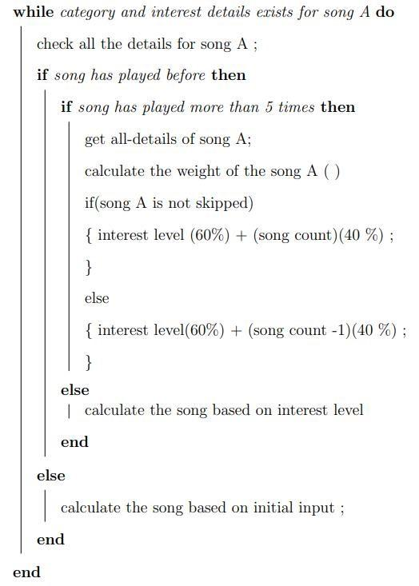
Result: Customize music list based on emotion-recognized initialization;

Algorithm 1. SEQ Algorithm_1. \* ARABIC 1EMO Algorithm to Calculate Song Weight

In this stage, the EMO algorithm determines the categorization of songs. When a user adds a song to the application, the system collects details such as the song category and user interest level. Upon the user's interaction with the application, the EMO algorithm takes various factors into account to customize the playlist. The factors influencing the calculation of the song weight include:
Category and interest level
Number of times the song has been played
If a song has never been played
If a song has been played less than 5 times
If a song has been played more than 5 times
Number of times the song has been skipped
The EMO algorithm employs the following formula to calculate the song weight, emphasizing the song's interest level and the frequency of play:
Song Weight
=
(
60
%
)
×
number of times played
+
(
40
%
)
×
song interest level
Song Weight=(60%)×number of times played+(40%)×song interest level

This algorithm accommodates instances where the user skips a song, presuming a lack of interest and subsequently reducing the song's weight.
Utilizing Algorithm 1, the application classifies songs based on each emotion, presenting them to the user. Each user benefits from a personalized playlist, allowing the addition of new songs to the music player. Through the EMO algorithm, all songs are dynamically reorganized at runtime, recalculating song weights whenever the user interacts with the application.

CHAPTER 5 SYSTEM RCHITECTURE
This chapter introduces us to the prototype model (GUI) which it has known us what the project looks like and the implementation detail of the first module.
Figure 5. 1 The prototype model of the system shows the activity of creating of prototypes of applications, that is, incomplete versions of the product being developed.

CHAPTER 6 DESIGN

6.1 As-Is-System
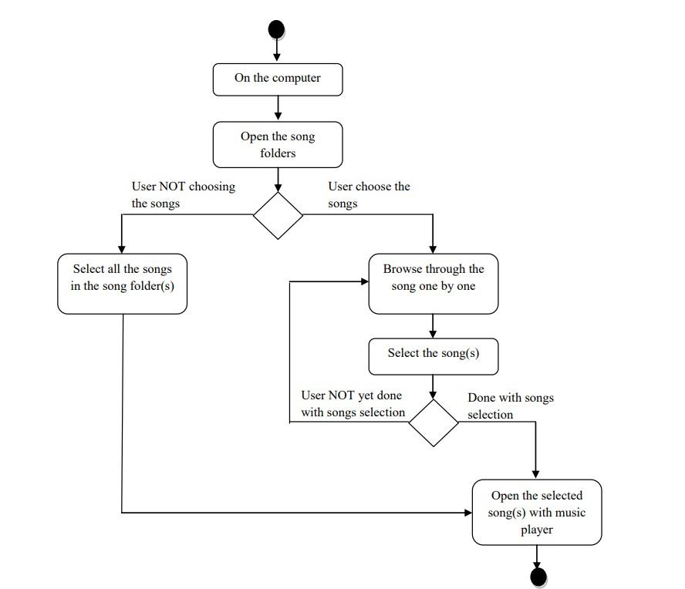
Figure 6. SEQ Figure_6. \* ARABIC 1 The As-Is user process flowchart

6.2 To-Be-System
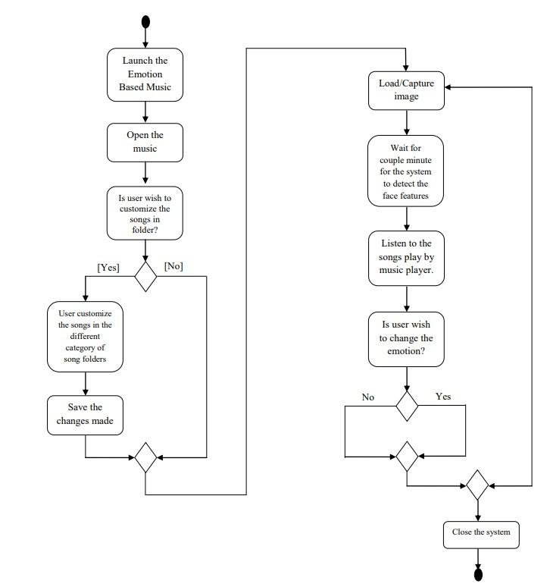
Figure 6. 2 The To-Be user process flowchart

6.3 UML DIAGRAM

The Unified Modeling Language (UML) is a versatile modeling language within the realm of software engineering, devised to establish a standardized method for visualizing system designs. UML serves as a means to depict a system's architectural plans through diagrams, encompassing elements such as:
Various activities or tasks.
Individual components constituting the system.
Interactions between different software components.
System execution details.
Entity interactions.
External user interface.

6.3.1 CLASS DIAGRAM
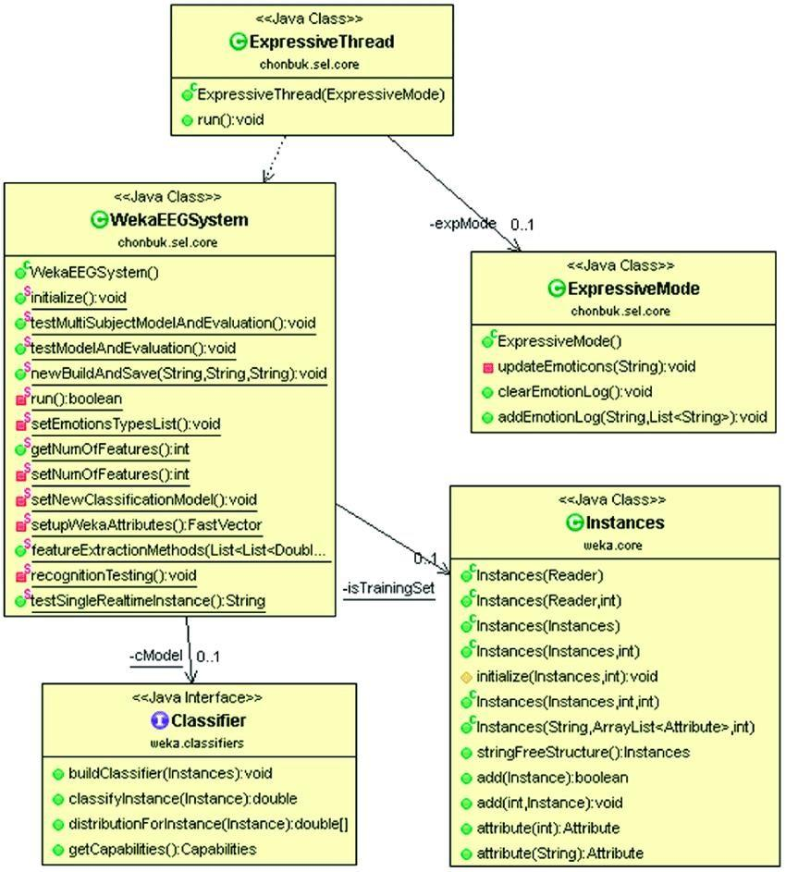
Class diagrams stand out as the most prevalent diagrams employed in UML. Comprising classes, interfaces, associations, and collaborations, a class diagram essentially portrays the object-oriented perspective of a system, emphasizing its static characteristics.
Figure 6. SEQ Figure_6. \* ARABIC 3 Class Diagram

6.3.2 SEQUENCE DIAGRAM

A sequence diagram in the Unified Modeling Language (UML) is a specific type of interaction diagram that illustrates how processes collaborate and the sequence in which they operate. It is structured akin to a Message Sequence Chart. This diagram places emphasis on the chronological order of messages, portraying objects along the X-axis and depicting the order of messages on the Y-axis in increasing time. The line representing an object's existence is termed the object lifeline.
User object has any PC related problem occurs then the user able to register this type of problem.
User is responsible for creating all other objects.
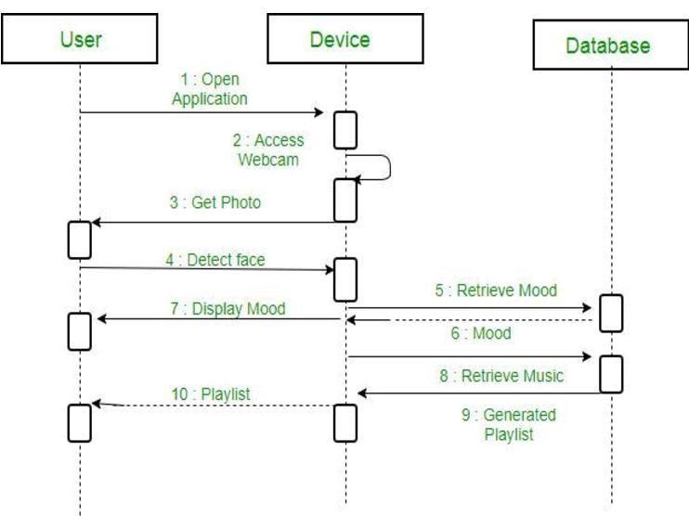
Figure 6. 4 Sequence Diagram

CHAPTER 7 FUTURE SCOPE

7.1 FUTURE SCOPE

The software can be stepped forward by using enhancement and functionality.
- The present application utilizes the Affective SDK, which poses several limitations. Developing a personalized emotion recognition system that seamlessly integrates with the existing software enhances the system's functionality and performance. Key enhancements include:
- Enabling the application to operate without requiring an internet connection.
- Introducing new emotions to expand the emotional range.
- Implementing automatic song playback.
- Enhancing the EMO algorithm by incorporating additional features that allow the system to categorize users based on various factors, such as location, and recommend the user explore that area while playing songs accordingly.

CHAPTER 8 CONCLUSION
The essence of this project lies in the emotion detection capability applied to loaded images in the proposed model. The primary objective is to enhance individual enjoyment through the integration of emotion detection technology and a music player. The proposed version can effectively detect four emotions—normal, happy, sad—based on the loaded images. Once the model identifies the user's emotion, the music player will play suitable songs accordingly.
The project's overarching goal was to implement an emotion-based music recommendation system utilizing facial expression recognition functionalities. Beyond theoretical underpinnings, the work outlined various strategies to address challenges and operate emotion-based music players. The system, as described, works by analyzing user facial images to determine mood, playing music aligned with the detected emotion, and recommending songs that complement the user's mood. In future iterations, expanding the number of recognized moods (including Disgust, Fear, and Neutral), improving the rate and accuracy of expression detection, and incorporating gesture controls for play, pause, and song navigation are areas of focus.
The Emotion-based music player offers users a novel approach to song selection that is more interactive and user-friendly. Instead of manually sifting through lengthy song lists, music enthusiasts can now choose songs based on the prevailing emotional context.

CHAPTER 9 REFERENCES
- Ekman, P. & Friesen, W. V. (1969): The repertoire of nonverbal behavior: Categories, origins, usage, and coding: Semiotica, Vol. 1: 49–98.
- Ying-Li Tian, Takeo Kanade, and Jeffrey F. Cohn. (2003): Facial Expression Analysis. Retrieved from www.ri.cmu.edu/pub_files/pub4/tian.../tian_ying_li_2003_1.pdf.
- Abat, F., Maaoui, C., and A.Prusk. Human-computer interaction using emotion recognition from facial expression. 2011 UKSim 5th European Symposium on Computer Modeling and Simulation (2011).
- Viola, P., and Jones, M. Rapid object detection using a boosted cascade of simple features. Proceedings of the 2001 IEEE Computer Society Conference on, vol. 1, pp. 511-518 IEEE, 2001 (2001).

