Please follow below processes to run the Project :

- Open project in your IDE.
- Configure the tomcat with GoogleAPI.war (GoogleAPI.war is the resultant war file)
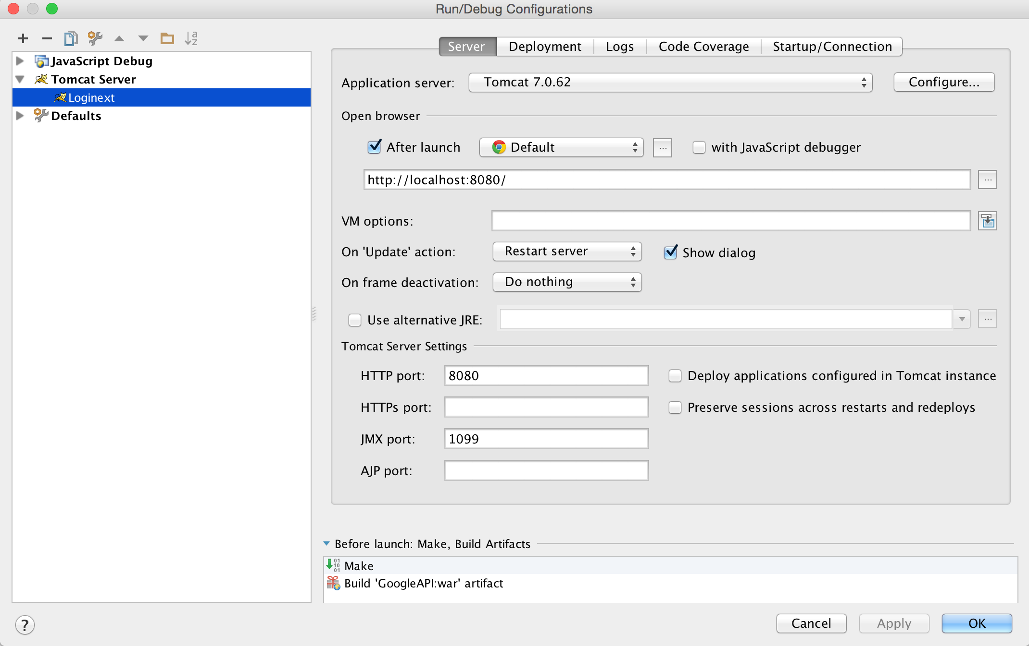

- Create Database loginext with appropriate credentials.
- Update the credentials in application.properties file.
- Run the SQL script included in the information folder on the loginext DB.
- Run the Project , You will see the solution for the first Question.
- For Bonus Points I am giving you the solution for the second question as well.
Use following URL to run the second question
http://localhost:8080/loginext2.html
- For screenshots Please find file : Screenshots

