- First Question :
URL : http://localhost:8080/

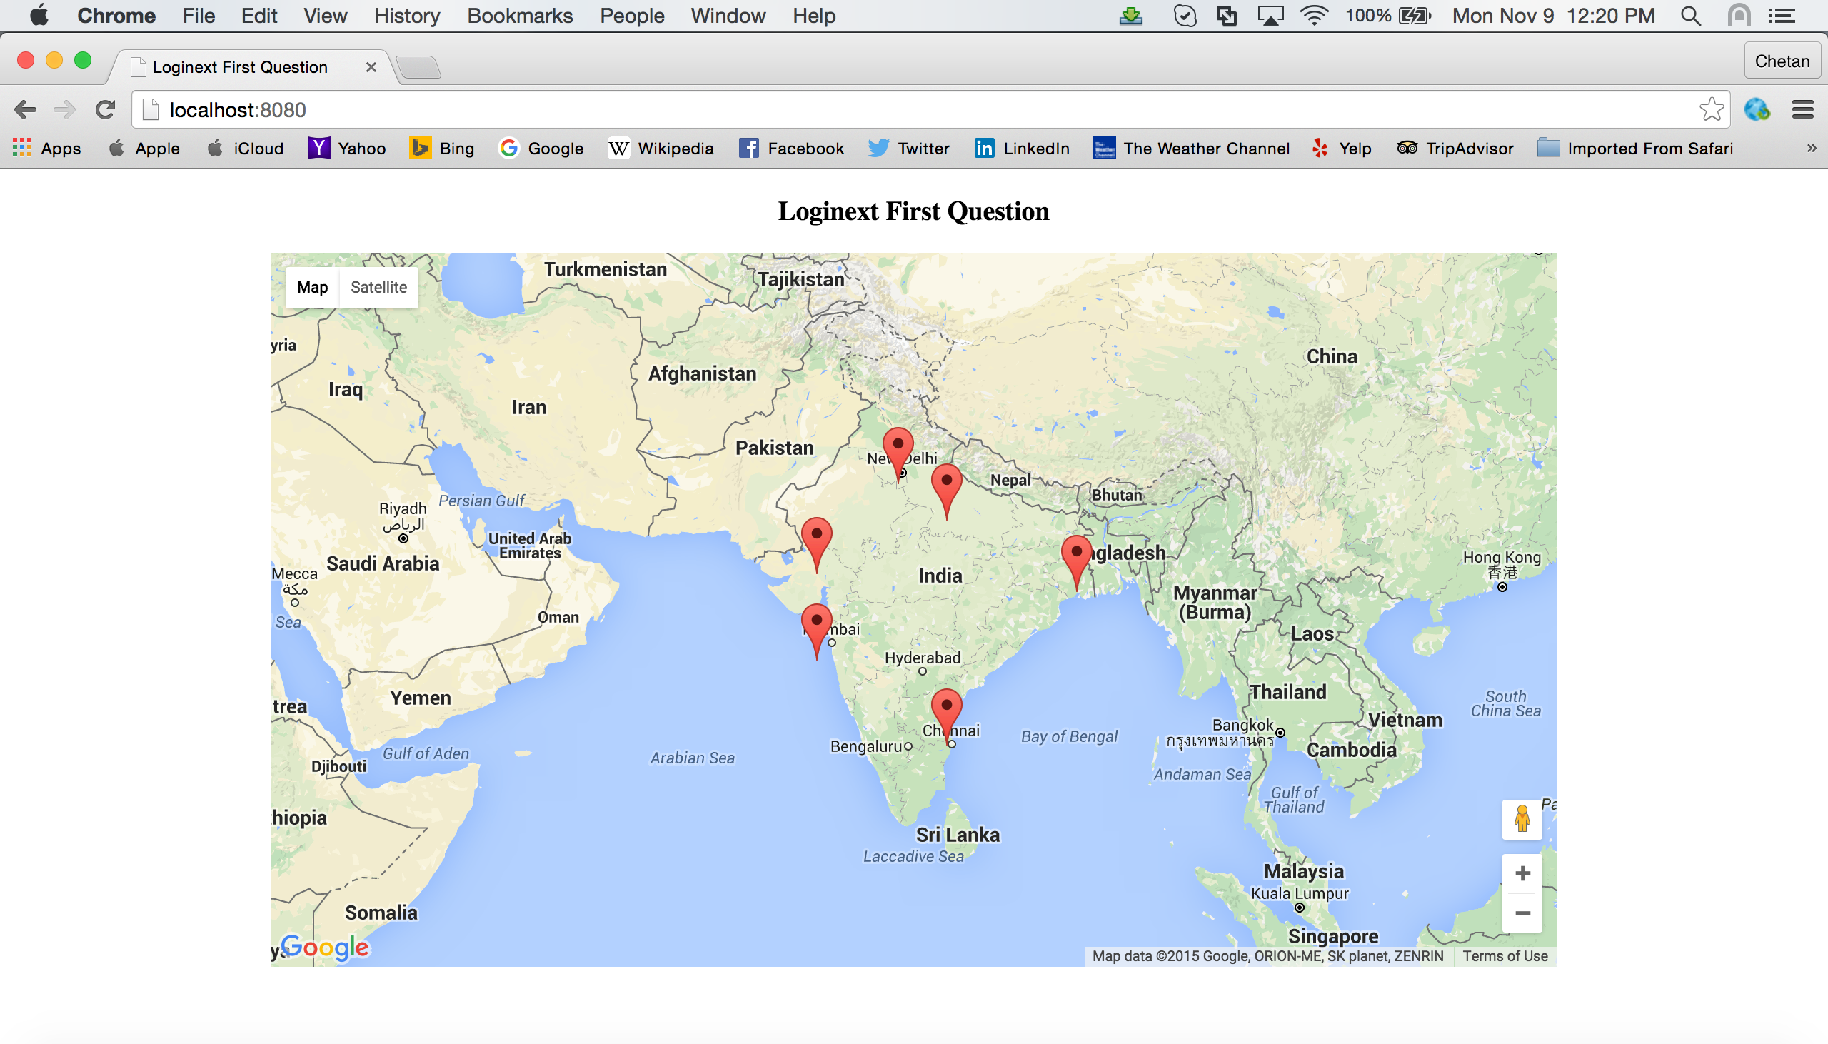
- Second Question on Click handlers :
URL : http://localhost:8080/loginext2.html

