

**G . H. Raisoni College Of Engineering & Management, Pune**

**Department Of Computer Engineering A.Y.: 2023-24**

**TERM VII**

# I NTERNSHIP MIDTERM

**P ROGRES REPORT**

* Internship Review Number: 02
* Company Name & Location: Soft The Next, Camp, Pune
* Student Name: Nihal Sheikh
* Student Roll No: BCOB82
* External Mentor Name: Gayatri Rajole
* Internal (College)Mentor Name: Prof. Pradip Taware

**Progress Period:** From: 14 August 2023 To: 04 September 2023

Coordinator Sign with Date Internal Mentor Sign with Date

Student Sign Industry Mentor Sign and Date

# Index:

|  |  |  |
| --- | --- | --- |
| Sr.NO | Items | Page No. |
| 1 | Introduction | 03 |
| 2 | About Company | 03 |
| 3 | Project/Work Assigned | 04-05 |
| 4 | Project/Work completed so far and Images of project | 06-08 |
| 5 | Technology Used | 09 |
| 6 | Task to be completed up to next review | 10 |
| 8 | Conclusion | 11 |

**Introduction**

This is a **Progress Report Number: 02** written to share the progress and insights gained during the internship at Soft The Next for the duration of **14 June 2023 to 04 August** 2023. I am Nihal Sheikh, a student of GHRCEM currently in the 7th semester. As a part of my curriculum, I’m required to do an internship. I joined the company Soft The Next as a Python Developer Intern, having received the offer letter on June 19th. Since my joining date, I have been actively engaged in various tasks and projects as assigned.

In the subsequent sections, I will provide an overview of the tasks and projects I've undertaken, discuss the learning and development opportunities that have arisen, reflect on challenges encountered, and conclude with an overall summary of my experience thus far.

**About Company**

Soft The Next is a Product Based Company, it is a Multi-skilled Software Service provider with high Performance with user-friendly utility. The company is situated in Camp, Pune, Maharashtra 411001.

Currently as a Python Developer Intern I’ve the privilege of working under the guidance of Mrs. Gayatri Rajole, a Senior Software Developer.

**Who we are?**

Soft The Next provides a value-based solution as well as professional service to the client.

**What we do?**

We develop, design and create computer software programs and systems. Our job is to apply the principles of engineering, analytics, and computer science towards the development and testing of all kinds of software and applications.

**Project/Work Assigned**

From the last review of internship, i.e. the time period of June to August, I have been assigned more tasks regarding the frontend of the application, along with the backend of the application.

The following are details of the tasks and works that’s been assigned to me since then:

1. Working on the front-end of the web application:

* In this task, I’ve worked on projects, in which I worked on the UI/UX of the website, making it more dynamic and attractive. Worked with the team of professionals on reviewing code, how to make the code better and fast and scalable. Worked on the scalability of the application.

1. Created the landing page of the applications:

* The task is to create the landing page of the application, that displays the company’s product information that is fetched from the Application Program Interface (API), using fetch method. The API is in .json file format. On the landing page, created the card components, in the card component, there are areas assigned to each value present in the api, then the javascript fetches information from the api, and displays it when called.

1. Industry Project:

* Started working on the individual industry project.
* Here are some sample ideas of websites you could build for your Capstone Project:
* A Product Ordering Website enabling the users to order products listed in the business website.
* A Service Booking Website which helps in booking of services provided by a business.
* A Hospital Management Website showcasing the functional aspects like booking a Doctor Appointment.
* An Event Booking Website with functionalities for a user to book for an event listed on the website’s web page.

1. Code reviews:

* Working with my peers, to review code, finding bugs, resolving errors and then debugging, scaling the application.

1. Data Refinement:

* The data fetched from RapidAPI is being further refined to ensure consistency and accuracy. This includes data validation and standardization.

1. User Authentication:

* The implementation of user authentication and account management is ongoing to allow users to create accounts, log in, and manage their bookings.

1. Booking System:

* The booking and reservation system is being developed to enable users to book cars easily and manage their reservations.

1. Payment Integration:

* Integration with payment gateways is underway to facilitate secure online payments for car rentals.

1. Testing and Quality Assurance:

* Rigorous testing and quality assurance procedures are being implemented to identify and rectify any bugs or usability issues.

**Project/Work completed so far**

The tasks that were assigned during this time period, were mostly regarding the frontend of the application development and an individual project was assigned.

Following are the project details of the work completed so far:

**Industry Project:**

* Initial Project Setup
* Research and Planning
* Website Design
* Data Fetching Integration
* Car Showcase Profile

**Background:**

This internship report presents the progress made on the Mobility Car Rental Website, a project focused on developing a user-friendly platform for car rentals. The project aims to streamline the process of renting cars by providing an intuitive web interface for users to browse and select vehicles. One of the key features of the website is the integration of RapidAPI to fetch data for showcasing car profiles.

**Objective:**

The primary objective of this internship is to contribute to the development of the Mobility Car Rental Website. This report outlines the completed work and details the current status of the project, focusing on the data fetching aspect from RapidAPI.

**Initial Project Setup**

The internship began with the setup of the development environment. This included the installation of necessary tools such as web development frameworks, version control systems, and code editors. The project was organized using Git for version control, ensuring efficient collaboration and code management.

**Research and Planning**

Before diving into development, thorough research was conducted on the car rental industry and the user expectations from such a platform. A detailed project plan and wireframes were created, outlining the website's structure and design.

**Website Design**

The design phase involved creating a responsive and visually appealing user interface. The design incorporated a clean and user-friendly layout, making navigation seamless. The color scheme, fonts, and overall aesthetic were carefully chosen to enhance the user experience.

**Data Fetching Integration**

To populate the car rental platform with up-to-date vehicle information, RapidAPI was integrated into the project. RapidAPI provides access to a vast repository of car-related data sources, enabling us to fetch car details, images, and specifications dynamically.

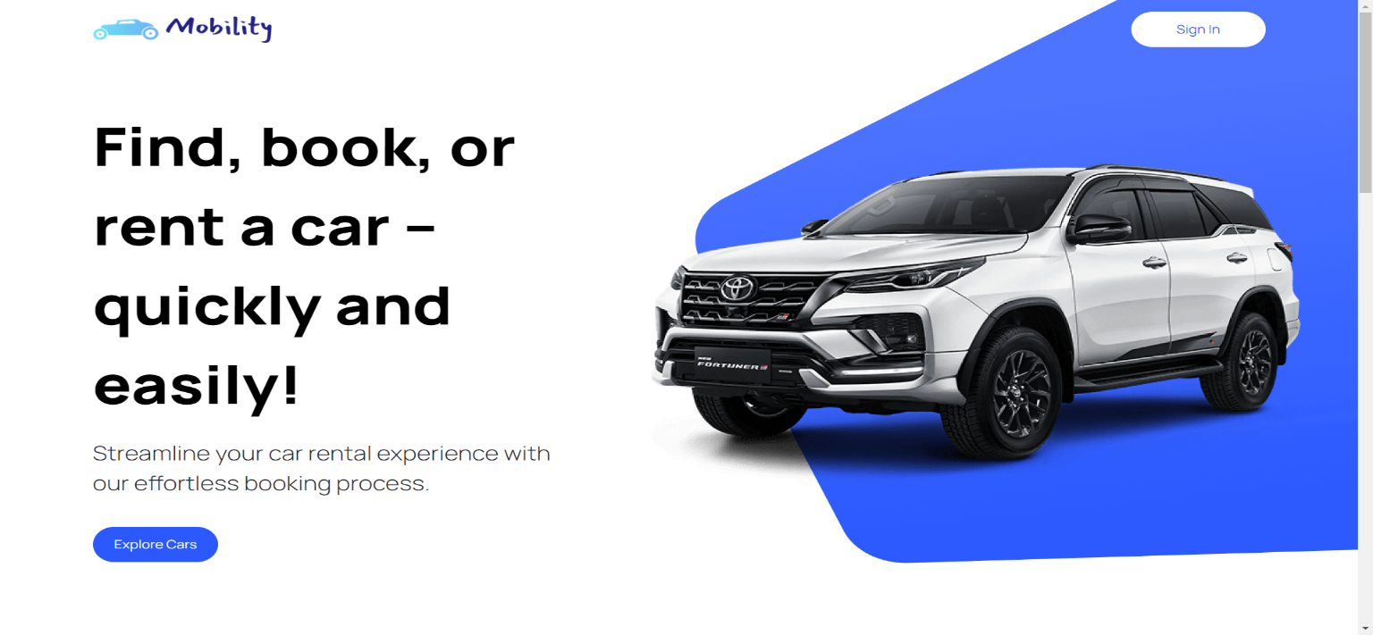

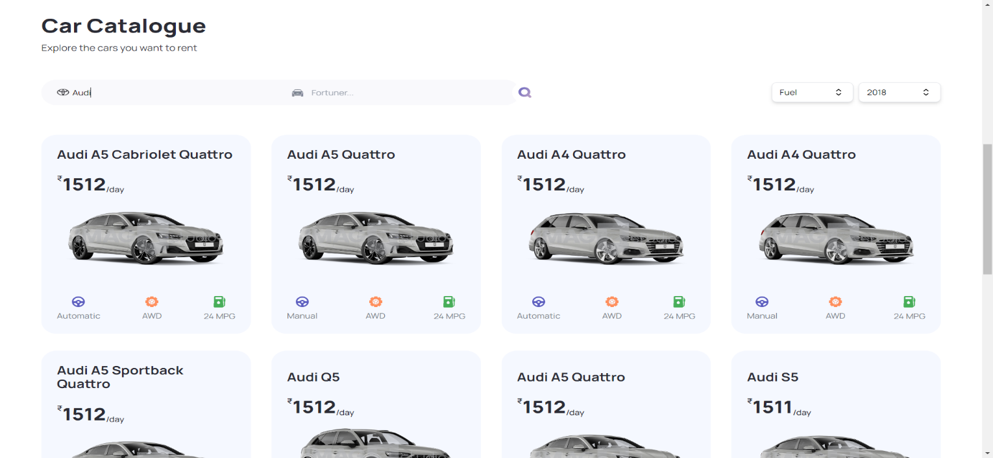

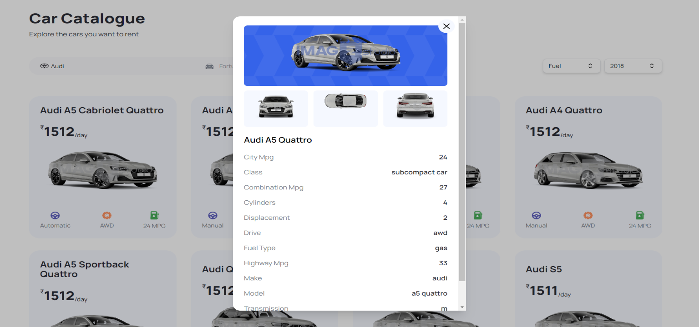

**Technology Used:**

Throughout this project, The Mobility Car Rental Website project leverages a range of modern technologies and platforms to ensure its successful development and deployment. This section provides an overview of the key technologies used:

**Front-End Framework: Next.js**:

Next.js, a popular open-source React framework, is the backbone of the Mobility Car Rental Website. It enables efficient server-side rendering (SSR) and client-side rendering (CSR), offering a smooth and performant user experience.

**Hosting Platform: Vercel**

The Mobility Car Rental Website is hosted on Vercel, a cloud platform specifically designed for hosting modern web applications.

**Version Control: GitHub**

GitHub is the chosen version control platform for this project, providing a collaborative and organized environment for code management.

**Data fetching and Integration: RapidAPI**

For data fetching and integration, RapidAPI is utilized to access various car-related data sources and keep the website's information up to date.

The combination of these technologies and platforms ensures the development of a robust, performant, and user-friendly Mobility Car Rental Website, and provides a solid foundation for future enhancements and features.

.

**Task to be complete up to next review**

As I continue to work on the Mobility Car Rental Website project, the following tasks are planned for completion by the next review period:

**User Authentication and Account Management:**

Implement a robust user authentication system that allows users to create accounts, log in, and manage their profiles. Ensure the security of user data and authentication processes.

**Booking and Reservation System:**

Develop a booking and reservation system that enables users to browse available cars, select vehicles, and make reservations. Implement features for viewing booking history and managing reservations.

**Payment Integration:**

Integrate a secure payment gateway to facilitate online payments for car rentals. Ensure that payment transactions are reliable, fast, and secure.

**Testing and Quality Assurance:**

Conduct comprehensive testing, including unit testing, integration testing, and user acceptance testing. Identify and resolve any bugs or usability issues to ensure a smooth user experience.

**Performance Optimization:**

Optimize website performance, including load times, by implementing best practices such as code splitting, image optimization, and server-side rendering (SSR) where applicable.

**Documentation:**

Create comprehensive documentation for the project, including installation instructions, usage guidelines, and developer documentation. Ensure that the codebase is well-documented for future maintainability.

In addition to these tasks, it's important to keep an eye on emerging technologies and trends, as you mentioned a future project involving cloud hosting and cloud platforms like AWS and Azure. Familiarizing yourself with these platforms and their services will be valuable for your upcoming projects.

**Conclusion**

In the period spanning from June to August, this internship has been marked by significant progress and learning experiences. The focus has primarily been on the development of the Mobility Car Rental Website, encompassing both front-end and back-end tasks, with notable achievements and ongoing endeavors.

Accomplishments

Front-End Enhancement: A considerable portion of the internship involved working on the front-end of the web application. This included refining the UI/UX, collaborating with experienced professionals, and optimizing the codebase for scalability.

Landing Page Creation: The creation of the landing page, which displays company product information fetched from an API, was a key milestone. Card components were utilized to organize and present data dynamically, enhancing the website's visual appeal.

Industry Project: The initiation of an individual industry project represents a significant step in applying acquired skills. The project's diversity, from product ordering to event booking websites, showcases the breadth of knowledge and creativity gained during the internship.

Code Reviews: Collaborative code reviews with peers enabled the identification and resolution of bugs and errors, leading to more robust and scalable applications.

As we approach the next review period, the outlined tasks are poised to be completed, leading to a fully functional Project Website. In summary, this internship has been a valuable journey of growth and hands-on experience in web development. As I look forward to the next review, I am eager to see the project's completion and embrace new challenges and opportunities on the horizon.

Thank You.