Mini Project

Student Name | Sharv Mahajan & Karan Mittal
Roll Number | 31430 & 31436
Batch | L4
Subject | Data Science & Big Data Analytics Lab (DSBDAL)
Assignment | Assignment 14 — Mini Project
Dataset | covid_vaccine_statewise.csv
Language | Python 3.10 | Pandas · Matplotlib · Seaborn
Platform | Google Colaboratory

0. Problem Statement
Use the following covid_vaccine_statewise.csv dataset and perform the following analytics on the given dataset:-
- Describe the dataset
- Number of persons state wise vaccinated for first dose in India
- Number of persons state wise vaccinated for second dose in India
- Number of Males vaccinated
- Number of Females vaccinated

1. Introduction & Objectives

1.1 Background
The COVID-19 pandemic necessitated one of the largest vaccination drives in human history. India rolled out its vaccination programme in phases starting January 2021, administering multiple vaccines — primarily Covishield (Oxford-AstraZeneca), Covaxin (Bharat Biotech), and Sputnik V — across all 28 states and 8 Union Territories.
Understanding the distribution, pace, and demographic spread of vaccinations is critical for public-health planning. This project analyses the covid_vaccine_statewise.csv dataset, which contains cumulative daily vaccination figures for each state and the national aggregate from January 2021 onwards.

1.2 Objectives
• Load and inspect the raw vaccination dataset.
• Perform data preprocessing — clean column names, convert types, filter aggregates.
• Extract key vaccination statistics per state (First Dose, Second Dose).
• Quantify gender-wise vaccination counts (Male vs. Female).
• Create informative visualisations to highlight top-performing states.

2. Dataset Description

2.1 Source & Overview
The dataset (covid_vaccine_statewise.csv) is sourced from India's Ministry of Health vaccination portal. Each row represents a single day's cumulative figures for a given state/UT.
Attribute | Detail
Total Records | 7,845 rows
Total Columns | 24 columns
Date Range | 16 Jan 2021 — latest available
Coverage | All Indian States + UTs + National aggregate
Memory Usage | ~1.4 MB

2.2 Column Glossary
Column Name | Description
Updated On | Date of the record (DD/MM/YYYY)
State | State or Union Territory name
Total Doses Administered | Cumulative total doses given up to this date
Sessions | Number of vaccination sessions conducted
Sites | Number of active vaccination sites
First Dose Administered | Cumulative 1st dose count
Second Dose Administered | Cumulative 2nd dose count
Male (Doses Administered) | Total doses given to males
Female (Doses Administered) | Total doses given to females
Transgender (Doses Administered) | Total doses given to transgender persons
Covaxin (Doses Administered) | Doses of Covaxin administered
CoviShield (Doses Administered) | Doses of CoviShield administered
Sputnik V (Doses Administered) | Doses of Sputnik V administered
AEFI | Adverse Events Following Immunisation count
18-44 / 45-60 / 60+ (Doses) | Age-group wise dose counts
18-44 / 45-60 / 60+ (Individuals) | Age-group wise unique individual counts
Male/Female/Transgender (Indiv.) | Gender-wise unique individual counts
Total Individuals Vaccinated | Total unique individuals with at least 1 dose

2.3 Missing Values Summary
Several columns have significant missing values, particularly age-group breakdowns and individual-level gender counts, which were only introduced later in the rollout.
Column Group | Missing Count | % Missing
Updated On / State | 0 | Complete
Total / First / Second Doses | 224 | ~2.9 %
Male / Female (Doses) | 384 | ~4.9 %
Sputnik V (Doses) | 4,850 | ~61.8 %
18-44 / 45-60 / 60+ (Doses) | 6,143 | ~78.3 %
Male/Female/Trans (Individuals) | 7,685 | ~97.9 %

3. Libraries & Environment
The notebook runs on Python 3.10 (Google Colab) and relies on three core libraries:
Library | Version | Usage in this Project
pandas | 1.x / 2.x | DataFrame creation, groupBy, aggregation, type conversion, null counting.
matplotlib | 3.x | Foundation plotting library — figure sizing, titles, axis formatting.
seaborn | 0.12+ | Statistical visualisation on top of Matplotlib; barplot() with hue support.

4. Data Loading & Initial Inspection

4.1 Loading the Dataset
The CSV is read with pandas.read_csv(). The dataset contains 7,845 rows and 24 columns. The first five rows reveal date-indexed cumulative figures for 'India' (national aggregate) and individual states.

4.2 Dataset Info
df.info() shows column types and non-null counts. All columns except Updated On and State (object) are stored as float64.

4.3 Statistical Summary
df.describe() yields 8 statistics for every numeric column. Selected highlights:
Column | Mean | Std Dev | Min | Max
Total Doses Administered | ~9.2M | ~37.5M | 7 | ~513M
First Dose Administered | ~7.4M | ~30M | 7 | ~400M
Second Dose Administered | ~1.8M | ~7.6M | 0 | ~113M
Male Doses Administered | ~3.6M | ~17.4M | 0 | ~270M
Female Doses Admin. | ~3.2M | ~15.2M | 2 | ~240M

4.4 Missing Values Count
df.isnull().sum() quantifies the data gaps. The Male/Female/Transgender (Individuals) columns are nearly empty (~97.9 %), as are age-group dose fields. Sputnik V data was only introduced mid-rollout.

5. Data Preprocessing
Step 1 — Strip Column Whitespace
Column names in the raw CSV contain leading/trailing spaces. str.strip() removes these for consistent key access.
Step 2 — Convert Numeric Types
Four key columns are explicitly coerced with pd.to_numeric(..., errors='coerce') to handle any stray non-numeric strings (which become NaN).
Step 3 — Remove National Aggregate Rows
All 212 rows where State == 'India' are excluded to prevent the national total from distorting state-level comparisons, leaving 7,633 records.

6. Data Extraction & Key Findings
After cleaning, four key aggregations are computed. For cumulative time-series data, the maximum value per state represents the latest (most complete) recorded figure.
States Covered | Total Males Vaccinated | Total Females Vaccinated | Combined M + F Doses
36 | 270,163,622 | 239,518,609 | 509,682,231

6.1 First Dose — State-wise Maximum
The maximum 'First Dose Administered' per state is extracted via groupby().max().astype(int), giving the highest cumulative 1st-dose count.
Top 10 States — First Dose Administered
Rank | State | First Doses Administered
1 | Uttar Pradesh | 45,932,488
2 | Maharashtra | 35,040,812
3 | Madhya Pradesh | 29,723,036
4 | Gujarat | 28,101,222
5 | Rajasthan | 27,008,606
6 | Karnataka | 25,847,691
7 | Bihar | 23,350,171
8 | West Bengal | 23,257,417
9 | Tamil Nadu | 20,836,674
10 | Andhra Pradesh | 17,628,583

6.2 Second Dose — State-wise Maximum
Similarly, the maximum 'Second Dose Administered' per state provides the fully-vaccinated coverage baseline at the time of data collection.
Top 10 States — Second Dose Administered
Rank | State | Second Doses Administered
1 | Maharashtra | 12,112,554
2 | West Bengal | 9,132,961
3 | Gujarat | 9,051,153
4 | Uttar Pradesh | 8,515,236
5 | Rajasthan | 8,375,056
6 | Karnataka | 7,432,852
7 | Kerala | 6,426,984
8 | Andhra Pradesh | 6,214,312
9 | Madhya Pradesh | 5,733,640
10 | Tamil Nadu | 4,686,034

6.3 Gender-wise Totals
National male and female totals come from the maximum value across all rows (the 'India' aggregate row before filtering).
Metric | Count | % of Combined
Males Vaccinated | 270,163,622 | 52.99 %
Females Vaccinated | 239,518,609 | 47.01 %
Combined (M + F) | 509,682,231 | 100 %

7. Visualisations
Four plots are generated to communicate the findings visually, using Seaborn on top of Matplotlib.

7.1 Top 10 States — First Dose Administered
A horizontal bar chart ranks the 10 states with the highest first-dose count using the viridis palette. Uttar Pradesh leads significantly (~45.9M), followed by Maharashtra (~35M) and Madhya Pradesh (~29.7M).
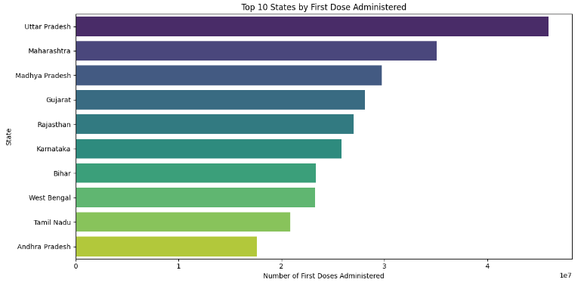
Figure 1 — Top 10 States by First Dose Administered (viridis palette)

7.2 Top 10 States — Second Dose Administered
A similar chart using the magma palette. Maharashtra leads second-dose completion (~12.1M), with West Bengal and Gujarat also ranking high. Notably, Uttar Pradesh (top in 1st doses) drops to 4th for 2nd doses.
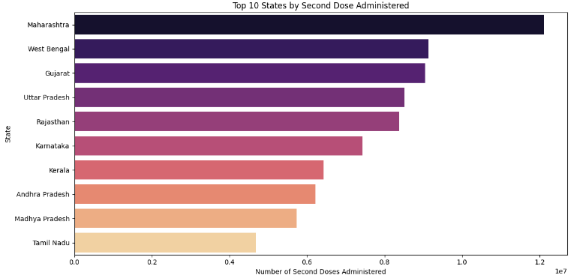
Figure 2 — Top 10 States by Second Dose Administered (magma palette)

7.3 Total Male vs. Female Vaccinations (National)
A simple two-bar chart comparing national male (~270M) and female (~239M) totals. The ~13 % gap highlights a consistent gender disparity across the vaccination drive.
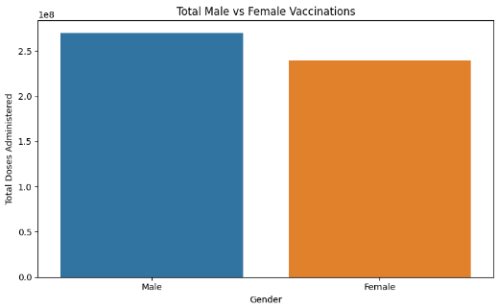
Figure 3 — National Male vs. Female Total Doses Administered

7.4 Top 10 States — Male vs. Female Vaccinations
A grouped bar chart for the top 10 states compares side-by-side male (blue) and female (brown) dose counts. Males consistently received more doses than females across all states, though the gap narrows in southern states like Tamil Nadu.
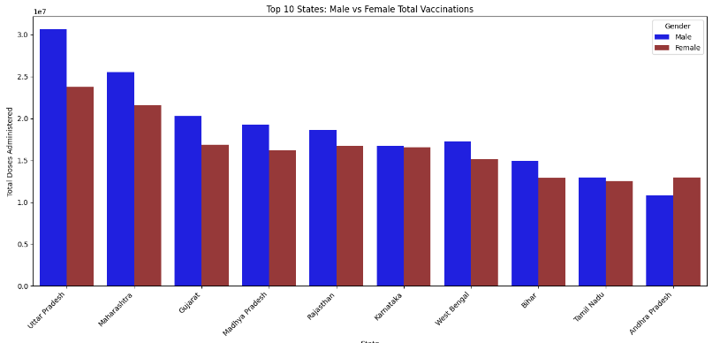
Figure 4 — Top 10 States: Male vs. Female Total Vaccinations

8. Results & Observations
First Dose Coverage
Uttar Pradesh, India's most populous state, administered the highest first doses (~45.9M). Large, populous states dominate. Smaller territories like Lakshadweep (~51K) and Ladakh (~188K) naturally record the fewest.
Second Dose Follow-through
Maharashtra leads second-dose administration (~12.1M). States with very high first-dose counts (e.g., UP: 45.9M first vs 8.5M second) show significant gaps, suggesting many individuals had not yet completed the two-dose regimen when data was collected.
Gender Disparity
Males received ~270M doses vs. ~239M for females — a ~13 % gap consistent across states. This likely reflects socio-economic and access factors. The combined 509M+ doses demonstrate the enormous scale of India's vaccination effort.
Missing Data Implications
Age-group and individual-level gender breakdowns have high missingness (>78 % for age groups, ~98 % for individual gender counts). Any analysis of these fields must account for potential bias introduced by collection gaps in the campaign's early phases.

9. Conclusion
This mini project demonstrates a complete data analysis pipeline — from raw CSV loading to insightful visualisations — on a real-world public-health dataset.
• India's vaccination drive achieved massive scale, with over 500M combined male and female doses recorded.
• Uttar Pradesh dominates first-dose distribution while Maharashtra leads second-dose completion.
• A consistent ~13 % gender gap (more males vaccinated) persists across states.
• High missingness in age and individual-count columns limits deeper demographic analysis.
• Preprocessing steps — removing the 'India' aggregate and stripping column whitespace — are critical for accurate state-level insights.

