A Project Report
On

Artificial Face Recognition Using Wavelet Transform &SVM

Submitted by

Pawar Manojkumar H.
(11IT18F)

in partial fulfillment for the award of the degree

of

MASTER OF TECHNOLOGY

in

INFORMATION TECHNOLOGY


DEPARTMENT OF INFORMATION TECHNOLOGY

National Institute Of Technology Karnataka, Surathkal

2012 – 2013

CERTIFICATE

This is to certify that the project entitled “Artificial Face Recognition Using Wavelet & SVM” is a bonafide work carried out under my guidance by Pawar Manojkumar Hanmantrao, M.Tech (Fulltime) student at the Department of Information Technology, National Institute of Technology Karnataka, Surathkal, during the year 2012-2013, in partial fulfillment of the requirements for the award of the degree of Master of Information Technology.

Signature of the Guide:

Place: Surathkal

Date:

DECLARATION

I hereby declare that the project entitled “Artificial Face Recognition Using Wavelet & SVM” submitted as part of the partial course requirements for the degree of M.Tech in Information Technology is my original work. The project has not formed the basis for the award of any degree, associateship, fellowship or any other similar titles elsewhere.

Signature of the Student:

Place: Surathkal

Date:

Abstract

This paper is presenting work performed on Face recognition on non-biological entries. As multiplayer games like second word, Avatar is an identity of each user. As many users invest their money in such gamming there are more chances of fraud over there. So this face recognition technique can be used to avoid such frauds. The same technique can be used for biological faces also.
In this paper, wavelet transform is used for retrieving characteristic from image and SVM is used for classifying data.

Table of Contents
List of Figures i
List of Tables ii
1. Introduction 1
2. Literature Survey 3
2.1 Architecture of the Face Recognition system 3
2.2 Wavelet Transform: 6
2.3 SVM 8
3. Implementation 10
3.1 Image Database 10
3.2 System 10
3.3 Results 11
4. Conclusion 14
5. Future work 15
References 16

List of Figures

Figure 1: Shopping mall & Dance club in Second Life 1
Figure 2: Architecture of Face Recognition System 4
Figure 3: Original signal and signal after 3 level wavelet transform 7
Figure 4: SVM optimal hyper plane 8
Figure 5: Avatar faces with different facial expressions 10

List of Tables

Table 1: Examples of methods for face recognition 5
Table 2: Results of face recognition 12

1. Introduction

A virtual world is an online community that takes the form of a computer-based simulated environment through which users can interact with one another and use and create objects. It derives itself from video games widely known as Massively Multiplayer Online Games (MMOG). The term has become largely synonymous with interactive 3D virtual environments, where the users take the form of avatars visible to others. These avatars usually appear as textual, two-dimensional, or three-dimensional representations. The virtual world is thus defined as a 2D or 3D environment simulating and emulating the aspects of real life. It offers an environment for business, trade and marketing and contains universities, shops, museums, beaches, etc. Examples of real-world games include Second Life[4], Active Worlds , Everquest , There [5], Sims Online [6].

Numerous incentives such as advertising, testing and selling of products and services at lesser costs have encouraged businesses to participate in these worlds. These factors have led to the emergence of an economy within the virtual world. Several virtual worlds have created their own currencies that can be exchanged for real money. Their constant growth and progress seem to offer more opportunities for our society in economic, cultural and social development that have been unexplored in the past.

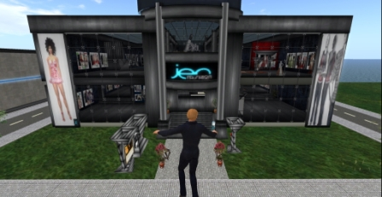

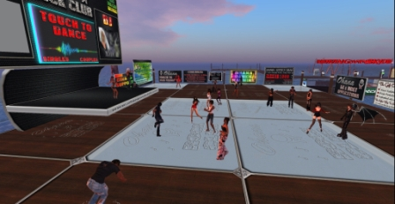

Figure 1: Shopping mall & Dance club in Second Life

However, these worlds have not escaped the real world criminal activities such as theft, fraud, gambling, money laundering, terrorism, etc. Virtual crimes have become such a critical issue that Second Life [9] displays an electronic bulletin board of crime for the police community. Financial interests of the real world are at stake as deviant acts committed by residents have “real” and disastrous consequences. When residents realize that their purchased virtual goods are either destroyed or stolen they undergo a “real” economic loss [1]. Biometric recognition technologies are the best tools to ensure maximum security in the real world. The evolution of crime has made virtual worlds even more vulnerable than the real world. Virtual crimes may cause real financial damages that will only worsen unless measures are taken to secure authentication and communication within these worlds. It is absolutely necessary to build a recognition system for “avatars”, virtual characters that are graphical representations of users, in virtual worlds. Not all avatars are human looking, and even with those that are humanoid there is a huge diversity of color. Originally, the word “avatar” comes from Sanskrit and literally means “descent,” however; it is commonly translated into English as “appearance”. The avatar is generally defined as "a physical image or graphic that allows the user to represent themselves in a virtual environment in real time" [1]. It allows a player to visually identify oneself to other players.

This paper demonstrates an approach towards applying the biometric tool of face recognition on non-biological entities (avatars) in virtual worlds to achieve authentication. The images representing the faces of the avatars were collected from the popular virtual world "Second Life” [4] and a biometric face recognition technique commonly applied to human beings was adopted.

2. Literature Survey

2.1 Architecture of the Face Recognition system

The architecture of a face recognition system is comprised of the following modules:

Preprocessing:
Preprocessing involves applying noise elimination techniques on images to compensate noise caused degradation.

Face detection:
This is an essential preliminary step to locate and extract the face from the acquired image. It depends on several factors such as variability of the scale, location, orientation, pose (front, profile), etc. Factors such as face occlusions and lighting conditions must also be taken into account and minimized to achieve reliable results.

Analysis or Characterization:
It involves the extraction and analysis of useful features towards building a face recognition model. Several methods such as PCA (Principal Component Analysis), Wavelet Transform, etc. are used to accomplish this task.

Identification or Verification:
This step deals with an image comparison between the acquired image and the database images to identify the feature similarities to recognize the individual. The purpose of this task is to verify the identity of the individual. Methods like SVM (Support Vector Machines), Neural Network are applied for classification. The enrollment phase and recognition phase are two essential phases to authenticate an individual’s biometrics. The enrollment phase is where the information related to the person to be identified is gathered and stored in the database. The recognition phase is a comparison of the image descriptors from the acquired and the enrolled images.

Decision making:
This is where the final decision is made. The performance of a recognition system can be measured primarily by two factors that represent the error rates in a decision-making system characterizing the performance of the biometric system [1]. The system can yield one of the following four decisions:
- The impostor is accepted (FAR: false acceptance rate): the probability that a biometric system identifies or authenticates an impostor by mistake.
- The impostor is rejected.
- The truth is accepted.
- The truth is rejected (FRR: false rejection rate) the probability that a biometric system fails during the identification or verification of a person enrolled.
Both factors FAR and FRR measure the accuracy of system identification. The comparison of the system performance is based on a rate called the Equal Error Rate (EER) where the values of FAR and FRR are equal. The FAR and FRR values are minimized for security systems.

Learning
External Interface
Pre-processing
Extract Parameters
Recognition System
Identification
Database
Read Image
Pre-processing
Extract Parameters
Testing

Figure 2: Architecture of Face Recognition System
Table 1 illustrates some of the face recognition methods while describing the advantages and disadvantages of each of them. We observe that PCA is a popular technique for efficiently representing facial images. The HMM (Hidden Markov Models) approach is not applicable for basic facial images which represent changes in facial expressions as some parts of the face and are relatively invariant in such situations. The last method presented in the table combines the wavelet transform for characterization and SVM for classification. It yields very good results and so it is used here.

Table 1: Examples of methods for face recognition
Methods | Advantages | Disadvantages
Principal Component Analysis (PCA) | Fast, simple and very popular  Smaller learning time | Unoptimized for  class separability  Very sensitive to  lighting or changes
Hidden Markov Model  (HMM) | Very simple  Noise avoidance by  the hair, glasses, etc.  Peculiarities of the face  taken into account | Lack of precision  Difficulty when  considering several  facial measures
Neural Networks | Considerable time  saving | Maybe unable to  resolve situations  already  encountered  in learning
Elastic Bunch Graph Matching  (EBGM) | Ease of adding new data  (new face)  Robustness  Insensitive to light and  pose variations | Many calculations  involved  Requested a larger  image
Support Vector Machine (SVM)- Wavelet | Good selection  SVM configuration  easy and inexpensive  Very successful and  well used especially in  face recognition. | Storage of  information  extracted  during learning

2.2 Wavelet Transform:
The wavelet transform can be compared to the Fourier transform. The great disadvantage of the Fourier transform is that it only has the frequency and not the time resolution. To overcome this problem several solutions have been developed that are more or less able to represent a concurrent signal in both the time and the frequency domain. The idea behind these time-frequency joint representations is to cut the signal into several parts and analyze them separately. It is clear that the analysis of a signal in this way provides more information on the timing and location of the frequencies of different components.
In wavelet analysis, the use of a fully scalable window solves the problem of cutting the signal. The window is moved along the signal, and the spectrum for each position is calculated. Then, this process is repeated several times with a window slightly shorter (or longer) for each new cycle. Ultimately, the result is a set of time-frequency representation
signals with different resolutions (multi resolution).
For many signals, the low-frequency content is the most important part. It is what gives the signal its identity. The high-frequency content, on the other hand, imparts flavor or nuance. Consider the human voice. If you remove the high-frequency components, the voice sounds different, but you can still tell what's being said. However, if you remove enough of the low-frequency components, you hear gibberish.
In wavelet analysis, we often speak of approximations and details. The approximations are the high-scale, low-frequency components of the signal. The details are the low-scale, high-frequency components. The detail coefficients cD are small and consist mainly of a high-frequency noise, while the approximation coefficients cA contain much less noise than does the original signal.
We can apply wavelet transform on multiple levels. In 3 level wavelet transformation, the approximation coefficient obtained after first level are again given as input to next level. So after applying 3 level transformation we get 3 sets of detail and 1 set of approximation.
Following fig shows original signal and signal after applying 3 level wavelet transform.
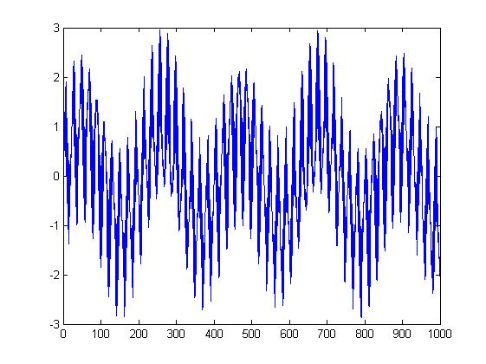
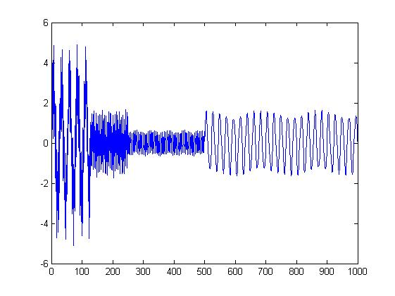

Figure 3: Original signal and signal after 3 level wavelet transform

2.3 SVM

Concept of optimal hyper plane and separators
A Support Vector Machine (SVM) is a set of supervised learning techniques to solve problems of discrimination and regression. SVMs are a generalization of linear classifiers, to which the hyper plane belongs. The goal of the SVM is to find a classifier for two classes of data, to separate copies of this data, and to maximize the distance between these two classes.
In order to have the properties of an SVM, it has to be an optimal hyper plane, which means the hyper plane needs to pass through the centre points of two classes of examples. The goal is now to find the maximum hyper plane that maximizes the distance to the training examples or margin.

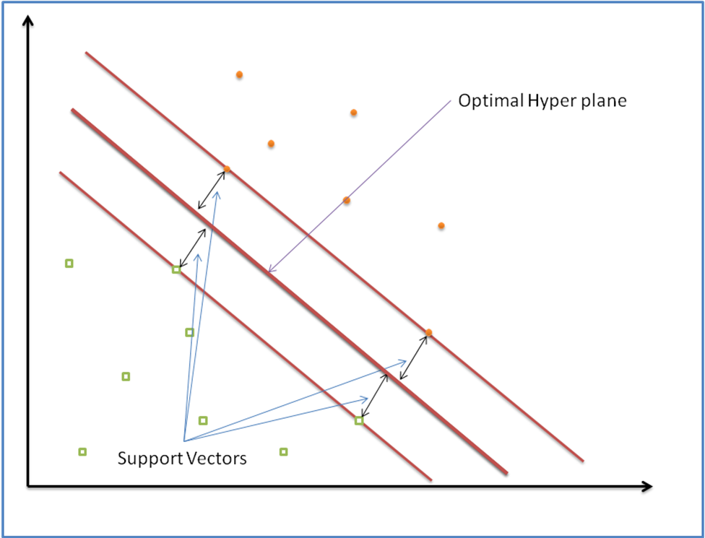

Figure 4: SVM optimal hyper plane

Linear, nonlinear and multi-class classification
There are two models of SVMs, one where the examples are linearly separable and one where they are non-linearly separable. The first case is simpler because it is easy to find a linear classifier. In this case it is possible to use the maximum margin classifiers. The margin between the positive and negative is defined by two hyper planes (w•x)+b=±1 . In addition, none of the points is lying between these hyper planes and has a margin width of z / ||w||.
The algorithm is trying to maximize the margin by minimizing ||w|| to achieve an optimal solution with a maximum spread. Data points on the separating hyper planes with maximum margin are called support vectors. There are ways to extend the SVM method to more than two classes. Among these approaches is a method of forming a classifier for each class that distinguishes examples of this class from examples of all other classes.
Another approach involves SVM for each pair of classes. It consists of using a classifier for each pair of categories. The classifier indexed by the pair (k, l) with (1 ≤ k<l≤Q) is intended to distinguish the category of index k of the index l. To assign one example, this therefore classifiers and the decision usually is obtained by performing a majority vote. The votes of each classifier may be weighted by a function of the output value. The number of classifiers needed in this approach is n (n-1) / 2, which is more complex than the first approach.

3. Implementation

3.1 Image Database

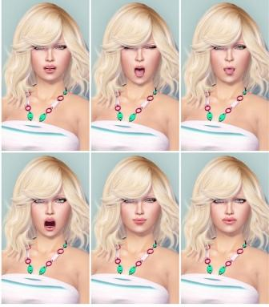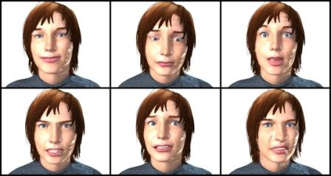

Figure 5: Avatar faces with different facial expressions

In the face recognition system image database is created to learn and analyze system performance. For this project the faces of Avatars are collected from various Online Multiplayer Game websites like Second life. In second life each user is provided with camera. So user can focus and capture appropriate image. Some data collected from websites which are enhancing look in second life . Parameters like brightness, color, facial expression are affecting results.
Almost all images were taken in frontal position with a homogeneous background. Initially the images were taken with screenshots containing a frontal pose of the avatar and the size was minimized by applying a mask that we minimized the background in order to minimize the noise in the image.

3.2 System

This current recognition system is designed in two phases Characterization & Classification. In characterization the required parameters are retrieved from image , for this purpose I used wavelet transform. After characterization this input is given to classifier, which recognize correct output . I used multi class SVM as classifier.

Characterization

Each image is read as three dimensional matrix. This matrix is converted into one dimensional matrix to apply wavelet transformation. The wavelet transform is a popular tool in image processing applications, such as compression, detection, and recognition. It represents good characteristics in the localization of the frequency space and multi-resolution. The main reason for its popularity lies in the flexibility of choice of bases and in the simplicity of calculation. We have improved our description of the face by extracting global features from the wavelet transform. The wavelet transform offers features that represent information about the texture of the image. Each image is considered as one approximation and three detail coefficient matrix. To reduce the number of wavelet coefficients, we will only consider the mean and standard deviation of approximation coefficients and the standard deviation of the three matrices of the detail coefficients.

Classification
SVMs have recently been used for a variety of object recognition techniques. In most cases, SVM generalization performance is significantly better than other techniques. During recent years, attempts have been made to apply SVM for classification of facial expressions. The results were among the best ever made, suggesting that SVM is actually a very appropriate approach for classifying facial expressions. For these reasons, we want to test the SVM classifier on our dataset. The extracted global information consists of characteristic vectors of SVM for recognition. SVM rearranges the points according to a mathematical function totransform them into a space that allows its classification. In this algorithm, we use the radial basis function (RBF). The system performance is estimated by measuring two error rates: False Acceptance Rate (FAR) and False Rejection Rate (FRR).

As I design this project in matlab , I used matlab's inbuilt functions to design SVM. While designing SVM, I provide training data set, output groups and test data. But as matlab is providing classifier based on two class only, so I applied recursively recognition technique which act like all against odd class.

3.3 Results
The performance of system is measured by calculating two factors FAR(False Acceptance Ratio) and FRR( False Rejection Ratio).

FRR(n) = | Number of rejected verification attempts for a qualified person n  Number of all verification attempts for a qualified person n

FAR(n) = | Number of successful independent fraud attempts against a person n  Number of all independent fraud attempts against a person n

Table 2: Experiment 1-Results of face recognition(Avatar Faces)
Avatar | FAR | FRR | R.rate
01 | 0 | 0 | 100
02 | 0 | 0 | 100
03 | 0 | 0 | 100
04 | 0 | 0 | 100
05 | 0 | 0 | 100
06 | 0 | 0 | 100
07 | 0 | 0 | 100
08 | 25 | 0 | 75
09 | 25 | 0 | 75
10 | 0 | 0 | 100
11 | 25 | 0 | 75
12 | 25 | 0 | 75
13 | 0 | 0 | 100
14 | 0 | 0 | 100
15 | 25 | 0 | 75
16 | 25 | 0 | 75
17 | 0 | 0 | 100
18 | 0 | 0 | 100
19 | 0 | 0 | 100
20 | 25 | 0 | 75
21 | 0 | 0 | 100
22 | 0 | 0 | 100
23 | 0 | 0 | 100
24 | 0 | 0 | 100
25 | 25 | 0 | 75

Results showing that Recognition rate for Avatar faces varies from 75% to 100%.
Table 3: Experiment 2- Results of face recognition (Human Faces)
Avatar | FAR | FRR | R.rate
01 | 0 | 0 | 100
02 | 0 | 0 | 100
03 | 0 | 0 | 100
04 | 0 | 0 | 100
05 | 0 | 0 | 100
06 | 0 | 0 | 100
07 | 0 | 0 | 100
08 | 0 | 0 | 100
09 | 0 | 0 | 100
10 | 0 | 0 | 100
11 | 25 | 0 | 100
12 | 0 | 0 | 75
13 | 0 | 0 | 100
14 | 0 | 0 | 100
15 | 0 | 0 | 100
16 | 25 | 0 | 75
17 | 0 | 0 | 100
18 | 0 | 0 | 100
19 | 0 | 0 | 100
20 | 0 | 0 | 100
21 | 0 | 0 | 100
22 | 0 | 0 | 100
23 | 0 | 0 | 100
24 | 0 | 0 | 100
25 | 25 | 0 | 75

Results showing that Recognition rate varies from 75% to 100%.
But the most of the results are accurate. So this algorithm is work better for human faces than avatar faces.

4. Conclusion

The work was presented in " Artificial Human Face Recognition via Daubechies Wavelet Transform and SVM" , and after implementing it, it shows that results are almost matching. The wavelet transformation along with SVM (Support Vector Machine ) gives better results. Skin color and intensity of light is doing much effect on performance. System performance can be improved by adding more images with different poses and lightning conditions.

5. Future work

As current project is running in sequential manner , it is possible to parallelize algorithm at following stages.
- Learning Phase
Each node can read image parallelly apply wavelet transformation and store characterized parameters in database, which will be used for training system.
- Recognition Phase
As current implementation of recognition, work serially on SVM network . It is possible to apply recognition part parallelly on different different group .
This parallelism will improve response time system.

References

- Manel Boukhris , Abdallah A. Mohamed, Darryl D’Souza, Marc Beck, " Artificial Human Face Recognition via Daubechies Wavelet Transform and SVM" presented at The 16th International Conference on Computer Games.

- Brendan Klare, Roman V. Yampolskiy, Anil K. Jain, " Face Recognition in the Virtual World: Recognizing Avatar Faces "

- MATLAB Workshop 2 "An introduction to Support Vector Machine implementations in MATLAB"

- Second Life : www.secondlife.com

- There : http://www.there.com/

- Sims : http://thesims.com/en_gb/home

- http://cswww.essex.ac.uk/mv/allfaces/index.html

- http://www.flickr.com/

