**Assignment**

*Use assets provided along with this assignment to complete it.*

1. Create layout as below and show any mouse rollover effect for both images.

1. Clicking each image will open a pop-up with Multiple Choice Question and 4 options overlay the images. Consider any one option as correct answer.

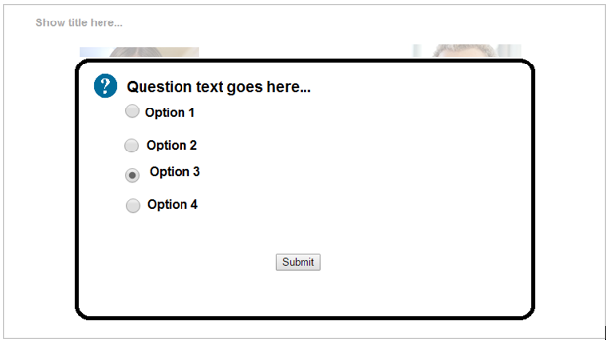

1. Select any option and press submit button. Clicking Submit button will close this question pop-up.
2. Show selected option text (‘Option 3’ in above image) and answer status (‘Correct’ or ‘Incorrect’) in a box below the image. Refer below screenshot.

1. Remove the click event from the image.
2. Implement same functionality (point 2 to point 5 above) for right-side image as well.
3. Once both questions are answered, show a ‘Thank-You’ message in the bottom.

1. Remove the click event from the second image as well.