## Capstone: Architectural Design

Information Systems Development and Design and Capstone Course (IS-5303)

Poonam Pawar

1429329

Trine University

Apr 26, 2019

Serve on Door (SOD) e-commerce website is a three-tier architecture system. The three layers are as below:

1. **Presentation layer/Client layer**: The presentation/client layer will be responsible for the user interface or the website. The websites/user interface/web portals are hosted over the internet. All the web calls will reach the system via the AWS VPC and ROUTE 53 services. All the services are hosted on port 443 (https services) using REST API transport.
2. **Application layer**: This layer is responsible to integrate the front end to the backend of the system. The integration layer is built on Java Servlet and Java Server Pages (JSP). The servers are Apache Tomcat Servers. All the user interface pages are developed in the AWS developer tool.
3. **Database layer**: This is the backend of the system where all the user information, advertisement details, legal documents, logs, transaction details, and service request details are available. We are using MYSQL database as the backend, and all the data are encrypted.

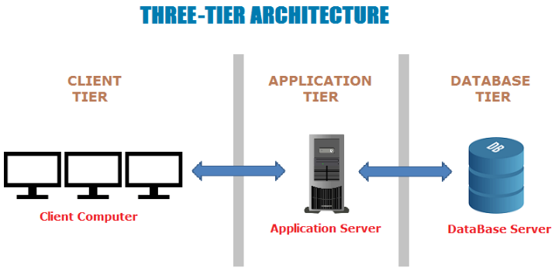

All the elements of the architecture design are on the cloud and do not need manual intervention in case of failover or upgrade. The cost of the upgrade or maintenance is very less as there are no infrastructure requirements. The data is also secure and safe due to versioning and encryption in AWS. The scalability and portability of the system are very high this is because of a three-tier architecture and cloud application. This keeps the architecture of the system simple and provides fewer issues.

The architecture of the product will have thin client technology. There is no physical server, desktop, network, database, or hardware which was required to develop the e-commerce website. With AWS service all the applications and tools are available on the cloud for use. This all architecture points make the system very robust. The future of the company is very prominent due to easy maintenance and scalability.

**Reference**

1. Rajkumar. (2017). Software Testing Material. Software Architecture: One-Tier, Two-Tier, Three Tier, N Tier. Retrieved on 26 May, 2019 from <https://www.softwaretestingmaterial.com/software-architecture/>