## Capstone: Final Deliverable

Information Systems Development and Design and Capstone Course (IS-5303)

Poonam Pawar

1429329

Trine University

April 26, 2019

Table of Contents

1 System Request 3

1.1 Project Sponsor 3

1.2 Business Need – Why is this request being made? 3

1.3 Business Requirements – What is specifically needed for this system? 3

1.4 Business Value – How will this benefit the business? 3

1.5 Special Issues or Concerns 4

2 Company Overview 4

2.1 Company History 4

2.2 Existing Problems – How does it effect the business? 5

2.3 Proposed Solution – How will it improve the business? 5

3 Feasibility Analysis 6

3.1 Description of Project 6

3.2 Operational Feasibility 6

3.3 Economic Feasibility 6

3.4 Technical Feasibility 7

3.5 Schedule Feasibility 7

4 Gantt Chart 7

5 Requirements Definition Statement 8

5.1 Output Requirements 8

5.2 Input Requirements 8

5.3 Process Requirements 9

5.4 Performance Requirements 9

5.5 Control Requirements 9

6 Data Flow Diagram 10

6.1 Context Diagram 10

6.2 Diagram 0 10

7 Use Cases 11

7.1 Registration 11

7.2 Login 11

7.3 Advertisement 12

7.4 Service Request 12

7.5 Payment Process 13

8 Acquisition Strategy 13

8.1 Alternatives Matrix 13

8.2 Technical Criteria 14

8.2.1 System Upgrade 14

8.2.2 Improvement in Security and Performance 14

8.3 Economic Criteria 14

8.3.1 Cost of the Project 14

8.3.2 Maintenance Cost 14

8.4 Organizational Criteria 14

8.4.1 User Training 14

8.4.2 Brand Expansion 14

9 Prototypes / Mockups 15

10 Hardware and Software Specification 24

11 Entity Relationships Diagram 24

12 Architectural Design 24

13 Non-functional Requirements 25

14 Implementation Plan 26

14.1 Documentation Plan 26

14.2 Testing Plan 27

14.3 System Changeover Plan 28

14.4 Training Plan 28

14.5 Support/Maintenance Plan 29

15 References 30

# System Request

## Project Sponsor

Name(s): Poonam Pawar. CEO, Serve on Door Pvt. LTD

Title(s): Serve on Door Pvt. LTD

## Business Need – Why is this request being made?

Serve on Door (SOD) is a Warsaw-based, family-owned business intended to provide all nearby families a commonplace to request for various services. SOD will provide better business opportunity to many local vendors and service providers. Currently, the SOD will target all towns within Kosciusko County, where the maximum population is resident to the place, and own their own houses. Most of the residents need facilities like house cleaning, carpet cleaning, lawn maintenance, ice cleaning, and delivery services on a regular basis. SOD can provide all the services to the customers at a reasonable price as the service providers and consumers are geographically very close. Apart from the mentioned services, SOD will also provide near-by airport transportation service.

SOD is an initiative which is made to boost the local economy by binding all the vendors and customers in the same business platform. With the inception of SOD, vendors can advertise their services in www.serveondoor.com to lure more customers. The customers can check various local vendors to select the most appropriate, quick, and reasonable service providers for their use. SOD will earn the profit from both vendors and customer based on the type of the service and pre-defined profit rate percentage.

Below are the main reasons why a business like Serve On Door is required:

* It is family owned and trusted.
* It will boost the local economy many folds.
* It is cost-effective and quick for the customer and vendors.
* Special people like elders, physically-challenged, or busy personals can benefit from SOD, as they can get easy and quick service by few clicks on [www.serveondoor.com](http://www.serveondoor.com).

## Business Requirements – What is specifically needed for this system?

Business requirements for www.serveondoor.com include below:

* Domain for hosting www.serveondoor.com website and company.
* A simple process for vendor registration, service request form, and advertisement.
* Web service development and Amazon account to manage the services.
* All local vendors to advertise their services in www.serveondoor.com.
* A communication channel between the consumer and the service provider.
* Service tracking and billing service mechanism.
* Services to receive feedback from the vendors and the consumers.

## Business Value – How will this benefit the business?

SOD will provide the common platform for all local customers and vendors. The main business value of SOD is transparency. SOD will operate within a small geographical region, therefore the services are bound to have better quality and cost-effective. The project will be evaluated based on the number of services made by the customers. SOD will earn the profit based on the services provided by the vendors to the customers. If the project for Kosciusko County is successful, the project can be implemented in more areas and services. The vision of SOD over the next year is to create a mobile application for easy and secure processes.

## Special Issues or Concerns

The main constraint with SOD implementation is the advertisement. The company has to lure local vendors and sellers to opt for online services instead of their traditional ways. Special strategies have to be made to advertise SOD on social platforms like Facebook, YouTube, and local papers. Additionally, the company should make decisions for the long-term as the decision to make investments in the IT system are costly and can break the business if not implemented perfectly.

# Company Overview

## Company History



|  |  |
| --- | --- |
| Company name | Serve on Door Pvt. LTD |
| Type of business structure | E-commerce business. |
| Established on | 15 Dec, 2018 |
| Website | [www.serveondoor.com](http://www.serveondoor.com/) |
| Ownership/management team | Poonam Pawar (CEO) |
| Location | Warsaw, Indiana |
| Company history | Serve on Door (SOD) is a Warsaw-based e-commerce company established in Dec' 2018. Warsaw's weekend farmer's market was the inspiration behind the inception of SOD. There are many small and local vendors whose business is limited to fewer customers. SOD will give all the vendors/ sellers/ service providers a common platform to expand their business. |
| Products/services and target market | At the initial phase of SOD, the company will accept few requests from end-users, which includes airport transportation, grocery request, lawn maintenance, ice cleaning, and other household services. For a vendor/ seller, SOD will provide an option to advertise their service directly in www.serveondoor.com.SOD will target to lure all vendors and customers, from Warsaw and nearby Kosciusko county towns. |
| Objectives | SOD wants to boost the local economy by giving all the nearby businesses/ sellers/ vendors an online platform to reach to the maximum number of potential customers. SOD will also strategize the advertisement plan to increase the profits with the help of social media. |
| Mission statement | To develop and deliver an e-commerce organization that provides all local business and an opportunity to join us in boosting the local economy by bringing the services to the door of the customers with ease. |
| Vision statement | To bring all the nearby business close to the consumers so that we can reach our common goal of providing quick and effective services. |

## Existing Problems – How does it effect the business?

SOD is a Warsaw-based, family-owned business intended to provide all nearby families a commonplace to request for various services. There are many local vendors, sellers, drivers, mechanics, plumbers, carpenters, janitors, and other service providers, who operate within their familiar network. There are a few main limitations or problems with the existing local business structure:

* Most of the local business never gets a chance to reach to their maximum potential customer.
* Many vendors/ sellers don't have a place to sell/provide their services/goods.
* Vendors need to work hard to reach to their customers.
* Customers have limited options for service providers.
* The local economy is restricted and does not generate the ideal monetary value, employment, and customer satisfaction.

SOD will be very effective to mitigate all these problems and bring new opportunities for the local business to grow and flourish quickly. SOD will also help in increasing the employment and economic status for the working class population. The business is not limited to provide services to vendors and customers. The main idea behind SOD is to bring the local community closer where the service provider and the user can have easy and quick communication.

## Proposed Solution – How will it improve the business?

SOD is intended to bring all the local business to the door of the customer. The e-commerce website will give the common platform from where the customers can check, compare, and select the most appropriate service provider for their requirements. SOD will also give the local business a common platform to reach out to the maximum customer. The business is estimated to bring a 30% rise in the local business sales, plus at least 15% profit to the company for every service request. SOD will also get additional profit by advertisement requested by local vendors and companies to list them in the website. The current scope of the SOD will provide below services:

* Airport and bus station transport facility.
* Provide on-demand services for house cleaning, carpet cleaning, lawn maintenance, ice cleaning, and other household services.
* Grocery delivery services from the nearby store to home.

SOD will help in improving the business and user-experience because:

* SOD will simplify the user-experience as none of the users has to physically go to the vendor, rather www.serveondoor.com will be there shopping place.
* SOD can help vendors reach out to especially challenged customers, like elder people, physically challenged persons, or even customers from busy-working class.
* The service will be cost effective and quick as the customers and vendors are geographically close to each other.
* Local business and service providers can reach to the customers easily.
* Customers will have more options to choose from.
* Scope for growing the business is limitless.

# Feasibility Analysis

## Description of Project

Serve on Door is the first e-commerce company in Kosciusko County which will provide a common online platform for all the local vendors and sellers to advertise and sell their products. The e-commerce site will also help all the customers to see different options of the service provider and request for the services as required. The current scope of the project is limited to services including airport transportation, various house repairs, lawn maintenance, and online grocery shopping.

## Operational Feasibility

The SOD is a family owned and family operated organization. All the operations in the e-commerce business will be handled by my family. The services are directly provided by the local vendors/ sellers. There is a direct interaction between the consumer and the seller which makes it a self-organized in nature.

SOD will be responsible for providing an easy platform for sellers to sell their service, and users to request for their service. The project will be managed by the SOD team, where all the assets are cloud-based and needs no physical interactions to fix or upgrade the service. AWS also provides 24x7 supports to all the customers for any issues with the e-commerce website. In case of any issues with the service, the users can directly connect with the vendors or sellers.

## Economic Feasibility

The project implementation and maintenance is very cost-effective and economically feasible. The duration of the project implementation is 16 weeks, which is enough to deploy it over the cloud.

The cost of the product implementation is very low, as all the AWS services are paid based on the usage with no contracts. In case the traffic to the website is low, SOD will pay less, and it cost can go up or down based on the traffic on the site. Although the SOD e-commerce site is new, there is no cost required for physical entities like the warehouse, working stations, inventories, or network appliances. All configurations are available on AWS with pay-per-use basis. The estimated cost can be calculated from https://calculator.s3.amazonaws.com/index.html service.

## Technical Feasibility

The project is highly feasible technically. The pre-requirements for the development of the e-commerce website are very minimal. The scope of the project is limited which adds more benefits to the technical feasibility.

The e-commerce website will need a domain name and website www.serveondoor.com which is currently available to purchase. The entire development will be done on AWS DevOps service. With using AWS as the platform, there is no overhead of physical hardware, software, or network infrastructure. The services will be developed in the cloud and will be maintained online.

## Schedule Feasibility

The project is given 16 weeks of time, which is highly feasible to achieve. The architecture and the cloud-based platform reduce the time to gather infrastructure, servers, database, and services to a minimum. The development will require less time as there are many templates we can use. We have strategized the project to be time-effective. The team has already thought about the architecture and a prototype for the project. The e-commerce domain and the website can be purchased immediately from goDaddy.com. And we already have the AWS account set up and ready for use. All these reasons guarantee the schedule feasibility of the project to 100 percent.

# Gantt Chart

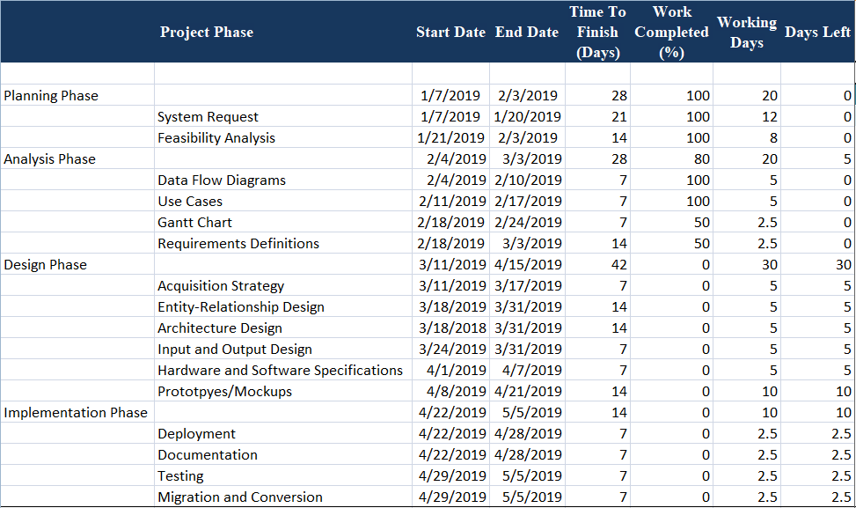

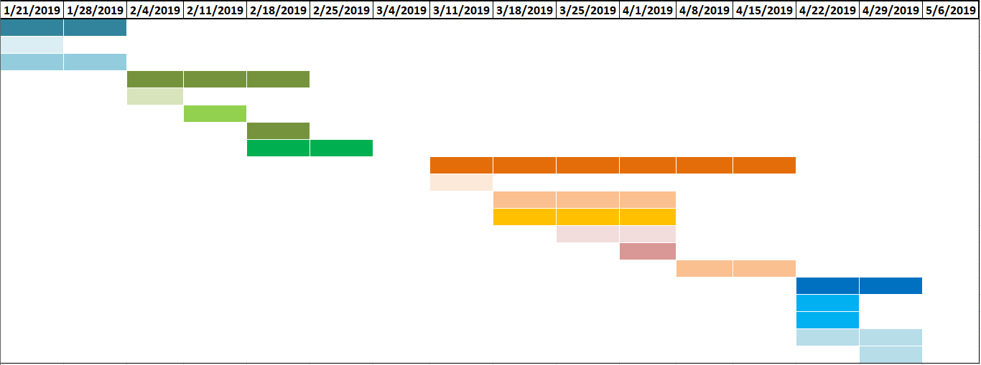

# Requirements Definition Statement

Serve on Door (SOD) is an e-commerce company intended to provide various services. The below document will list down all the requirements based on the five project areas including output, input, process, performance, and control.

## Output Requirements

* The website must provide vendors with registration and login capabilities.
* With a valid vendor login, the website should give options to submit an advertisement for review.
* The website must provide vendors the capability to update the advertisement.
* The website must provide customers with proper payment gateway options.
* The e-commerce site must present various options to the potential customers to make their choice of services and vendors.
* The website must have dynamic web pages. All the web pages must be integrated with each other.
* The website must be properly designed for the simple user interface.
* The website should be able to send notifications to the users or vendors about their service request, queries, or payment.
* The system must provide customers with updated rates, and available services.

## Input Requirements

* The system must provide vendors with an advertisement template and form, which should be submitted for review.
* All the service request must have a standard application form.
* Every information in the system must be stored in a database, which will be maintained by the system administrators.
* Each advertisement request must be stored in the backend database.
* All service request details must be stored in the backend database.
* All invoices must be stored in a backend database.
* All registration request must be validated for duplicity.

## Process Requirements

* Business contract between a vendor and SOD system is pre-determined.
* All logins will be validated against the database records of the registration details.
* All service request must be directly sent to the selected vendors. The system will keep a track of the service request from the backend.
* The payment must be done directly to the payment gateway, from where Serve on Door will pay the vendors and keep the profits.
* For any concern and coordination, the customer and vendors will directly interact.
* All communications will be done via email between vendors and customers.
* All the service request details, vendor details, advertisement details will be verified and handled by the system administrators.

## Performance Requirements

* Serve on Door must be available via internet with no downtime seven days a week, 365 days a year.
* The system must support any number of concurrent users.
* All processes are synchronous in nature.
* The user details, service request details, advertisement details, and other transactional details must be stored in the backend with 99.99% availability.
* Serve on Door e-commerce website must be hosted in North-America AWS region with at least 2 backend servers.
* There must be no impact to the customer when the system is upgraded or maintained.

## Control Requirements

* The system must save all the audit logs about user logins, service requests, payments transactions, invoices, and advertisements.
* All transactions must have audit trails.
* Server On Door's system administrator will be the part of all email communication between customer and vendors.
* The system must generate error details which will include error type, severity, error description, and time stamp.

# Data Flow Diagram

## Context Diagram

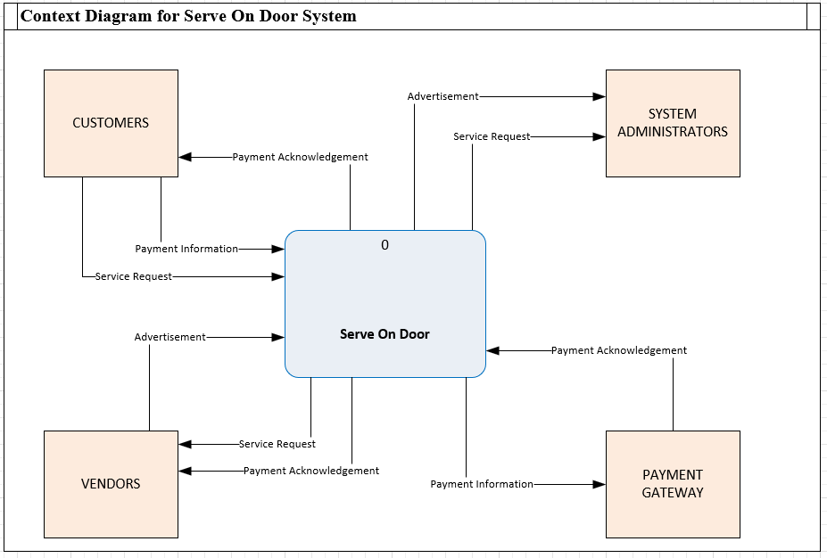

## Diagram 0

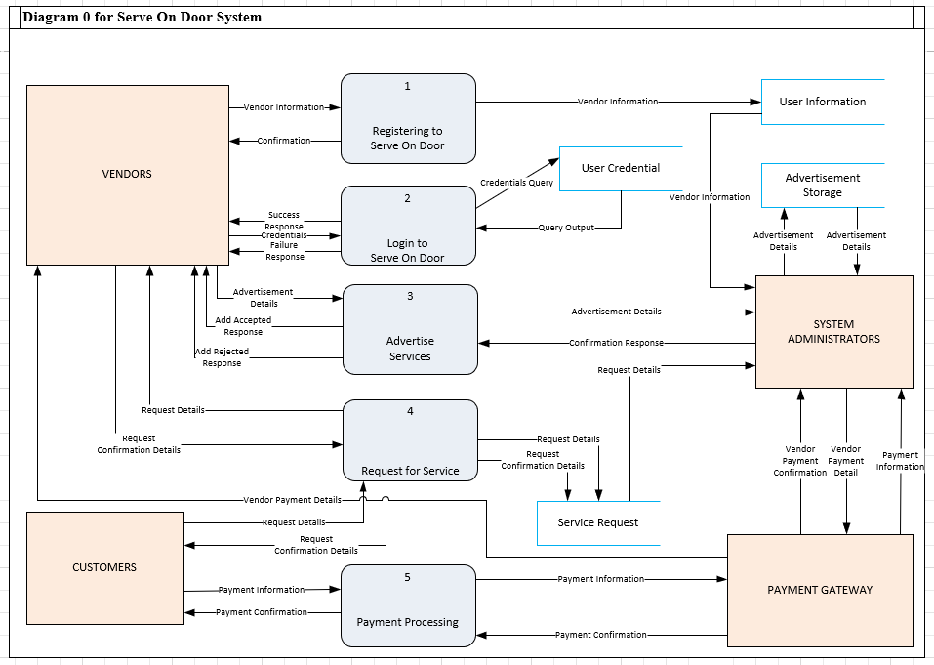

# Use Cases

## Registration

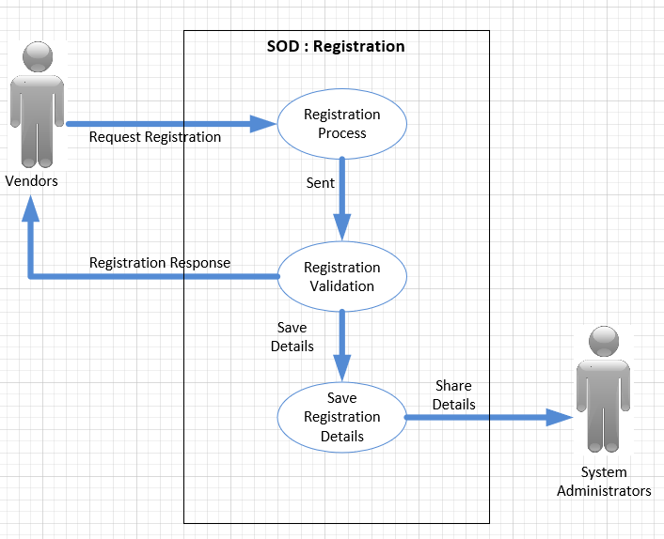

## Login

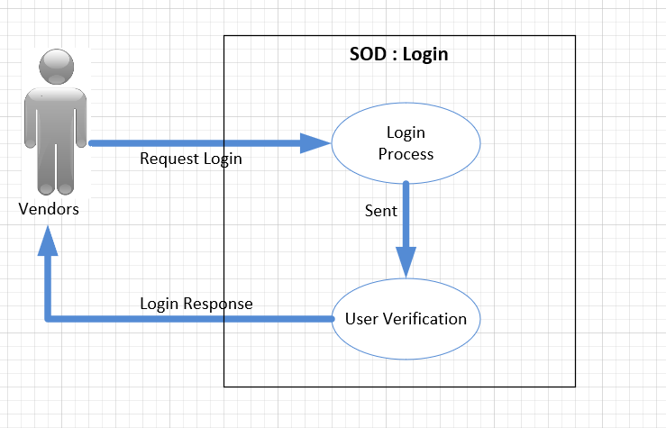

## Advertisement

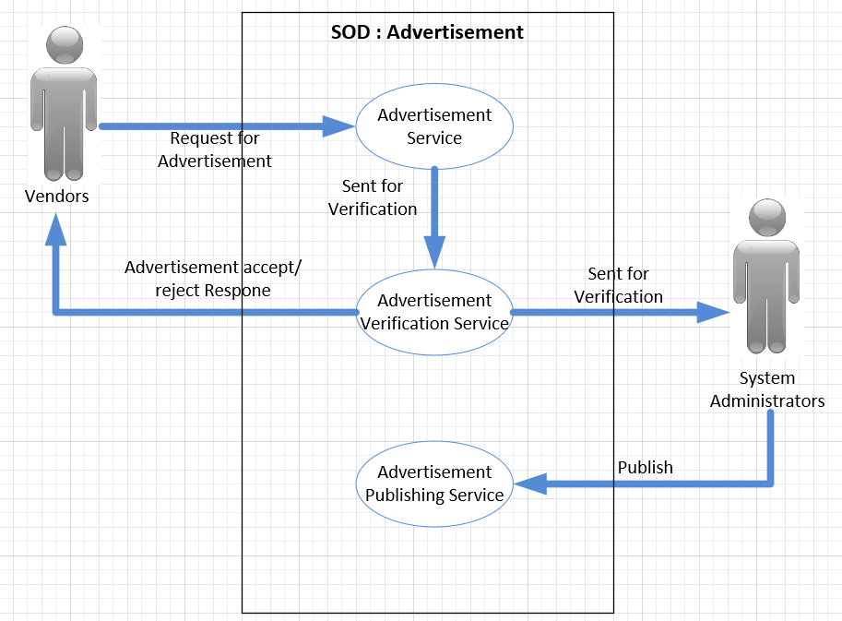

## Service Request

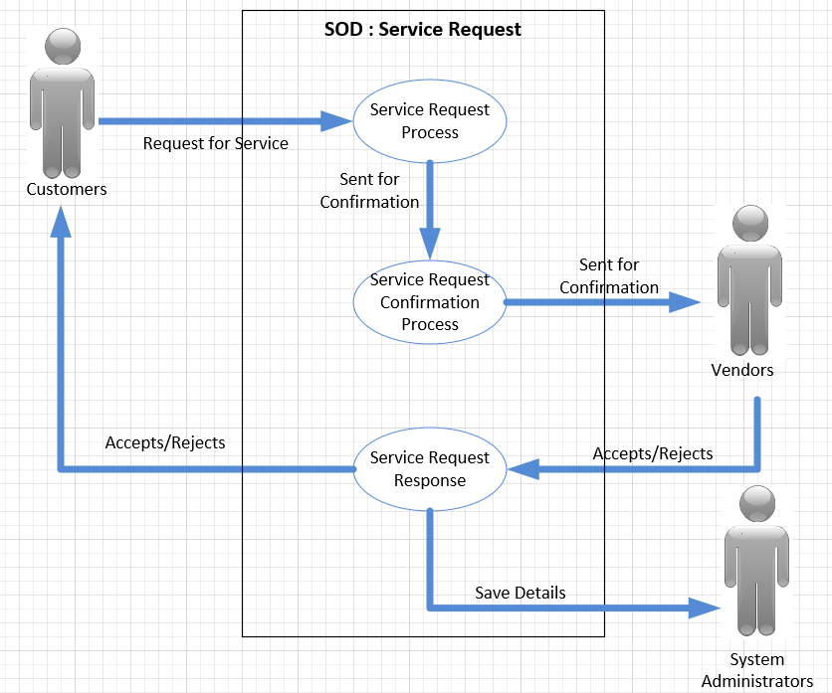

## Payment Process

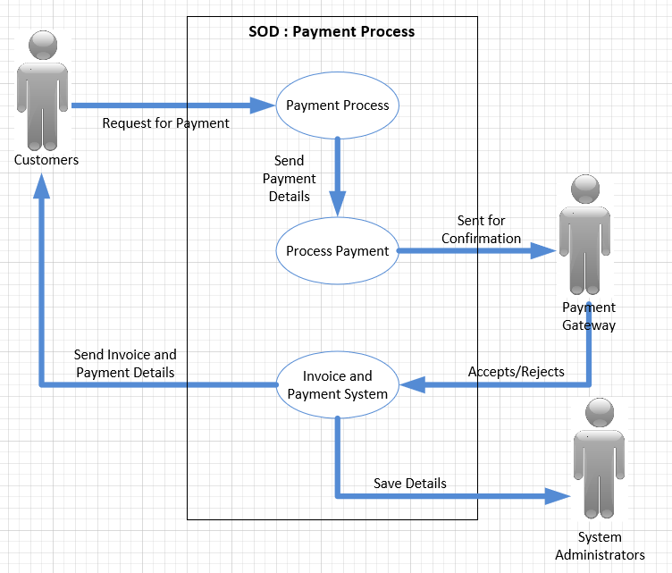

# Acquisition Strategy

## Alternatives Matrix

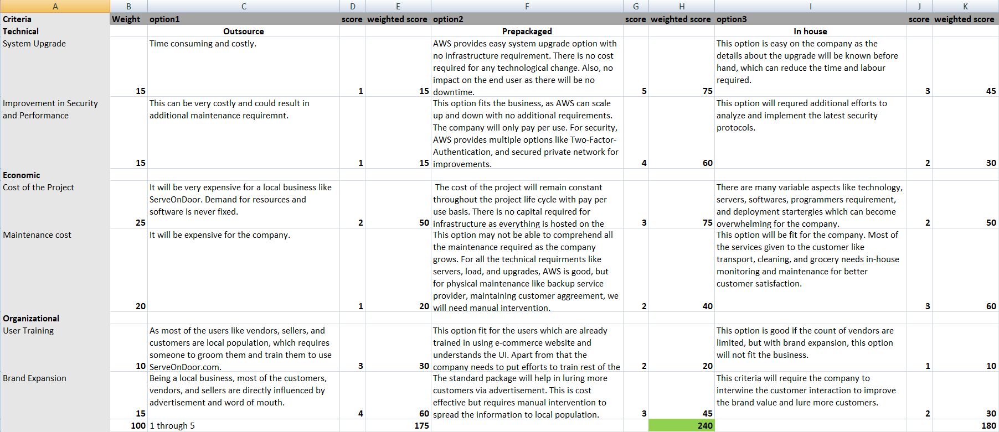

## Technical Criteria

### System Upgrade

System upgrade has many aspects like infrastructure, hardware, software, and servers. We have opted for a *prepackaged* option. All the various aspects come in the package with AWS which make it easy for Serve on Door to upgrade. Also, there is no overhead of cost, the company has to pay per use. There is no impact on the end user as there will be no downtime.

### Improvement in Security and Performance

System improvements in security in performance is essential for any company. The knowledge about system usage and possible security threats can be vast and often unknown. We have opted for a prepackaged option. With the pre-packaged AWS application, performance and security are well handled. As a company, with the pre-packaged option, there is less cost involved.

## Economic Criteria

### Cost of the Project

We have opted for *prepackaged* option as the cost is pay per use. There is no agreement for AWS service usage and the development effort is quick, which reduces the project cost. Along with that, AWS services can scale up or down automatically. The cost of the project will remain constant throughout the project life cycle with pay per use basis. There is no capital required for infrastructure as everything is hosted on the cloud.

### Maintenance Cost

We opted for the *in-house* option. This option will be fit for the company. Most of the services given to the customer like transport, cleaning, and grocery needs in-house monitoring and maintenance for better customer satisfaction.

## Organizational Criteria

### User Training

A maximum number of the users of Serve on Door will be common people who may not be groomed to use e-commerce site. User training will become an essential part of the success of the business. We have opted for *outsourcing* the user training, so that company's representative can meet with the vendors and explain them the system UI and usage.

### Brand Expansion

We have opted for *Outsouring* option. As most of the users like vendors, sellers, and customers are the local population, we have opted for outsourcing to increase the brand value of Serve On Door company. Being a local business, most of the customers, vendors, and sellers are directly influenced by advertisement and word of mouth. The inception of the company is limited to Kosciusko county, where the company is trying to lure vendors by meeting them and requesting them to join the venture. As the brand value increases, we will need more people to connect with local businesses and bring them to Serve On Door.

We have chosen **Pre-packaged** option as acquisition strategy, because :

* Easy system upgrade. No infrastructure required.
* Cost is low. Globally accessible.
* Pay per ruse with no contractual limitations.

# Prototypes / Mockups

**Home Page**

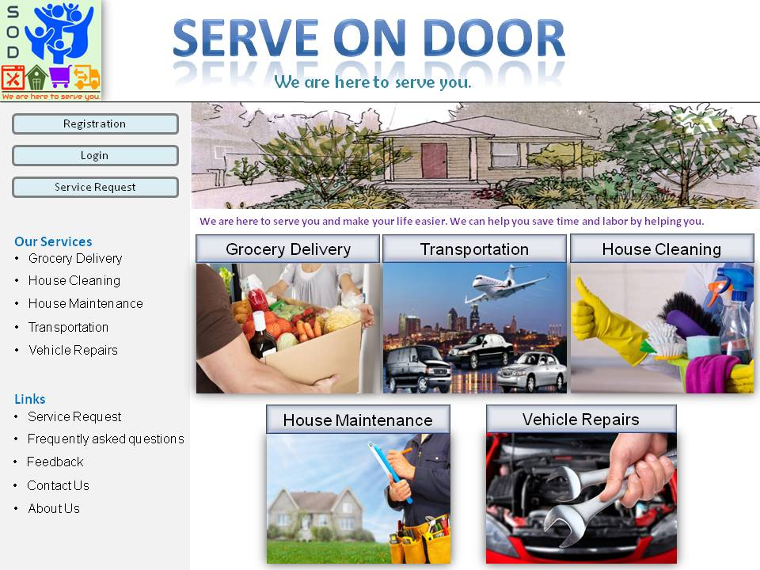

**Vendor Registration**

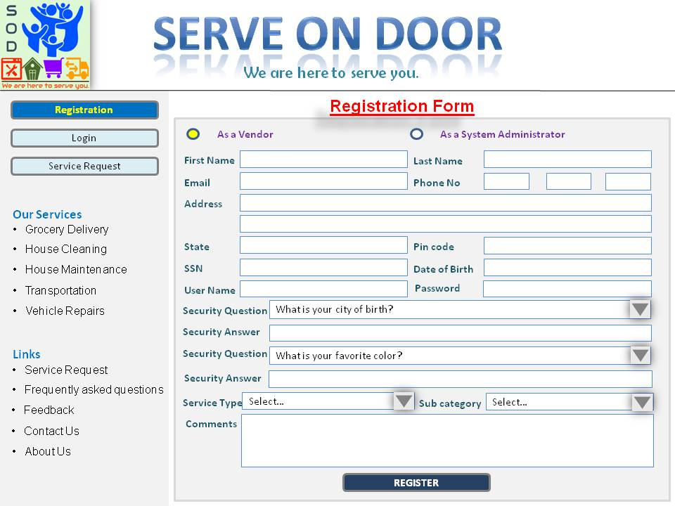

**System Administration**

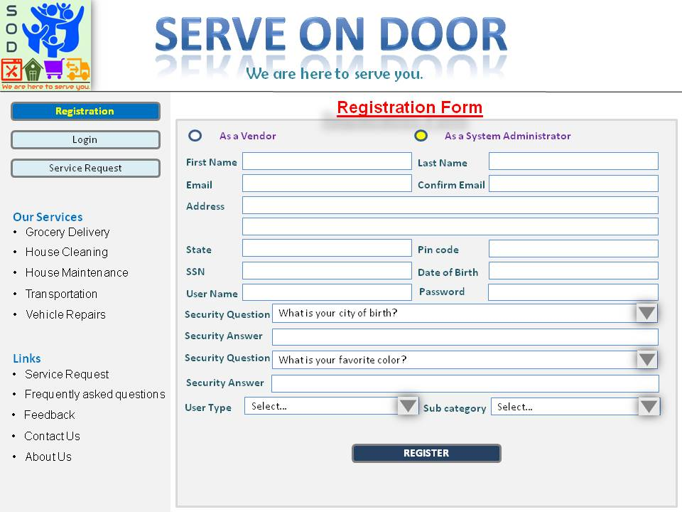

**Login Page**

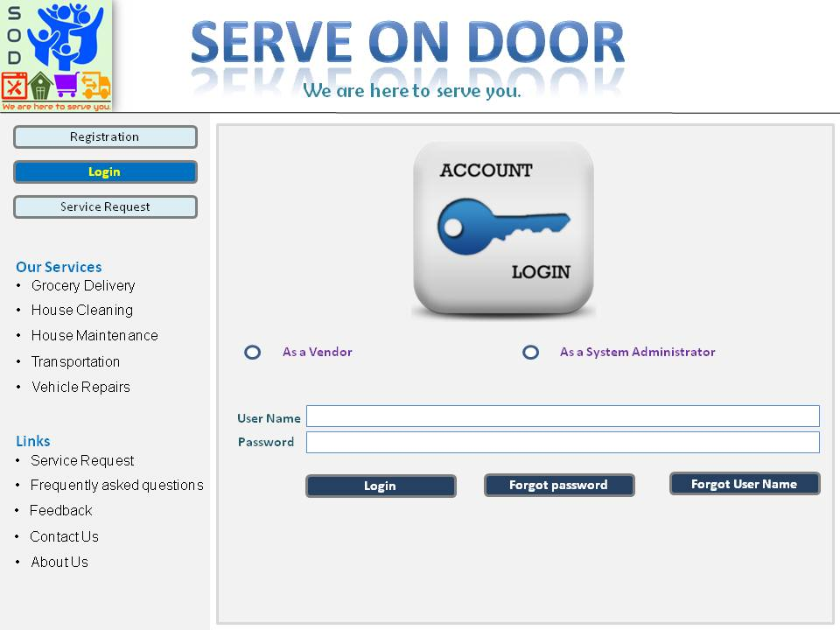

**Forgot Password**

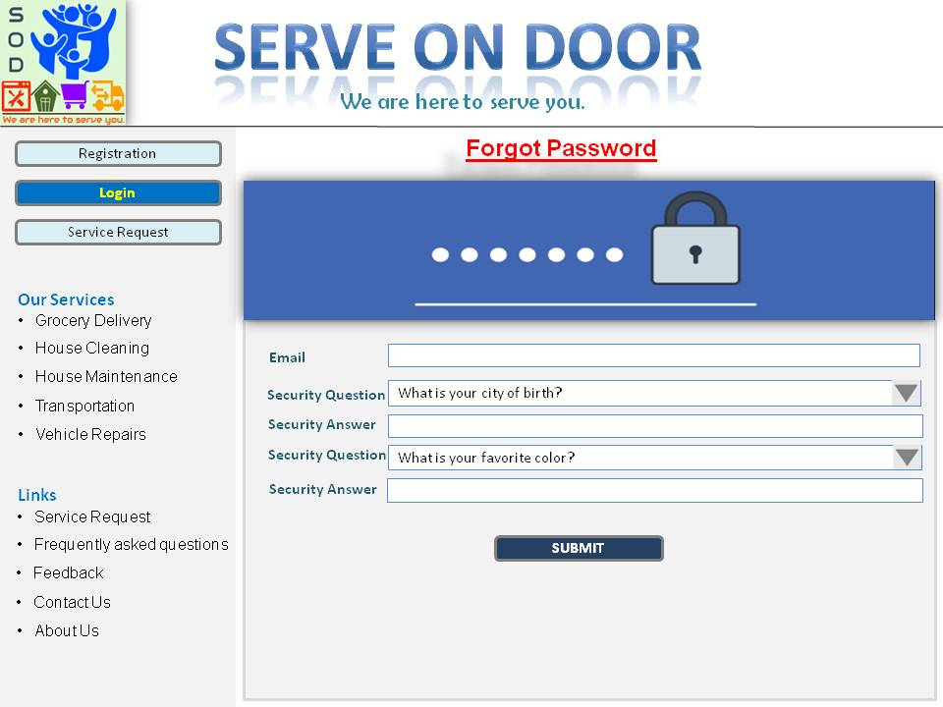

**Forgot Username**

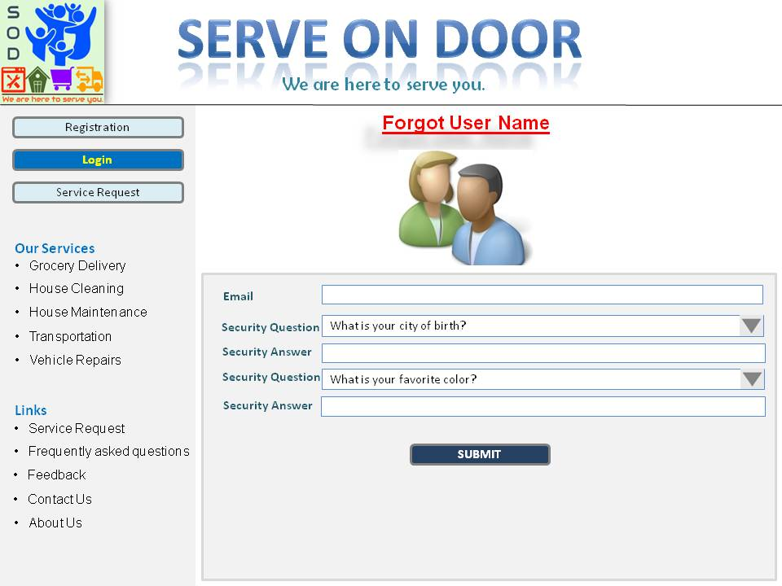

**You are Logged in as a Vendor**



**You are Logged in as a System Administration**

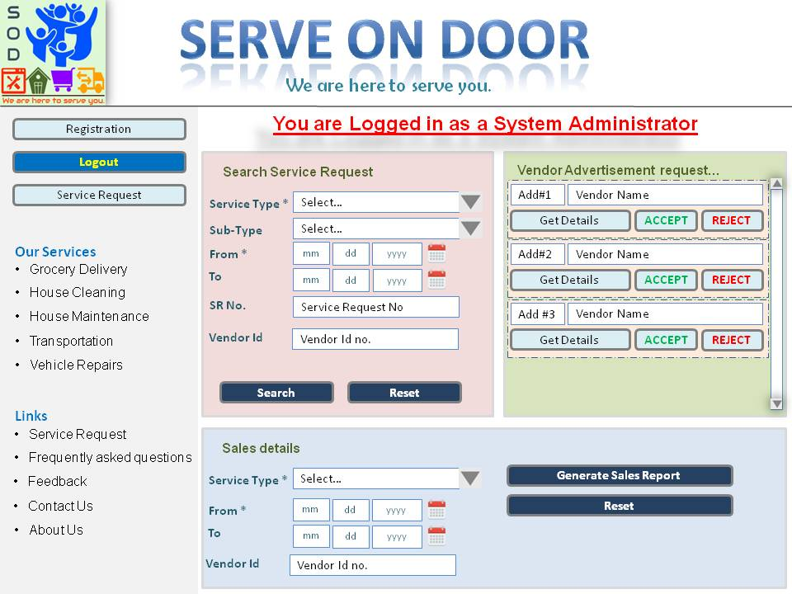

**Grocery Delivery Service**

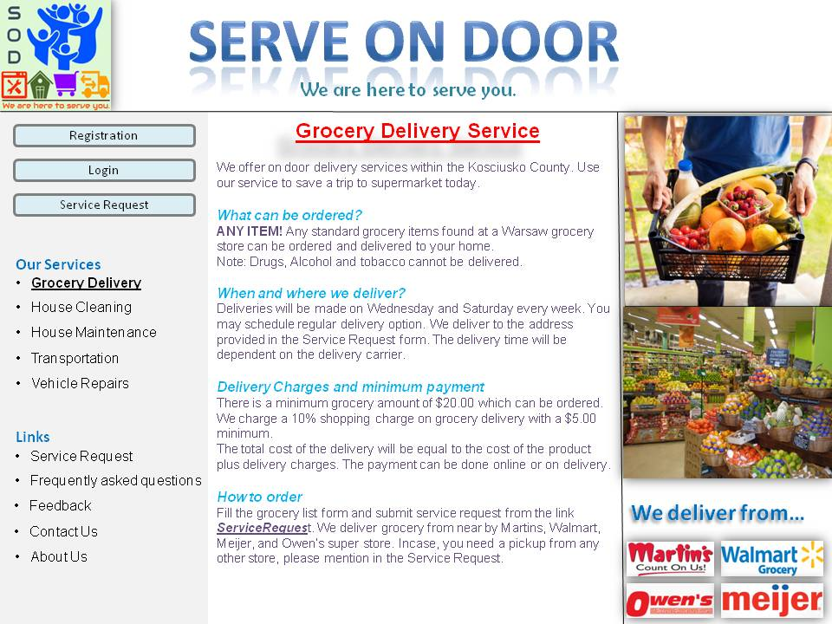

**House Cleaning Services**

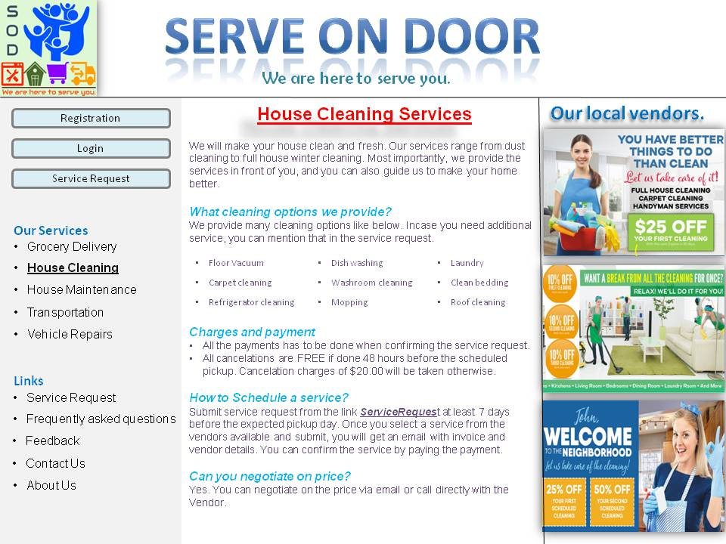

**House Maintenance Services**

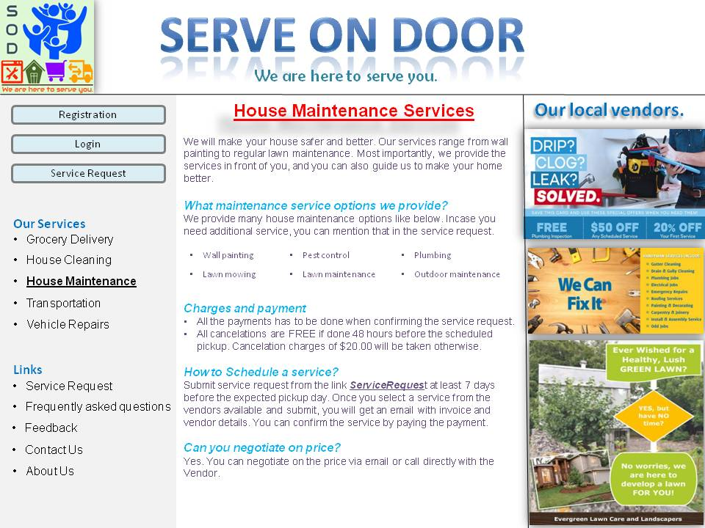

**Transport Service**

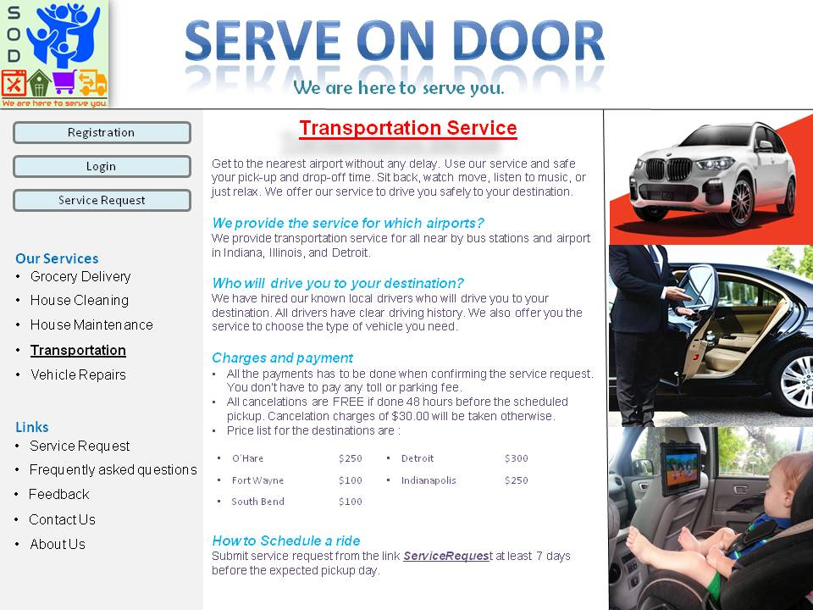

**Vehicle Repair Service**

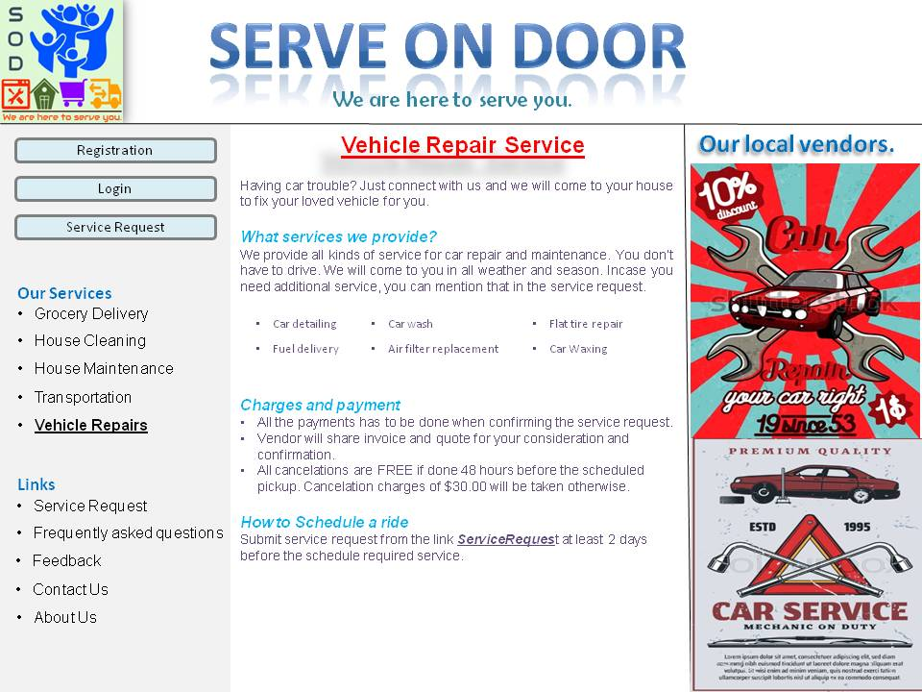

**Service Request Form**

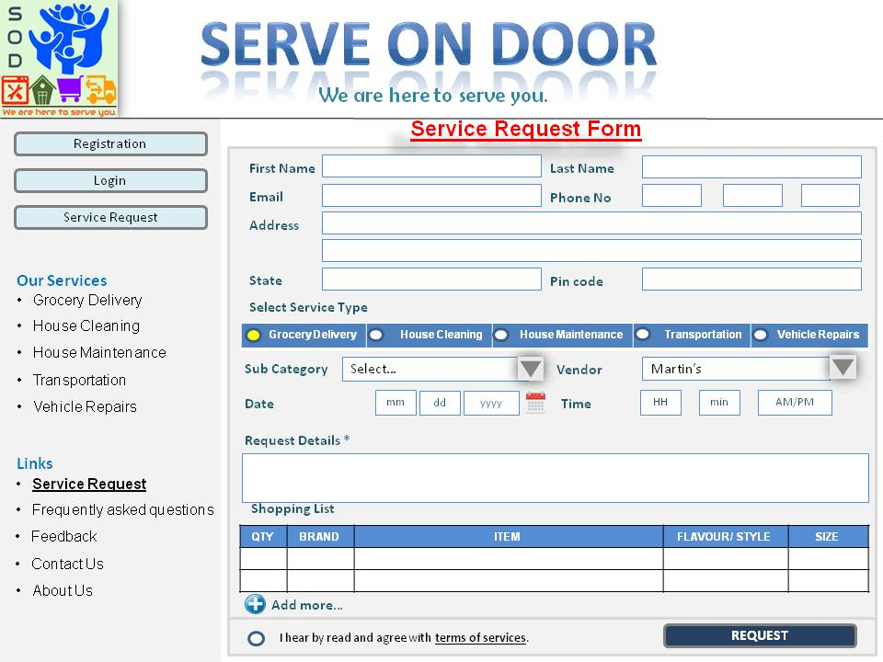

**Frequently Asked Questions**

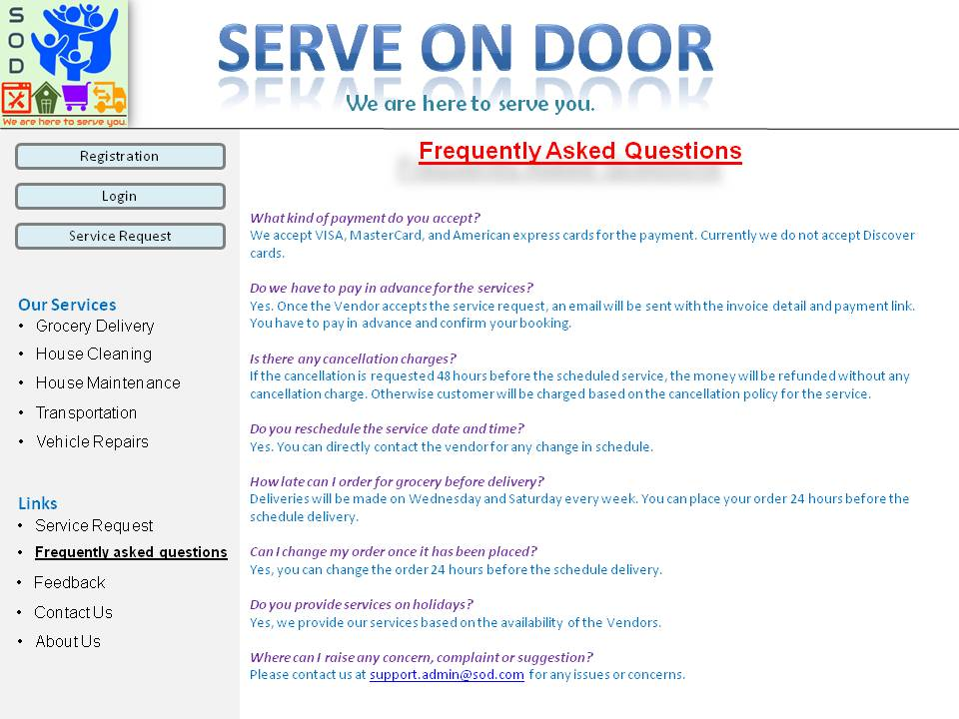

**Feedback Form**

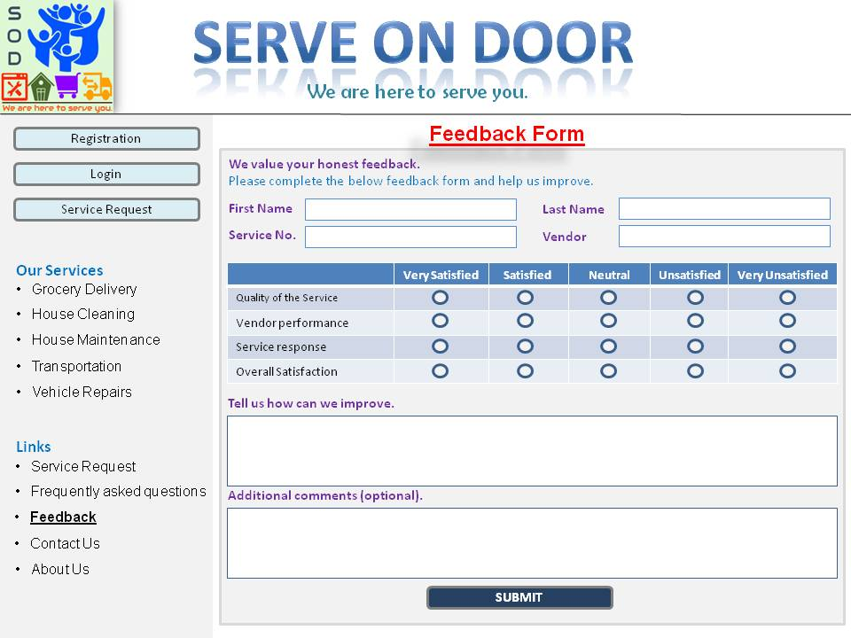

**Contact Us**

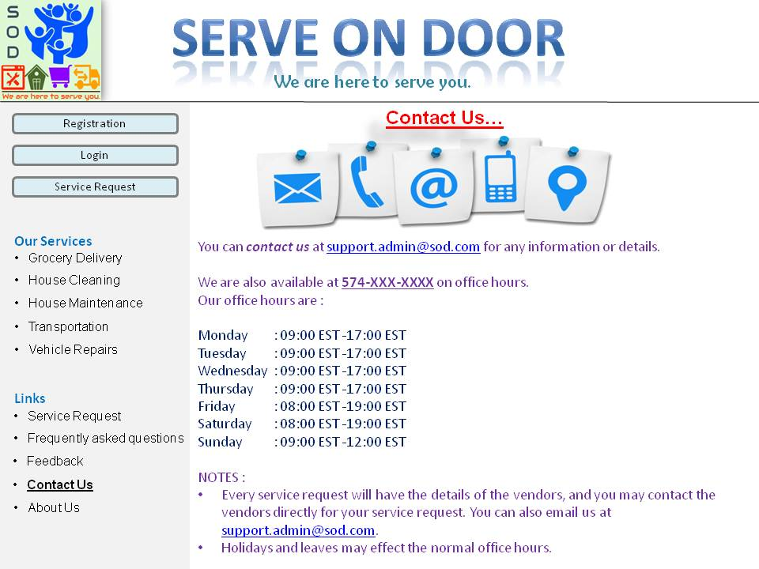

**About Us**

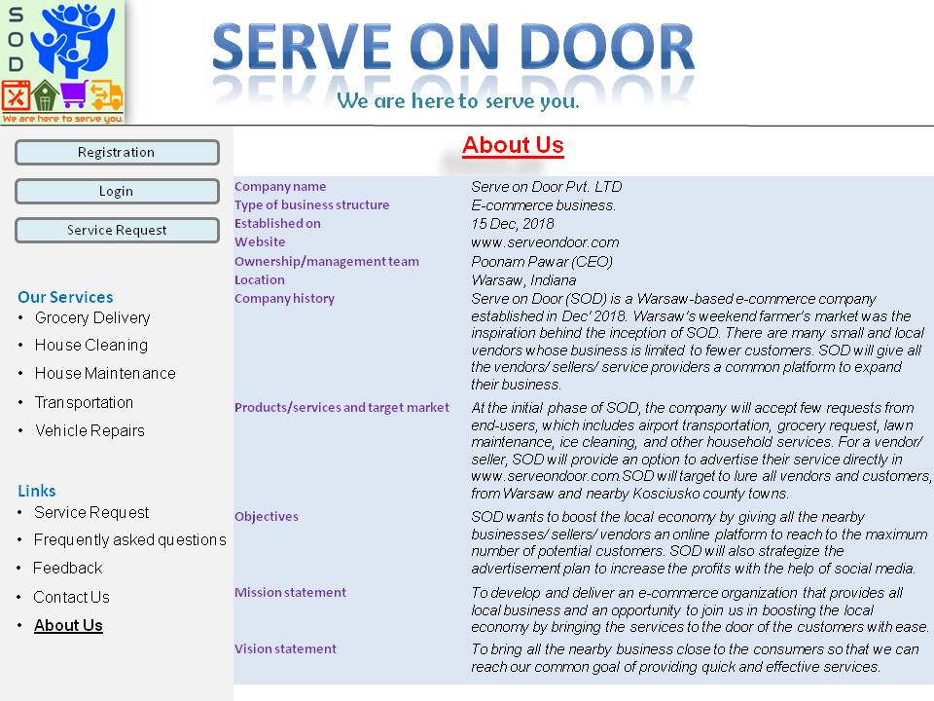

# Hardware and Software Specification

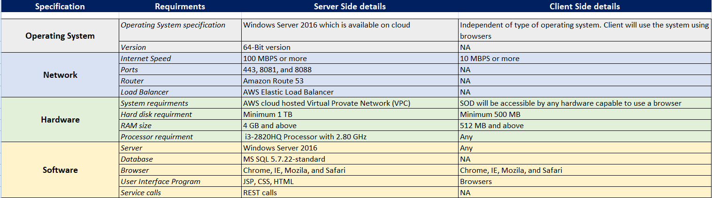

# Entity Relationships Diagram

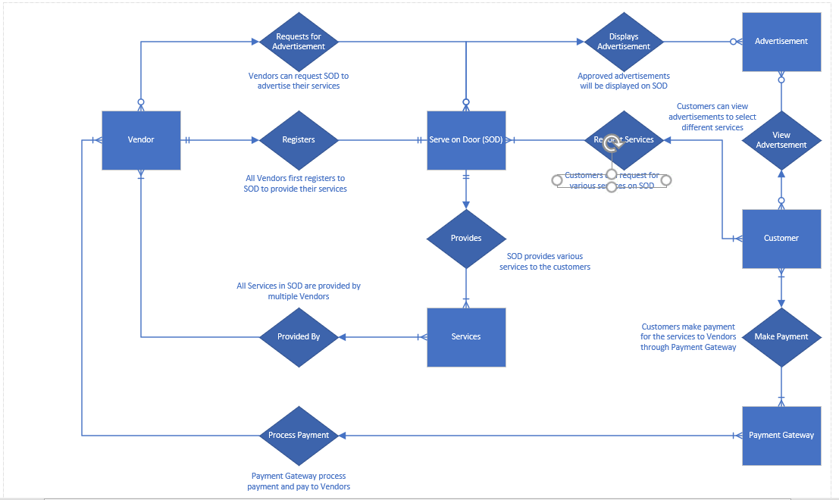

# Architectural Design

Serve on Door (SOD) e-commerce website is a three-tier architecture system. The three layers are as below:

* **Presentation layer/Client layer:** The presentation/client layer will be responsible for the user interface or the website. The websites/user interface/web portals are hosted over the internet. All the web calls will reach the system via the AWS VPC and ROUTE 53 services. All the services are hosted on port 443 (https services) using REST API transport.
* **Application layer:** This layer is responsible to integrate the front end to the backend of the system. The integration layer is built on Java Servlet and Java Server Pages (JSP). The servers are Apache Tomcat Servers. All the user interface pages are developed in the AWS developer tool.
* **Database layer:** This is the backend of the system where all the user information, advertisement details, legal documents, logs, transaction details, and service request details are available. We are using MYSQL database as the backend, and all the data are encrypted.

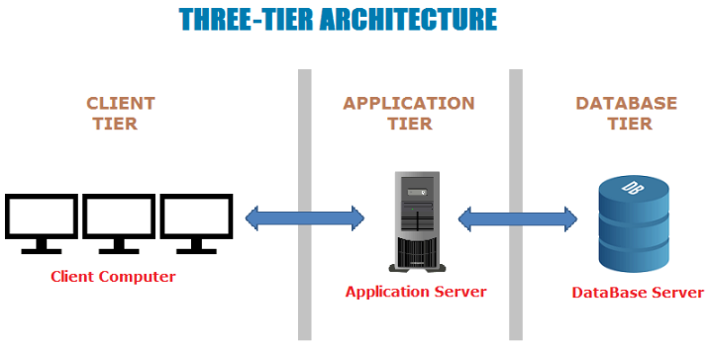

All the elements of the architecture design are on the cloud and do not need manual intervention in case of failover or upgrade. The cost of the upgrade or maintenance is very less as there are no infrastructure requirements. The data is also secure and safe due to versioning and encryption in AWS. The scalability and portability of the system are very high this is because of a three-tier architecture and cloud application. This keeps the architecture of the system simple and provides fewer issues.

The architecture of the product will have thin client technology. There is no physical server, desktop, network, database, or hardware which was required to develop the e-commerce website. With AWS service all the applications and tools are available on the cloud for use. This all architecture points make the system very robust. The future of the company is very prominent due to easy maintenance and scalability.

# Non-functional Requirements

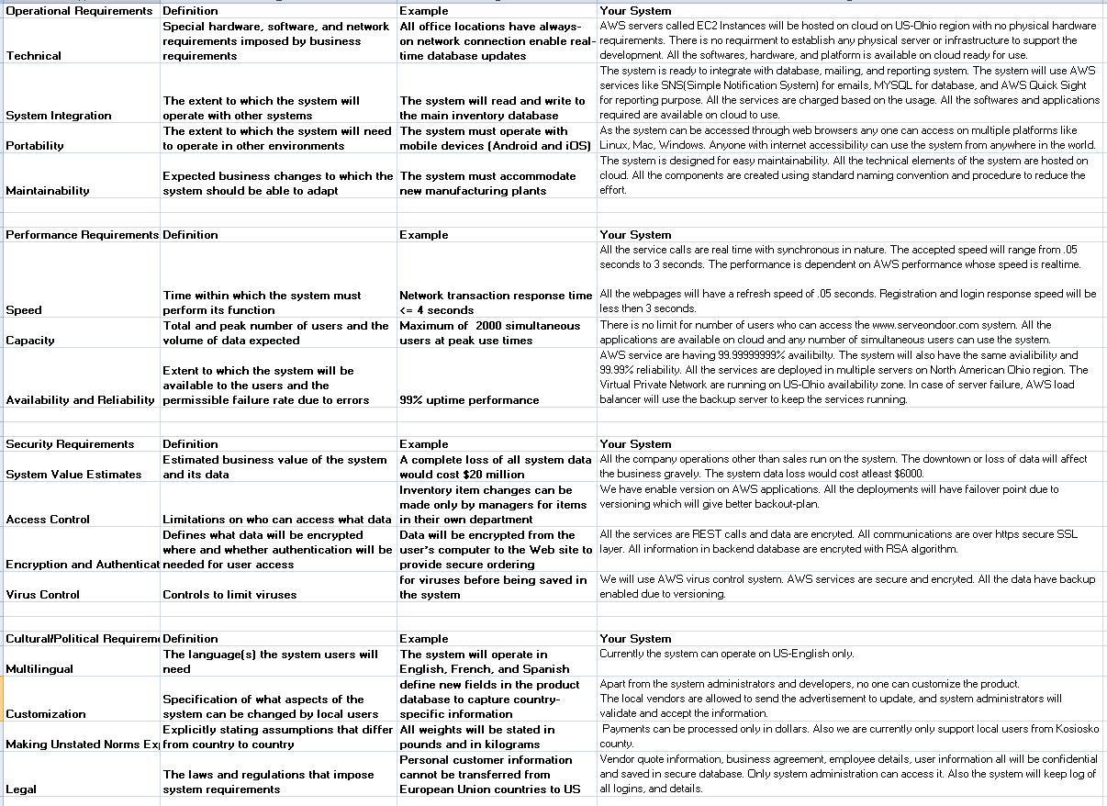

# Implementation Plan

## Documentation Plan

Serve on Door, as an e-commerce company is totally dependent on market analysis and documentation. The documentation plan will include technical and functional documents. Every aspect of the project will go through the documentation and review process. The authors of the documents will be different based on the type of documents. All the documents will be version as major, minor, and revision. For instance, the initial version of the high-level design document will be named 'HighLevelDesign_v1_0_0.docx, which signifies that it’s the first major version with no minor changes and no revision changes. Below are a few of the mandatory documents that will be part of the project life cycle.

|  |  |  |  |
| --- | --- | --- | --- |
| **Document Name** | **Type** | **Authors** | **Description** |
| System Requirements Specification | Functional | Project Management | Detailed business requirement document. |
| Functional Requirements/ Use case | Functional | Project Management | Use case document listing all the functional details. |
| Risk Analysis | Functional | Project Management | Risk analysis document defining the RACI matrix |
| Cost Estimation | Functional | Project Management | Document defining resource and infrastructure requirement to determine the estimated project cost. |
| High level design | Functional | Architect | High level graphical document representing all actors and actions. |
| Infrastructure checklist | Technical | Architect | Document representing all the infrastructure required for project implementation. |
| Low Level Detailed design | Technical | Developers | Detailed technical design document, representing all the aspects of project implementation. |
| Technical Business flow | Technical | Developers | Document representing how the technical components will interact with each other. |
| Test Cases Checklist | Technical | Developers | List of pre-defined test cases. |
| Performance Reports | Technical | Developers | Weekly or monthly report for performance analysis. |
| Sales Reports | Technical | Project Management | Weekly or monthly report for sales analysis. |
| Vendor Business Agreement | Functional | Project Management | Individual business agreement between Serve on Door and the vendors. |

Apart from the above, there will be some additional documents which will be created and maintained by the team.

|  |  |  |  |
| --- | --- | --- | --- |
| **Document Name** | **Type** | **Authors** | **Description** |
| Resource allocation | Functional | Project Management | Resource allocation document. |
| Vendor portfolios | Functional | Project Management | Individual vendor profiles with advertisement, services, and access details. |
| User Manuals | Functional | Developers | Detailed document for users (vendors, customers, or sellers) |
| Support and Maintenance | Technical | Developers | Business agreement document for entire company to provide best possible support to the end users. |

## Testing Plan

This document will provide an overview of the testing functions and details that will take place in various phases of the project life cycle for Server on Door. The aim of the testing plan is to provide the most viable and effective system for all the users of the e-commerce system. The test plan will be created for various levels of the project as below:

|  |  |
| --- | --- |
| Testing Module | Details |
| Unit Testing | All the developers will be responsible for unit testing. In this testing phase, individual interfaces will be tested for their operations. This can be done independently. This testing will extend to system testing once all the individual interfaces are tested. |
| Integration Testing | Once the prototype or the original project is deployed in development environment, all the teams will work together to perform the integration testing to test functional use cases. |
| Performance Testing | Load testing will be performed by replicating the real-world customer base and bombard the system to test its performance and responses. |
| Negative Testing | This set of test plan will be embedded in all the testing phases to determine all possible failure points and the remedies needed to resolve them. This testing will create list of bugs and enhancements for the betterment of the product. |
| User Acceptance Testing | This is the official user acceptance or production assurance testing, where the system will be tested by proxy users to test the product functionality in real world. |
| Migration Testing | This test plan will include a set of test cases which has to be performed every time the company thinks to migrate the product, such as in case of major upgrade, disaster, or backup. |

Based on the type of the test plan, the deliverables of the test plan changes. A large chunk of the project timeline will be devoted to test plan and testing so that we can deliver the best possible product to the end user.

## System Changeover Plan

System changeover plan document focuses on the impact on the business if the current system is moved to a new platform. Typically, a system changeover plan will include the analysis and details about system compatibility, infrastructure requirements, and cost.

Serve on Door is built using Amazon Web Services (AWS) applications, which is hosted on the cloud. All the interfaces and services will be released in batches to the users. The cloud infrastructure is the most optimal and economically effective solution for the business. But in case we have to make a changeover plan, we will do the below:

* Re-analyses all the functional requirements and business use cases to determine the impact on the current project.
* Determine the phases and release scope for system changeover.
* Define the dependencies and expected cost for upgrades and maintenance.
* To maintain business continuity, the best possible approach has to be taken to make the necessary changes.

We have opted for the Pilot method for system changeover plan. Traditionally, the pilot method is low in cost, with medium risk and lengthy changeover duration. But since all the applications in the project are cloud-based we can reduce the time required for infrastructure change, network update, or even software changes. All the required elements are available to use at our leisure.

## Training Plan

For successful project implementation, training plan play a vital role. For Serve on Door Company, most of the users are not technically educated to use the system. The company has to conduct training and knowledge transfer sessions to all probably local vendors and sellers to showcase the use and usage of the e-commerce website. The training plan is defined based on the participants as below:

1. **Training plan for new developers/ system architects/designers:** Serve on Door is built using AWS services which are cloud-based. All the AWS application's training material is available online globally, and anyone interested in that can use it.
2. **Training vendors/ sellers about Serve on Door website:** The project management team will send the company's representatives to the local business and express the idea behind the e-commerce website. The presentation or interaction will include the impact, benefits, and user interfaces details so that the end users can comprehend the system easily.
3. **Training for real-world users/customers:** There will be no formal training for real world users. But the website will have easy forms and web pages designed for the effective user interface.

**Modes of Training:** All the formal trainings will have standard documents explaining the details about the subject in hand. Apart from that project management team will have presentations, videos, conferences, meetings, and WebEx to accommodate the maximum number of audiences. All the training material will be documented and kept in storage for future use.

The future scope of training plan will be to include various online training that every vendor can take at their leisure to know more about the topics.

## Support/Maintenance Plan

Serve on Door is a family owned and family managed e-commerce business. The idea behind the business was to provide the local business an opportunity to lure more customers directly to them, but using a common website. The business will share the support with the vendors and sellers who can directly interact with the users. All service requests will contain direct contact details of the sellers or vendors that a user can directly use. The company will also provide email support to its users. The maintenance and support plan are as follows:

1. **Technical Issues:** For all technical reasons related to the e-commerce website will be managed by the project management team and developers. For instance, if the user interface needs to update, or it is not reachable, the vendors will directly email the Serve on Door team with the error and the team will act upon it.
2. **Upgrades/ downtime**: In case of upgrades and maintenance, the development team will coordinate the changes and other details directly with the vendors and on the website. The system will also populate notifications on the website in case of upgrades or downtimes.
3. **User queries:** For all the user queries about any service, the users can directly contact the vendors or sellers using their contact details that will be present in the service request acknowledgment form.

Apart from the above, all the advertisement details, service request details, user details, customer queries, historical data, payment details, and feedback will be maintained in a backend database, which will act as the source of truth to support any kind of issue.

# References

* Rajkumar. (2017). Software Testing Material. Software Architecture: One-Tier, Two-Tier, Three Tier, N Tier. Retrieved on 26 May, 2019 from <https://www.softwaretestingmaterial.com/software-architecture/>
* Chizum, E. (2010). My Personal Assistant, LLC. Retrieved on 26 May, 2019 from http://mypawarsaw.com/
* Delivery Man Giving Grocery Box To Woman. Reprinted [or adapted] from CanStockPhoto. Retrieved from <https://www.canstockphoto.com.au/delivery-man-giving-grocery-box-to-woman-47029173.html>
* The 5 Best Gifts for Cleaning Addicts. Reprinted [or adapted] from RegalOS21.com. Retrieved from <https://www.regalos21.com/hogar/los-5-mejores-regalos-para-adictos-limpieza>
* Quality Smoke Alarm Maintenance. Reprinted [or adapted] from Baker’s Electrical. Retrieved from <https://www.bakerselectrical.com.au/smoke-alarm-maintenance-service.php>
* Car Repairing. Reprinted [or adapted] from Rahul Automobiles. Retrieved from <http://www.rahulautomobiles.com/car-repairing.html>
* Martin’s Super Markets. Reprinted [or adapted] from Matin’s Groceries To Go. Retrieved from <https://www.martinsgroceriestogo.com/>
* Walmart Grocery. Reprinted [or adapted] from Walmart Grocery. Retrieved from <https://grocery.walmart.com/>
* Owen’s Market. Reprinted [or adapted] from Owen’s Market. Retrieved from <https://www.owensmarket.com/>
* Meijer. Reprinted [or adapted] from Meijer. Retrieved from <https://www.meijer.com/>
* 5 North Shore Cleaning Services to Make your Home Sparkle. Reprinted [or adapted] from Chicago Parent. Retrieved from <https://www.chicagoparent.com/archives/cleaning_2/>
* Handyman Services. Reprinted [or adapted] from Jamie’s Power Wash. Retrieved from <http://www.jamiespowerwash.com/handyman.html>
* Private VIP Transfer. Reprinted [or adapted] from Colombo VIP Transfer. Retrieved from <https://colomboviptransfer.com/>
* Car Repair Banner. Reprinted [or adapted] from Shutter Stock. Retrieved from <https://www.shutterstock.com/image-illustration/car-repair-banner-good-template-advertisement-492569680>