Facebook KPI
- Total Ad Spend
- Total Impressions
- Total Reach
- Total Link Clicks
- Click-Through Rate (CTR%)
- Conversion Rate (%)
- Return on Ad Spend (ROAS)
- Cost per Purchase (CPP)
- Website Leads
- Performance by Age Group / Gender / Day of Week
- Total Cost – SUM([Total Cost])
- Total Page Likes – SUM([PageLikes])
- Total People Reached – SUM([Reach])
- Total Post Comments – SUM([PostComments])
- Total Post Reactions – SUM([PostReactions])
- Total Post Shares – SUM([PostShares])
- Total Social Interactions – SUM([PostComments] + [PostReactions] + [PostShares])
- Total Website Purchases – SUM([WebsitePurchases])
- Total Website Purchase Value – SUM([WebsitePurchaseValue])
- Total Campaigns – DISTINCTCOUNT([CampaignName])
- LTR (Lead-Through Rate)
- Page Likes per Impression
- Post Comments per Impression
- Post Reactions per Impression

use facebook_qa;

-- 1. Total Ad Spend
SELECT SUM(`TotalCost`) AS Total_Ad_Spend
FROM `facebook_data_csv`;

-- 2. Total Impressions
SELECT SUM(`Impressions`) AS Total_Impressions
FROM `facebook_data_csv`;

-- 3. Total Reach
SELECT SUM(`Reach`) AS Total_Reach
FROM `facebook_data_csv`;

-- 4. Total Link Clicks
SELECT SUM(`LinkClicks`) AS Total_Link_Clicks
FROM `facebook_data_csv`;

-- 5. Click-Through Rate (CTR%)
SELECT
(SUM(`LinkClicks`) * 100.0 / NULLIF(SUM(`Impressions`), 0)) AS CTR_Percent
FROM `facebook_data_csv`;

-- 6. Conversion Rate (%)
SELECT
(SUM(`WebsitePurchases`) * 100.0 / NULLIF(SUM(`LinkClicks`), 0)) AS Conversion_Rate
FROM `facebook_data_csv`;

-- 7. Return on Ad Spend (ROAS)
SELECT
(SUM(`WebsitePurchases`) * AVG(`Avg Purchase Value`) / NULLIF(SUM(`TotalCost`), 0)) AS ROAS
FROM `facebook_data_csv`;

-- 8. Cost per Purchase (CPP)
SELECT
(SUM(`TotalCost`) / NULLIF(SUM(`WebsitePurchases`), 0)) AS CPP
FROM `facebook_data_csv`;

-- 9. Website Leads
SELECT SUM(`WebsiteLeads`) AS Total_Website_Leads
FROM `facebook_data_csv`;

-- 10. Total Cost
SELECT SUM(`Total Cost (Expression)`) AS Total_Cost
FROM `facebook_data_csv`;

-- 11. Total Page Likes
SELECT SUM(`Page Likes`) AS Total_Page_Likes
FROM `facebook_data_csv`;

-- 12. Total People Reached
SELECT SUM(`Reach`) AS Total_People_Reached
FROM `facebook_data_csv`;

-- 13. Total Post Comments
SELECT SUM(`Post Comments`) AS Total_Post_Comments
FROM `facebook_data_csv`;

-- 14. Total Post Reactions
SELECT SUM(`Post Reactions`) AS Total_Post_Reactions
FROM `facebook_data_csv`;

-- 15. Total Post Shares
SELECT SUM(`Total Post Shares (Expression)`) AS Total_Post_Shares
FROM `facebook_data_csv`;

-- 16. Total Social Interactions
SELECT
SUM(`Total Post Comments (Expression)`) + SUM(`Total Post Reactions (Expression)`)
+ SUM(`Total Post Shares (Expression)`) AS Total_Social_Interactions
FROM `facebook_data_csv`;

-- 17. Website Purchases
SELECT SUM(`WebsitePurchases`) AS Total_Website_Purchases
FROM `facebook_data_csv`;

-- 18. Website Purchase Value
SELECT SUM(`Total Website Purchases Value (Expression)`) AS Total_Website_Purchase_Value
FROM `facebook_data_csv`;

-- 19. Total Campaigns
SELECT COUNT(DISTINCT `Campaign Name`) AS Total_Campaigns
FROM `facebook_data_csv`;

-- 20. Lead-Through Rate (LTR)
SELECT
(SUM(`WebsiteLeads`) * 1.0 / NULLIF(SUM(`Total Link Clicks`), 0)) AS LTR
FROM `facebook_data_csv`;

-- 21. Page Likes per Impression
SELECT
(SUM(`Page Likes`) * 1.0 / NULLIF(SUM(`Total Impressions`), 0)) AS Page_Likes_per_Impression
FROM `facebook_data_csv`;

-- 22. Post Comments per Impression
SELECT
(SUM(`Total Post Comments (Expression)`) * 1.0 / NULLIF(SUM(`Total Impressions (Expression)`), 0))
AS Post_Comments_per_Impression
FROM `facebook_data_csv`;

-- 23. Social Interactions per Impression
SELECT
((SUM(`Total Post Comments (Expression)`)
+ SUM(`Total Post Reactions (Expression)`)
+ SUM(`Total Post Shares (Expression)`)) * 1.0 / NULLIF(SUM(`Total Impressions (Expression)`), 0))
AS Social_Interactions_per_Impression
FROM `facebook_data_csv`;

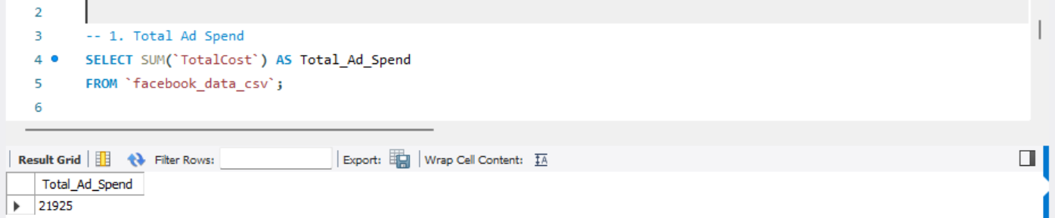

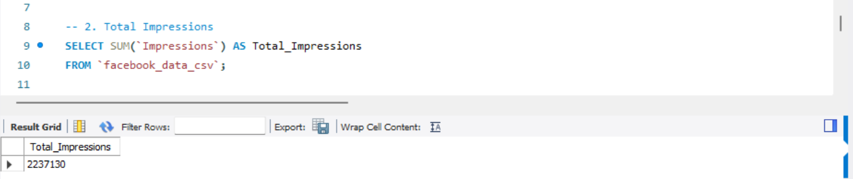

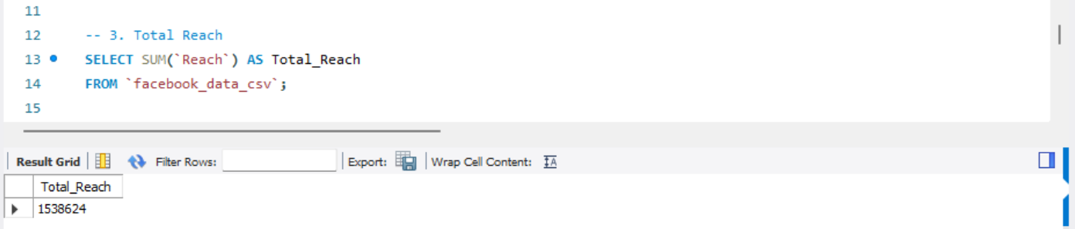

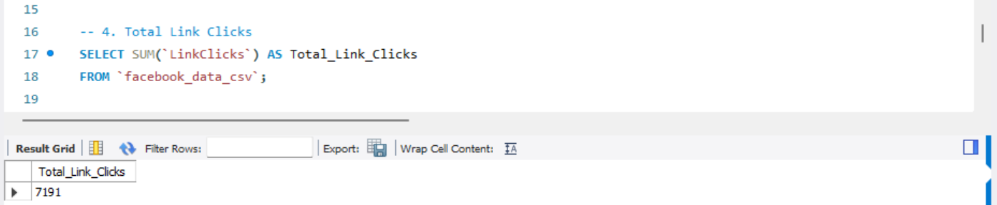

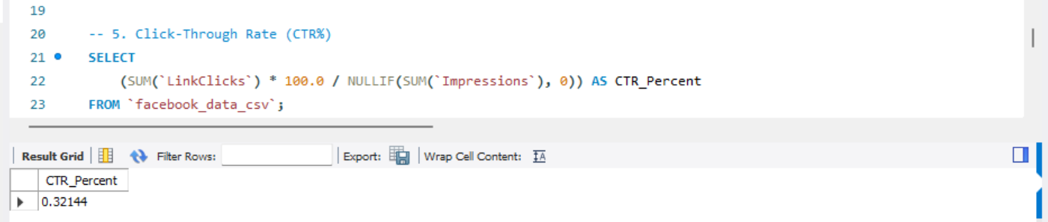

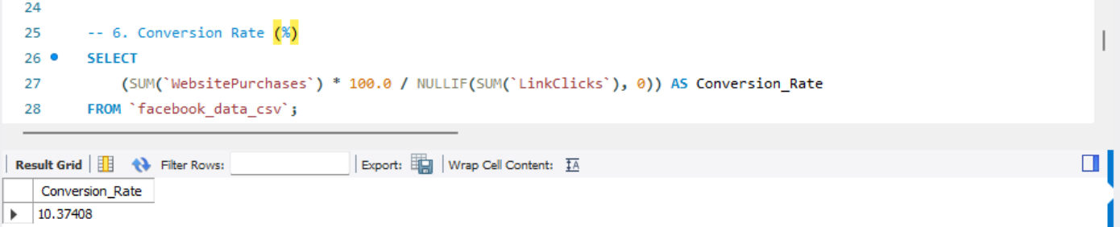

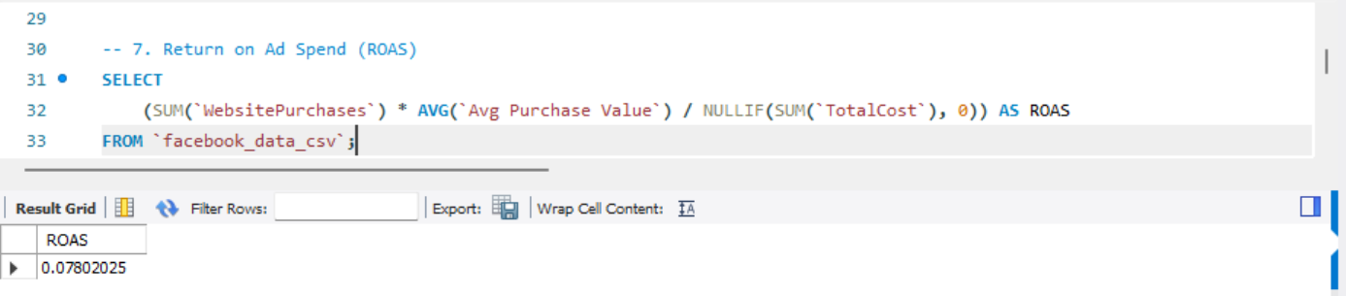

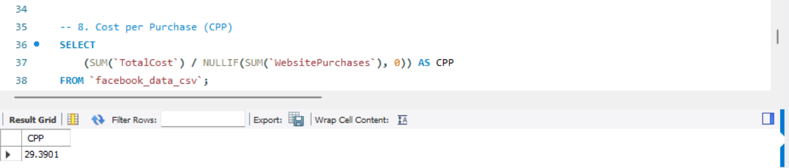

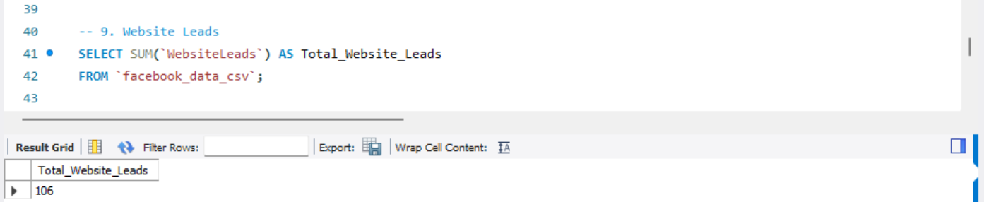

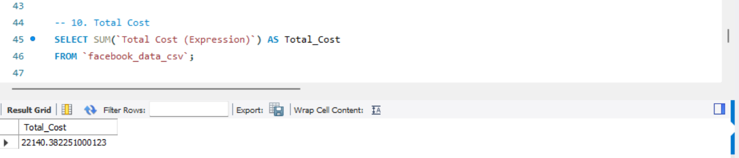

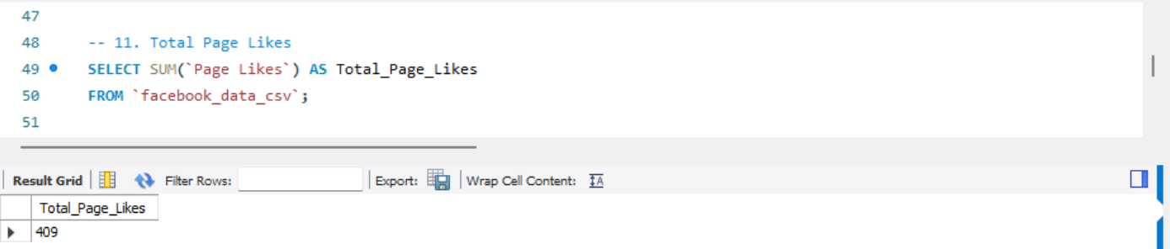

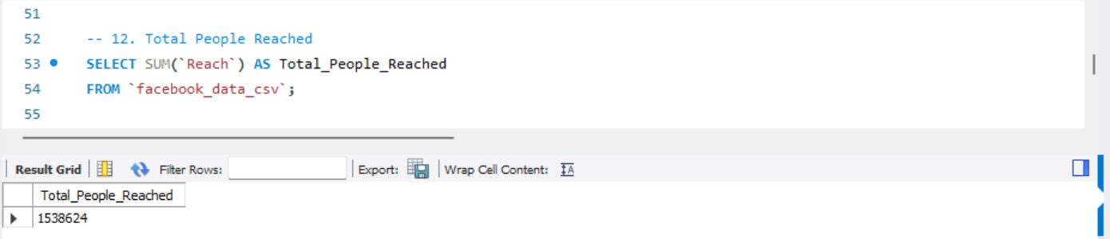

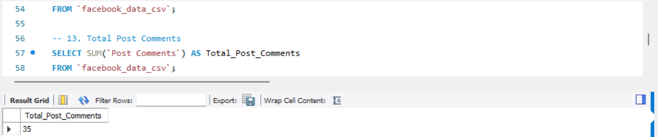

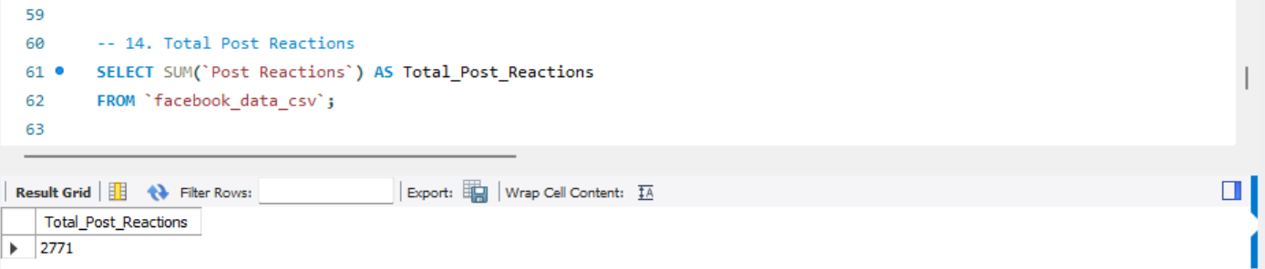

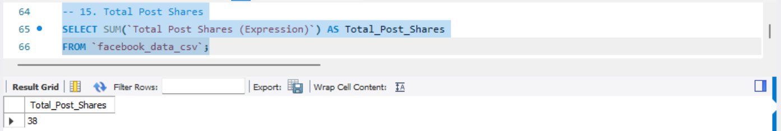

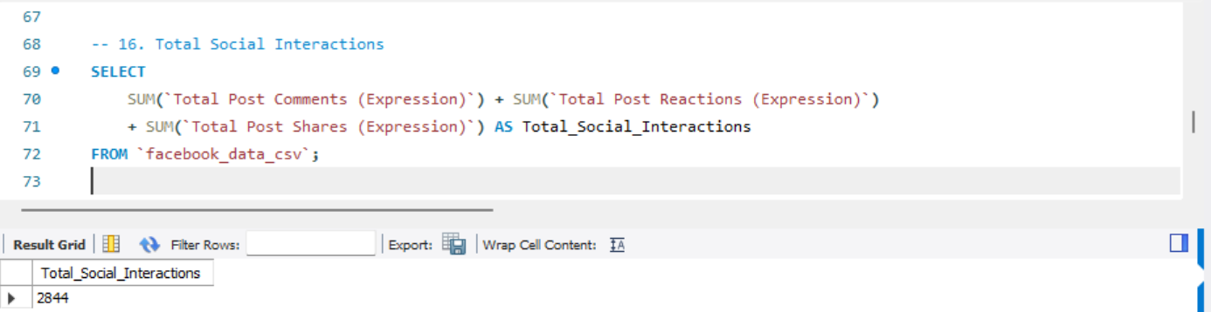

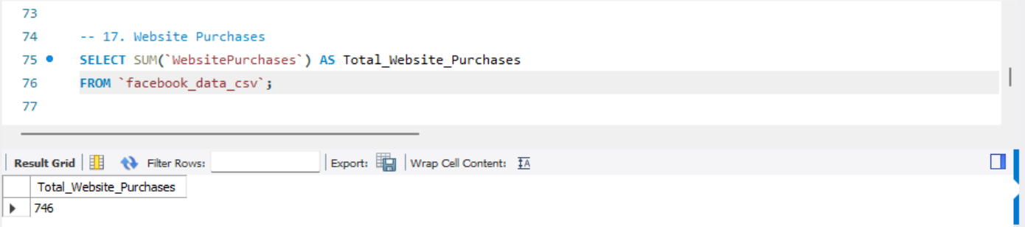

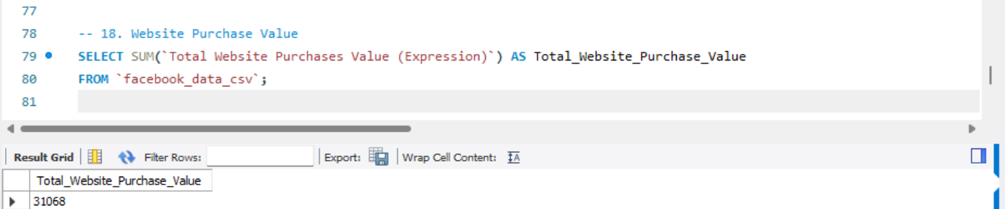

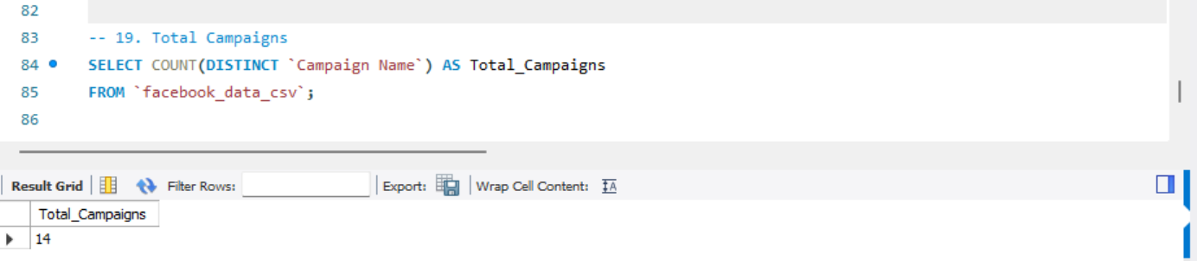

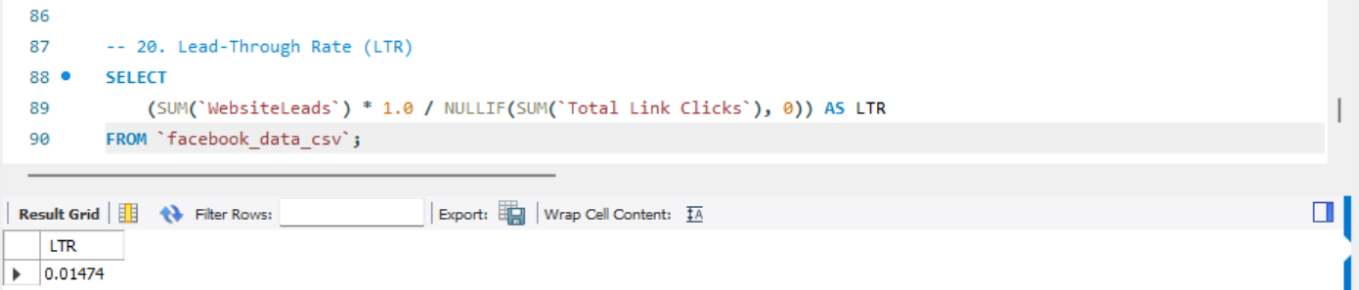

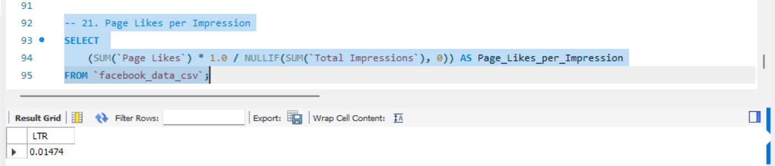

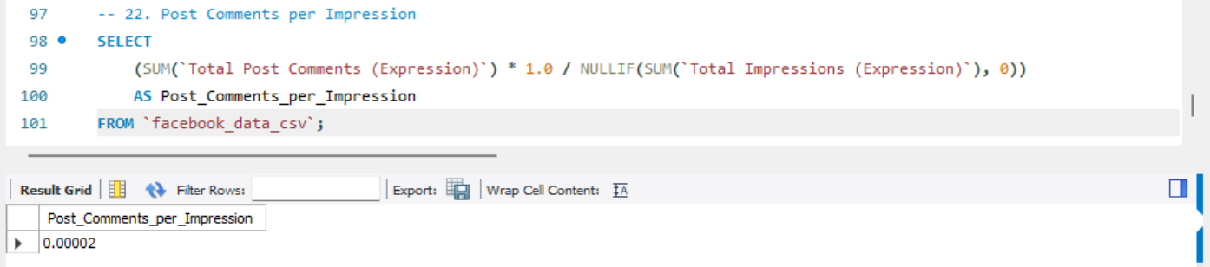

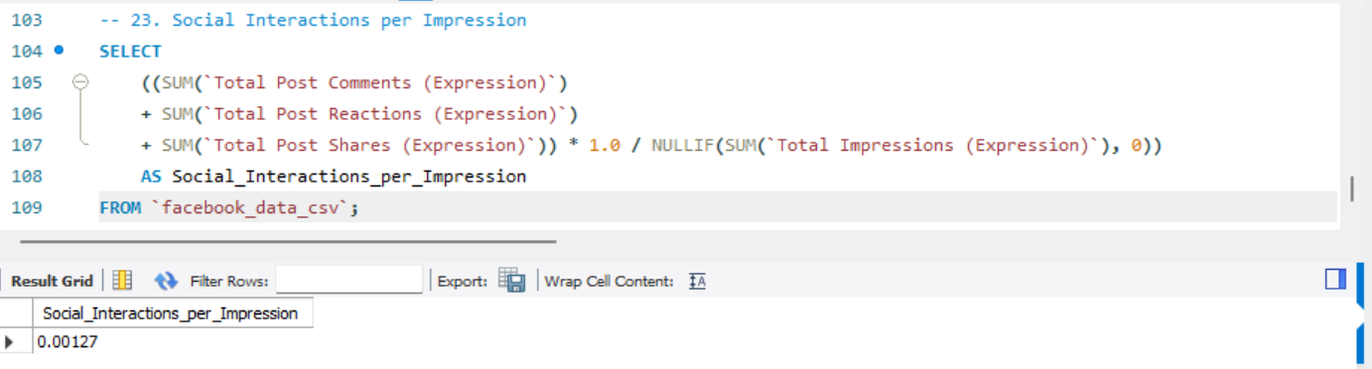

Ad-Level KPIs (Using ad_ columns)*
KPI Name | DAX/Logic Formula
CTR (%) | ad_clicks / ad_impressions
Conversion Rate (%) | ad_conversions / ad_clicks
Average CPC | ad_cost_usd / ad_clicks
Cost per Conversion | ad_cost_usd / ad_conversions
ROAS | ad_conversion_value / ad_cost_usd
CPM | (ad_cost_usd / ad_impressions) * 1000
Campaign-Level KPIs (Using campaign_ columns)*
KPI Name | DAX/Logic Formula
Campaign CTR (%) | campaign_clicks / campaign_impressions
Campaign Conversion Rate (%) | campaign_conversions / campaign_clicks
Campaign CPC | campaign_cost_usd / campaign_clicks
Campaign Cost per Conversion | campaign_cost_usd / campaign_conversions
Campaign ROAS | campaign_conversion_value / campaign_cost_usd
Campaign CPM | (campaign_cost_usd / campaign_impressions) * 1000

use google_qa ;
#Ad-Level KPIs
-- Ad CTR (%)
SELECT
(SUM(ad_clicks) * 100.0 / SUM(ad_impressions)) AS Ad_CTR_Percent
FROM `google_ads_data`;

-- Ad Conversion Rate (%)
SELECT
(SUM(ad_conversions) * 100.0 / SUM(ad_clicks)) AS Ad_Conversion_Rate_Percent
FROM `google_ads_data`;

-- Average CPC
SELECT
(SUM(ad_cost_usd) / SUM(ad_clicks)) AS Ad_Average_CPC
FROM `google_ads_data`;

-- Cost per Conversion
SELECT
(SUM(ad_cost_usd) / SUM(ad_conversions)) AS Ad_Cost_per_Conversion
FROM `google_ads_data`;

-- ROAS (Return on Ad Spend)
SELECT
(SUM(ad_conversion_value) / SUM(ad_cost_usd)) AS Ad_ROAS
FROM `google_ads_data`;

-- CPM (Cost per 1000 Impressions)
SELECT
(SUM(ad_cost_usd) * 1000.0 / SUM(ad_impressions)) AS Ad_CPM
FROM `google_ads_data`;

#Campaign-Level KPIs
-- Campaign CTR (%)
SELECT
(SUM(campaign_clicks) * 100.0 / SUM(campaign_impressions)) AS Campaign_CTR_Percent
FROM `google_ads_data`;

-- Campaign Conversion Rate (%)
SELECT
(SUM(campaign_conversions) * 100.0 / SUM(campaign_clicks)) AS Campaign_Conversion_Rate_Percent
FROM `google_ads_data`;

-- Campaign CPC (Cost per Click)
SELECT
(SUM(campaign_cost_usd) / SUM(campaign_clicks)) AS Campaign_CPC
FROM `google_ads_data`;

-- Campaign Cost per Conversion
SELECT
(SUM(campaign_cost_usd) / SUM(campaign_conversions)) AS Campaign_Cost_per_Conversion
FROM `google_ads_data`;

-- Campaign ROAS
SELECT
(SUM(campaign_conversion_value) / SUM(campaign_cost_usd)) AS Campaign_ROAS
FROM `google_ads_data`;

-- Campaign CPM
SELECT
(SUM(campaign_cost_usd) * 1000.0 / SUM(campaign_impressions)) AS Campaign_CPM
FROM `google_ads_data`;

