# Define the Bayesian interpretation of probability.

The Bayesian interpretation of probability is a philosophical approach to understanding probability as a measure of uncertainty or degree of belief in an event, based on prior knowledge and information. Unlike the frequentist interpretation, which defines probability as the limit of the relative frequency of an event occurring in repeated trials, the Bayesian interpretation views probability as a subjective measure that quantifies a person's confidence or belief in the occurrence of an event.

## Key Concepts of the Bayesian Interpretation:

1. **Subjective Probability**: According to Bayesians, probability reflects an individual's subjective belief or degree of certainty about the likelihood of an event occurring. It encapsulates personal judgment and incorporates prior knowledge, experience, and available evidence.
2. **Bayes' Theorem**: The cornerstone of Bayesian inference is Bayes' theorem, which mathematically describes how to update prior beliefs in the light of new evidence or data. It provides a principled way to incorporate new information and revise probabilities based on observed outcomes.

Bayes' theorem states:

1. **Prior and Posterior Probability**: In Bayesian reasoning:
   * **Prior Probability**: Initial belief or probability assigned to an event before any data or evidence is observed.
   * **Posterior Probability**: Updated probability after considering new evidence or data, obtained using Bayes' theorem.
2. **Bayesian Inference**: The process of making statistical inference and decisions based on Bayesian principles involves:
   * Defining a prior distribution that represents initial beliefs.
   * Updating this distribution using observed data to obtain a posterior distribution.
   * Using the posterior distribution to make decisions or predictions.
3. **Advantages**:
   * **Flexibility**: Can incorporate prior knowledge and subjective beliefs.
   * **Updating**: Provides a systematic way to update beliefs based on new evidence.
   * **Decision Making**: Facilitates decision-making under uncertainty by quantifying uncertainty and risk.
4. **Criticism**:
   * **Subjectivity**: Critics argue that Bayesian probabilities depend heavily on subjective priors, which can introduce bias.
   * **Computational Complexity**: Bayesian methods can be computationally intensive, especially for complex models with high-dimensional data.

In summary, the Bayesian interpretation of probability views probability as a measure of belief or uncertainty, incorporating prior knowledge and updating beliefs based on observed data using Bayes' theorem. It provides a powerful framework for decision-making under uncertainty and is widely used in fields such as statistics, machine learning, and artificial intelligence.

# Define probability of a union of two events with equation.

The probability of the union of two events ***A*** and ***B***, denoted as ***P (A U B)***, is defined as the probability that at least one of the events ***A*** or ***B*** occurs.

Mathematically, it is given by the formula:

***P (A $∪$ B) = P(A) + P(B) - P (A $∩$ B)***

Where:

- P(A) is the probability of event A.

- P(B) is the probability of event B.

- P(A $∩$ B) is the probability of the intersection of events A and B.

## Explanation:

- P (A $∩$ B): This term represents the probability that both events A and B occur simultaneously. When we add P(A) and P(B), we are counting P (A \cap B) twice. Therefore, to correct for this overlap, we subtract P (A \cap B) once to ensure we don't double-count the intersection.

## Special Cases:

* **Mutually Exclusive Events:** If A and B are mutually exclusive (i.e., A $∩$ B = $∅$), then P (A $∩$ B) = 0, and the formula simplifies to P (A U B) = P(A) + P(B).
* **Independent Events:** If A and B are independent, P (A $∩$ B) = P(A) $∙$ P(B), and the formula becomes P (A U B) = P(A) + P(B) - P(A) $∙$ P(B).

## Example:

Consider rolling a fair six-sided die:

- Let A be the event of rolling an even number: A = {2, 4, 6}.

- Let B be the event of rolling a number greater than 4: B = {5, 6}.

To find P (A U B):

- P(A) = 3/6 = 1/2 (since there are 3 even numbers out of 6).

- P(B) = 2/6 = 1/3 (since there are 2 numbers greater than 4 out of 6).

- A $∩$ B = {6}, so P (A $∩$ B) = 1/6.

Now apply the formula:

P (A U B) = P(A) + P(B) – P (A $∩$ B)

P (A U B) = 1/2 + 1/3 – 1/6

P (A U B) = 3/6 + 2/6 – 1/6

P (A U B) = 4/6 = 2/3

Therefore, the probability of the union of events A (even number) and B (number greater than 4) is 2/3.

# What is joint probability? What is its formula?

Joint probability refers to the probability of two (or more) events occurring simultaneously. It quantifies the likelihood of the intersection of events happening together.

## Formula for Joint Probability:

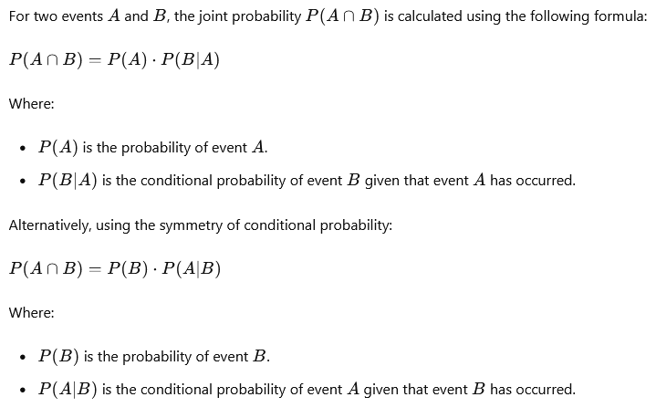

## Understanding the Formula:

## Example:

# What is chain rule of probability?

The chain rule of probability is a fundamental rule in probability theory that allows us to calculate the probability of multiple events occurring together by breaking down the joint probability into conditional probabilities. It is particularly useful when dealing with complex events that can be decomposed into a sequence of simpler events.

## Chain Rule of Probability for Two Events:

## Chain Rule for Three Events:

## Understanding the Chain Rule:

1. **Sequential Dependence**: The chain rule reflects the idea that the probability of multiple events occurring together can be calculated step-by-step, considering the influence of each event on subsequent events.
2. **Conditional Probabilities**: Each term in the chain rule accounts for the probability of an event given the occurrence of all previous events in the sequence.
3. **Application**: The chain rule is essential for decomposing complex joint probabilities into simpler conditional probabilities, making it easier to compute probabilities in multi-step processes or in scenarios involving multiple dependencies.

## Example:

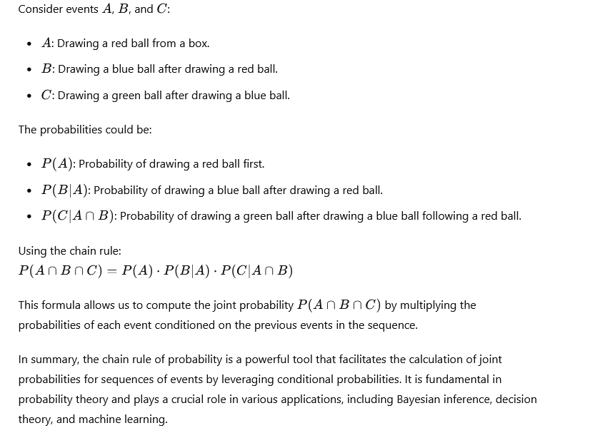

# What is conditional probability means? What is the formula of it?

Conditional probability is the probability of an event occurring given that another event has already occurred. It quantifies the likelihood of one event happening under the condition that another event has occurred, providing a more refined probability estimate when additional information is known.

## Formula for Conditional Probability:

## Understanding Conditional Probability:

## Special Cases:

# What are continuous random variables?

Continuous random variables are variables that can take on an infinite number of values within a specified range (interval) on the real number line. Unlike discrete random variables, which can only take on distinct values, continuous random variables can take on any value in each interval, typically represented by real numbers.

## Key Characteristics of Continuous Random Variables:

1. **Infinite Possible Values**: A continuous random variable can theoretically assume an uncountably infinite number of values within its range. For example, the height of a person, the time it takes to complete a task, or the temperature in each region are all examples of continuous variables because they can take on any value within a certain range.
2. **Probability Density Function (PDF)**: Instead of a probability mass function (PMF) used for discrete random variables, continuous random variables are described by a probability density function $f (x)$, where f (x) ≥0 for all x and the total area under the curve equals 1 over the entire range of possible values.
3. **Probability as Area under the Curve**: The probability that a continuous random variable X falls within a specific interval [a, b] is given by the integral of the probability density function f (x) over that interval:
$$P(a≤ X≤ b) = \int_{a}^{b}{f(x) dx}$$

4. **No Point Probabilities**: Unlike discrete random variables, which have positive probabilities assigned to individual points, the probability P (X = x) for a continuous random variable X is zero for any specific value x. Instead, probabilities are assigned to intervals or ranges of values.
5. **Examples**: Common examples of continuous random variables include:
   * **Height** of individuals.
   * **Weight** of objects.
   * **Time** taken to complete a task.
   * **Temperature** measurements.
   * **Length** or **width** of objects.
   * **Velocity** or **speed** of an object.

## Applications:

* **Statistics and Data Analysis**: Continuous random variables are used extensively in statistical modeling, hypothesis testing, and regression analysis.
* **Engineering and Physics**: They are essential in fields like physics, engineering, and economics where measurements are often continuous.
* **Probability Theory**: They play a central role in probability theory, particularly in studying concepts such as expected values, variance, and distribution functions.

Continuous random variables are fundamental in both theoretical and applied contexts, providing a flexible framework for modeling and analyzing a wide range of real-world phenomena where measurements are not restricted to discrete values but can vary continuously across a spectrum.

# What are Bernoulli distributions? What is the formula of it?

The Bernoulli distribution is a discrete probability distribution that models a random experiment with two possible outcomes: success (1) and failure (0). It is named after Jacob Bernoulli, a Swiss mathematician who introduced the concept in the 18th century.

## Characteristics of the Bernoulli Distribution:

1. **Single Trial**: The Bernoulli distribution describes the outcome of a single Bernoulli trial, which can result in either success or failure.
2. **Parameters**:
   * p: The probability of success in a single trial.
   * 1−p: The probability of failure in a single trial.
3. **Probability Mass Function (PMF)**:

1. **Expectation and Variance**:

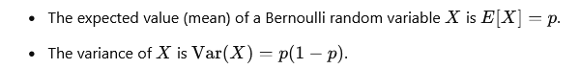

## Applications of the Bernoulli Distribution:

* **Binary Outcomes**: Modeling outcomes such as success/failure, heads/tails, yes/no, etc.
* **Risk Assessment**: Modeling binary events where the outcome is success or failure (e.g., survival/death).
* **Machine Learning**: Used in classification tasks where outcomes are binary.

## Example:

In summary, the Bernoulli distribution is a fundamental discrete probability distribution with applications in modeling binary outcomes where each trial has a fixed probability p of success and 1−p of failure. It serves as the basis for more complex distributions like the Binomial distribution, which models the number of successes in a fixed number of independent Bernoulli trials.

# What is binomial distribution? What is the formula?

The binomial distribution is a discrete probability distribution that describes the number of successes k in a fixed number n of independent Bernoulli trials, where each trial has two possible outcomes: success (with probability p) and failure (with probability 1−p). It is named after Jacob Bernoulli.

## Characteristics of the Binomial Distribution:

1. **Parameters**:
   * n: The number of independent trials.
   * p: The probability of success on each trial.
   * 1−p: The probability of failure on each trial.
2. **Probability Mass Function (PMF)**:A math problem with equations

   Description automatically generated with medium confidence
3. **Mean and Variance**:

• The expected value (mean) of X is E[X]=np.

• The variance of X is Var(X)= np (1−p).

## Applications of the Binomial Distribution:

* **Counting Successes**: Modeling scenarios where the number of successes in a fixed number of trials follows a specific probability distribution.
* **Probability Calculations**: Used in various fields such as statistics, biology, finance, and quality control to calculate probabilities of specific outcomes.
* **Statistical Inference**: Provides the basis for hypothesis testing and confidence interval calculations in the context of proportions and success rates.

## Example:

Consider flipping a fair coin 10 times. The probability of getting exactly k heads (successes) in these 10 flips follows a binomial distribution where n = 10 and p = 0.5.

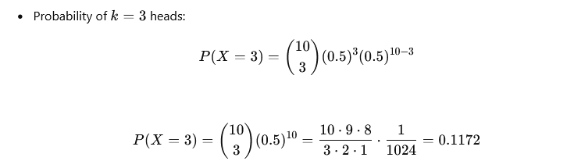

This calculation gives the probability of getting exactly 3 heads in 10-coin flips using the binomial distribution formula.

In summary, the binomial distribution is a fundamental discrete probability distribution that models the number of successes in a fixed number of independent trials, each with the same probability of success p. It is widely used in various fields for modeling and analyzing binary outcomes and provides a basis for more complex distributions like the Poisson distribution and the negative binomial distribution.

# What is Poisson distribution? What is the formula?

The Poisson distribution is a discrete probability distribution that expresses the probability of a number of events occurring in a fixed interval of time or space, given that these events happen with a known constant rate and independently of the time since the last event. It is named after the French mathematician Siméon Denis Poisson.

### Characteristics of the Poisson Distribution:

1. **Parameter**:
   * λ: The average rate (or mean rate) of events occurring in the given interval. This parameter can also be interpreted as the expected number of events in the interval.
2. **Probability Mass Function (PMF)**: The probability mass function P (X=k) of a Poisson random variable X, which represents the number of events occurring in the interval, is given by:

Where:

* k is the number of events that occur in the interval.
* λ is the average rate of events per interval.
* e is the base of the natural logarithm (approximately equal to 2.71828).
* k! denotes the factorial of k (i.e., k factorial).

1. **Mean and Variance**:

* The expected value (mean) of X is E[X]=λ.
* The variance of X is Var(X)=λ.

## Assumptions and Applications:

* **Assumptions**: The Poisson distribution assumes that events occur independently of each other and at a constant average rate λ over the interval of interest.
* **Applications**:
  + **Counting Events**: Modeling the number of occurrences of rare events, such as the number of phone calls received by a call center in a minute, the number of accidents at an intersection in a day, or the number of mutations on a DNA strand.
  + **Queueing Theory**: Analyzing the number of customers arriving at a service point within a given time period.
  + **Biological and Environmental Sciences**: Modeling the number of bacteria colonies in a petri dish or the number of raindrops falling in a certain area during a specified time.

## Example:

In summary, the Poisson distribution is a valuable tool in probability theory and statistics for modeling the occurrence of rare events where the average rate of occurrence is known. It provides a straightforward way to calculate probabilities of different event counts within a fixed interval based on the expected rate of occurrence λ.

# Define covariance.

Covariance is a measure of how much two random variables change together. It quantifies the degree to which two variables tend to deviate from their respective means in a consistent way. In simpler terms, covariance indicates the direction of the linear relationship between two variables (whether they tend to increase or decrease together) and the strength of that relationship.

## Formula for Covariance:

## Interpretation of Covariance:

1. **Sign of Covariance**:
   * Cov (X, Y) >0: Indicates that as X increases, Y tends to increase as well (positive covariance), suggesting a positive linear relationship.
   * Cov (X, Y) <0: Indicates that as X increases, Y tends to decrease (negative covariance), suggesting a negative linear relationship.
   * Cov (X, Y) =0: Indicates no linear relationship between X and Y; they are uncorrelated.
2. **Magnitude of Covariance**:
   * The magnitude of covariance is not standardized and depends on the scales of X and Y. Therefore, it is often difficult to compare covariances across different pairs of variables without standardization.
3. **Unit of Measurement**:
   * Covariance is expressed in the units of the product of X and Y. For example, if X is in meters and Y is in kilograms, then covariance Cov(X,Y) would be in square meters-kilograms.

## Properties of Covariance:

• **Bilinearity**: Cov (X, Y) is linear in each argument separately.

• **Symmetry**: Cov (X, Y) =Cov (Y, X).

• **Relation to Variance**: Cov (X, X) =Var(X), where Var(X) is the variance of X.

## Limitations of Covariance:

* **Sensitive to Scale**: Covariance depends on the scales of X and Y, making it difficult to interpret without normalization.
* **Limited to Linear Relationships**: Covariance measures only linear relationships between variables and may not capture non-linear relationships.

In summary, covariance provides a useful measure to understand the relationship between two variables, indicating both the direction and strength of their association. However, its interpretation requires careful consideration of scale and context, especially when comparing covariances across different pairs of variables.

# Define correlation

Correlation is a statistical measure that describes the strength and direction of a linear relationship between two variables. In other words, it quantifies how strongly two variables are related to each other and the direction of that relationship (whether it is positive or negative).

## Key Points about Correlation:

1. **Range of Values**:
   * Correlation coefficients typically range between -1 and +1.
   * ρ=+1: Perfect positive correlation, meaning that as one variable increases, the other variable also increases linearly.
   * ρ=−1: Perfect negative correlation, meaning that as one variable increases, the other variable decreases linearly.
   * ρ=0: No linear correlation, indicating that there is no linear relationship between the variables. However, note that lack of linear correlation does not imply independence.
2. **Strength of Correlation**:
   * The closer the correlation coefficient ρ is to ±1, the stronger the linear relationship between the variables.
   * ∣ρ∣≈1: Strong linear relationship.
   * ∣ρ∣≈0: Weak or no linear relationship.
3. **Interpretation**:
   * Positive Correlation: Indicates that as one variable increases, the other variable tends to also increase. The variables move in the same direction.
   * Negative Correlation: Indicates that as one variable increases, the other variable tends to decrease. The variables move in opposite directions.
   * Zero Correlation: Indicates no linear relationship between the variables, but they may still be related in a non-linear manner or through other factors.

## Types of Correlation Coefficients:

1. **Pearson Correlation Coefficient (ρ)**:
   * Measures the linear relationship between two continuous variables.
   * Formula:

1. **Spearman Rank Correlation**:
   * Measures the strength and direction of association between two ranked variables.
   * Appropriate for variables measured on an ordinal scale or when the relationship is non-linear.
2. **Kendall's Tau**:
   * Similar to Spearman correlation, it measures the association between two ranked variables.
   * Emphasizes concordant and discordant pairs of observations.

## Applications of Correlation:

* **Data Analysis**: Assessing relationships between variables in datasets.
* **Research**: Studying associations between factors in scientific research.
* **Finance**: Analysing relationships between economic indicators and asset prices.
* **Quality Control**: Monitoring relationships between process variables and product quality.

## Limitations of Correlation:

* **Linearity Assumption**: Correlation measures only linear relationships and may miss non-linear associations.
* **Sensitive to Outliers**: Outliers can disproportionately influence correlation coefficients.
* **Cannot Establish Causation**: Correlation does not imply causation; it only indicates association.

In summary, correlation provides a quantitative measure of the relationship between variables, helping to understand how changes in one variable may be associated with changes in another. It is a fundamental concept in statistics and plays a crucial role in various fields for analyzing and interpreting data relationships.

# Define sampling with replacement. Give example.

Sampling with replacement is a sampling method where each member of a population or dataset has an equal probability of being selected at each draw, and after each selection, the chosen item is returned to the population. This means that the same item can be selected more than once in the sampling process.

## Characteristics of Sampling with Replacement:

1. **Equal Probability**: Each item in the population has an equal chance of being selected at each draw, regardless of whether it has been selected previously.
2. **Independence**: The selection of one item does not affect the probability of selecting any other item in subsequent draws.
3. **Examples**:
   * **Example 1**: Imagine a bag containing colored balls (red, blue, green, yellow). If you randomly select a ball, record its color, and then return it to the bag before the next draw, you are sampling with replacement. This means you could draw the same color multiple times in a row.
   * **Example 2**: In statistical simulations or experiments, if you need to repeatedly sample from a dataset or population where each observation represents a unique event (e.g., a dice rolls or customer transaction), sampling with replacement allows for the possibility of repeated occurrences of the same event in subsequent samples.

## Procedure:

1. **Selection**: Randomly choose an item from the population or dataset.
2. **Replacement**: After recording the selected item, return it to the population so it is eligible for selection in future draws.
3. **Repeat**: Continue the process for the desired number of samples or iterations.

## Advantages and Considerations:

* **Simple Implementation**: Sampling with replacement is straightforward and often easier to implement than sampling without replacement.
* **Repeated Selection**: Allows for the possibility of selecting the same item multiple times, which can be useful in certain types of analyses or simulations.
* **Impact on Analysis**: Because items can be selected more than once, results may show higher variability compared to sampling without replacement, where each item can be selected only once.

## Example Scenario:

Suppose you have a deck of 52 playing cards. You randomly draw a card, record its value, and then place it back in the deck before drawing again. If you repeat this process several times, you might draw the same card (e.g., the Ace of Spades) multiple times in your sample.

Sampling with replacement is commonly used in statistical modeling, simulation studies, and certain types of research where the ability to select the same item multiple times is necessary to accurately represent the underlying distribution or process being studied.

# What is sampling without replacement? Give example.

Sampling without replacement is a sampling method where each member of a population or dataset can be selected only once in a single draw. Once an item is selected, it is removed from the population, and therefore cannot be chosen again in subsequent draws. This ensures that each sample drawn is unique.

## Characteristics of Sampling without Replacement:

1. **Non-Repetition**: Once an item is selected, it is excluded from the population, reducing the pool of available items for subsequent selections.
2. **Probability Adjustments**: The probability of selecting each item changes with each draw, as the size of the population decreases.
3. **Examples**:
   * **Example 1**: Selecting a jury from a pool of eligible citizens. Once a person is chosen and seated on the jury, they are no longer available for subsequent selections.
   * **Example 2**: Conducting a survey where each participant can be surveyed only once. Once a person completes the survey, they cannot be included in the sample again.

## Procedure:

1. **Selection**: Randomly choose an item from the population or dataset.
2. **Exclusion**: Remove the selected item from the population or dataset.
3. **Repeat**: Continue the process until the desired number of samples or iterations is reached, or until the population or dataset is exhausted.

## Advantages and Considerations:

* **Avoids Duplication**: Ensures that each sample drawn is unique, which can be crucial in many statistical analyses and research studies.
* **Representative Samples**: Helps in obtaining representative samples from the population, especially when the population is large and varied.
* **Decreasing Pool**: The pool of available items decreases with each selection, which can affect subsequent probabilities and the representativeness of the sample.

## Example Scenario:

Consider a bag containing colored balls (red, blue, green, yellow). If you randomly select a ball, record its color, and then do not return it to the bag before the next draw, you are sampling without replacement. This ensures that each draw results in a different color until all balls have been selected exactly once.

Sampling without replacement is commonly used in statistical sampling, experimental designs, and various types of research where uniqueness of samples is essential for accurate representation of the population or dataset being studied. It contrasts with sampling with replacement, where items can be selected more than once, potentially leading to different statistical properties and implications in analysis.

# What is hypothesis? Give example.

A hypothesis is a proposed explanation or tentative statement about a phenomenon or a relationship between variables. It is typically formulated based on existing knowledge, observations, or theories and is subject to empirical testing or investigation to determine its validity.

## Key Characteristics of a Hypothesis:

1. **Statement**: A hypothesis is a clear and specific statement that proposes a relationship between variables or an explanation for a phenomenon.
2. **Testability**: It must be possible to test the hypothesis through empirical observation or experimentation.
3. **Falsifiability**: A good hypothesis should be falsifiable, meaning that it is possible to prove it wrong through experimentation or observation.

## Example of a Hypothesis:

**Example 1:**

* **Phenomenon**: Exposure to sunlight affects plant growth.
* **Hypothesis**: Plants exposed to more sunlight will grow taller than plants exposed to less sunlight.
* **Explanation**: This hypothesis suggests a relationship between the amount of sunlight (independent variable) and the height of plants (dependent variable). It implies that sunlight has a direct effect on plant growth, which can be tested by conducting an experiment where plants are grown under different levels of sunlight exposure and their growth is measured.

**Example 2:**

* **Phenomenon**: Higher levels of exercise are associated with lower blood pressure.
* **Hypothesis**: Individuals who engage in regular exercise will have lower blood pressure compared to those who do not exercise regularly.
* **Explanation**: This hypothesis proposes a relationship between exercise (independent variable) and blood pressure (dependent variable). It suggests that exercise influences blood pressure, and this relationship can be tested by comparing the blood pressure levels of individuals who exercise regularly with those who do not, controlling for other relevant factors.

## Hypothesis in Scientific Methodology:

In the scientific method, hypotheses are formulated based on observations or theories and are then tested through experimentation or data analysis. The results of these tests provide evidence to support or refute the hypothesis, leading to conclusions and further refinement of scientific understanding.

## Importance of Hypothesis:

* **Guiding Research**: Hypotheses provide a framework for designing experiments or studies, guiding the collection and analysis of data.
* **Focus**: They help researchers focus their efforts on specific questions or relationships within a broader field of study.
* **Testing and Validation**: Through testing, hypotheses contribute to the validation or rejection of theories, enhancing our understanding of natural phenomena and relationships between variables.

In summary, a hypothesis is a fundamental component of scientific inquiry, serving as a proposed explanation or prediction that guides research and testing in various fields of study. It plays a crucial role in forming the basis for empirical investigation and advancing scientific knowledge.