# Using a graph to illustrate slope and intercept, define basic linear regression.

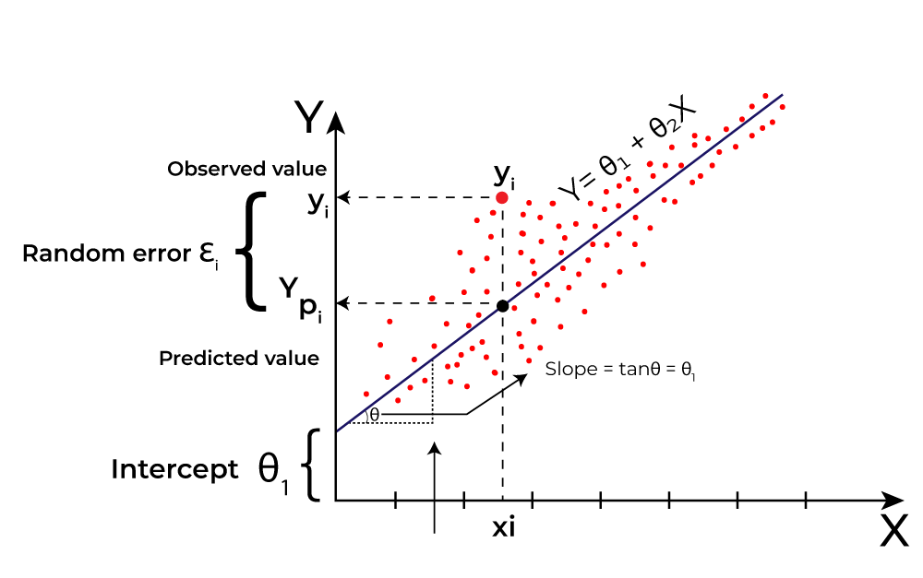

# In a graph, explain the terms rise, run, and slope.

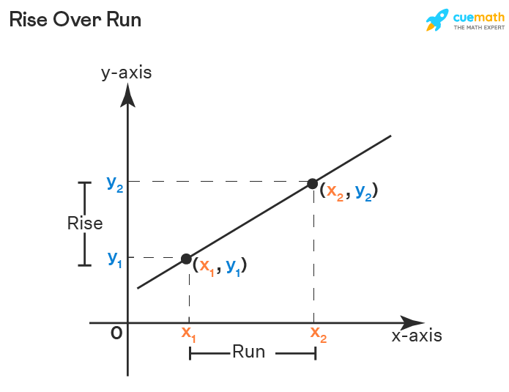

# Use a graph to demonstrate slope, linear positive slope, and linear negative slope, as well as the different conditions that contribute to the slope.

## WHAT IS A SLOPE?

Several absolute values that represent whether a line is **steeper or flatter** and the **direction** of the line on the graph are known as a **slope or gradient.** The slope of a line is a fundamental concept in economics and mathematics. It is generally denoted by the letter **'m'.** The slope can be calculated by dividing the **'vertical change'** with the **'horizontal change'** between two distinct points on a line.

## TYPES OF SLOPES

There are two main types of slopes which are given below:

* **Positive Slope:** A slope in which two variables, i.e., variable at x-axis and variable at the y-axis, shows a **positive relationship** is known as **positive slope.** In simpler words, a positive slope is one in which the variable x increases with the increase in variable y and/or variable y increases with the increase in variable x. Similarly, the variable x decreases with the decrease in variable y, and/or variable y decreases with the decrease in variable x. It means both the variables are **complements** to each other. A positive slope moves in the **upward direction** or is **upward sloping.**  
  In graphical terms, a positive slope is one in which the line on the graph rises when it moves from left to right. The concept of positive slope can be clearly understood with the help of the **supply curve** of a producer or firm in economics. The two variables of the curve are price at the y-axis and quantity of goods at the x-axis. Let us assume the firm is producing the goods for **profit maximization.** Therefore, when the prices of the goods increase, the quantity supplied by the firm of those goods will also increase, while when the prices decrease, the quantity supplied by the firm will decrease. In other words, at higher prices, the firm or producer will increase the quantity supplied to earn more profit, while at lower prices, they will reduce the quantity supplied to reduce the loss. Hence, it shows the prices and quantity supplied are positively related to each other, which can be cleared from the diagram given below:  
  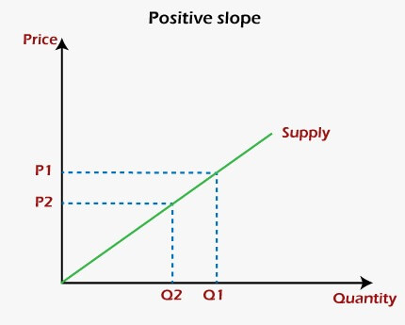
* **Negative Slope:** A slope in which two variables, i.e., variable at x-axis and variable at the y-axis, shows a **negative relationship** is known as **negative slope.** In other words, a negative slope is one in which the variable x increases with the decrease in variable y and/or variable y increases with the decrease in variable x. In the same manner, the variable x decreases with the increase in variable y, and/or variable y decreases with the increase in variable x. This represents an **inverse relationship** between these two variables. A negative slope moves in the **downward direction** or is **downward sloping.**  
  Graphically, a negative slope is one in which the line on the graph falls when it moves from left to right. One of the best examples of the negative slope of the graph is the **demand curve** in economics. The two variables of the curve are price at the y-axis and quantity of goods at the x-axis. As we know, the consumers buy a large quantity of a good at a lower price than at a higher price. Therefore, the quantity demanded by the consumers of goods will decrease with an increase in the prices of those goods. On the other hand, when prices of the goods will decrease, the quantity demand will increase. Hence, it shows a **negative relationship** between the prices and quantity supplied of those goods. It can be cleared from the diagram given below:  
  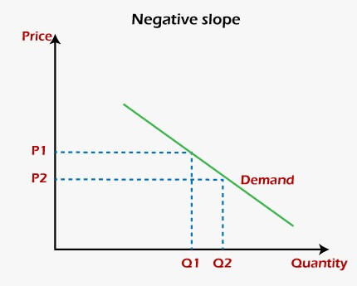

## TWO OTHER TYPES OF SLOPES

Other than positive and negative slopes, there are two more types of slopes named zero slope and infinite slope. They can be understood from the given explanation:

* **Zero Slope:** A condition in which the variable at the y-axis remains the same with the change in the variable at the x-axis is known as the **slope of zero.** Graphically, a **horizontal or flat line** on the graph has a zero Slope. Hence, it is called a **constant function.** A slope of zero neither moves into the upward or downward direction. It moves only to the leftward or rightward directions.  
  The diagram given below is a graphical presentation of the zero slope:  
  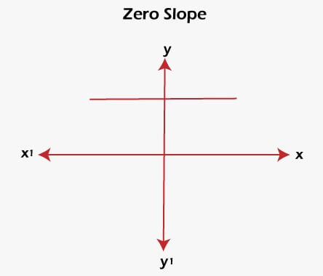
* **Infinite Slope:** A condition in which the variable at the x-axis remains the same with the change in the variable at the y-axis is known as the **infinite slope.** It is also called the **undefined slope.** As per the graphical terms, a **vertical or perpendicular line** on the graph has an infinite slope. An infinite slope neither moves to the leftward or rightward direction. It shows a movement only in the upward or downward direction.  
  An infinite slope is shown in the given diagram:  
  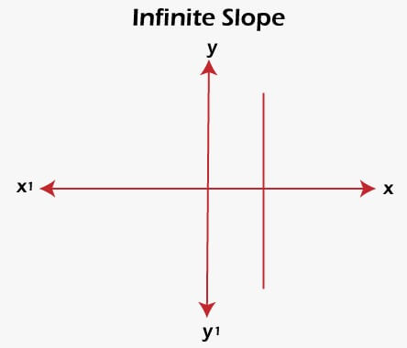

## CALCULATION OF SLOPE

* In a linear equation of **ax + by + c = 0,** the slope is defined as **-a/b.**
* The equation of the line can be calculated with the help of the **point-slope formula** if both the slope **m** of a line and point **(x1, y1)** are known. The formula is given below:  
  **y - y1 = m (x - x1)**
* The two-line will be **parallel** if their slopes are **equal,** while two lines will be **perpendicular** if the product of their slopes is **-1.**

## ADDITIONAL INFORMATION

* The absolute value of the slope is used to find whether a curve is **steeper or flatter.**
* The positive and negative value of the slope decides the direction, i.e., **upward or downward,** of the slope.
* A curve becomes **steeper** with the increase in the absolute value of the slope.
* A curve becomes **flattered** with the decrease in the absolute value of the slope.
* These conditions are not affected by the **negative or positive slope** (not the negative or positive value).
* A **lower positive slope** implies a flatter curve that is tilted in the upward direction will be formed.
* A **higher positive slope** means a steeper curve that is bent in the upward direction will be formed.
* A **negative slope with a large absolute value** implies a steeper curve that is tilted in the downward direction will be formed.
* A **negative slope having a smaller absolute value** means a flatter curve that is bent in the downward direction will be formed.

# Use the formulas for a and b to explain ordinary least squares.

In the context of linear regression, ordinary least squares (OLS) is a method used to estimate the parameters of a linear regression model. The goal is to find the best-fitting line through a set of data points by minimizing the sum of the squared differences between the observed values and the values predicted by the linear model.

## Formulas for Ordinary Least Squares (OLS)

## Explanation of Ordinary Least Squares (OLS)

## Practical Application

## A white paper with black text Description automatically generatedConclusion

Ordinary least squares is a foundational method in statistics and machine learning for fitting a linear model to data. It finds the best-fitting line by minimizing the sum of squared differences between observed and predicted values, yielding estimates β^0​ (intercept) and β^​1​ (slope) that describe the linear relationship between variables x and y.

# Provide a step-by-step explanation of the OLS algorithm.

Here's a step-by-step explanation of the Ordinary Least Squares (OLS) algorithm for fitting a linear regression model:

## Step-by-Step Explanation of OLS Algorithm

### **Input Data**:

* Obtain a dataset consisting of paired observations {(xi​, yi​)} for i= 1, 2, ..., n, where xi​ are the independent variables (predictors) and yi​ are the dependent variables (responses).

### **Calculate Means**:

### **Compute Covariance and Variance**:

### **Estimate the Slope (β^​1​)**:

### **Estimate the Intercept (β^​0​)**:

### **Regression Line Equation**:

### **Evaluate Model Fit**:

* Assess the goodness of fit of the model using metrics such as the coefficient of determination R2, which measures the proportion of the variance in the dependent variable that is predictable from the independent variable(s).

### Summary

The Ordinary Least Squares algorithm involves calculating the means of x and y, determining the covariance and variance of x and y, estimating the slope and intercept of the regression line, and then using these parameters to define the best-fit line through the data points. This method minimizes the sum of squared differences between observed and predicted values of y, providing a linear model that describes the relationship between the independent and dependent variables in the dataset.

# What is the regression's standard error? To represent the same, make a graph.

The regression standard error, also known as the standard error of the regression or residual standard error, is a measure of the accuracy of predictions made with a regression model. It quantifies the average amount that the observed values of the response variable (dependent variable) differ from the predicted values given by the regression model.

## Definition and Calculation

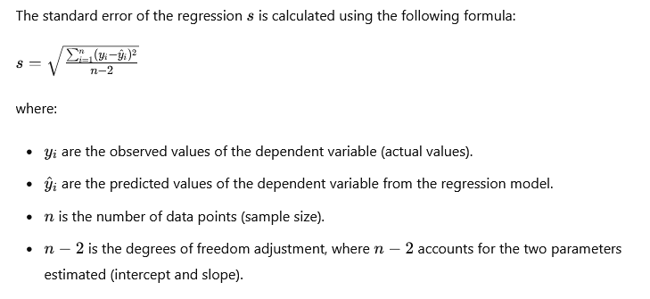

## Interpretation

1. **Lower Standard Error**: A lower value of s indicates that the regression predictions are closer to the actual data points, suggesting a better fit of the model to the data.
2. **Higher Standard Error**: A higher value of s indicates that the predictions are more spread out from the actual data points, indicating a poorer fit of the model.
3. **Comparison with Residuals**: The standard error s is related to the residuals ei​=yi​−y^i​, which are the differences between observed and predicted values. It reflects the average magnitude of these residuals.

## Usage

* **Assessment of Model Fit**: Researchers and analysts use the standard error of the regression to assess how well the regression model fits the data.
* **Comparing Models**: It can be used to compare the goodness of fit of different regression models. A lower s indicates a better fit.

## Example

Suppose a regression model has a standard error s=3.5s = 3.5s=3.5. This means that, on average, the observed values of the dependent variable y differ from the predicted values y^​ by approximately 3.5 units. If s is small, it suggests that the model's predictions are relatively close to the actual data points, indicating a good fit.

In summary, the standard error of the regression is a crucial metric in regression analysis, providing insights into the accuracy and reliability of the predictions made by the model.

# Provide an example of multiple linear regression.

Multiple linear regression is an extension of simple linear regression that involves more than one independent variable (predictor). Here’s an example to illustrate multiple linear regression using a hypothetical dataset:

## Example: Predicting House Prices

Suppose we want to predict the selling price of houses based on several variables such as size (in square feet), number of bedrooms, and distance to the city center. Here’s a hypothetical dataset with these variables:

* **Response Variable (Dependent Variable)**:
  + Selling Price of Houses (y)
* **Predictor Variables (Independent Variables)**:
  + Size of the House (in square feet) (x1​)
  + Number of Bedrooms (x2​)
  + Distance to the City Center (in miles) (x3​)

## Hypothetical Dataset

Let's assume we have the following data (a simplified example for illustration):

|  |  |  |  |
| --- | --- | --- | --- |
| Size (sq. ft) | Bedrooms | Distance to City Center (miles) | Price ($1000s) |
| 2000 | 3 | 5 | 300 |
| 1600 | 2 | 3 | 240 |
| 2400 | 4 | 8 | 350 |
| 1800 | 3 | 4 | 280 |
| 3000 | 5 | 10 | 400 |

## Multiple Linear Regression Model

The multiple linear regression model can be represented as:

where:

## A white background with black text Description automatically generated Estimating Coefficients

To find the coefficients β0​,β1​,β2​, and β3​, we use statistical techniques such as Ordinary Least Squares (OLS) regression, which minimizes the sum of squared differences between the observed and predicted prices.

## Example Calculation (Simplified)

Using software or statistical tools, the coefficients might be estimated as follows (hypothetical values):

* β^​0​ (intercept) = 50
* β^​1​ (size coefficient) = 0.1
* β^​2​ (bedrooms coefficient) = 10
* β^​3​ (distance coefficient) = -5

## Interpretation

* β^​0​=50: The predicted price when the size, number of bedrooms, and distance to the city center are all zero (which might not be meaningful in this context).
* β^​1​=0.1: Holding number of bedrooms and distance constant, a one-unit increase in size (in square feet) is associated with a $0.1 thousand increase in price.
* β^​2​=10: Holding size and distance constant, a one-unit increase in the number of bedrooms is associated with a $10 thousand increase in price.
* β^​3​=−5: Holding size and number of bedrooms constant, a one-unit increase in distance to the city center is associated with a $5 thousand decrease in price.

## Prediction

Using the estimated coefficients, we can predict the selling price for a new house with given characteristics (size, bedrooms, distance to city center).

## Conclusion

Multiple linear regression extends the concepts of simple linear regression to situations where there are multiple independent variables influencing a dependent variable. It allows us to understand how each variable contributes to the prediction of the outcome variable and is widely used in various fields such as economics, finance, and social sciences for predictive modeling and understanding relationships between variables.

# Describe the regression analysis assumptions and the BLUE principle.

Regression analysis relies on several key assumptions to ensure the validity and reliability of the results. These assumptions pertain to both the model itself and the underlying data. Additionally, the BLUE principle (Best Linear Unbiased Estimators) is a fundamental concept in regression analysis that addresses the properties of the estimated coefficients.

## Assumptions of Regression Analysis

1. **Linearity**: The relationship between the dependent variable y and the independent variables x is linear. This means that changes in y are proportional to changes in x, with constant slope.
2. **Independence of Errors**: The errors (residuals), ϵi​ = yi​ − y^​i​, should be independent of each other. This implies that the error term for one observation should not predict the error term for another observation.
3. **Homoscedasticity (Constant Variance)**: The variance of the errors should be constant for all values of x. In other words, the spread of residuals should be consistent across the range of predictor variables.
4. **Normality of Errors**: The errors should follow a normal distribution. While this assumption is more critical for smaller sample sizes, large samples tend to mitigate violations of normality due to the Central Limit Theorem.
5. **No Perfect Multicollinearity**: There should not be exact linear relationships among the independent variables. This means that no independent variable should be a perfect linear combination of others.
6. **No Autocorrelation**: The errors should not be correlated with each other. Autocorrelation occurs when residuals from time series data or spatial data are correlated.

## The BLUE Principle (Best Linear Unbiased Estimators)

The BLUE principle addresses the properties of the estimated coefficients (slopes) in a regression model:

* **Best**: The estimators (coefficients) should be optimal in terms of minimizing the variance among all unbiased estimators. In other words, they are the most efficient estimators possible under the assumptions.
* **Linear**: The estimators are linear functions of the observed data and the dependent variable.
* **Unbiased**: The estimators should not systematically overestimate or underestimate the true population parameters. This is ensured when the expected value of the estimators equals the true population parameters.
* **Estimators**: The coefficients obtained through ordinary least squares (OLS) regression are often referred to as BLUE estimators because they satisfy these criteria under the assumptions of the regression model.

## Practical Implications

* **Model Diagnostics**: Before interpreting the results of a regression analysis, it's crucial to check whether these assumptions hold. Violations of these assumptions can lead to biased estimates or unreliable conclusions.
* **Data Transformation and Remedies**: If assumptions are violated (e.g., non-normality or heteroscedasticity), transformations of variables or robust regression techniques may be employed to improve the model's validity.
* **Interpretation of Results**: Understanding these assumptions helps in interpreting the significance and reliability of the estimated coefficients and the overall model fit.

In summary, regression analysis assumes linearity, independence of errors, constant variance of errors, normality of errors, no multicollinearity, and no autocorrelation. The BLUE principle ensures that the estimated coefficients are optimal in terms of efficiency and unbiasedness under these assumptions, making them reliable for inference and prediction.

# Describe two major issues with regression analysis.

Regression analysis, while a powerful and widely used tool, is not without its limitations and potential issues. Here are two major issues that can arise in regression analysis:

## 1. Assumption Violations

Regression analysis relies on several key assumptions, as discussed earlier. Violations of these assumptions can lead to biased estimates, incorrect inferences, and unreliable predictions. Here are two common issues related to assumption violations:

* **Multicollinearity**: This occurs when independent variables in the regression model are highly correlated with each other. High multicollinearity can inflate the standard errors of the regression coefficients, making them imprecise and difficult to interpret. It also makes it challenging to identify the individual effects of each predictor variable on the dependent variable.
* **Heteroscedasticity**: This refers to the situation where the variance of the errors (residuals) is not constant across all values of the predictor variables. Heteroscedasticity violates the assumption of homoscedasticity and can lead to inefficient estimates of the coefficients. In extreme cases, it can affect the reliability of hypothesis tests and confidence intervals.

## 2. Overfitting and Underfitting

These issues relate to the complexity of the regression model and its ability to generalize to new data:

* **Overfitting**: This occurs when a regression model fits the training data too closely, capturing noise and random fluctuations rather than the underlying relationships. Overfitting can result in a model that performs well on the training data but fails to generalize to new, unseen data. It often occurs when the model is too complex relative to the amount of data available (e.g., including too many predictor variables or using higher-order polynomial terms).
* **Underfitting**: This happens when a regression model is too simple to capture the underlying patterns in the data. Underfitting can occur if the model is too linear or basic to adequately represent the relationships between the variables. As a result, the model may have high bias and low predictive accuracy both on the training data and new data.

## Mitigating Issues in Regression Analysis

To address these issues and enhance the reliability of regression analysis:

* **Diagnostic Checks**: Always perform diagnostic checks to assess whether the assumptions of regression analysis are met. This includes examining residual plots for patterns that suggest multicollinearity or heteroscedasticity.
* **Variable Selection**: Use techniques such as stepwise regression, regularization methods (e.g., ridge regression, lasso regression), or feature selection algorithms to identify the most relevant predictor variables and reduce the risk of overfitting.
* **Cross-validation**: Implement cross-validation techniques to evaluate model performance on unseen data and avoid overfitting. Cross-validation helps assess the model's ability to generalize by splitting the data into training and testing sets multiple times.
* **Model Complexity**: Strike a balance between model complexity and interpretability. Avoid unnecessarily complex models that may lead to overfitting, while ensuring that the model is adequately capturing the relationships between variables.

By being aware of these issues and employing appropriate strategies, analysts can mitigate the potential pitfalls associated with regression analysis and enhance the robustness and reliability of their findings.

# How can the linear regression model's accuracy be improved?

Improving the accuracy of a linear regression model involves several strategies aimed at enhancing its predictive power and ensuring that it appropriately fits the data. Here are several key approaches to consider:

## 1. Feature Selection and Engineering

* **Identify Relevant Features**: Choose predictor variables (independent variables) that have the strongest relationships with the dependent variable (target variable). This helps to reduce noise and focus on the most influential factors affecting the outcome.
* **Feature Engineering**: Transform or create new features that better represent the underlying relationships in the data. For example, you might create interaction terms (multiplicative combinations of predictors) or polynomial features to capture nonlinear relationships.

## 2. Addressing Multicollinearity

* **Detect Multicollinearity**: Use techniques like correlation matrices or variance inflation factors (VIF) to identify highly correlated predictor variables.
* **Handle Multicollinearity**: Consider removing one of the correlated variables, combining them into a composite variable, or using regularization techniques like ridge regression or lasso regression, which penalize large coefficients and can mitigate multicollinearity effects.

## 3. Handling Outliers and Data Cleaning

* **Identify and Address Outliers**: Outliers can disproportionately affect the regression model's fit. Consider whether outliers are valid data points or errors, and decide whether to remove, transform, or adjust them appropriately.
* **Data Cleaning**: Ensure data quality by addressing missing values, inconsistencies, and errors that can adversely affect model accuracy.

## 4. Model Selection and Validation

* **Cross-validation**: Use techniques like k-fold cross-validation to assess how well the model generalizes to new data. This helps to identify and mitigate overfitting issues.
* **Regularization**: Implement regularization techniques (e.g., ridge regression, lasso regression) to prevent overfitting and improve model stability by penalizing large coefficients.

## 5. Assumption Checking and Residual Analysis

* **Check Assumptions**: Verify that the assumptions of linear regression (e.g., linearity, independence of errors, homoscedasticity) hold for the data. If assumptions are violated, consider applying appropriate transformations or using robust regression techniques.
* **Residual Analysis**: Examine residual plots to identify patterns that suggest heteroscedasticity or other issues. Addressing these patterns can lead to more accurate model predictions.

## 6. Model Complexity and Interpretability

* **Simplify or Regularize the Model**: Avoid overly complex models that may overfit the data. Balance model complexity with interpretability and ensure that the model captures the essential relationships without unnecessary complexity.

## 7. Ensemble Methods and Advanced Techniques

* **Ensemble Methods**: Consider ensemble techniques such as random forests or gradient boosting, which combine multiple models to improve predictive accuracy.
* **Advanced Techniques**: Explore advanced regression techniques such as support vector regression (SVR) or neural networks if the relationships in the data are highly nonlinear or complex.

## 8. Continuous Improvement and Iteration

* **Iterative Process**: Improving model accuracy is often an iterative process. Continuously evaluate and refine the model based on new data, insights, and feedback to enhance its performance over time.

By implementing these strategies and techniques, analysts can systematically improve the accuracy and reliability of linear regression models, making them more effective tools for predictive modeling and decision-making.

# Using an example, describe the polynomial regression model in detail.

Polynomial regression is a form of regression analysis where the relationship between the independent variable x and the dependent variable y is modeled as an nnn-th degree polynomial in x. This allows the model to capture nonlinear relationships between variables that a simple linear model cannot accommodate. Let's delve into polynomial regression using an example.

## Example: Predicting Fuel Efficiency

Suppose we want to predict the fuel efficiency (miles per gallon, mpg) of a car based on its speed (miles per hour, mph). A simple linear regression might not adequately capture the relationship, as fuel efficiency might decrease at higher speeds due to increased resistance and energy consumption.

### Hypothetical Dataset

Let's assume we have the following hypothetical dataset:

|  |  |
| --- | --- |
| Speed (mph) | Fuel Efficiency (mpg) |
| 30 | 25 |
| 40 | 22 |
| 50 | 20 |
| 60 | 18 |
| 70 | 15 |
| 80 | 12 |

### Polynomial Regression Model

In polynomial regression, we model the relationship between x (Speed) and y (Fuel Efficiency) as:



where:

* x is the independent variable (Speed).
* y is the dependent variable (Fuel Efficiency).
* β0​, β1​, and β2​ are the coefficients to be estimated.
* X2 represents the squared term of x, allowing the model to capture curvature or nonlinearity in the relationship.
* ϵ is the error term, representing the difference between the observed and predicted values.

### Estimating Coefficients

To estimate the coefficients β0​, β1​, and β2​, we perform least squares regression like linear regression. This involves minimizing the sum of squared differences between the observed y values and the predicted values from the polynomial model.

### Example Calculation (Simplified)

Assume after performing polynomial regression, we obtain the following estimated coefficients:

* β^​0​ (intercept) = 50
* β^​1​ (linear term coefficient) = -2
* β^​2​ (quadratic term coefficient) = 0.03

### Interpretation

* β^​0​=50: This is the estimated fuel efficiency when the speed x is zero (which is not meaningful in this context).
* β^​1​=−2: This coefficient indicates how much the fuel efficiency changes linearly with speed. For every 1 mph increase in speed, fuel efficiency decreases by 2 mpg, holding other factors constant.
* β^​2​=0.03: This coefficient represents the curvature in the relationship. It indicates that the rate of decrease in fuel efficiency with speed diminishes as speed increases. Specifically, it suggests that for every 1 mph increase in speed, the rate of decrease in fuel efficiency decreases by 0.03 mpg.

### Prediction

Using the estimated coefficients, we can predict the fuel efficiency for a new speed value x. For example, if x = 65 mph:

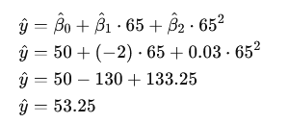

So, the predicted fuel efficiency for a speed of 65 mph would be approximately 53.25 mpg.

## Conclusion

Polynomial regression allows us to model nonlinear relationships between variables by including polynomial terms in the regression equation. It provides a more flexible approach than simple linear regression for capturing curvature and improving the accuracy of predictions when the relationship between variables is nonlinear. However, it's essential to balance model complexity with interpretability and ensure that the chosen degree of polynomial fits the data appropriately without overfitting.

# Provide a detailed explanation of logistic regression.

Logistic regression is a statistical model used for binary classification tasks, where the outcome or dependent variable y takes on two possible discrete values, usually coded as 0 and 1. It models the probability of the dependent variable belonging to a particular category (e.g., whether an email is spam or not, whether a customer will churn or not) based on one or more predictor variables x1​, x2​, ..., xp​.

## Key Concepts in Logistic Regression

### **Logistic Function (Sigmoid Function)**:

The logistic regression model uses the logistic function (also known as the sigmoid function) to model the relationship between the predictors and the probability of the outcome:

Here,

* p (y=1 ∣ x) is the probability that the dependent variable y is 1 given the predictors x.
* x is the vector of predictor variables.
* β is the vector of coefficients (parameters) that logistic regression estimates.

### **Interpretation of Coefficients**:

* The coefficients β in logistic regression represent the change in the log-odds of the outcome for a one-unit change in the predictor variable, holding other variables constant.
* The odds ratio **OR = eβj** ​indicates how a one-unit change in xj​ affects the odds of y=1, again holding other variables constant.

### **Model Fitting**:

* Logistic regression estimates the coefficients β using maximum likelihood estimation (MLE), which finds the parameters that maximize the likelihood of observing the data given the model.
* It does not assume a linear relationship between the predictors and the outcome but models the log-odds of the outcome as a linear function of the predictors.

### **Decision Boundary**:

* Logistic regression predicts probabilities that can be converted into class labels (0 or 1) using a threshold (e.g., 0.5). If p(y=1∣x)≥0.5, the predicted class is 1; otherwise, it's 0.
* The decision boundary is the threshold value where the model is indifferent between predicting 0 or 1.

## Advantages of Logistic Regression

* **Interpretability**: The coefficients β\betaβ can be interpreted in terms of odds ratios, providing insights into how each predictor influences the probability of the outcome.
* **Efficient for Binary Classification**: Logistic regression is particularly efficient when the outcome variable is binary, and it doesn't require the assumptions of linear regression (e.g., normality of residuals).
* **Can Handle Non-linear Effects**: While logistic regression assumes a linear relationship between predictors and the log-odds of the outcome, it can model complex relationships by including interactions or polynomial terms.

## Limitations of Logistic Regression

* **Assumption of Linearity**: Logistic regression assumes a linear relationship between the log-odds of the outcome and the predictors. Non-linear relationships may not be well-captured without transformations or feature engineering.
* **Sensitivity to Outliers**: Outliers can disproportionately affect logistic regression coefficients and predictions.
* **Binary Outcome Only**: Logistic regression is inherently suited for binary outcomes. Extensions exist for multinomial logistic regression (multiple categories) and ordinal logistic regression (ordered categories).

## Application Example

Imagine predicting whether a customer will subscribe to a service based on their age, income, and previous purchase behavior. Logistic regression would estimate the probabilities of subscription based on these predictors, allowing businesses to focus marketing efforts on customers more likely to subscribe.

In conclusion, logistic regression is a powerful and interpretable tool for binary classification tasks, providing estimated probabilities that can inform decision-making in various fields, including healthcare, marketing, finance, and more.

# What are the logistic regression assumptions?

Logistic regression, like any statistical model, relies on certain assumptions to ensure the validity and reliability of its results. These assumptions are important to consider when interpreting the outputs of logistic regression models:

## Assumptions of Logistic Regression

### **Binary or Ordinal Dependent Variable**:

* Logistic regression is suitable for binary (two categories) or ordinal (ordered categories) dependent variables. For binary logistic regression, the dependent variable y should take values of 0 or 1.

### **Independence of Observations**:

* The observations in the dataset should be independent of each other. This means that the occurrence of one observation should not influence the occurrence of another. If observations are not independent (e.g., time-series data with autocorrelation), adjustments or different modeling techniques may be necessary.

### **Linearity of Log-Odds**:

* Logistic regression assumes a linear relationship between the log-odds of the dependent variable and each predictor variable. While this doesn't require the predictors to be linearly related to the dependent variable themselves, they do need to be linearly related to the log-odds.

### **No Multicollinearity**:

* Similar to linear regression, multicollinearity (high correlation among predictor variables) can affect the estimation of coefficients. It can make interpretation difficult and inflate standard errors. It's essential to check for multicollinearity and consider addressing it (e.g., through variable selection or regularization techniques).

### **Large Sample Size**:

* Logistic regression typically performs well with a large sample size. While there's no strict minimum sample size requirement, having an adequate number of observations relative to the number of predictor variables helps ensure stable parameter estimates and reliable inference.

## Practical Considerations

* **Model Fit**: Assess the goodness of fit of the logistic regression model using techniques like the Hosmer-Lemeshow test or deviance residuals. This helps evaluate how well the model fits the observed data compared to expected values.
* **Residual Analysis**: Examine residuals (deviance residuals or Pearson residuals) to check for patterns that could indicate model misspecification or violations of assumptions.
* **Outliers and Influential Observations**: Like in other regression models, outliers and influential observations can affect parameter estimates and predictions. It's important to identify and appropriately handle such observations.

## Conclusion

Understanding and checking these assumptions is crucial for interpreting the results of logistic regression accurately. Violations of these assumptions can lead to biased estimates, incorrect inferences, or unreliable predictions. Therefore, careful consideration of these assumptions and appropriate model diagnostics are essential steps in applying logistic regression effectively in practice.

# Go through the details of maximum likelihood estimation.

Maximum Likelihood Estimation (MLE) is a method used to estimate the parameters of a statistical model by maximizing the likelihood function. It is widely used in various statistical models, including linear regression, logistic regression, and many others. Let's go through the details of maximum likelihood estimation step by step:

## Likelihood Function

## Log-Likelihood Function

## Maximum Likelihood Estimation

## Steps in Maximum Likelihood Estimation

* **Specify the Likelihood Function**: Define the likelihood function L (θ; y) based on the distributional assumptions of the model and the observed data.
* **Compute the Log-Likelihood**: Calculate ℓ (θ; y) by summing the logarithms of the probability densities or mass functions of the observed data.
* **Maximize the Log-Likelihood**: Find the values of θ that maximize ℓ (θ; y). This can be done analytically (if feasible) or numerically using optimization algorithms such as gradient descent, Newton-Raphson method, or other optimization techniques.
* **Interpretation**: Once θ^MLE​ is obtained, it represents the maximum likelihood estimate of the parameters. These estimates are chosen such that the observed data are most probable under the assumed model and given the estimated parameters.

## Properties of MLE

* **Consistency**: Under certain regularity conditions, MLE is consistent, meaning that as the sample size n approaches infinity, θ^MLE ​ converges in probability to the true parameter value θ*.
* **Efficiency**: MLE is asymptotically efficient, meaning that among all unbiased estimators, MLE has the smallest variance as n grows large.
* **Invariance**: MLE is invariant under reparameterization. That is, if θ^MLE​ is the MLE of θ, then g(θ^MLE) is the MLE of g(θ) for any function g.

## Practical Considerations

* **Model Checking**: Assess the goodness of fit of the model using diagnostic tools such as residual analysis, goodness-of-fit tests, and model comparison criteria (e.g., AIC, BIC).
* **Robustness**: MLE can be sensitive to outliers and violations of distributional assumptions. Robust versions of MLE or alternative estimation methods may be needed in such cases.
* **Computational Methods**: Use numerical optimization techniques to maximize the log-likelihood function efficiently, especially for complex models or large datasets.

## Example

In logistic regression, MLE is used to estimate the coefficients β\betaβ that maximize the likelihood of observing the binary outcomes yi​ given the predictor variables xi​. The log-likelihood function is maximized to find the optimal β\betaβ values that best fit the observed data.

In summary, maximum likelihood estimation is a powerful and widely used method for estimating the parameters of statistical models. It provides estimates that are theoretically grounded in probability theory and allows for inference about the population based on observed data.