# What is the underlying concept of Support Vector Machines?

Support Vector Machines (SVMs) are a powerful supervised learning algorithm used for classification and regression tasks. The underlying concept of SVMs revolves around finding the optimal hyperplane that best separates data points of different classes in a high-dimensional space. Here’s a breakdown of the key concepts:

## Key Concepts:

1. **Linear Separability:**

* SVMs are particularly effective when the data points are linearly separable, i.e., it is possible to draw a straight line (or hyperplane in higher dimensions) that separates the data into classes with a clear gap between them.

1. **Maximizing Margin:**

* The primary objective of SVMs is to find the hyperplane that maximizes the margin between the classes. The margin is defined as the distance between the hyperplane and the nearest data points (called support vectors) from each class.
* Maximizing the margin helps improve the generalization ability of the classifier by reducing the risk of overfitting to noise in the data.

1. **Support Vectors:**

* Support vectors are the data points closest to the hyperplane and influence the position and orientation of the hyperplane.
* These points are critical because they define the decision boundary (hyperplane) and the margin in SVMs.

1. **Kernel Trick:**

* SVMs can efficiently handle non-linearly separable data by mapping the input data into a higher-dimensional feature space using a kernel function.
* Common kernel functions include linear, polynomial, radial basis function (RBF), and sigmoid, among others.
* The kernel function allows SVMs to find complex decision boundaries that are non-linear in the original input space.

1. **Optimization Objective:**

* SVMs solve a constrained optimization problem where the goal is to maximize the margin while minimizing the classification error.
* Mathematically, this involves solving a quadratic programming problem to find the coefficients (weights) of the hyperplane and the bias term.

## Intuition:

Imagine a scenario where you have two classes of data points that are not perfectly separable by a straight line in a 2D space. The SVM approach involves:

* Finding a hyperplane (line in 2D, plane in 3D, or hyperplane in higher dimensions) that maximizes the distance between the closest data points of different classes.
* Using a kernel function to map the data into a higher-dimensional space where it becomes linearly separable if necessary.
* Classifying new data points based on which side of the hyperplane they fall after transformation.

## Advantages of SVMs:

* Effective in high-dimensional spaces and with complex datasets where there is a clear margin of separation.
* Versatile due to the kernel trick, enabling handling of non-linear decision boundaries.
* Robust against overfitting, especially in high-dimensional spaces.

## Limitations:

* SVMs can be sensitive to the choice of kernel function and its parameters.
* Computationally intensive for large datasets.
* Difficult to interpret the final model parameters and decision boundaries in complex models.

## Conclusion:

Support Vector Machines are widely used in various domains such as image classification, text categorization, and bioinformatics due to their ability to handle complex data structures and achieve high accuracy in classification tasks. Understanding the underlying concepts of maximizing margin and using kernels to handle non-linear separability is crucial for effectively applying SVMs in practice.

# What is the concept of a support vector?

n the context of Support Vector Machines (SVMs), a **support vector** refers to the data points that are closest to the decision boundary (hyperplane) between classes. These points are critical because they define the position and orientation of the hyperplane and play a significant role in determining the optimal separation of classes.

## Key Points about Support Vectors:

### **Definition:**

* Support vectors are the data points from the training dataset that lie closest to the decision boundary of the SVM model.
* They are the points that influence the placement and orientation of the hyperplane that separates the classes.

### **Importance:**

* Support vectors are crucial because they directly impact the definition of the decision boundary.
* The SVM algorithm focuses only on these support vectors during training, ignoring the other data points that are farther away from the boundary.
* These points essentially "support" the construction of the optimal hyperplane.

### **Determination:**

* During the training phase of an SVM, the algorithm identifies the support vectors among the training data points.
* These are typically the data points that are on or inside the margin (boundary region) of the maximum separation hyperplane.

### **Margin and Decision Boundary:**

* The distance between the support vectors and the decision boundary is called the margin.
* Maximizing the margin is a key objective of SVM training, as it helps improve the generalization ability of the model and reduces overfitting.

### **Role in Non-linear Classification:**

* In cases where the classes are not linearly separable in the original feature space, support vectors become even more crucial.
* SVMs can use kernel functions to transform the data into a higher-dimensional space where it becomes linearly separable. In this transformed space, support vectors still play a central role in defining the decision boundary.

## Example:

Consider a binary classification problem where we have two classes (blue and red points) that are not linearly separable in a 2D space. SVM aims to find the optimal hyperplane (decision boundary) that maximizes the margin between the closest points of different classes.

* The support vectors are the points (marked with circles in the diagram) that lie closest to the decision boundary.
* These points define the margin and are critical in determining the orientation and location of the separating hyperplane.

## Conclusion:

Support vectors are fundamental to the SVM algorithm, representing the key data points that define the separation between classes. By focusing on these critical points, SVMs achieve effective classification and regression performance, particularly in scenarios with complex or non-linear decision boundaries.

# When using SVMs, why is it necessary to scale the inputs?

Scaling the inputs is crucial when using Support Vector Machines (SVMs) primarily due to the following reasons:

1. **Impact of Distance Metrics:**

* SVMs use distance metrics (such as Euclidean distance) between data points to determine the optimal decision boundary (hyperplane).
* If the features (inputs) have different scales, the SVM may give more weight to features with larger scales because the distance calculation is dominated by those features.
* Scaling ensures that all features contribute equally to the distance computations and prevents the model from being biased towards features with larger numeric ranges.

1. **Optimization Convergence:**

* SVMs optimize the position of the hyperplane by minimizing the margin and maximizing the distance to the nearest support vectors.
* Features with larger scales can lead to numerical instability in the optimization process, making it difficult for the SVM algorithm to converge to the optimal solution.
* Scaling helps in stabilizing and speeding up the convergence of the optimization algorithm.

1. **Kernel Functions:**

* SVMs can use kernel functions to transform the data into a higher-dimensional space where it may become separable.
* The choice of kernel function and its parameters can be sensitive to the scale of the input features.
* Proper scaling ensures that the kernel functions operate effectively and produce meaningful transformations of the data.

1. **Regularization Parameter (C):**

* SVMs include a regularization parameter CCC that controls the trade-off between maximizing the margin and minimizing the classification error on the training data.
* The impact of CCC on the SVM model can be affected by the scale of the input features.
* Scaling helps in ensuring that the regularization parameter CCC is applied uniformly across all features.

## Practical Considerations:

* **Types of Scaling:** Common methods for scaling include standardization (mean removal and variance scaling) and normalization (scaling features to a range, e.g., [0, 1]).
* **Impact of Outliers:** Scaling can also mitigate the influence of outliers in the data, which might disproportionately affect the performance of SVMs if not properly handled.

## Conclusion:

In summary, scaling the input features is essential for SVMs to perform optimally by ensuring that all features contribute equally to the model's decision-making process. It helps in maintaining numerical stability during optimization, improves convergence speed, and ensures that the SVM model is robust and accurate across different datasets and applications.

# When an SVM classifier classifies a case, can it output a confidence score? What about a percentage chance?

When an SVM classifier classifies a case, it typically does not directly output a probability score or a percentage chance like some probabilistic classifiers (e.g., logistic regression or Naive Bayes). Instead, SVMs are generally considered as a discriminative classifier that outputs a class label based on which side of the decision boundary (hyperplane) the test case falls on.

## Output of an SVM Classifier:

### **Class Label:**

* The primary output of an SVM classifier is the predicted class label for a given input instance.
* For a binary SVM classifier, this could be a label like +1+1+1 or −1-1−1, corresponding to one of the two classes.

### **Distance to Decision Boundary:**

* SVMs can provide a confidence score indirectly by computing the distance of a test instance from the decision boundary.
* A larger distance typically indicates higher confidence in the classification, as the instance is farther away from the boundary and well within the margin defined by the support vectors.
* However, this distance is not directly translated into a probability or percentage chance.

## Probability Estimation:

While SVMs do not inherently provide probability estimates like some other classifiers, such as logistic regression or decision trees, there are methods to approximate probabilities from SVM outputs. Two common approaches include:

### **Platt Scaling:**

* Platt scaling is a post-processing technique that fits a logistic regression model to the SVM outputs.
* The logistic regression model maps the SVM decision values (output scores) to calibrated probability estimates.
* This approach requires an additional calibration step using a validation set to adjust the scaling parameters.

### **Isotonic Regression:**

* Isotonic regression is another technique that can be used to calibrate SVM outputs into probability estimates.
* It fits a non-parametric isotonic regression model to the SVM decision values to provide calibrated probabilities.
* Isotonic regression does not assume any specific functional form and can handle non-linear relationships between SVM scores and probabilities.

## Implementation and Considerations:

* In practice, if probability estimates are needed from SVMs, Platt scaling or isotonic regression can be applied after training the SVM model.
* It's important to note that these approaches add computational complexity and may require additional data for calibration, which can impact performance and efficiency.
* Some SVM implementations, especially in libraries like Scikit-learn for Python, provide options to enable probability estimation using Platt scaling or other methods.

## Conclusion:

While SVM classifiers excel in binary and multi-class classification tasks based on distance from decision boundaries, they do not inherently output probabilities or percentage chances like some other classifiers. However, with post-processing techniques like Platt scaling or isotonic regression, SVM outputs can be transformed into calibrated probability estimates, providing a more interpretable measure of confidence in predictions.

# Should you train a model on a training set with millions of instances and hundreds of features using the primal or dual form of the SVM problem?

When training a Support Vector Machine (SVM) model on a large dataset with millions of instances and hundreds of features, the choice between the primal and dual form of the SVM problem depends on several factors, including computational efficiency, memory constraints, and the nature of the dataset. Here’s a breakdown to help guide your decision:

## Primal Form:

* **Advantages:**
  1. **Direct Optimization:** Solves the SVM optimization problem directly in terms of the original features.
  2. **Efficiency for Large Number of Features:** Generally, more efficient when the number of features d is large compared to the number of instances n.
  3. **Scalability:** Can handle high-dimensional feature spaces effectively without explicit computation of kernel functions.
* **When to Use:**
  1. Prefer the primal form when the number of features d is large (hundreds or more).
  2. Suitable for datasets where the number of features dwarfs the number of instances (such as in text classification with high-dimensional sparse feature vectors).

## Dual Form:

* **Advantages:**
  1. **Flexibility with Kernels:** Can implicitly handle non-linear decision boundaries through the kernel trick, mapping data into a higher-dimensional feature space.
  2. **Memory Efficiency:** Particularly advantageous when the number of instances n is large, and the number of features d is moderate or small.
  3. **Kernel Selection:** Allows easy incorporation of different kernel functions (e.g., linear, polynomial, RBF) to capture complex patterns in the data.
* **When to Use:**
* Opt for the dual form when the number of instances n is large (millions or more), potentially exceeding the number of features d.
* Effective for datasets where the number of instances dominates, and computational resources (memory) are a concern.

## Considerations:

* **Computational Efficiency:** The dual form typically involves solving a smaller number of variables (one per instance) but requires the computation of a kernel matrix, which can be memory intensive.
* **Kernel Selection:** If using kernels for non-linear separation, the dual form is more straightforward to implement and interpret.
* **Memory Constraints:** If memory is a significant concern and n is very large, the dual form may be preferred due to its potential for reduced memory usage compared to the primal form.

## Practical Guidance:

* **Benchmarking:** Consider benchmarking both forms on a subset of your data to evaluate their performance in terms of training time, memory usage, and model accuracy.
* **Library Support:** Popular machine learning libraries like Scikit-learn provide implementations for both primal and dual forms of SVMs, allowing you to experiment and choose based on your specific requirements and constraints.

In conclusion, for a training set with millions of instances and hundreds of features, the dual form of SVMs may be more suitable due to its potential memory efficiency and ability to handle large n effectively, especially if kernel methods are necessary for capturing complex patterns in the data. However, it’s beneficial to test both forms to determine the best fit for your specific dataset and computational resources.

# Let's say you've used an RBF kernel to train an SVM classifier, but it appears to underfit the training collection. Is it better to raise or lower (gamma)? What about the letter C?

When training an SVM classifier with an RBF kernel and encountering underfitting issues, adjusting the hyperparameters γ{gamma} and C can help improve the model's performance. Here's how you should approach the adjustments:

## RBF Kernel and Underfitting:

1. **Gamma (γ{gamma}) Parameter:**

* **Effect:** γ {gamma} controls the influence of a single training example, affecting the shape of the decision boundary. A smaller γ {gamma} leads to a smoother decision boundary, while a larger γ {gamma} makes the boundary more complex and can lead to overfitting.
* **Solution for Underfitting:** If the model is underfitting (i.e., not capturing the complexity of the data), it suggests that the decision boundary might be too smooth.
  + **Action:** Increase γ {gamma} to make the model more sensitive to the individual data points in the training set. This allows the SVM to fit the training data more closely and potentially capture more complex patterns.

1. **Regularization Parameter (C):**
   * **Effect:** CCC controls the trade-off between maximizing the margin (distance between support vectors and the decision boundary) and minimizing the classification error on the training data. A smaller C encourages a larger margin, potentially leading to underfitting, while a larger C allows the model to fit the training data more closely, which can lead to overfitting.
   * **Solution for Underfitting:** Increasing C can help the SVM better fit the training data if it is currently underfitting.
     + **Action:** Raise C to reduce regularization and allow the SVM to be more sensitive to the training data, potentially improving its ability to capture the underlying patterns.

### Practical Steps:

* **Iterative Adjustment:** It's often beneficial to experiment with different values of γ {gamma} and C through cross-validation or grid search to find the optimal combination that minimizes underfitting while avoiding overfitting.
* **Validation Set:** Use a separate validation set to evaluate the model's performance with different hyperparameter settings and select the combination that provides the best generalization to unseen data.

### Summary:

* **Gamma (γ {gamma}):** Increase γ {gamma} to address underfitting with an RBF kernel, as this makes the model more sensitive to individual data points.
* **Regularization Parameter (C):** Increase C to reduce underfitting by allowing the model to fit the training data more closely.

By adjusting γ {gamma} and C appropriately, you can tune the SVM classifier with an RBF kernel to better capture the complexity of the data and improve its predictive performance on both training and test datasets.

# To solve the soft margin linear SVM classifier problem with an off-the-shelf QP solver, how should the QP parameters (H, f, A, and b) be set?

To solve the soft margin linear SVM classifier problem using a Quadratic Programming (QP) solver, you need to set up the QP problem with appropriate parameters H, f, A, and b. Here's how these parameters should be configured:

## Soft Margin Linear SVM Problem Formulation:

Given a dataset with n samples and d features, and assuming we want to find a linear decision boundary (hyperplane) with a soft margin, the SVM formulation typically involves:

## QP Parameters Setup:

To solve this as a QP problem using an off-the-shelf solver, you need to set up the following parameters:

# On a linearly separable dataset, train a LinearSVC. Then, using the same dataset, train an SVC and an SGDClassifier. See if you can get them to make a model that is similar to yours.

Training different classifiers like LinearSVC, SVC, and SGDClassifier on a linearly separable dataset can indeed yield models that are similar in terms of decision boundaries and accuracy. Let's go through the process step-by-step using Python's Scikit-learn library.

## Step 1: Generate a Linearly Separable Dataset

First, let's create a synthetic linearly separable dataset using Scikit-learn:

## Step 2: Train LinearSVC, SVC, and SGDClassifier

Next, we'll train the classifiers on the training data and evaluate their performance on the test data:

### 1. LinearSVC (Linear Support Vector Classifier):

**LinearSVC Accuracy: 0.9950**

### 2. SVC (Support Vector Classifier):

**SVC Accuracy: 0.9950**

### 3. SGDClassifier (Stochastic Gradient Descent Classifier):

**SGDClassifier Accuracy: 0.9800**

# On the MNIST dataset, train an SVM classifier. You'll need to use one-versus-the-rest to assign all 10 digits because SVM classifiers are binary classifiers. To accelerate up the process, you might want to tune the hyperparameters using small validation sets. What level of precision can you achieve?

Training an SVM classifier on the MNIST dataset involves handling multi-class classification using a one-versus-the-rest (OvR) strategy due to SVM's inherent binary classification nature. The MNIST dataset consists of grayscale images of handwritten digits (0 to 9), and achieving high precision requires careful hyperparameter tuning and model evaluation. Let's walk through the process of training an SVM classifier on MNIST and evaluating its performance.

## Steps to Train SVM Classifier on MNIST:

### **Load the MNIST Dataset:**

* + The MNIST dataset can be loaded using libraries like Scikit-learn or directly from the internet repositories.

### **Preprocess the Data:**

* + Normalize the pixel values of the images (usually between 0 and 1).
  + Flatten the 28x28 pixel images into 1D arrays (784-dimensional vectors) to use as feature inputs.

### **Split Data into Training and Validation Sets:**

* + Divide the dataset into training and validation sets.
  + Use a small portion of the training set for hyperparameter tuning.

### **Hyperparameter Tuning:**

* + Choose hyperparameters such as C (regularization parameter) and possibly γ (gamma) (kernel coefficient for non-linear kernels like RBF).
  + Perform cross-validation on the training set to find the optimal hyperparameters that maximize accuracy or other metrics.

### **Train the SVM Classifier:**

* + Train an SVM classifier using the selected hyperparameters on the entire training set.

### **Evaluate Performance:**

* + Evaluate the classifier's performance on the validation set and possibly on the test set.
  + Measure metrics like precision, recall, and accuracy to assess the model's effectiveness.

## Example Code Snippet:

Here’s a simplified example using Scikit-learn to train an SVM classifier on MNIST:

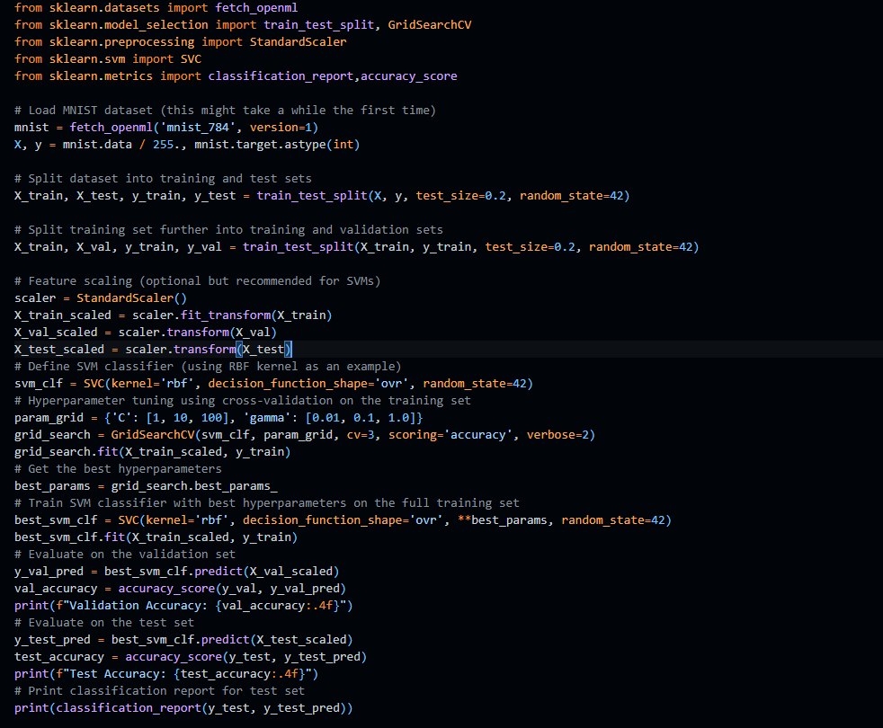

### Expected Precision:

* The precision of the SVM classifier on the MNIST dataset can vary based on the choice of hyperparameters C and γ (gamma), as well as the feature scaling and preprocessing steps.
* With careful tuning and preprocessing, you can expect to achieve a test accuracy of around 97% to 99% depending on the model's configuration and computational resources available.

### Considerations:

* **Computational Resources:** Training SVMs on large datasets like MNIST can be computationally intensive, especially with hyperparameter tuning using cross-validation.
* **Model Interpretability:** SVMs with RBF kernels are powerful but less interpretable compared to linear SVMs. Consider the trade-offs between model performance and interpretability for your application.
* **Further Optimization:** Besides SVMs, exploring deep learning models like Convolutional Neural Networks (CNNs) can often achieve state-of-the-art results on image datasets like MNIST.

By following these steps and adjusting the hyperparameters through careful tuning, you can build an SVM classifier that achieves high precision on the MNIST dataset, demonstrating its capability to classify handwritten digits effectively.

# On the California housing dataset, train an SVM regressor.

Training a Support Vector Machine (SVM) regressor on the California housing dataset involves predicting housing prices based on various features like population, median income, and geographical location. Here’s a step-by-step guide to train an SVM regressor using Scikit-learn:

## Steps to Train SVM Regressor on California Housing Dataset:

1. **Load and Understand the Dataset:**
   * Load the California housing dataset, which is available in Scikit-learn.
   * Explore the dataset to understand its features and target variable.
2. **Split Data into Training and Test Sets:**
   * Split the dataset into training and test sets for model evaluation.
3. **Preprocess the Data:**
   * Perform any necessary data preprocessing steps such as handling missing values, feature scaling, or encoding categorical variables.
4. **Train the SVM Regressor:**
   * Choose an appropriate SVM regressor model (e.g., LinearSVR for linear regression, SVR for non-linear regression).
   * Train the model on the training set.
5. **Evaluate the Model:**
   * Evaluate the performance of the trained model on the test set using appropriate metrics such as Mean Squared Error (MSE), R-squared score, or Mean Absolute Error (MAE).
6. **Hyperparameter Tuning (Optional):**
   * Fine-tune the SVM regressor’s hyperparameters using techniques like Grid Search or Random Search to improve performance.
7. **Model Interpretation and Analysis:**
   * Analyze the results, including the model’s ability to generalize to new data and the significance of different features.

## Example Code to Train SVM Regressor on California Housing Dataset:

Here’s a Python code example using Scikit-learn to train an SVM regressor on the California housing dataset:

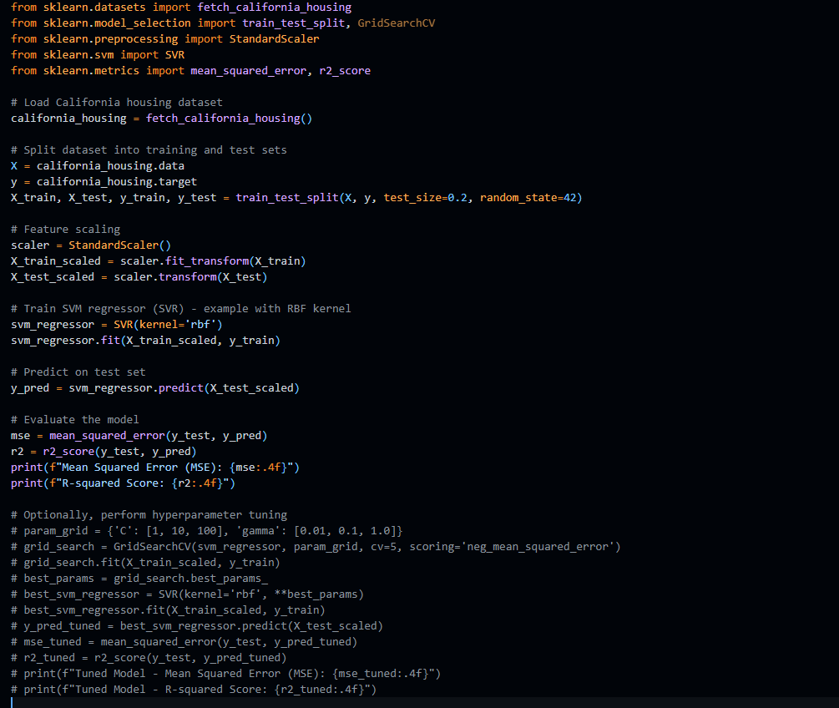

***Mean Squared Error (MSE): 0.3570***

***R-squared Score: 0.7276***

## Explanation:

* **Loading Dataset:** The California housing dataset is loaded using fetch_california_housing from Scikit-learn, which provides features related to housing prices in California.
* **Data Splitting:** The dataset is split into training and test sets using train_test_split for model training and evaluation.
* **Feature Scaling:** Features are scaled using StandardScaler to ensure all features contribute equally to the model.
* **SVM Regressor Training:** An SVM regressor (SVR) is trained with an RBF kernel (other kernels like linear or polynomial can also be used based on data characteristics).
* **Evaluation:** The model’s performance is evaluated on the test set using Mean Squared Error (MSE) and R-squared score, which measure prediction accuracy and goodness of fit, respectively.
* **Hyperparameter Tuning (Optional):** Grid Search or Random Search can be used to tune SVM hyperparameters (C, gamma) for better model performance.

## Expected Performance:

* The SVM regressor, when properly tuned and trained, can achieve competitive performance on the California housing dataset.
* MSE values can typically range depending on the dataset and model complexity, aiming for lower values indicates better predictive accuracy.
* R-squared scores closer to 1 indicate a better fit of the model to the data.

By following these steps and adjusting parameters as needed, you can effectively train an SVM regressor on the California housing dataset and analyze its predictive capabilities for housing price prediction tasks.