ASSIGNMENT 7

NAME : SAHIL SATISH PAWAR
SUBJECT : FSDL LAB
PRN : 123B1B228
BATCH : D-1

ASSIGNMNET TITLE : Develop a web application for Water Usage Tracker System with MongoDB Backend and using React.js and Express.

OUTPUT :
- Dashboard

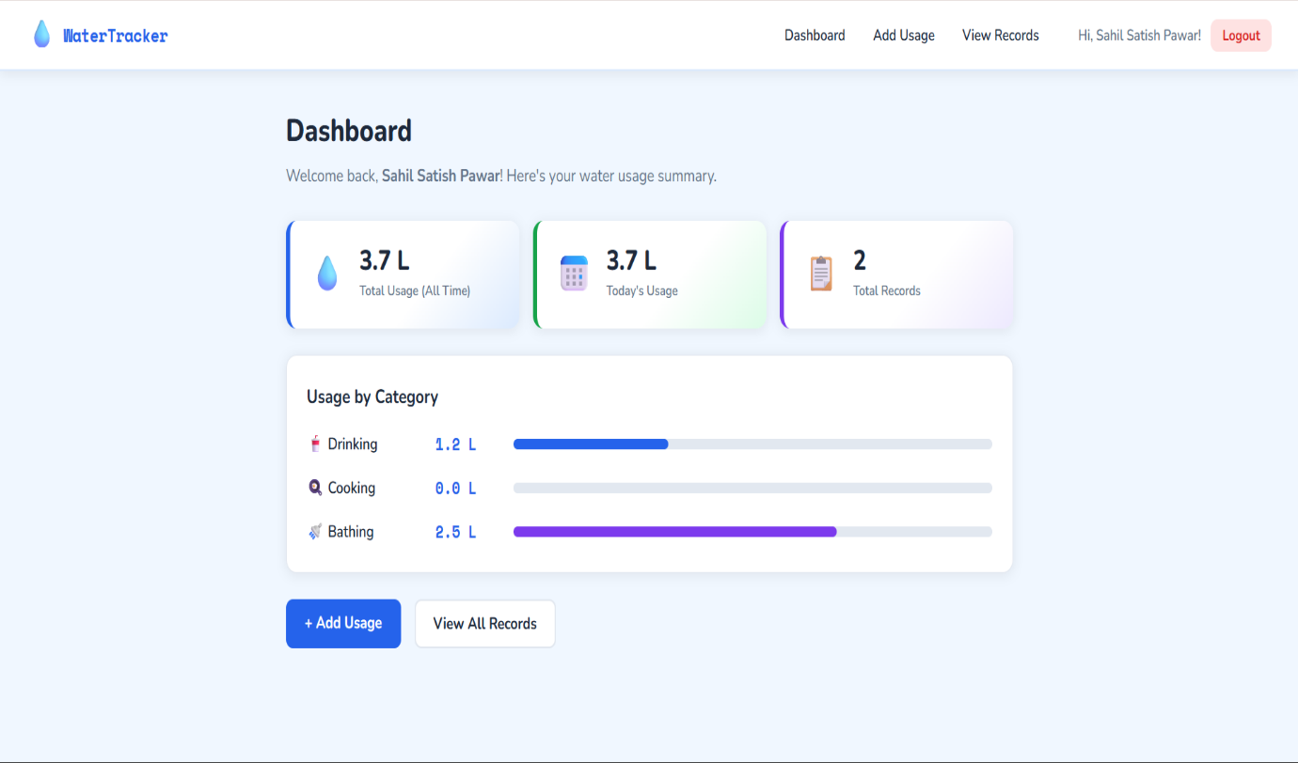

- Add Water Usage

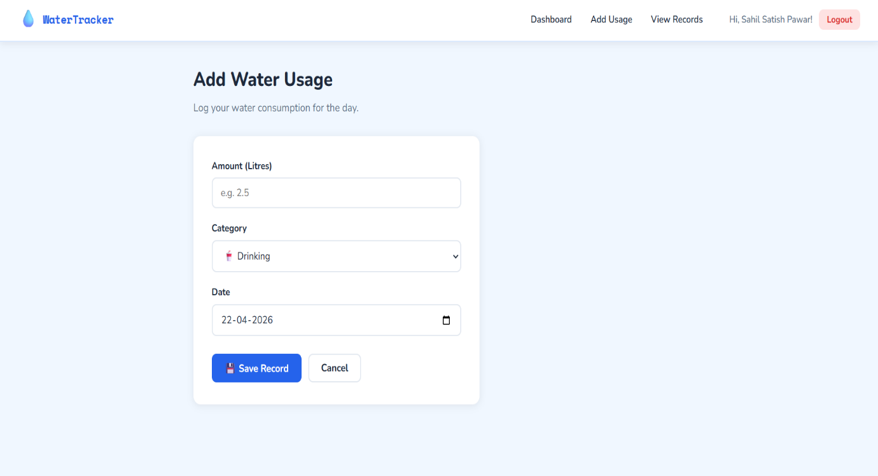

- View water Usage

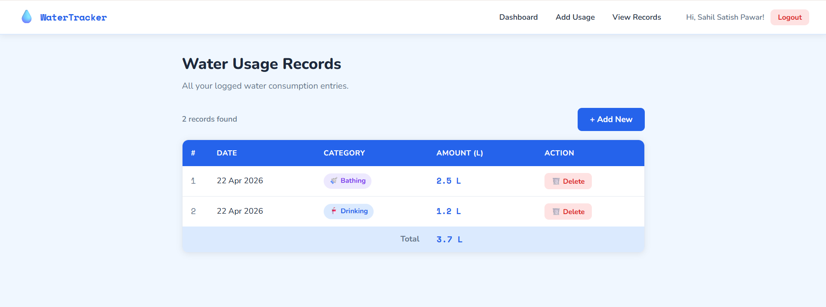

- Login

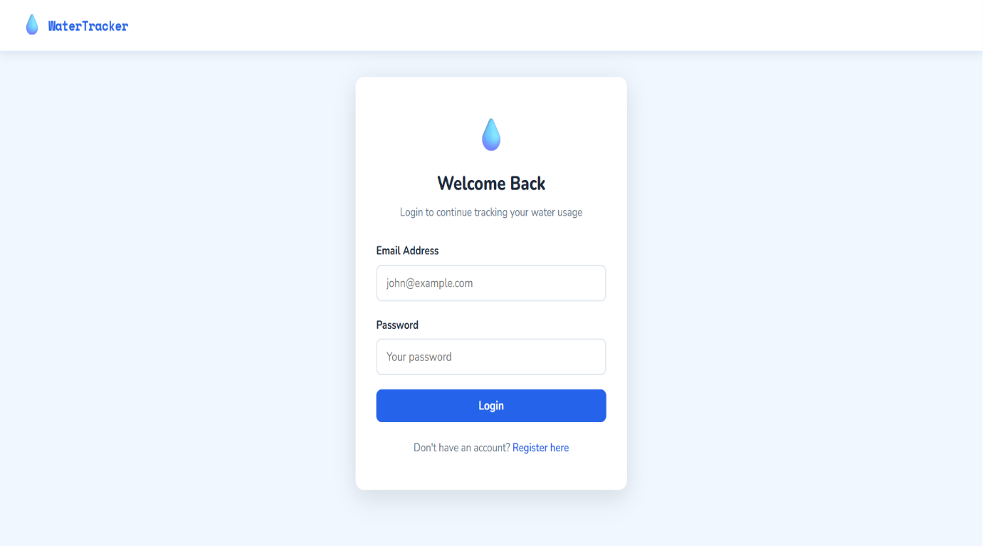
- Register

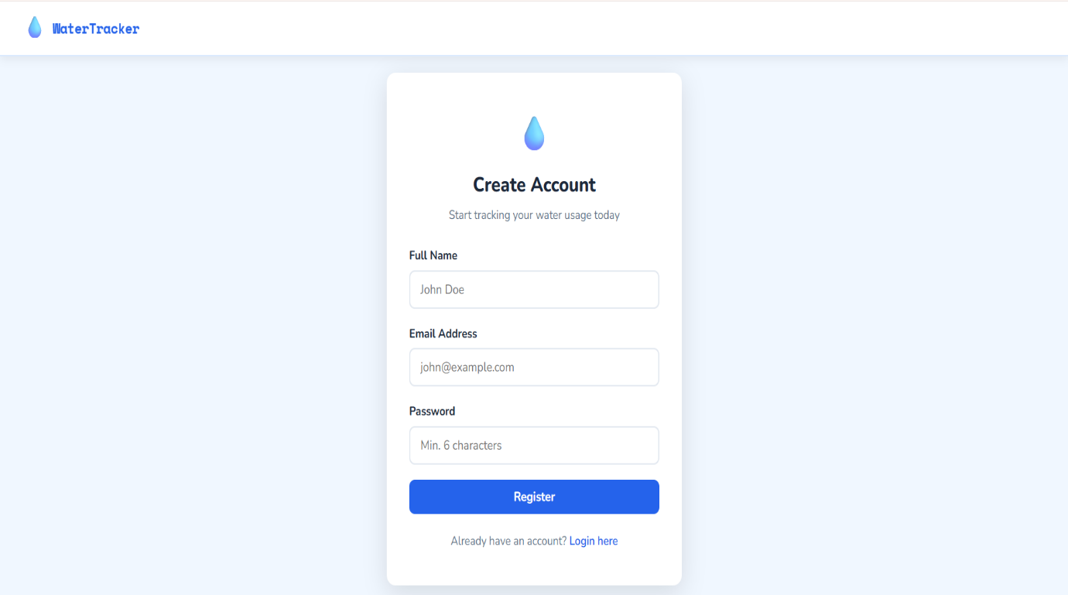

- Database
