**INDIVIDUAL PROJECT**

NAME: SAKSHEE PAWAR

NUID:002201494

**Observations on the dataset**: -

1) **Null** values are present in the columns for "neighbourhood," "county," "police district," and "parcel id",etc.

2) The dataset contains a column named "**Department,**" but the "Department" information is redundantly mentioned in the "**Workgroup**" column, which is unnecessary since there is a dedicated column for it.

3) The "**DAYS TO CLOSE**" column should have an integer (INT) data type, but it is currently defined as a float.

4) The "**ZIPCODE**" column should be of integer (INT) data type, but it is defined as a float.

5) The "**CREATION TIME**" column should use the HH:MI:SS format for time, rather than AM/PM.

6) The "**EXCEEDED EST TIMEFRAME**" column is defined as VARCHAR(254), but it only contains a single character, which is unnecessary.

7) The table contains a total of **1,563,215** rows.

ALTERYX:

Browse tool can be used to observe the data

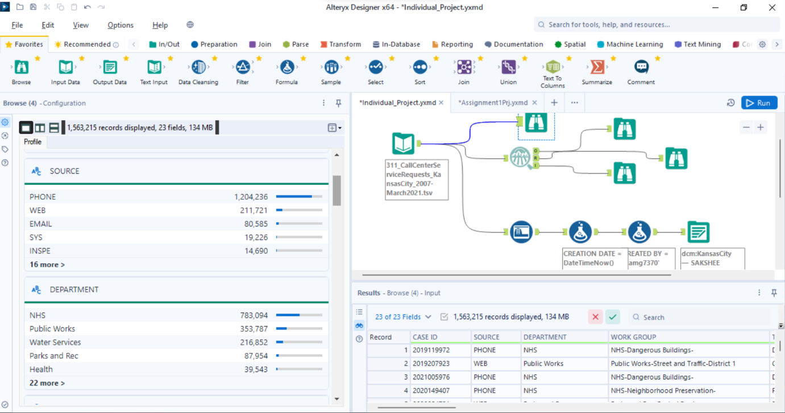

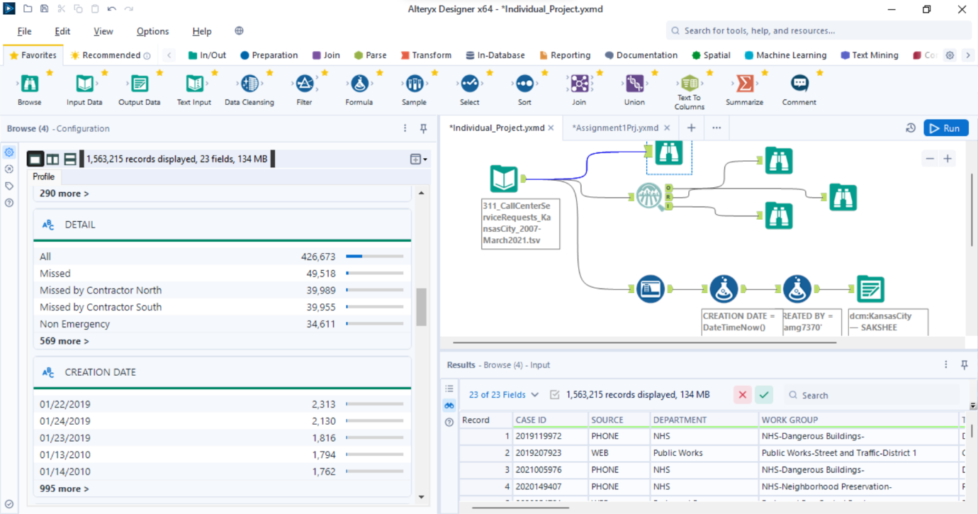

Below are the results using Field Summary tool:

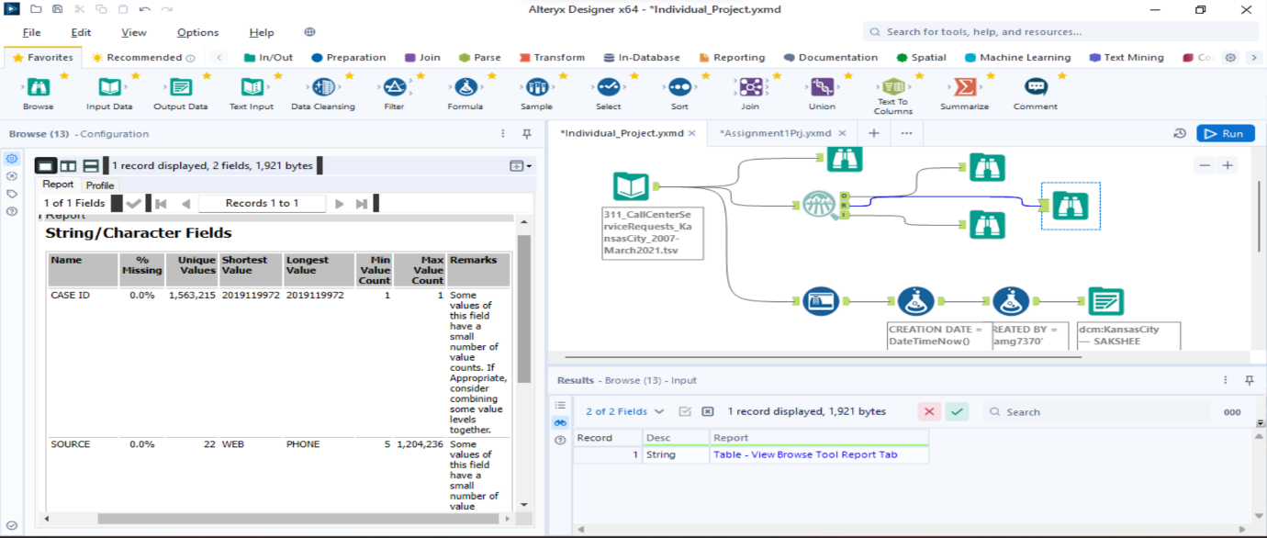

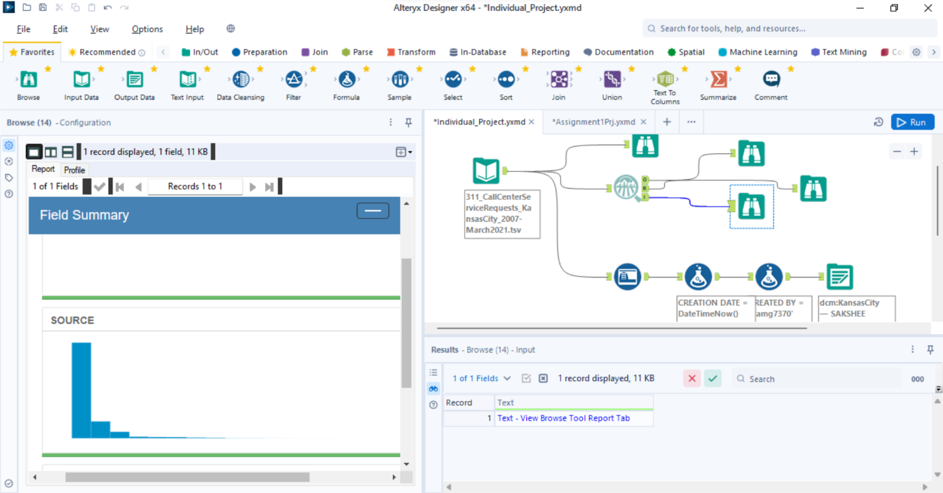

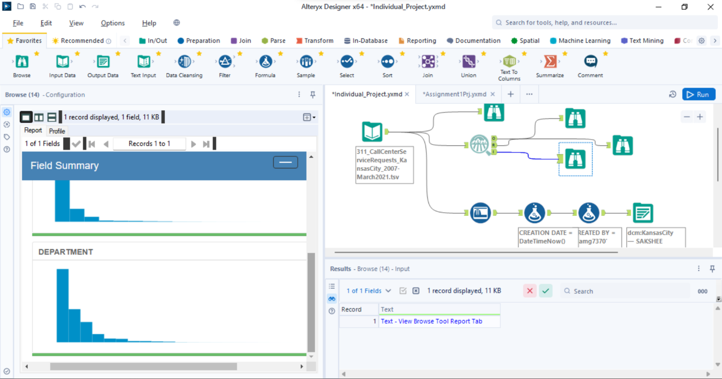

By using the Auto field tool change the datatype:

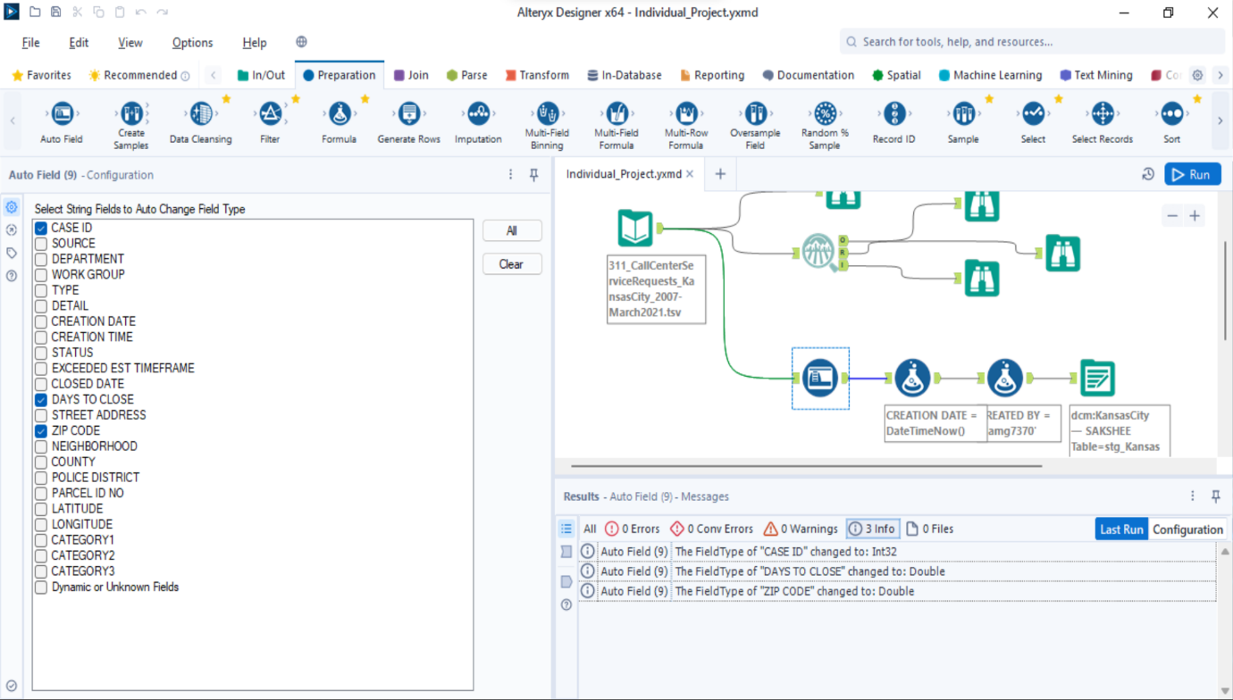

By using the formula created Column named CREATED BY:

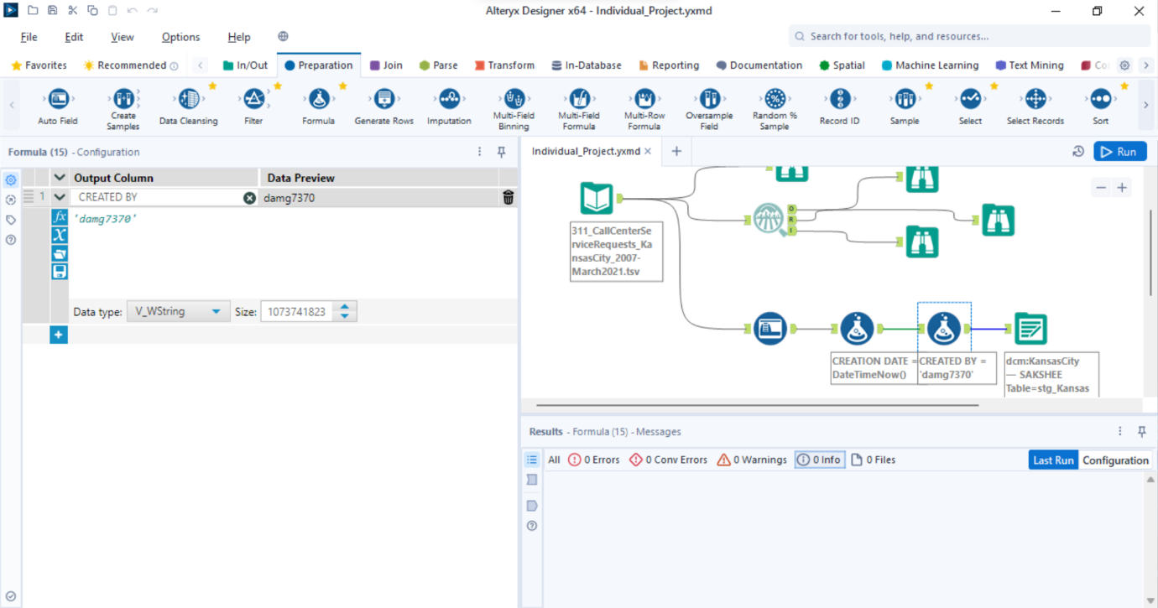

By using the Formula tool created Creation date column:

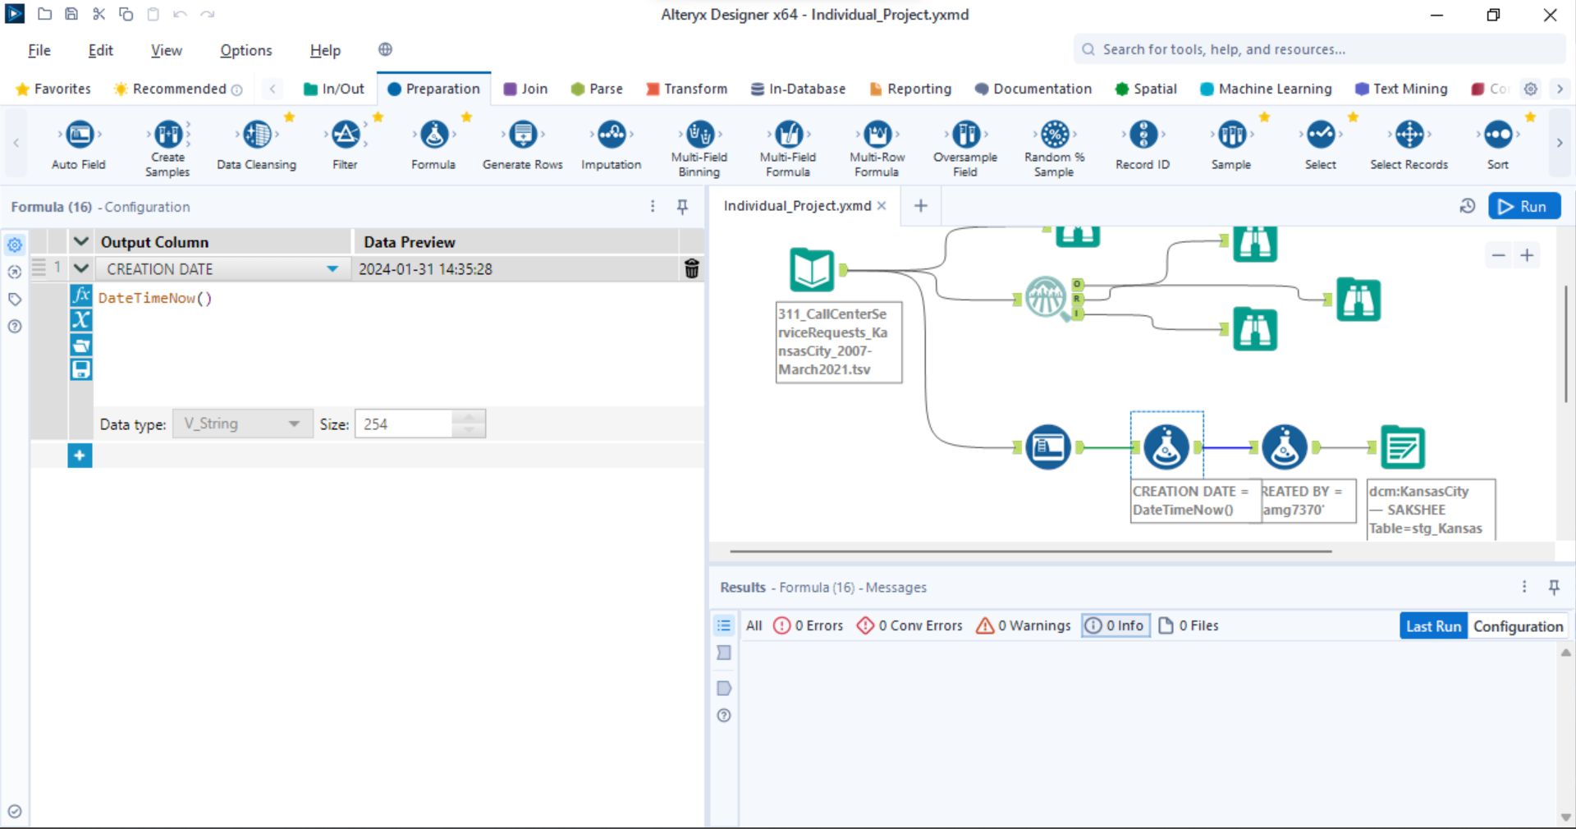

 Row counts using SQL query:-

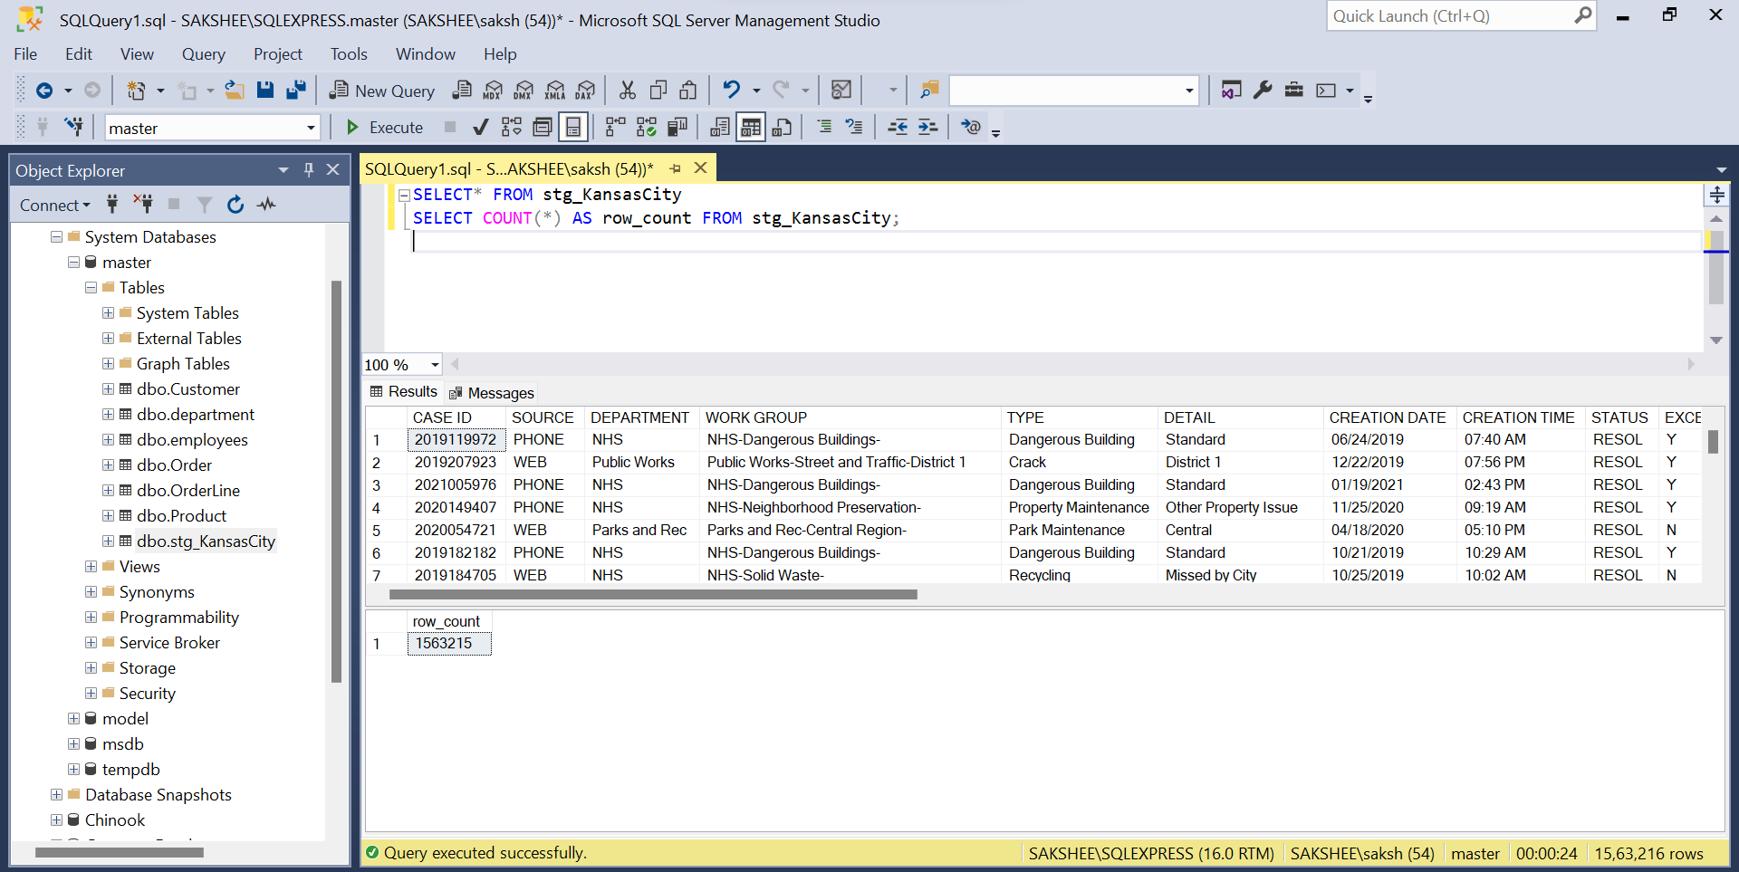

**BUSINESS QUESTIONS**:

(1) **What is the overall trend in Service Requests over the years 2018-2021?**

There was a significant increase in service request in the year 2019 but the service request again decreased for the year 2019 to 19,683.

• **How have Service Requests changed on a monthly basis?**

The highest number of service request were observed in the month of January 2019 and the lowest number of service request was in October 2021.

(2**) What is the overall trend in Service Requests over Sources?**

The Service request for the source phone was the highest and reached 1204236 and the lowest service request received was for the source KCSPD with a number of just 5.

(3**) What is the overall trend in Service Requests received by Departments?**

NHS department had received the highest number of service request which is 783094 and the Human Resource and IT department received lowest service request with 1 request.

(4) **What are the top 10 cases whose response time was fastest? Categorize it with Category1 and Type of Request.**

The top 10 cases include air quality as the highest in the top 10 with type as pollutant

(5) **What are the Top 10 areas where most number of request were raised?**

**top 10 ZIP codes by the number of requests raised. Here are the top 10 areas based on the request count:**

1. ZIP Code: 64130 - Requests: 133154

2. ZIP Code: 64128 - Requests: 90667

3. ZIP Code: 64127 - Requests: 80986

4. ZIP Code: 64114 - Requests: 73097

5. ZIP Code: 64131 - Requests: 76437

6. ZIP Code: 64132 - Requests: 70661

7. ZIP Code: 64110 - Requests: 70073

8. ZIP Code: 64126 - Requests: 63771

9. ZIP Code: 64119 - Requests: 52724

10. ZIP Code: 64111 - Requests: 50195

(6) **How does the workload vary among different departments and work groups? Create a visual representation to highlight the distribution.**

The department NHS with WORKGROUP with NHS neighbourhood preservation has the highest workload among different department and groups.

(7) **Visualize the distribution of response times for each department. Are there any outliers or patterns in response times?**

The distinct outlier is the NHS Department which has a significantly higher response time with value of 2500 days while the other majority departments have response time clustered below 500days.

(8) **Create a visualization to show the composition of service request statuses (open, closed, in progress). How has this composition changed over the years 2018-2021?**

The composition of service request statuses from 2018 to 2021 showed a fluctuating trend, the number of resolved requests increased substantially in 2019 but decreased in 2020 and 2021, indicating changing patterns in request handling efficiency over these years.

(9) **Visualize the average days to close service requests for each category1. Are there categories with consistently longer closure times?**

The category Data Not Available has an exceptionally long closure time, averaging 1,189 days. The next highest average is “Weeds” at 420 days. All other categories shown range from 66 to 187 days to close, which are considerably shorter durations.

• **Show top 10**

The top 10 are Data not Available, Weeds, Property and Nuisance Violations, Property Violations, Water Main Break, Property, Mowing, Information Request, Water Service and Nuisance Violations respectively.

(10**) Show the relationship between workload (number of service requests) and efficiency (days to close) for each department?**

The NHS Department has highest number of days to close at 762,712 which suggests proportionate relationship between workload and days to close. The Human Resource and IT department has fewer service request lowest total days to close showing direct relation.