(1) Service Requests Over Time:

• What is the overall trend in Service Requests over the years 2018-2021?

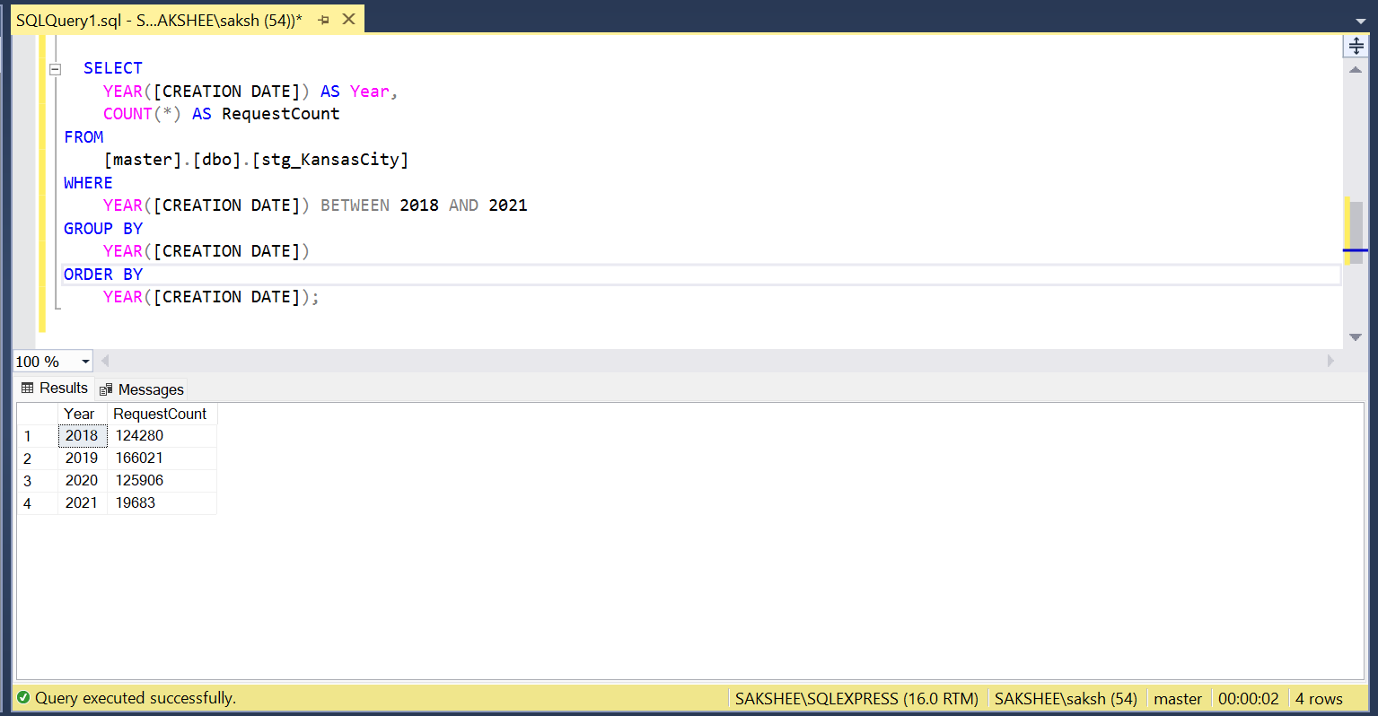

• How have Service Requests changed on a monthly basis?

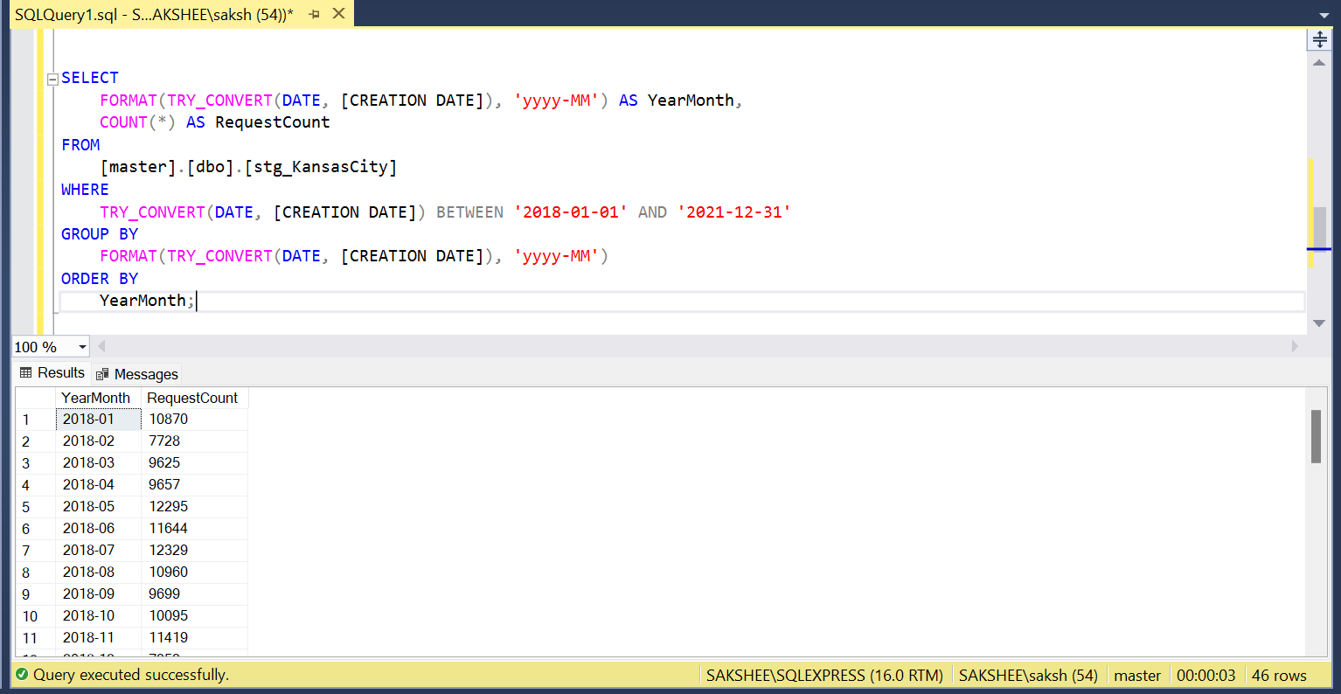

(2) Volume of service requests received from different sources:

• What is the overall trend in Service Requests over Sources?

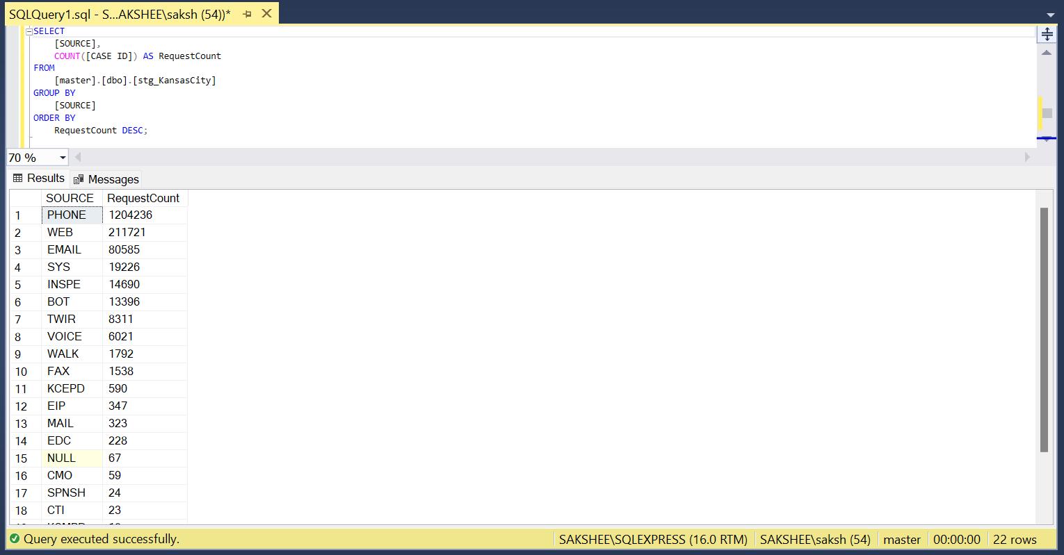

(3) Volume of service requests received by Department:

• What is the overall trend in Service Requests received by Departments?

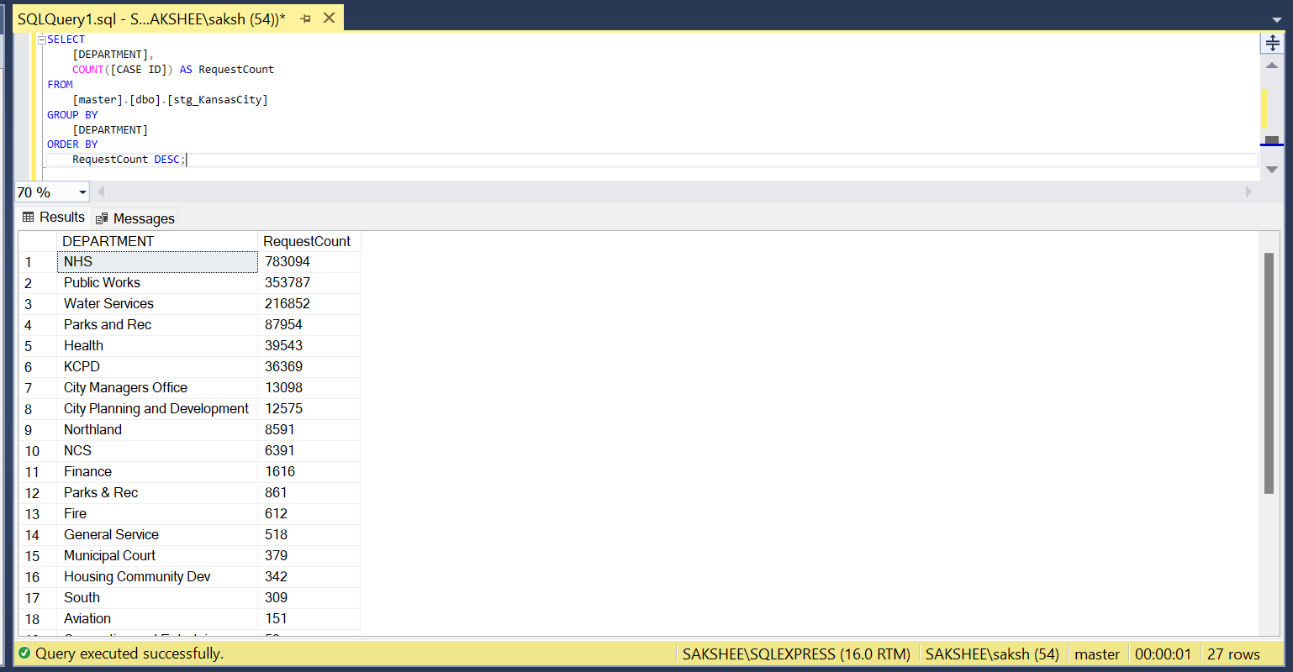

(4) Top 10 Performance Metrics (Response Time) per CATEGORY and Type of Request:

• What are the top 10 cases whose response time was fastest? Categorize it with Category1 and Type of Request.

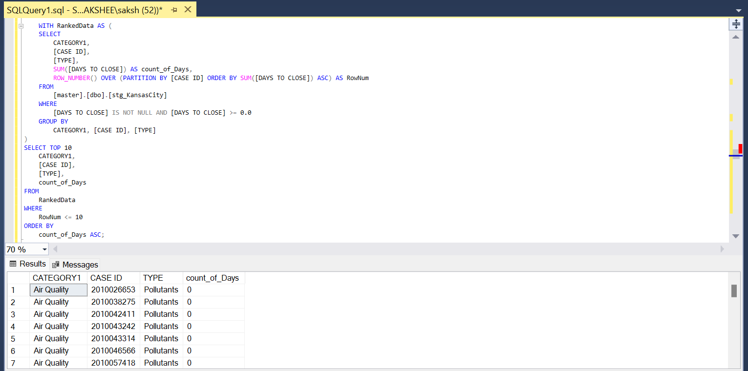

(5) Geographical Visualization:

• What are the Top 10 areas where most number of request were raised?

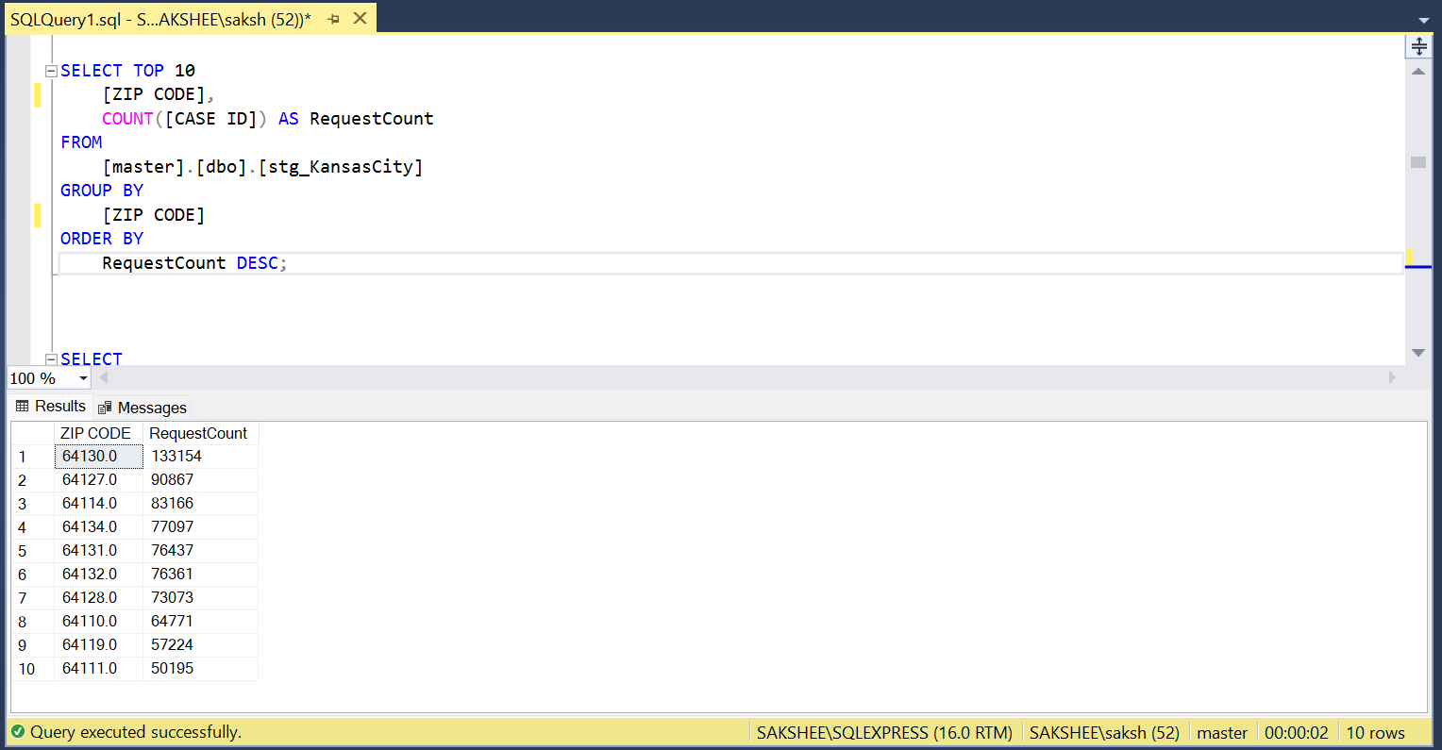

(6) Departmental Workload Comparison:

• How does the workload vary among different departments and work groups? Create a visual representation to highlight the distribution.

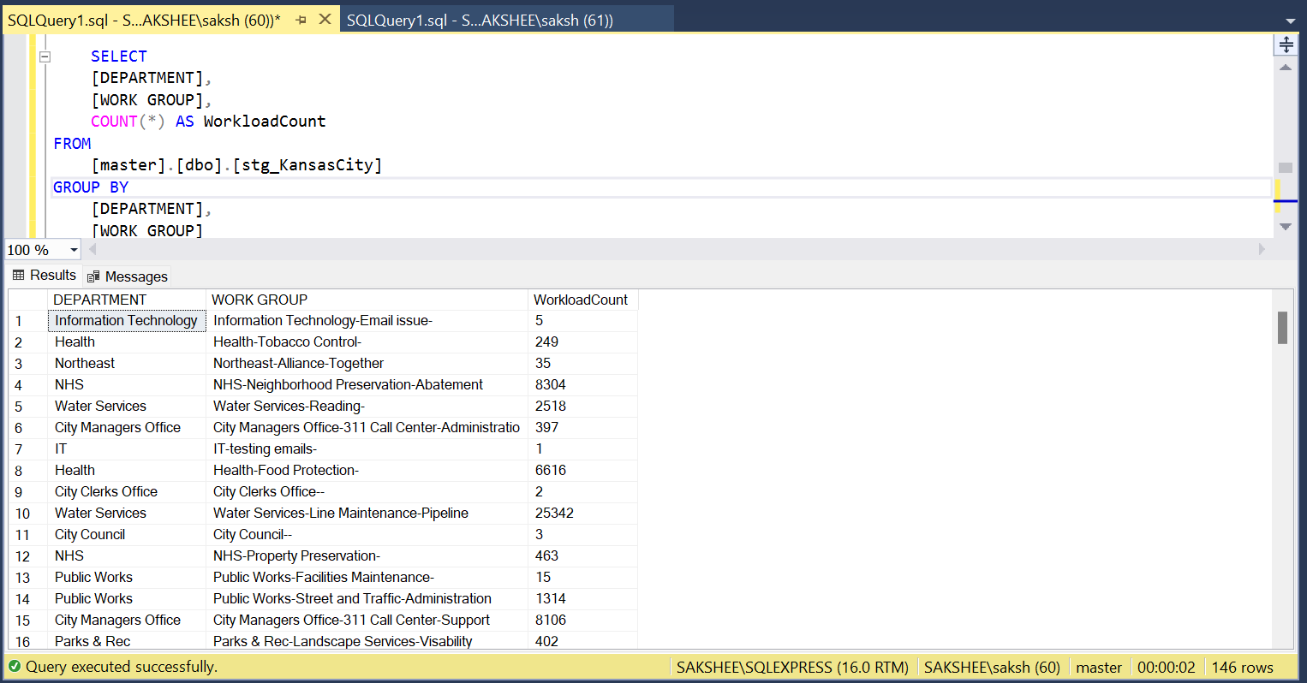

(7) Response Time Analysis:

• Visualize the distribution of response times for each department. Are there any outliers or patterns in response times?

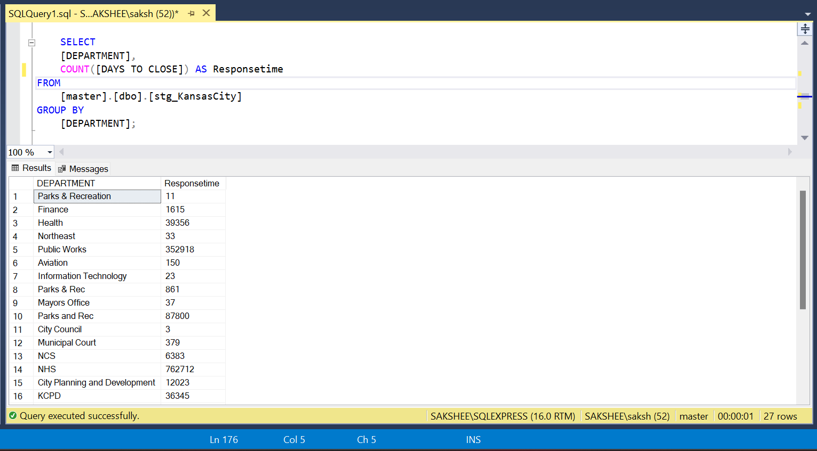

(8) Service Request Status Composition:

• Create a visualization to show the composition of service request statuses (open, closed, in progress). How has this composition changed over the years 2018-2021?

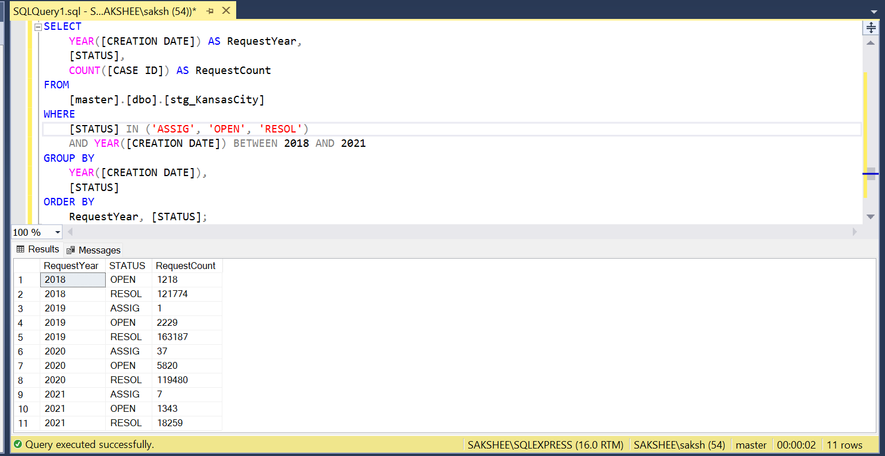

(9) Time to Closure Analysis:

• Visualize the average days to close service requests for each category1. Are there categories with consistently longer closure times?

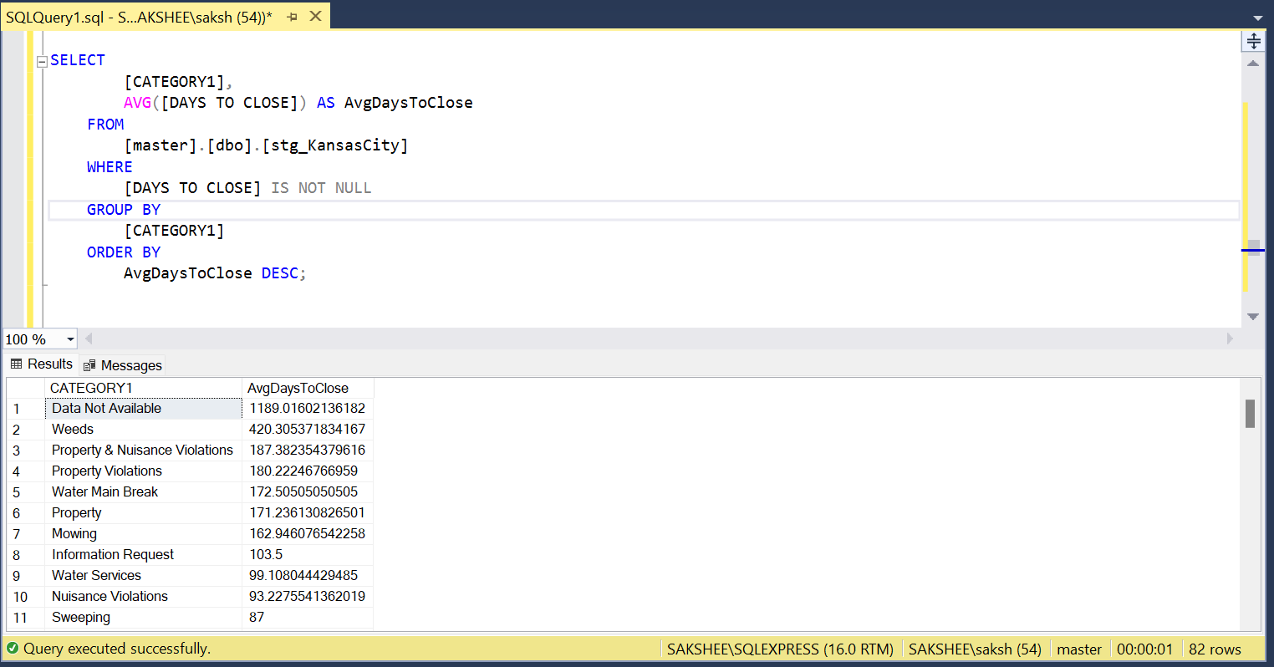

• Show top 10 (If you need help on how to restrict top 10 contact us and we can guide / help you)

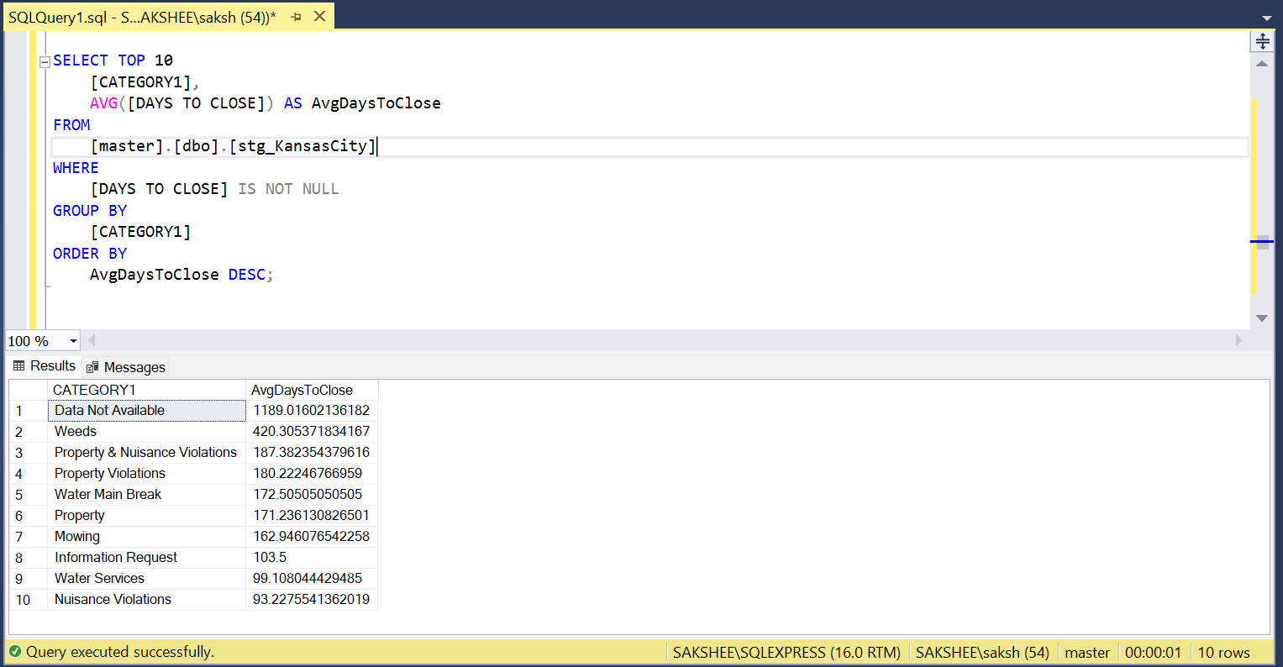

(10) Workload Efficiency:

• Create a visualization to show the relationship between workload (number of service requests) and efficiency (days to close) for each department?

