Python and Bash – Assignment (Python Basics)
Name: Snehal
GitHub Repository: PASTE YOUR GITHUB REPOSITORY LINK HERE
Objective: Practise core Python programming: conditionals, dictionaries, and file handling (reading and writing files). All programs were written in Python 3 and run in a Linux terminal. The source files are in this folder: grade_checker.py, student_grades.py, write_file.py, read_file.py.

Task 1 – Grade Checker
Code (grade_checker.py):
# Task 1: Grade Checker
# Takes a score as input and prints the grade.

score = float(input("Enter the score: "))

if score >= 90:
grade = "A"
elif score >= 80:
grade = "B"
elif score >= 70:
grade = "C"
elif score >= 60:
grade = "D"
else:
grade = "F"

print("Grade:", grade)
Explanation: The program reads a score with input() and converts it to a number with float(). An if / elif / else chain checks the ranges from the highest to the lowest: 90 or more is A, 80 or more is B, 70 or more is C, 60 or more is D, and anything else (below 60) is F. Because the checks go from the top down, each elif only needs the lower limit. The screenshot shows five runs with scores 95, 85, 72, 65 and 40, giving A, B, C, D and F.
Output:
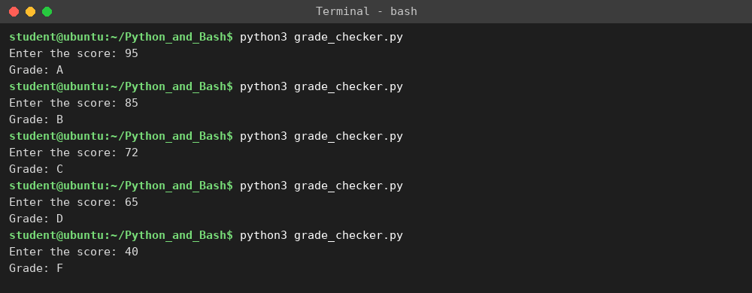

Task 2 – Student Grades
Code (student_grades.py):
# Task 2: Student Grades
# A dictionary stores student names (keys) and their grades (values).

grades = {
"Amit": "A",
"Riya": "B",
"John": "C",
}

while True:
print()
print("1. Add a new student")
print("2. Update a student's grade")
print("3. Print all student grades")
print("4. Exit")
choice = input("Enter your choice (1-4): ")

if choice == "1":
name = input("Enter student name: ")
if name in grades:
print(name, "already exists. Use option 2 to update the grade.")
else:
grade = input("Enter grade: ").upper()
grades[name] = grade
print(name, "added with grade", grade)

elif choice == "2":
name = input("Enter student name: ")
if name in grades:
grade = input("Enter new grade: ").upper()
grades[name] = grade
print(name, "updated to grade", grade)
else:
print(name, "not found. Use option 1 to add the student.")

elif choice == "3":
print("--- Student Grades ---")
for name in grades:
print(name, ":", grades[name])

elif choice == "4":
print("Goodbye!")
break

else:
print("Invalid choice. Please enter 1, 2, 3 or 4.")
Explanation: A dictionary called grades stores student names as keys and their grades as values. A while loop shows a menu until the user chooses Exit. Option 1 adds a student: if the name is already a key it tells the user to use Update, otherwise it adds the new key and value. Option 2 updates a grade: if the name exists the value is changed, otherwise it says the student was not found. Option 3 loops over the dictionary and prints every name with its grade. The screenshot shows printing all grades, adding Meena, updating Riya, trying to add an existing student (Amit), trying to update a missing student (Sam), printing again, and exiting.
Output:
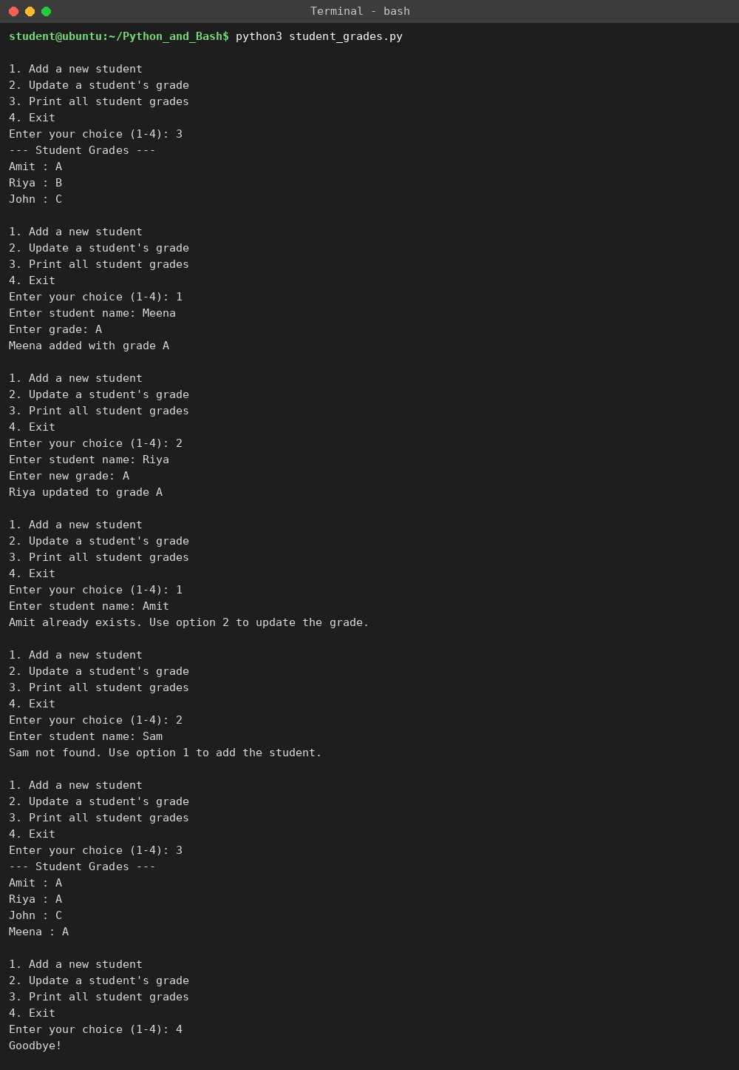

Task 3 – Write to a File
Code (write_file.py):
# Task 3: Write to a File
# Creates a text file and writes some content to it.

file = open("sample_file.txt", "w")
file.write("Hello, this is my first file written with Python.\n")
file.write("Python makes file handling easy.\n")
file.write("This file was created for the Python and Bash assignment.\n")
file.close()

print("File 'sample_file.txt' created and content written successfully.")
Explanation: open('sample_file.txt', 'w') opens the file in write mode, which creates it if it does not exist (and overwrites it if it does). file.write() writes each line, with \n to start a new line, and file.close() saves and closes the file. The screenshot shows the program running, ls showing the new file, and cat displaying what was written.
Output:
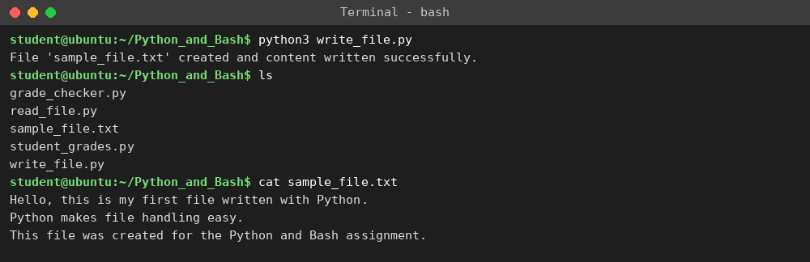

Task 4 – Read from a File
Code (read_file.py):
# Task 4: Read from a File
# Opens the file in read mode and displays its content using read().

file = open("sample_file.txt", "r")
content = file.read()
file.close()

print("Content of sample_file.txt:")
print(content)
Explanation: open('sample_file.txt', 'r') opens the file in read mode. file.read() returns the whole content as one string, which is stored in content and printed. The file is then closed. The output matches what Task 3 wrote.
Output:


