Check if a given Binary Tree is Heap

Given a binary tree we need to check it has heap property or not, Binary tree need to fulfill following two conditions for being a heap –

1. It should be a complete tree (i.e. all levels except last should be full).
2. Every node’s value should be greater than or equal to its child node (considering max-heap).

For example this tree contains heap property –

[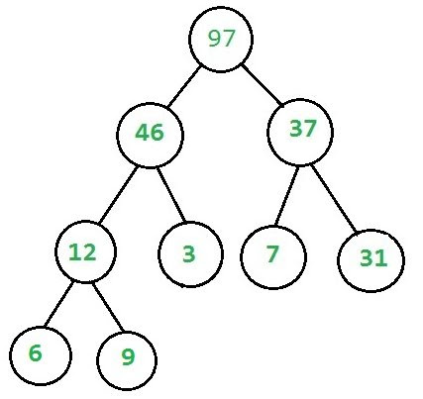](http://d1gjlxt8vb0knt.cloudfront.net/wp-content/uploads/yes.jpg)

While this doesn’t –

