The A-Files: A Python software for audio steganography, speech quality analysis and robustness testing
Paweł KACZMAREK – corresponding author, Military University of Technology, Faculty of Electronics, Kaliskiego 2 str., 00-908 Warsaw, Poland, pawelk.kaczmarek@wat.edu.pl
Zbigniew PIOTROWSKI - Military University of Technology, Faculty of Electronics, Kaliskiego 2 str., 00-908 Warsaw, Poland, zbigniew.piotrowski@wat.edu.pl

Abstract
The A-Files is a Python software package that enables the steganography of digital audio file samples, analysis of speech quality degradation between the original and encoded audio, and testing the resilience of digital audio samples representing the sound before and after the encoding of steganographic information. While various audio steganography software is available on the market, The A-Files stands out with its exceptional features and extensibility. One of the main advantages of The A-Files is its ability to perform steganography using different methods on audio files, including Frequency Singular Value Coefficient Modification (FSVC), DCT Delta LSB method, and Phase coding technique, making it versatile and suitable for various applications. This allows for choosing the most appropriate method for a specific use case. The software includes metrics for measuring the quality of audio signals in the domain of speech, such as Segmental Signal-to-Noise Ratio (SNRseg), Log-likelihood Ratio (LLR), and Perceptual Evaluation of Speech Quality (PESQ). For resilience testing, The A-Files provides various options for simulating different attacks on the audio signal, such as resampling, amplitude scaling, and frequency cutting/filtering. These tests are essential for evaluating the resilience of the audio signal against potential attacks and can help identify areas that require improvement in the signal processing pipeline. One of the key advantages of The A-Files is its open nature, allowing for customization and expansion of the software. The Python programming language also facilitates integration with existing workflows and pipelines. Overall, The A-Files is a versatile and extensible software package for audio steganography, speech signal quality analysis, and resilience testing. Its open-source nature and abstraction make it a valuable tool for researchers and practitioners in the field of audio signal processing.

Keywords
audio-steganography, steganography-algorithms, audio-steganalysis, speech-quality

Metadata

Nr | Code metadata description | Please fill in this column
C1 | Current code version | V0.2.0
C2 | Permanent link to code/repository used for this code version | https://github.com/pawelkaczmarek12/The-A-Files
C3 | Permanent link to reproducible capsule
C4 | Legal code license | GNU General Public License v3.0
C5 | Code versioning system used | git
C6 | Software code languages, tools and services used | Python
C7 | Compilation requirements, operating environments and dependencies | Python, Python packages: NumPy and SciPy
C8 | If available, link to developer documentation/manual | https://github.com/pawelkaczmarek12/The-A-Files/blob/master/README.md
C9 | Support email for questions | pawelk.kaczmarek@wat.edu.pl

Motivation and significance
Generating and copying audio content on the Internet poses a threat to data integrity, credibility, and authenticity. To prevent this, appropriate tools for verification and identification of fake content, as well as copyright protection systems, are needed. Additionally, these tools need to be developed in the context of the amount of information that can be embedded in the audio signal without significantly impacting sound quality, maintaining a low level of hidden information detection, and ensuring high audio signal quality after embedding. It is also important to increase the resilience of the embedded information to various types of attacks. The existing tools developed so far are divided across different platforms and programming languages, and their usage requires mapping or adaptation to different types of data. Examples of software for steganography and metrics have been developed, among others, in [1], [2], [3], [4], [5], [6], and [7].

The A-Files is a powerful audio steganography software that allows users to embed secret data in an audio signal, measure speech quality metrics, and test the resilience of watermarking (hidden information) against various types of attacks. The developed software for different audio marking techniques, attacks on the steganography signals, and speech quality measurements enable scientists and programmers to implement, evaluate, and optimize data embedding algorithms in audio (especially speech signals). The A-Files help solve scientific problems related to:

- Protection of digital audio content - protecting digital audio content from unauthorized use, piracy, and distribution by embedding an invisible watermark signal in an audio file, studying watermark capacity and resilience, which makes it difficult for unauthorized users to manipulate the file and remove the watermark.

- Data hiding - secure communication and authentication: helps address the problem of embedding secret data in an audio signal while maintaining acceptable sound quality.

- Authentication - verification of the authenticity of the audio signal: comparing the embedded watermark signal with the original watermark signal.

Integrating methods, metrics, and attacks in one platform, enables rapid prototyping, and its abstract approach allows for easy expansion of software capabilities.

Software description
The software is developed using the Python programming language and the NumPy and SciPy libraries. The source code has been divided into a Python package, allowing for easy location of the relevant files and classes corresponding to the presented functions and methods.

Software architecture

The A-Files is an audio steganography software that allows users to hide confidential data in an audio signal. To do so, users can load both an audio file and specify or generate the data they want to conceal in the software. A-Files supports various types of audio files, such as WAV or FLAC. After loading the audio file and confidential data, the software can embed the data in the audio signal.
Capacity
The A-Files offers several techniques for embedding confidential data in the audio signal, such as Least Significant Bit (LSB) insertion, phase coding, and echo hiding. Each technique has its strengths and weaknesses, and users can choose the technique that best suits their application requirements.
Transparency
The A-Files includes tools for measuring speech quality indicators, such as PESQ (Perceptual Evaluation of Speech Quality), SNR (Signal-to-Noise Ratio), and STOI (Short-time Objective Intelligibility). By measuring these indicators, users can ensure that the audio signal is not degraded during the process of embedding confidential data.
Robustness
The A-Files provides tools for testing the resilience of the audio signal against various types of attacks. Attackers may attempt to remove hidden data or alter the audio signal to render the hidden data useless. The software includes tools for testing the resilience of the audio signal against different types of attacks, such as adding noise, frequency truncation, and frequency filtering. By testing the robustness of the audio signal, users can determine the effectiveness of the audio steganography technique and make necessary improvements to enhance its strength and resilience.
The above elements are depicted in Figure 1 along with their corresponding main classes or functions in the source code. The use of typing allows for invoking functions or creating class instances in any order, preventing misunderstandings and errors during program execution.
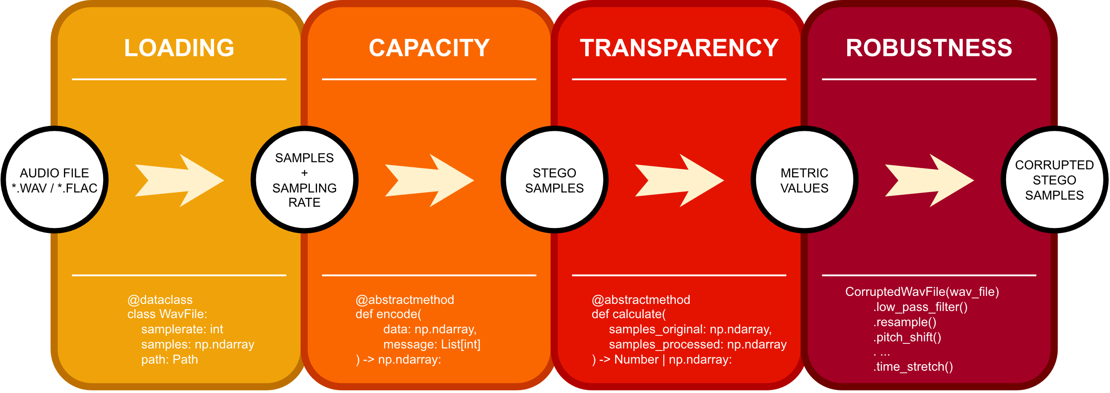
Fig. 1. Workflow of the functions.

Software functionalities

The watermark embedding module, the metrics computation module between the original and steganography audio signals, and the attacks (signal degradation) module on the audio signal are illustrated in Figure 2.
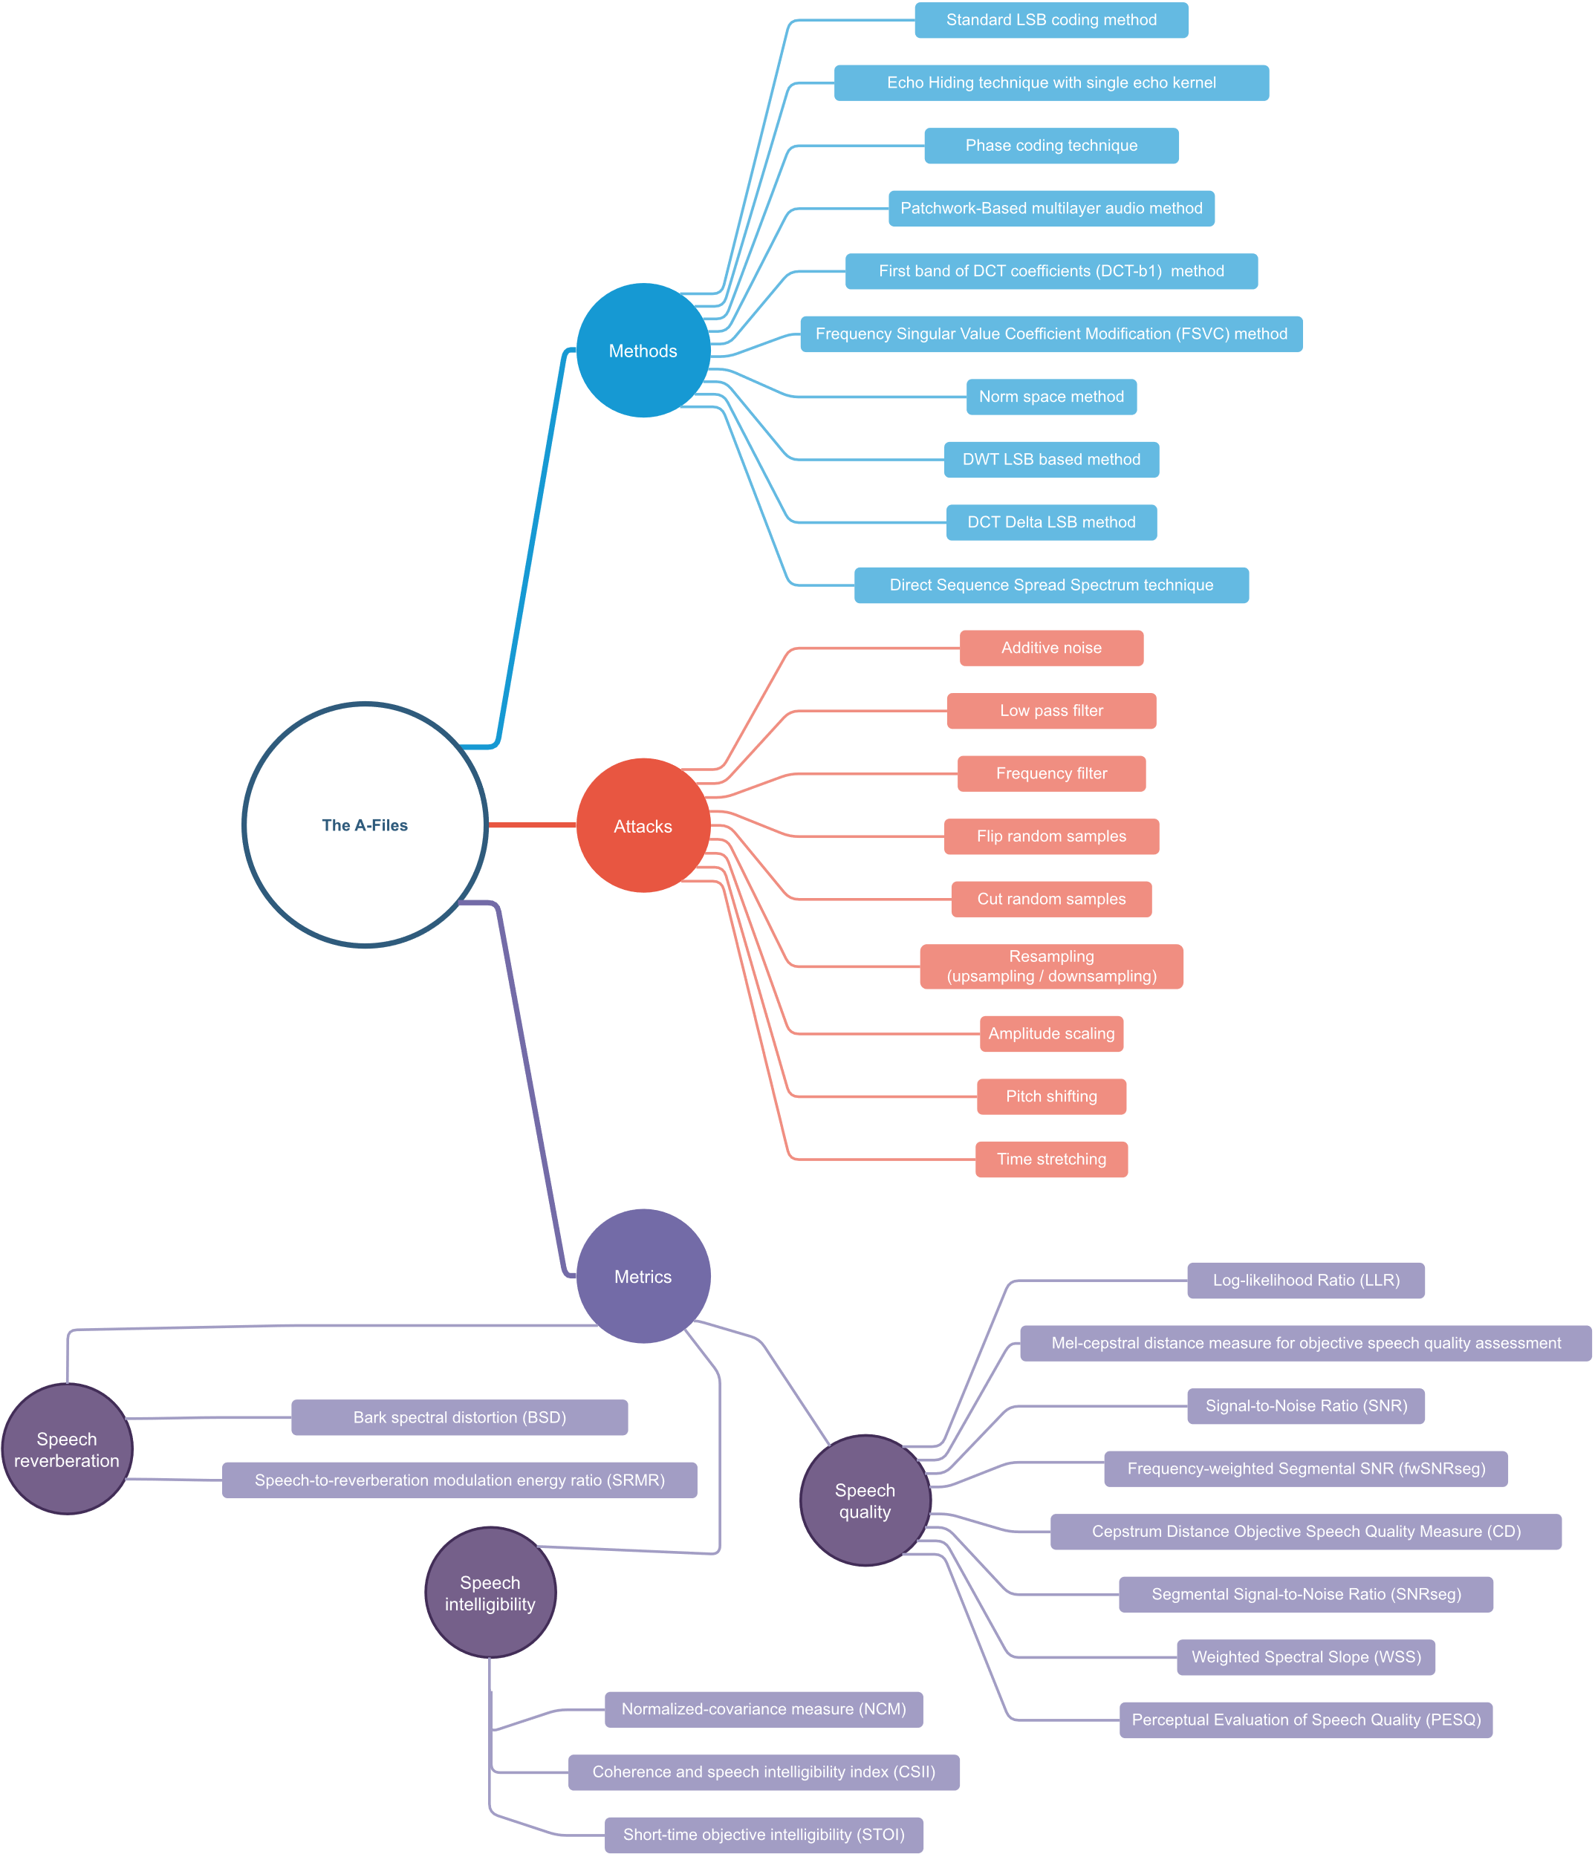
Fig. 2. Software Python packages diagram
The software implements fundamental steganographic methods that allow for embedding invisible (inaudible) information in audio signals. To achieve this, various domains of embedding (DOE) are utilized, including time domain, frequency domain, as well as DCT and DWT transforms. The detailed breakdown is presented in Table 1.

Table 1:
A list of algorithms with their respective methods
No. | Class (file) name | Method name | DOE
1 | LsbMethod.py | Standard LSB coding [8] | Time
2 | EchoMethod.py | Echo Hiding technique with single echo kernel [8] | Time
3 | PhaseCodingMethod.py | Phase coding technique [8] | FFT
4 | DctDeltaLsbMethod.py | DCT Delta LSB [8] | DCT
5 | DwtLsbMethod.py | DWT LSB based [8] | DWT
6 | DctB1Method.py | First band of DCT coefficients (DCT-b1) [9] | DCT
7 | PatchworkMultilayerMethod.py | Patchwork-Based multilayer [17] | DCT
8 | NormSpaceMethod.py | Norm space method [18] | DCT + DWT
9 | FsvcMethod.py | Frequency Singular Value Coefficient Modification (FSVC) [19] | DCT
10 | DsssMethod.py | Direct Sequence Spread Spectrum technique [13] | Time

All methods extend a common abstract class, which specifies that the encoding requires a sample array and a list of bits to be embedded. The output is a sample array of steganographic information. In the case of decoding, the output of the encode function serves as the input for the decode function, and the message length needs to be provided.

A similar breakdown is presented in Table 2 for speech evaluation metrics. The metrics are divided into three groups based on the type of value being evaluated: reverberation, intelligibility, and quality. Each metric implementation extends the abstract class, where two arrays containing the signal before and after watermarking are required for computations. The return value depends on the metric and can be a number or an array of numbers.

Table 2:
A list of classes with their respective methods
No. | Class (file) name | Method name [Reference]
Speech Reverberation
1 | BsdMetric.py | Bark spectral distortion (BSD) [14]
2 | SrmrMetric.py | Speech-to-reverberation modulation energy ratio (SRMR) [10]
Speech Intelligibility
3 | CsiiMetric.py | Coherence and speech intelligibility index (CSII) [14]
4 | NcmMetric.py | Normalized-covariance measure (NCM) [14]
5 | StoiMetric.py | Short-time objective intelligibility (STOI) [16]
Speech Quality
6 | SnrMetric.py | Signal - to - Noise Ratio (SNR) [19]
7 | MelCepstralDistanceMetric.py | Mel-cepstral distance measure for objective speech quality assessment [18]
8 | SnrSegMetric.py | Segmental Signal-to-Noise Ratio (SNRseg) [14]
9 | FWSnrSegMetric.py | Frequency-weighted Segmental SNR (fwSNRseg) [14]
10 | CepstrumDistanceMetric.py | Cepstrum Distance Objective Speech Quality Measure (CD) [14]
11 | LlrMetric.py | Log - likelihood Ratio (LLR) [14]
12 | WssMetric.py | Weighted Spectral Slope (WSS) [14]
13 | PesqMetric.py | Perceptual Evaluation of Speech Quality (PESQ) [15]

The implemented methods for attacks on audio files are presented below:
- low_pass_filter: This function applies a low-pass filter to the audio signal. Its purpose is to remove high-frequency components that may interfere with the analysis of the audio signal.
- additive_noise: This function adds Gaussian noise to the audio signal with a specified standard deviation. The purpose of this function is to simulate disturbances that may occur in real sound recording conditions.
- frequency_filter: This function applies a frequency-sensitive filter to the signal, allowing for the removal of undesired signal components at specific frequencies.
- flip_random_samples: This function randomly flips the values of a specified number of samples in a WAV file. The purpose of this function is to simulate the occurrence of individual sample errors.
- cut_random_samples: This function randomly removes the values of a specified number of samples in a WAV file. The purpose of this function is to simulate the loss of parts of the audio signal.
- resample: This function changes the sampling frequency of a WAV file to a specified value. Both downsampling and upsampling can be performed.
- amplitude_scaling: This function scales the amplitude of the audio signal by a specified value. The purpose of this function is to simulate changes in the volume of the audio signal.
- pitch_shift: This function performs pitch shifting of the sound by a specified number of semitones.
- time_stretch: This function changes the duration of the sound by scaling the time. The purpose of this function is to simulate the increase or decrease in playback speed.

Sample code snippets analysis
Class representing the steganographic method (Fig. 3):
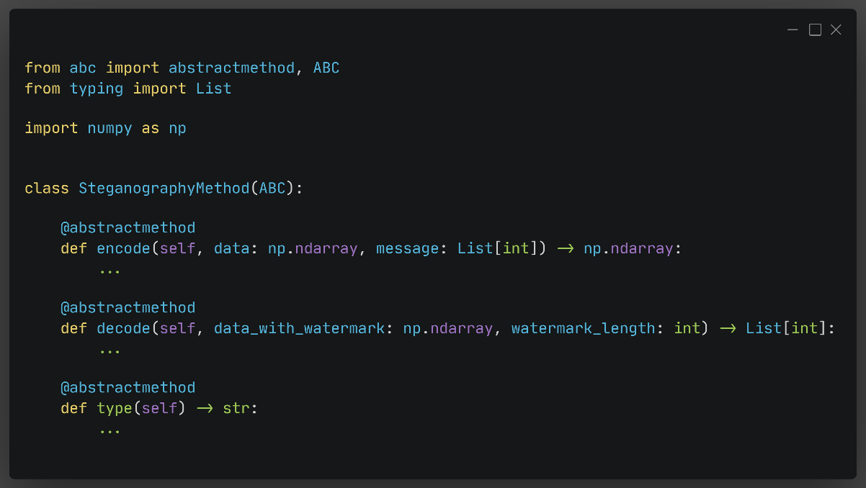
Fig. 3. SteganographyMethod abstract class
Class representing the quality assessment metric of steganographic methods (Fig. 4):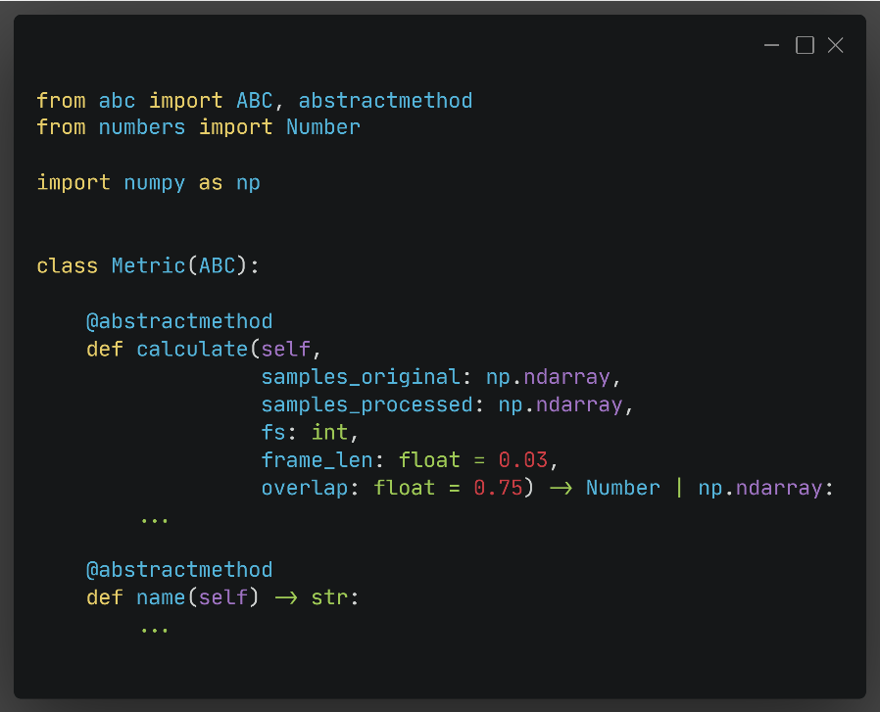
Fig. 4. Metric abstract class

The main() method, which shows an example of all the functions of the software (Fig. 5)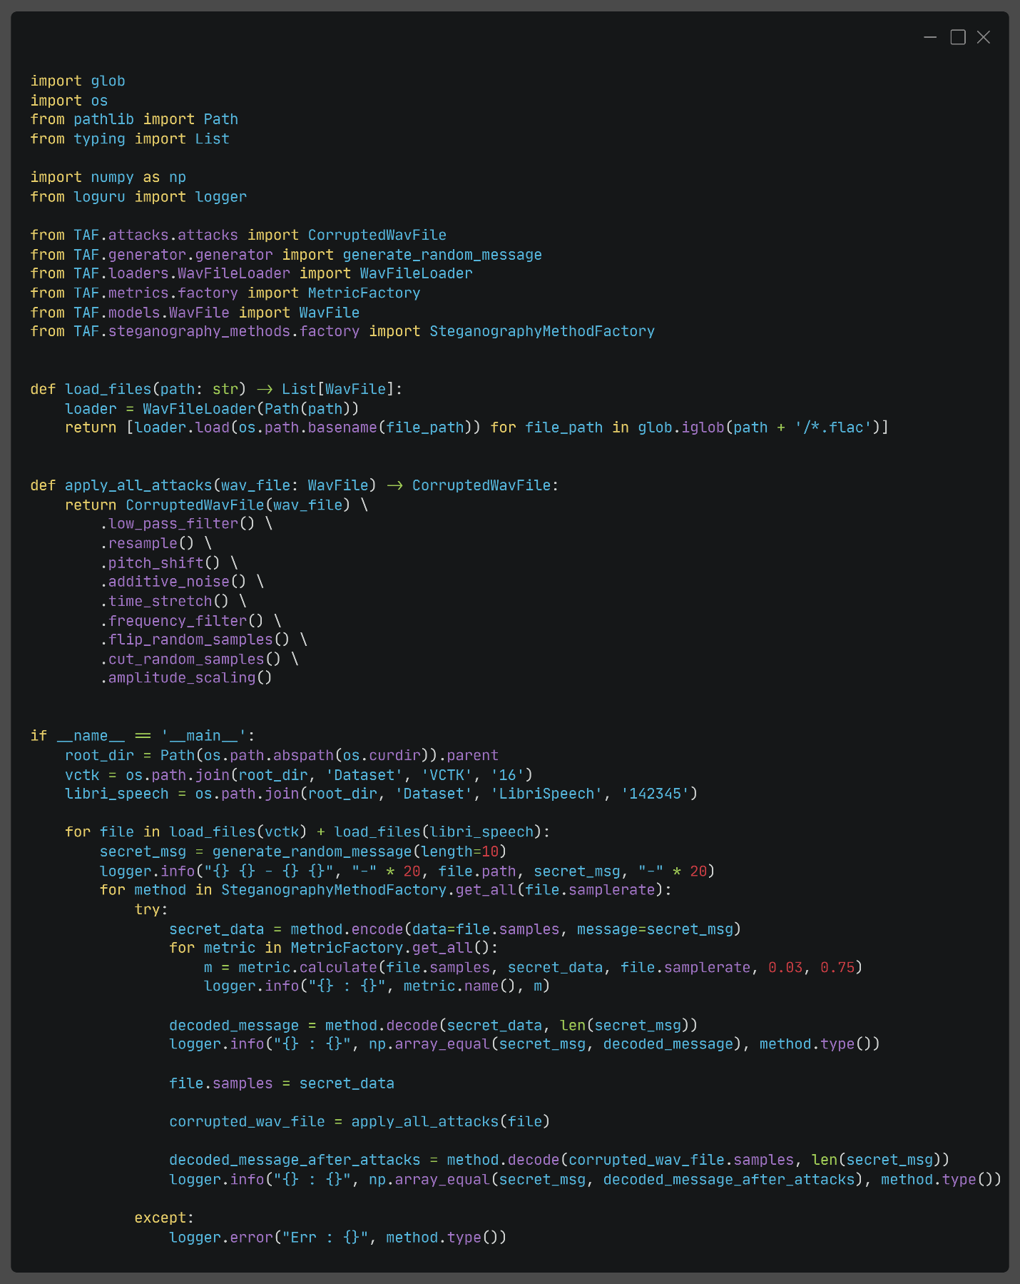
Fig. 5. Main function for use cases

Illustrative examples
This section presents an illustrative example of the software. Figures 6, 7, and 8 demonstrate the utilization of the described features of the program. The resulting logs are displayed in the program's console through the invocation of the __main__ method. Two sample datasets, LibriSpeech [20] and VCTK [21], which are commonly used in speech recognition and natural language processing (NLP) research, were used for testing purposes.
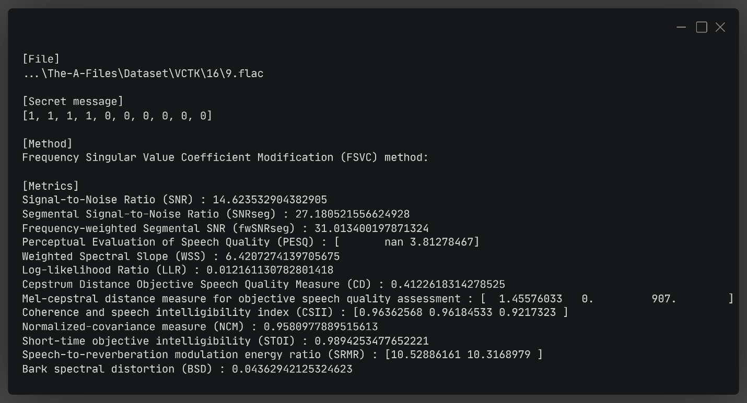
Fig. 6. Output logs for method FSVC with VCTK file
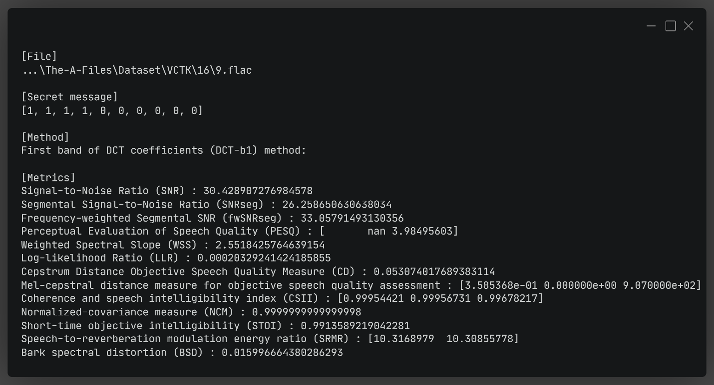
Fig. 7. Output logs for method DCT-b1 with VCTK file
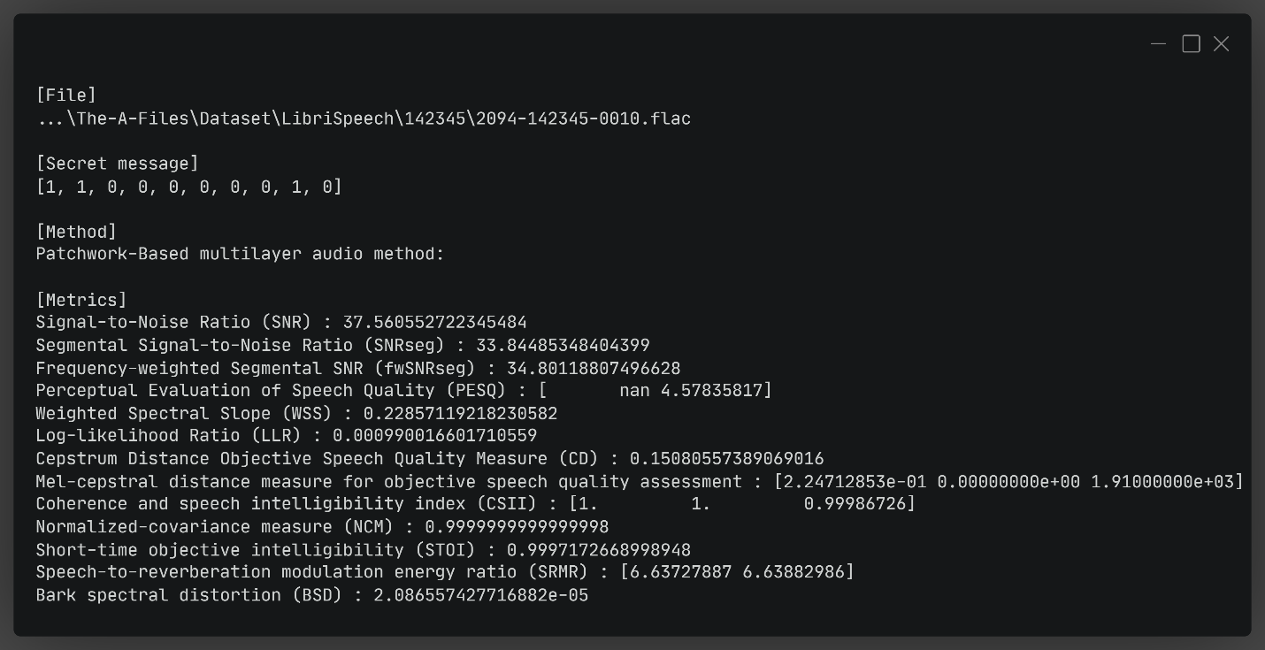
Fig. 8. Output logs for patchwork multilayer method with VCTK file

The above images depict the results of the system's performance effectiveness using a set of objective speech quality measures. Each objective measure provides a different evaluation of the system's performance. The interpretation of these measures depends on the context in which the system is evaluated and the criteria for acceptable performance. These metrics are used to assess the transparency of the embedded information in ten random bits, allowing for the determination of signal degradation for different encoding techniques. This enables the examination of steganography techniques that provide the highest performance without exceeding an acceptable degradation level.

- Impact
The A-Files software has transformed the daily practices of its users by enabling rapid prototyping, implementation, and optimization of data embedding algorithms in audio signals. Users can easily test various data embedding techniques in audio signals and measure sound quality and resilience to attacks, leading to more efficient and effective methods for protecting digital audio content.

The A-Files software is relatively new, and precise statistics regarding the number of users or downloads are not available. However, given that the software is utilized within its target user groups, such as researchers, programmers, and security specialists, it can be expected to be relatively popular in this field. The software is also publicly available, which means it can be used by anyone interested in data embedding in audio signals.

The A-Files software can be used in commercial settings, for example, by companies involved in digital security or music publishing, to protect their digital audio content. It may also lead to the emergence of spin-off companies that leverage the software as a foundation for their operations, such as offering data embedding services in audio signals or testing audio signal resilience to attacks.

Furthermore, the software can be used on training and validation data from vast collections of audio data, which can be utilized to train neural networks with various architectures, including sound hiding or steganalysis (determining if a sound contains hidden information, what that information is, and which algorithm was likely applied).

Further development of the software will involve additional methods, measures, and attacks, including the incorporation of neural networks.

Conclusions
The article "The A-Files: A Python software for audio steganography, speech quality analysis, and robustness testing" describes software that enables various analyses and tests on audio files, including audio steganography, speech quality, and resilience to different attacks and disturbances of steganographic data.
The authors provide a detailed overview of the software's features and demonstrate its practical applications. The A-Files includes functionalities such as algorithms for hiding information in audio files, speech quality analysis using implemented metrics, and testing resilience to disturbances such as noise, compression, or filtering.

The authors emphasize that The A-Files is an open-source software, making it accessible to researchers and programmers interested in the field. The article also provides implementation details for each functionality and tool, which can be helpful for individuals seeking a thorough understanding of the software or aiming to contribute to its development. The availability of tools for speech quality measurements, audio signal resilience testing, and embedding effectiveness verification allows researchers to quickly and accurately compare different audio signal embedding techniques and choose the best technique based on specific needs.

In summary, The A-Files is a comprehensive software that enables various analyses of audio files while being user-friendly and accessible to everyone. The authors emphasize that The A-Files can be applied not only in scientific research but also in practical scenarios, such as protecting the privacy of audio data or in the audio industry.

Acknowledgements
Funding: This research was funded by the NATIONAL CENTRE FOR RESEARCH AND DEVELOPMENT, grant number CYBERSECIDENT/381319/II/NCBR/2018 on “The federal cyberspace threat detection and response system” (acronym DET-RES) as part of the 2nd competition of the CyberSecIdent Research and Development Program—Cybersecurity and e-Identity.

References
[1] Audio watermarking (2022) [Computer software]. Retrieved April 30, 2023 from https://github.com/kosta-pmf/audio-watermarking
[2] Tekeli K., Audio Steganography Algorithms (2022) [Computer software]. Retrieved April 30, 2023 from https://github.com/ktekeli/audio-steganography-algorithms
[3] Pariente Manuel, Python implementation of the Short Term Objective Intelligibility measure (2022) [Computer software]. Retrieved April 30, 2023 from https://github.com/mpariente/pystoi
[4] João Felipe Santos, SRMRpy: a Python implementation of the SRMR Toolbox (2021) [Computer software]. Retrieved April 30, 2023 from https://github.com/jfsantos/SRMRpy
[5] schmiph2, pysepm - Python Speech Enhancement Performance Measures (Quality and Intelligibility) v0.1 (Version 0.1) [Computer software]. Zenodo. https://doi.org/10.5281/zenodo.4021861
[6] Miao Wang, Christoph Boeddeker, Rafael G. Dantas and Ananda Seelan. PESQ (Perceptual Evaluation of Speech Quality) Wrapper for Python Users. May,2022.[Computer software] v0.0.4 (Version 0.0.4). Zenodo. https://doi.org/10.5281/zenodo.6549559
[7] Sternkopf, J., & Taubert, S. (2022). mel-cepstral-distance (Version 0.0.2) [Computer software]. https://doi.org/10.5281/zenodo.7044405
[8] Alsabhany, Ahmed A., Ahmed Hussain Ali, Farida Ridzuan, A. H. Azni, and Mohd Rosmadi Mokhtar. “Digital Audio Steganography: Systematic Review, Classification, and Analysis of the Current State of the Art.” Computer Science Review 38 (2020): 100316. https://doi.org/10.1016/j.cosrev.2020.100316
[9] Hu, Hwai Tsu, and Ling Yuan Hsu. “Robust, Transparent and High-Capacity Audio Watermarking in DCT Domain.” Signal Processing 109 (2015): 226–35. https://doi.org/10.1016/j.sigpro.2014.11.011
[10] Natgunanathan, Iynkaran, Yong Xiang, Guang Hua, Gleb Beliakov, and John Yearwood. “Patchwork-Based Multilayer Audio Watermarking.” IEEE/ACM Transactions on Audio Speech and Language Processing 25, no. 11 (2017): 2176–87, https://doi.org/10.1109/TASLP.2017.2749001
[11] Saadi, Slami, Ahmed Merrad, and Ali Benziane. “Novel Secured Scheme for Blind Audio/Speech Norm-Space Watermarking by Arnold Algorithm.” Signal Processing 154 (2019): 74–86. https://doi.org/10.1016/j.sigpro.2018.08.011
[12] Zhao, Juan, Tianrui Zong, Yong Xiang, Longxiang Gao, Wanlei Zhou, and Gleb Beliakov. “Desynchronization Attacks Resilient Watermarking Method Based on Frequency Singular Value Coefficient Modification.” IEEE/ACM Transactions on Audio Speech and Language Processing 29 (2021): 2282–95. https://doi.org/10.1109/TASLP.2021.3092555
[13] Nugraha, Rizky M. “Implementation of Direct Sequence Spread Spectrum Steganography on Audio Data.” Proceedings of the 2011 International Conference on Electrical Engineering and Informatics, ICEEI 2011, no. July (2011). https://doi.org/10.1109/ICEEI.2011.6021662
[14] Philipos C. Loizou. “Speech Enhancement. Theory and Practice, Second Edition” CRC Press (2013). https://doi.org/10.1201/b14529
[15] Miao Wang, Christoph Boeddeker, Rafael G. Dantas and ananda seelan. “PESQ (Perceptual Evaluation of Speech Quality) Wrapper for Python Users” Zenodo 2022. https://doi.org/10.5281/zenodo.6549559
[16] C.H.Taal, R.C.Hendriks, R.Heusdens, J.Jensen 'A Short-Time Objective Intelligibility Measure for Time-Frequency Weighted Noisy Speech', ICASSP 2010, Texas, Dallas. https://doi.org/10.1109/ICASSP.2010.5495701
[17] Tiago H. Falk, Chenxi Zheng, and Way-Yip Chan. A Non-Intrusive Quality and Intelligibility Measure of Reverberant and Dereverberated Speech, IEEE Trans Audio Speech Lang Process, Vol. 18, No. 7, pp. 1766-1774, Sept.2010. https://doi.org/10.1109/TASL.2010.2052247 \
[18] R. Kubichek, "Mel-cepstral distance measure for objective speech quality assessment," Proceedings of IEEE Pacific Rim Conference on Communications Computers and Signal Processing, Victoria, BC, Canada, 1993, pp. 125-128 vol.1, https://doi.org/10.1109/PACRIM.1993.407206.
[19] Wikipedia contributors. (2023). Signal-to-noise ratio. Wikipedia. https://en.wikipedia.org/wiki/Signal-to-noise_ratio
[20] V. Panayotov, G. Chen, D. Povey and S. Khudanpur, "Librispeech: An ASR corpus based on public domain audio books," 2015 IEEE International Conference on Acoustics, Speech and Signal Processing (ICASSP), South Brisbane, QLD, Australia, 2015, pp. 5206-5210, doi: https://doi.org/10.1109/ICASSP.2015.7178964.
[21] Veaux, Christophe; Yamagishi, Junichi; MacDonald, Kirsten. (2017). CSTR VCTK Corpus: English Multi-speaker Corpus for CSTR Voice Cloning Toolkit, [sound]. University of Edinburgh. The Centre for Speech Technology Research (CSTR). https://doi.org/10.7488/ds/1994

