EatSafe API Documentation
The EatSafe API collection provides a comprehensive set of HTTP requests for interacting with the application's food safety warning system and subscriber management features.
The core mission of this architecture is to parse, structure, and simplify access to public health and safety data provided by the government (GIS - Główny Inspektorat Sanitarny).
This collection includes endpoints for:
- Retrieving a complete list of all active food safety warnings.
- Filtering warnings precisely using custom search parameters (e.g., by brand, danger type, or product name).
- Fetching detailed information for a specific warning by its ID (including nested product lists and image galleries).
- Registering new subscribers to the automated newsletter system.
- Updating existing subscriber email addresses.
- Managing the subscriber lifecycle through both soft (deactivation) and hard (permanent) deletion methods.
JSON Structure Example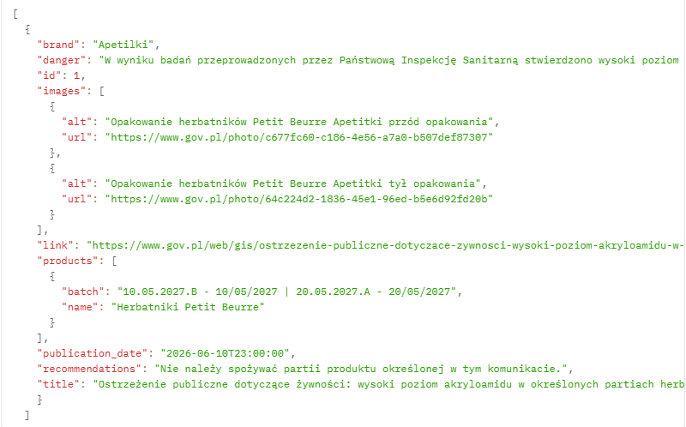
Warnings Endpoints

GET All Warnings
- Method: GET
- Endpoint: /api/warnings
- Description: Retrieves a complete list of all food safety warnings from the database, sorted by publication date in descending order (newest first).
- Path Params: None
- Query Params: None
- Body: None
- Responses: 200 OK

GET Filter Warnings
- Method: GET
- Endpoint: /api/warnings/search
- Description: Filters the warnings database based on specific criteria. Multiple filters can be combined (acting as a logical AND). Matches are case-insensitive.
- Path Params: None
- Query Params:
  - danger (string, optional) - Filters by the type of hazard.
  - brand (string, optional) - Filters by the brand name.
  - product_name (string, optional) - Filters by the product name.
- Body: None
- Responses: 200 OK

GET Warning by ID
- Method: GET
- Endpoint: /api/warnings/<id>
- Description: Retrieves the complete details of a specific GIS warning based on its unique integer ID, including relational data (products and images).
- Path Params:
  - id (integer, required) - The unique identifier of the warning.
- Query Params: None
- Body: None
- Responses: 200 OK, 404 Not Found

GET Warning Products
- Method: GET
- Endpoint: /api/warnings/<id>/products
- Description: Retrieves a list of products associated with a specific warning. Includes the basic warning context alongside the queried products.
- Path Params:
  - id (integer, required) - The unique identifier of the warning.
- Query Params:
  - product_name (string, optional) - Filters the products within this specific warning by name.
- Body: None
- Responses: 200 OK, 404 Not Found

GET Warning Images
- Method: GET
- Endpoint: /api/warnings/<id>/images
- Description: Retrieves a dedicated list of all image URLs and their alternative text descriptions associated with a specific warning ID.
- Path Params:
  - id (integer, required) - The unique identifier of the warning.
- Query Params: None
- Body: None
- Responses: 200 OK, 404 Not Found

Subscriber Endpoints
POST Add subscriber
- Method: POST
- Endpoint: /api/subscribers
- Description: Registers a new, unique email address to the newsletter subscriber list.
- Path Params: None
- Query Params: None
- Body: JSON
JSON
{ "email": “kowalicki-marian@wp.pl” }
- Responses: 200 OK, 404 Not Found, 409 Conflict

PUT Change email
- Method: PUT
- Endpoint: /api/subscribers/<email>
- Description: Updates the email address for an existing subscriber.
- Path Params:
  - email (string, required) - The current email address of the subscriber.
- Query Params: None
- Body: JSON
JSON
{ "new_email": “nowy.adres@wp.com” }
- Responses: 200 OK, 400 Bad Request, 404 Not Found, 409 Conflict

DELETE Delete subscriber (Force)
- Method: DELETE
- Endpoint: /api/subscribers/<email>/force
- Description: Performs a hard delete. Irreversibly and permanently removes the subscriber's record from the database.
- Path Params:
  - email (string, required) - The current email address of the subscriber.
- Query Params: None
- Body: None
- Responses: 200 OK, 400 Bad Request

DELETE Deactivate subscriber (Soft delete)
- Method: DELETE
- Endpoint: /api/subscribers/<email>
- Description: Performs a soft delete on a subscriber. Instead of permanently erasing the record, it safely flags the user as inactive. Preserves historical data.
- Path Params:
  - email (string, required) - The current email address of the subscriber.
- Query Params: None
- Body: None
- Responses: 200 OK, 400 Bad Request

