STEP 1 Identification of a clogged nozzle
Preliminary procedure:  1. Switch the machine to manual mode and then to setup mode  2. Move the injection unit away from the mold.  3. Activate the Inject function. | The nozzle should be considered clogged if:  - the plastic comes out in an irregular, scattered stream, sprays to the sides, or flows out only partially,  - no plastic flows out of the nozzle despite activating the Inject function. | 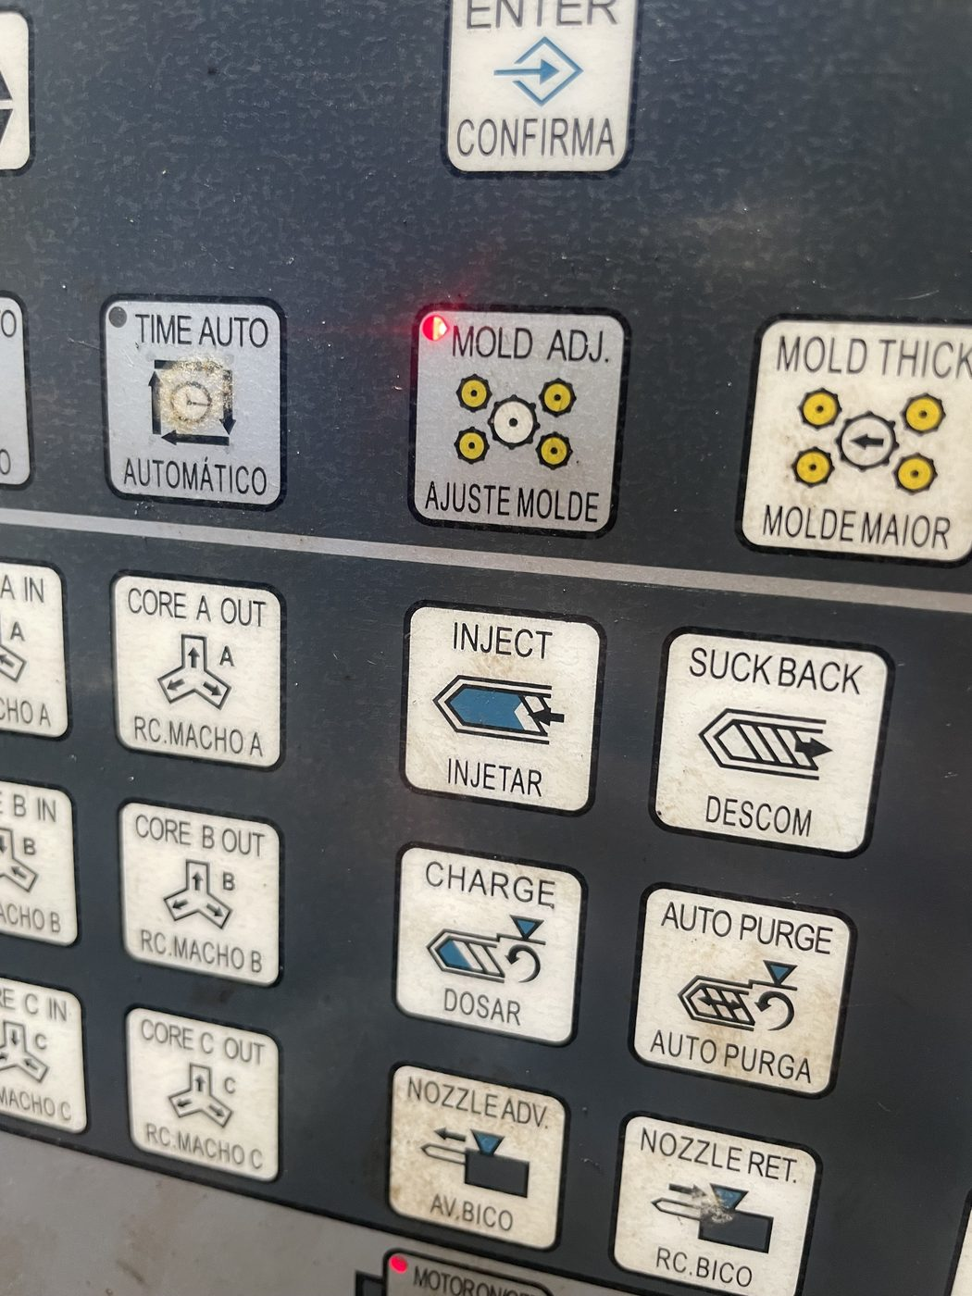  Recommended setup mode (Mold Adj.)

⚠ WARNING
If any abnormality is detected, it must be assumed that the nozzle is clogged and hot plastic under pressure may be present in the barrel.

STEP 2 Starting the unscrewing process
1. If possible, empty the barrel of plastic by activating the Inject function.  (If emptying the barrel is not possible, perform only screw decompression in setup mode.)  2. Hold the decompression button for approximately 3–4 seconds so that the screw fully retracts. | 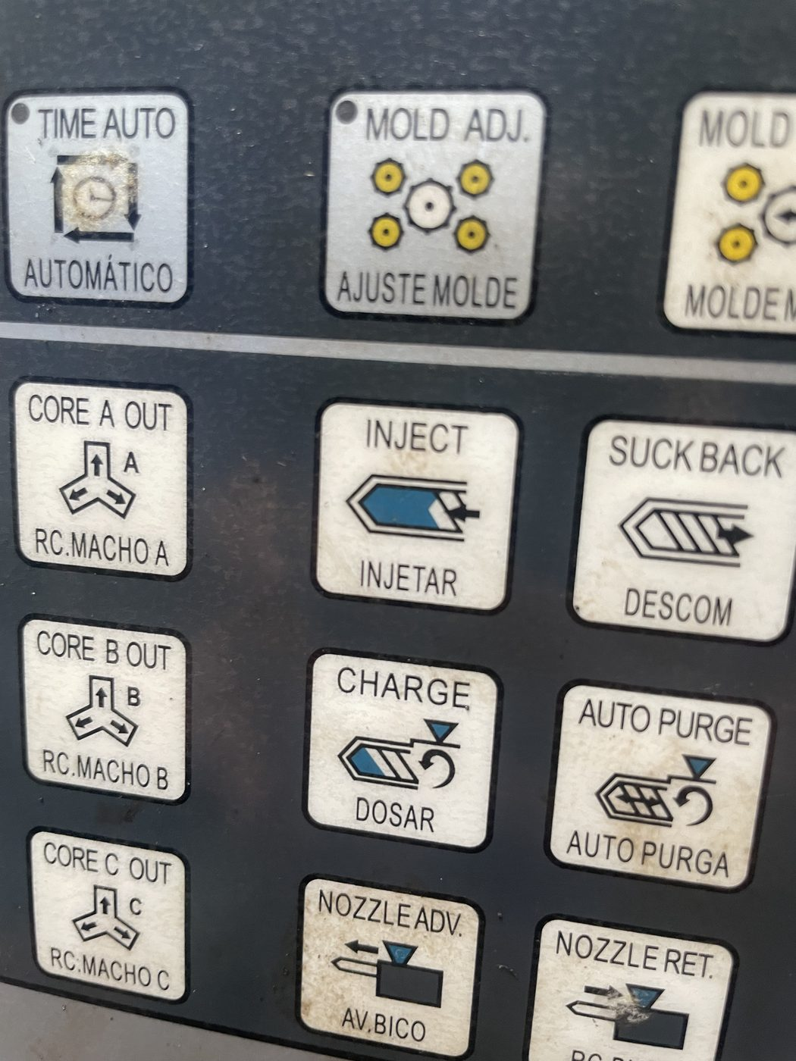 Inject button 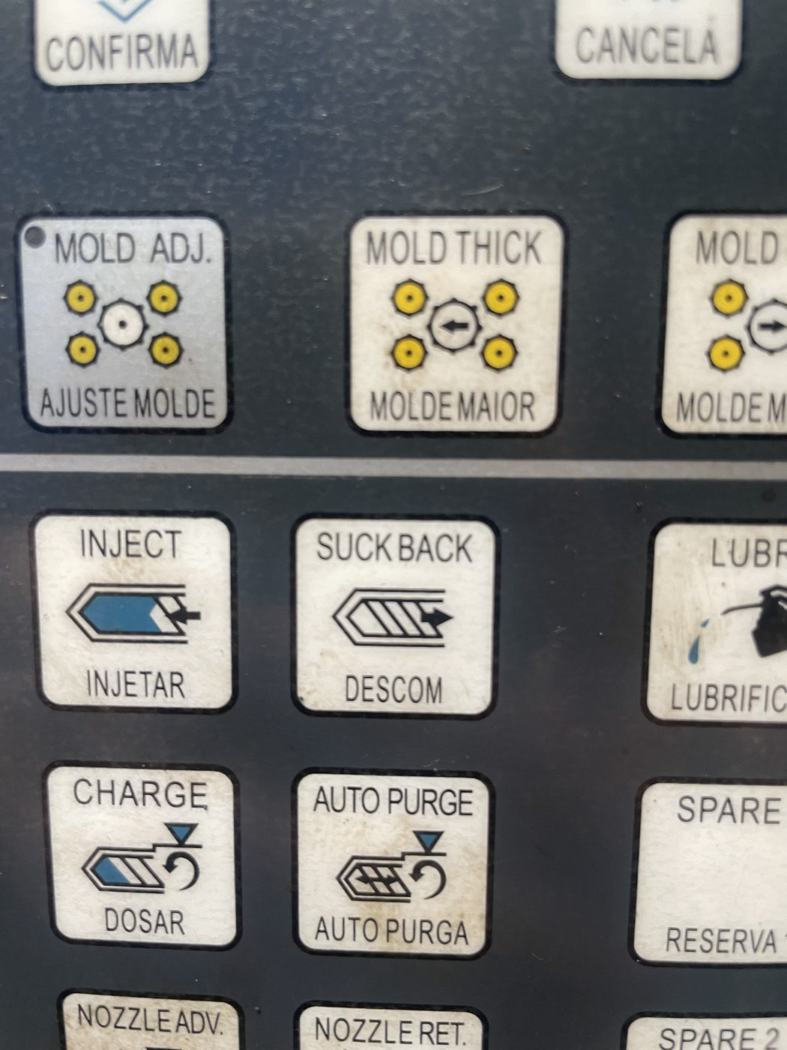 Decompression button (Suck Back)
⚠ WARNING
Decompression reduces residual pressure but does not guarantee its complete removal.

STEP 3 Preparation for nozzle disassembly
After the screw has fully retracted:  1. Switch off the heating.  2. Switch off the hydraulic pump.  3. Remove the nozzle heater band.  4. Remove the nozzle temperature sensor. | 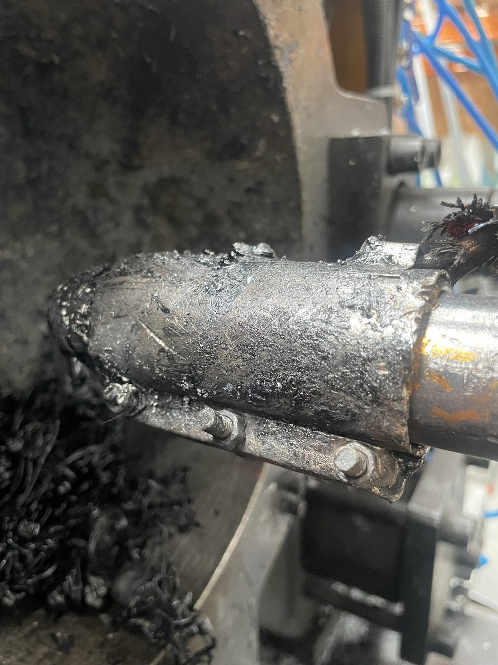 Nozzle heater band 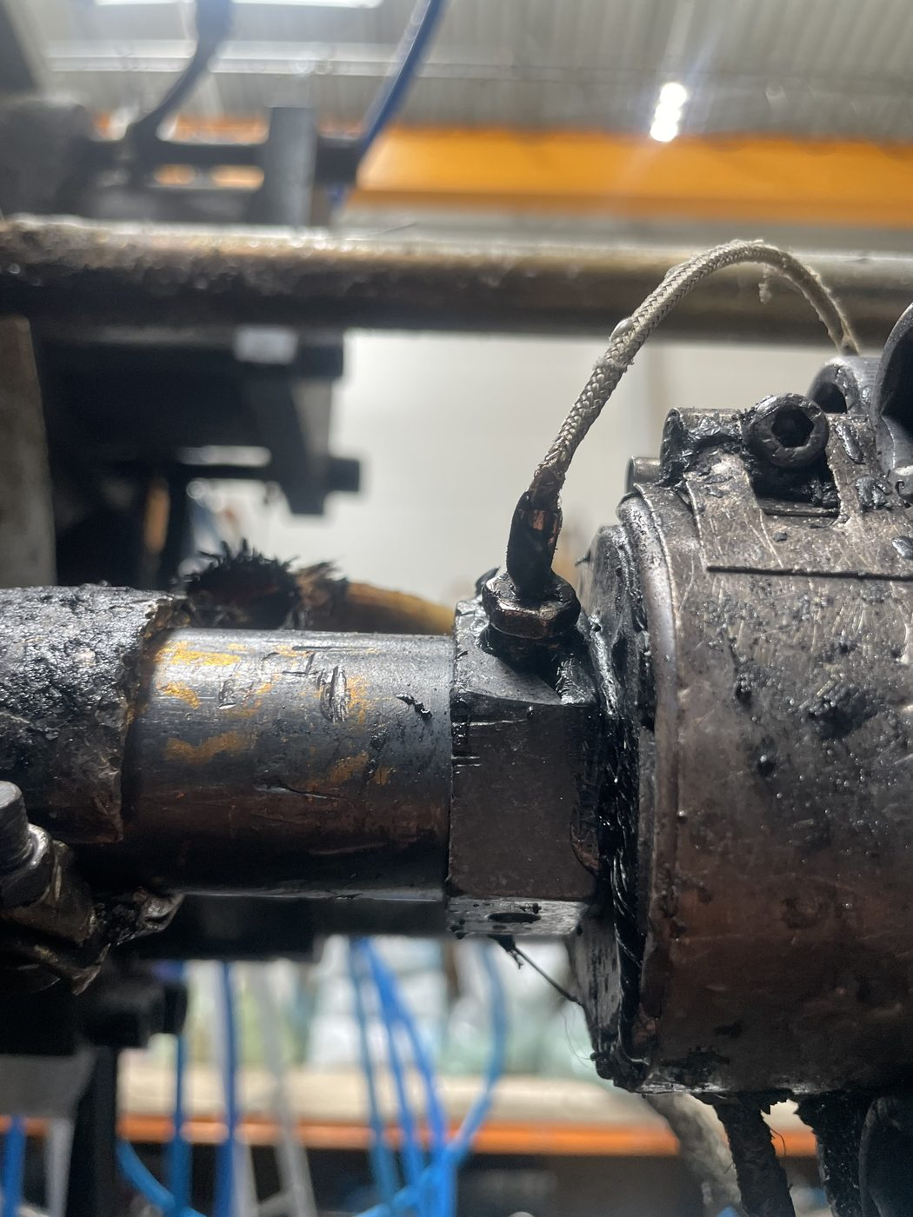 Nozzle temperature sensor

STEP 4 Preparation for unscrewing the nozzle
Before starting to unscrew the nozzle, you must:
✔ Put on a protective face shield.
✔ Put on heat-insulating gloves.
✔ Put on heat-insulating clothing with long sleeves.
✔ Put on a protective cap.
✔ Select a suitable wrench for unscrewing the nozzle.

⚠ WARNING
Unscrewing a clogged nozzle without the required personal protective equipment is prohibited.

STEP 5 Unscrewing the nozzle
1.Start unscrewing the nozzle using a suitable wrench.

During the final unscrewing:
- do not position your face or any other part of your body in line with the nozzle axis,
- maintain a safe position at the side of the machine,
- unscrew the nozzle slowly and in a controlled manner.
⚠ GREATEST HAZARD
After the nozzle has been loosened and during its final unscrewing, exercise extreme caution. At this point, a sudden release of pressure and an uncontrolled ejection of hot plastic may occur.

STEP 6 Cleaning and reinstalling the nozzle
1. After fully unscrewing the nozzle, remove residual plastic and contaminants from the flow channel using suitable tools.
2. Install the nozzle, tightening it with the appropriate force.
3. Install the heater band and the temperature sensor.
4. Switch on the heating and, once the required temperature is reached, start the hydraulic pump.
5. Perform a test of the Inject function and make sure the plastic flows out evenly.
6. After confirming correct machine operation, production may be resumed.

