ONTOGENESIS OF COHERENCE (OC): Camera‑Ready Manuscript (JCAP Style)

Abstract
We present the Ontogenesis of Coherence (OC) framework ... Camera‑ready manuscript with figures and appendices.

1 Introduction
OC treats dimensional coherence σ as adaptive geometry. Screening arises automatically via M_*'(σ). CR1–CR3 provide observational tests.

2 Action
S = ∫ d⁴x √(-g)[½ M_*² R − ½(∂σ)² − V(σ) − ½ c_T T²σ²] + S_m.
M_*² = M_Pl²[1 + ξ²(σ−σ*)²/Λ_M²].

3 Field Equations
Fundamental scalar equation:
□σ − V' − c_T T²σ + ½ R M_*'(σ) = 0.

4 Screening
m_eff² = V'' + c_T T² + ½ R M_*'' + β²ρ/M_Pl².
Leads to GR recovery in dense regions.

5 FLRW Evolution
3H² = (ρ_m+ρ_r+ρ_σ)/M_*². σ pinned at z>10⁶.

6 Weak Field Limit
Φ = Φ_N + β δσ / M_Pl.
(∇² − m_eff²)δσ = βρ/M_Pl.

7 EFT Mapping
μ = 𝒜(1+ε), η=(1−ε)/(1+ε), Σ=𝒜 where ε = 2β²k²/(k²+a² m_eff²).

8 Predictions CR1–CR3
CR1: d_L^GW/d_L^EM.
CR2: constant void/cluster ratio.
CR3: edge enhancement at ∇σ peaks.
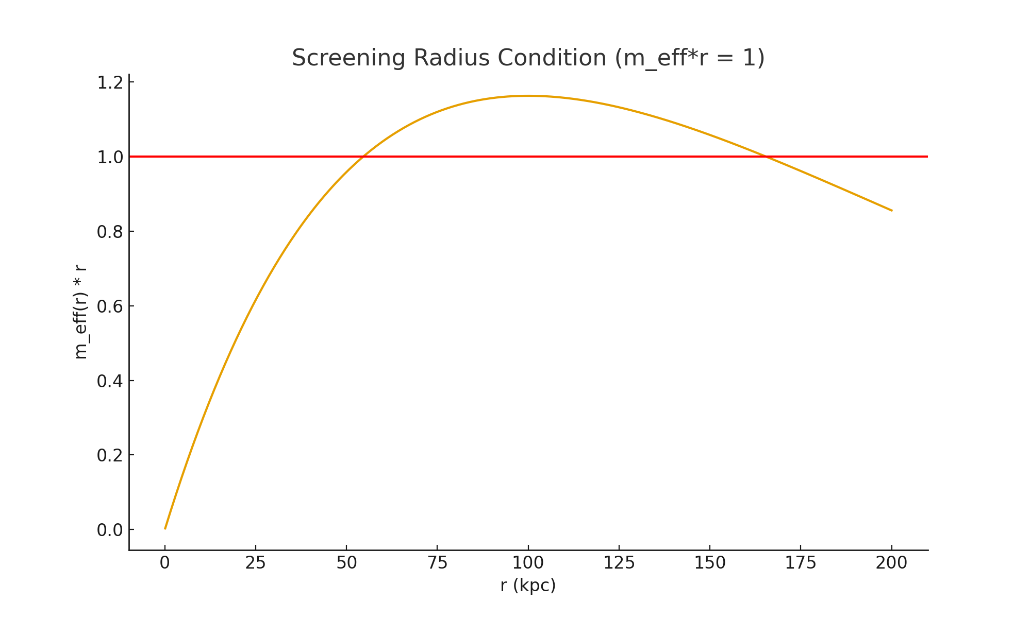
Figure 1 — Screening radius condition m_eff(r)*r = 1.
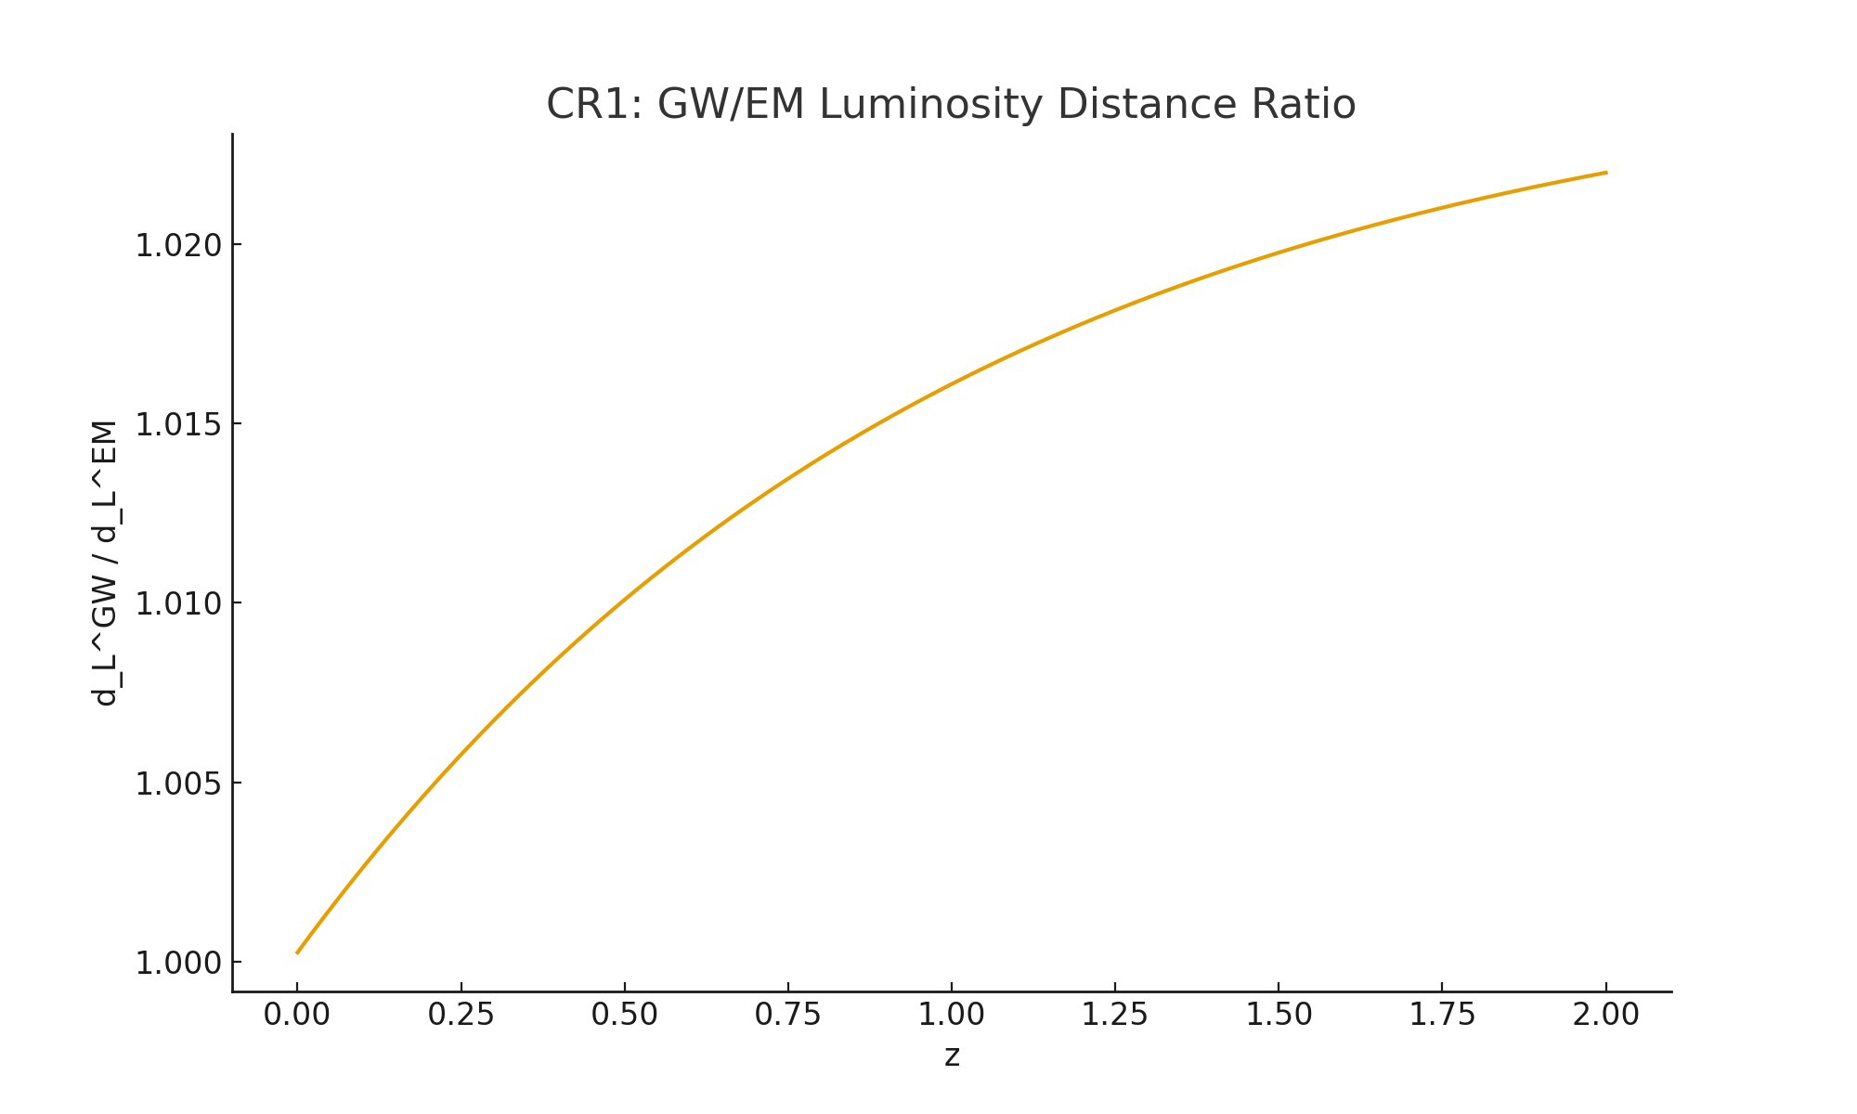
Figure 2 — CR1: GW/EM luminosity distance ratio.
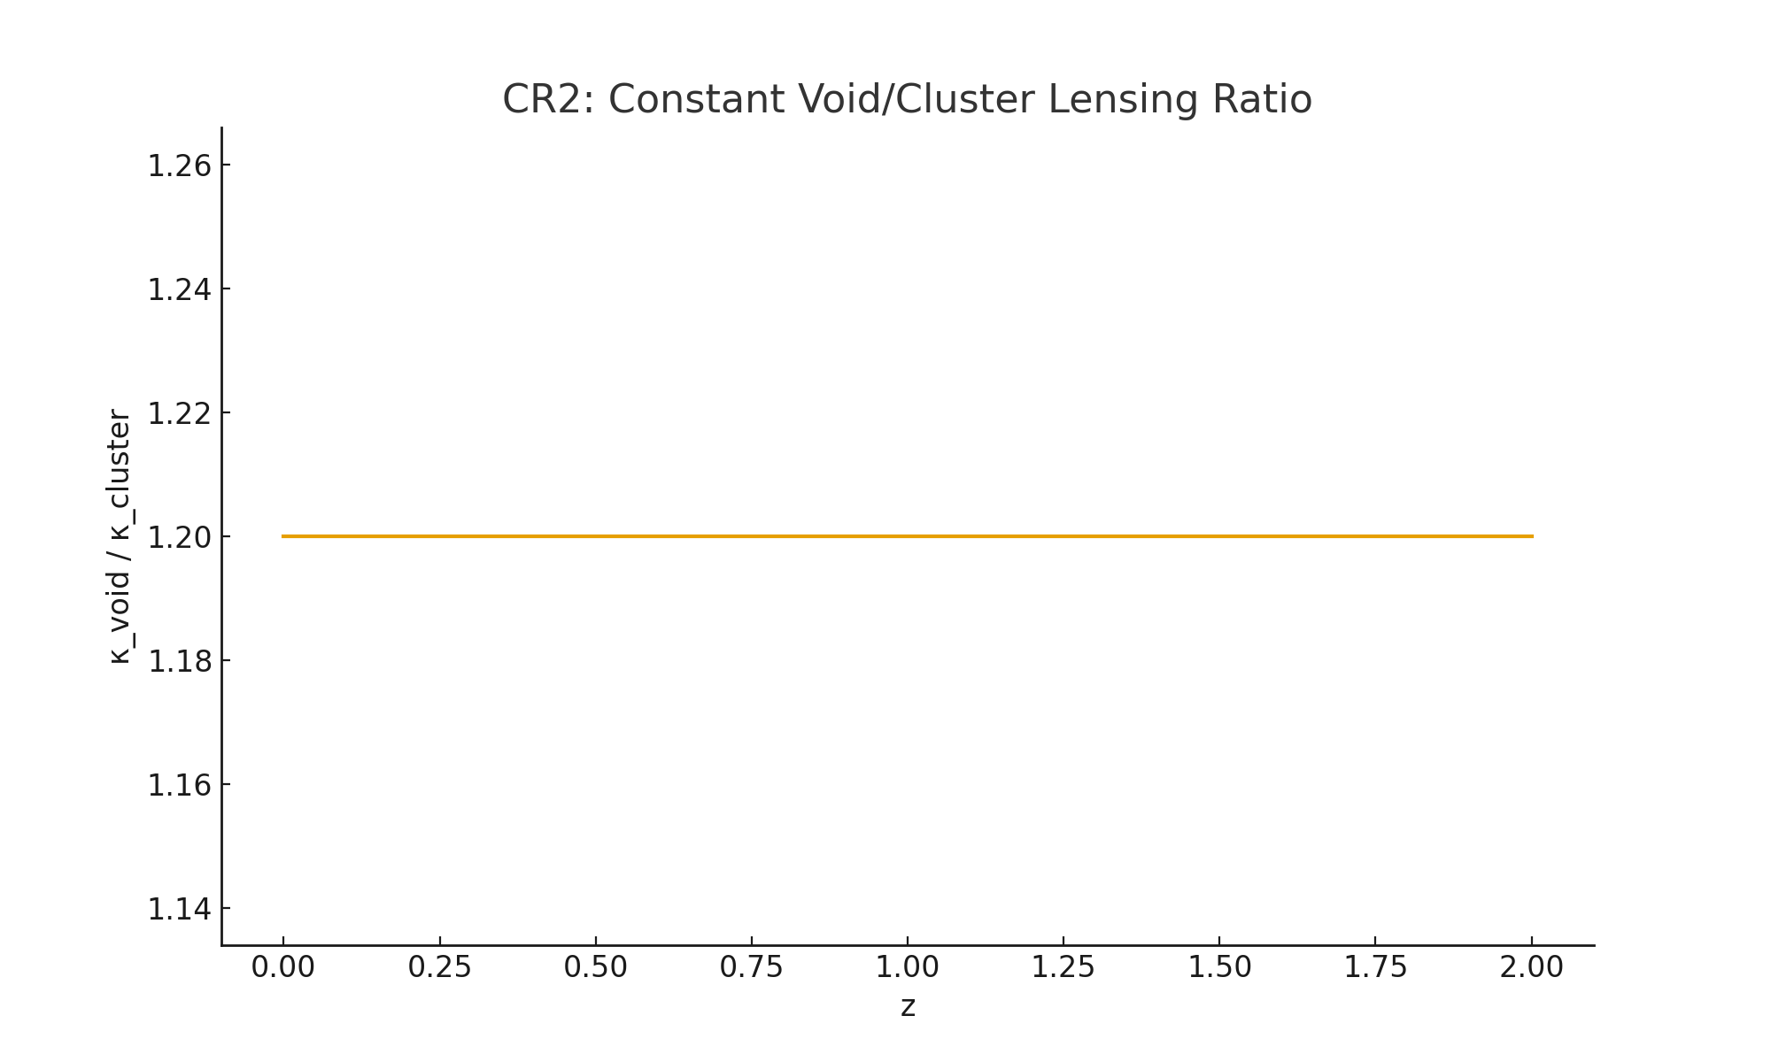
Figure 3 — CR2: Void/Cluster lensing ratio.
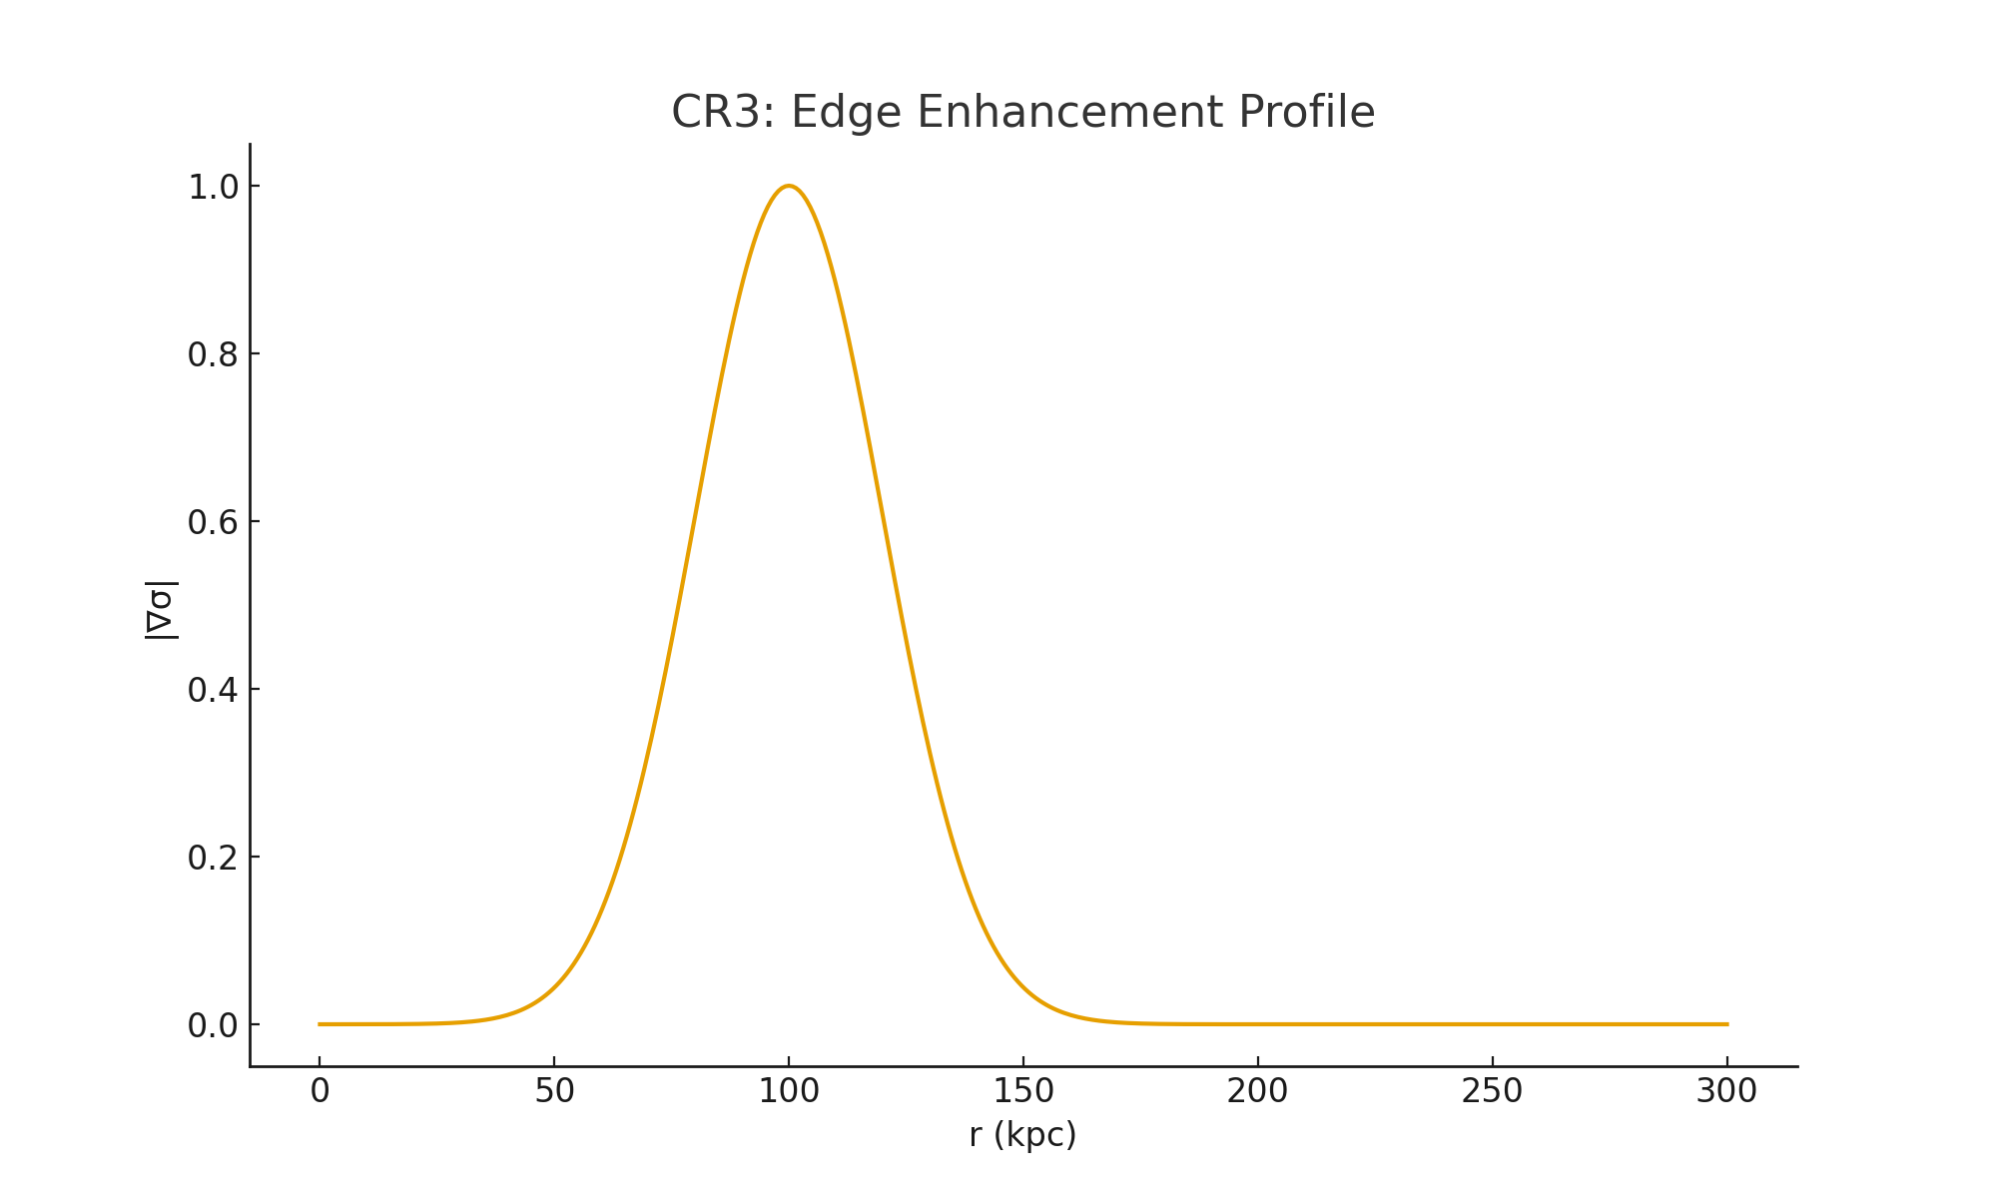
Figure 4 — CR3: Edge enhancement profile.
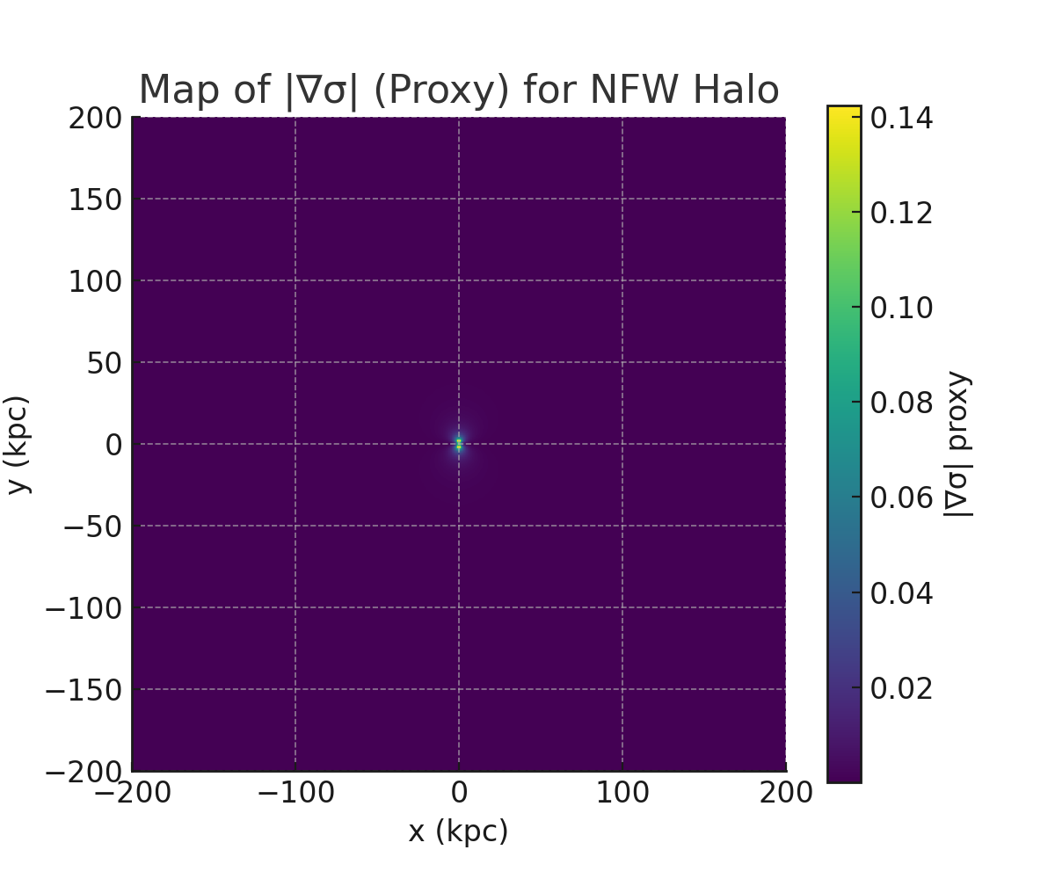
Figure 5 — 2D map of |∇σ| proxy for NFW halo.

9 Related Work / Comparison Table
Feature | OC | f(R) | Chameleon | Symmetron | Vainshtein
Origin | Adaptive M_*² | f''(R) | m_eff(ρ) | Z2 breaking | Derivative self-interactions
Screening | Crystallization | Chameleon-like | Chameleon | Symmetry | Vainshtein
c_T | 1 | ≠1 tuned | 1 | 1 | 1
Unique | CR1–CR3 | — | — | — | Strong-field

Appendix F — Visual Coherence Maps
This appendix provides visualizations for coherence gradients, lensing strength Σ(r), running α_M(z), and m_eff(r).

