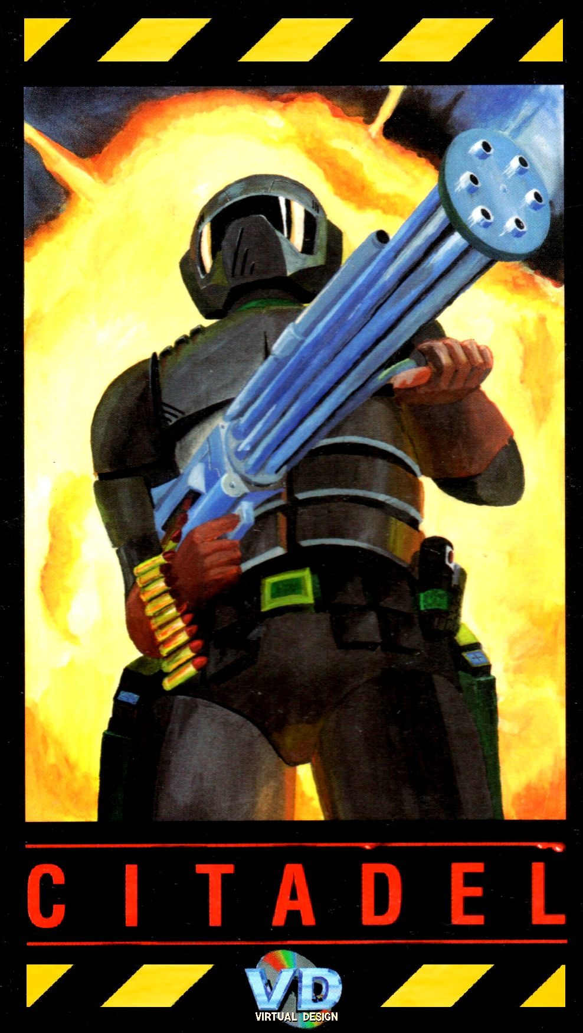

Citadel
Version 1.3 (January 2022)

BACKGROUND STORY

In the 24th century the Earth lies within an intricate web of conquest, politics, and economic gain.
On the outermost points of this web lie the bridgeheads, which are the points of strategic importance for the Earth's galactic defence and inter-planetary communication systems.
One of these bridgeheads was situated on a small distant planet orbiting Tau Ceti about 12 light years away from Earth and marked on stellar maps as B104-GS12. Once one of the “verge world” planets of the Earth’s galactic empire, it had originally become known for the discovery of stone structures created by a long gone, primitive alien civilization. A military training and research base was built on top of one of these vast, ancient underground structures. However, following rapid galactic expansion, the military base situated there lost its strategic significance and continued to exist for some time as a research facility into the alien culture and a re-fueling point for inter-stellar cargo travelling across the galaxy.
That did not last long as the facility was situated too far from the main transport routes. Further structures were added to the base and the site was transformed into a harsh penal colony. Two years later the colony was officially closed as B104-GS12 was supposedly in the path of a huge meteor swarm. This was however a fabrication sourced from the Military Council, who had their own plans for B104-GS12.
Consequently, the base became shrouded in mystery after being taken over by BioTec, a private company backed by the Earth’s Central Government and the Military Council. Some rumours started circulating among space cargo pilots about transports of sophisticated laboratory equipment and materials presumably used to modify and further expand the base, which BioTec internally referred to as the Citadel.
Away from prying eyes, inmates on death-row from other penal colonies were secretly transferred to the Citadel and used as additional slave labour to complete the modifications to the base. A few months later a huge, secret laboratory began to function there. While officially a BioTec verge world research facility, in practice it was an under-cover military funded lab in which ethically dubious and officially forbidden research into extreme biotechnological extensions to the human body took place. Most of the former inmates became subjects for the experiments.
At the start of 2305 all communication between the Citadel and the BioTec HQ on Earth stopped without any apparent reason. Efforts to restore the link failed, causing BioTec and the Military Council to convene and decide on sending a special landing force to B104-GS12 to establish what had happened.
A modern military spaceship, X16, with a crew of over 950, was dispatched to B104-GS12. While officially on a reconnaissance and training flight, the purpose of the mission had been kept secret and the crew were only briefed when they approached the destination. The orders from Earth were short and to the point: "Communications and control over the Citadel must be restored at all costs. If this is not possible then the Citadel must be destroyed".
As the X16 approached the planet it repeatedly failed to make contact with the Citadel, which remained silent on all wavelengths. With final preparations for landing under way a decision was made to send a small reconnaissance unit “Scout 01” to investigate the base from a closer distance. Just before its launch the main ship’s defence and comms system went down for an unknown reason and initiated a lengthy diagnostic and reboot procedure.
You were one of the two pilots on board of the Scout. Being wary of the Citadel's defence mechanism you and your co-pilot orbited the planet several times to take pictures and readings. As your Scout made a sweep of the planet something went drastically wrong. A rocket launched from the Citadel and headed directly for your mothership, blasting the unsuspecting and still defenceless X16 into oblivion, damaging the Scout and sending a horrifying shudder down your spine as you were forced to make an emergency crash landing on the planet's surface.
Unfortunately, your co-pilot did not survive the crash. YOU are the only survivor, 11 light years from home, with no one aware of your fate and no one coming to the rescue any time soon. Amidst falling X16 debris you make your way towards an emergency side entrance to the Citadel, leading you to the underground post-alien part of it.
You know that your only chance for survival and of getting home might lie somewhere within the Citadel.
Driven by the will to live you are ready to do anything that would ensure your survival.
It’s you against the Citadel and whatever evil lurks within.

RUNNING THE GAME

The latest Citadel version 1.3 is currently supported only using WHDLoad (version 17 or newer). It will run on any Amiga with a minimum of 0.5MB Chip and 1MB other (Fast or Chip) memory available for the game and meeting other WHDLoad requirements.
- To run it from CLI, type: whdload citadel.slave
- To run it from Workbench, click on the citadel.slave icon

MAIN MENU

After the game has been loaded the main menu will appear with the following options:
- START. Starts the game
- LOAD GAME. Loads a game which has been saved. Note the disc 4 is used for saves. You can only save the game in between levels.
- OPTIONS. Allows to configure several in-game options:
  - DFIFFICULTY. Can be set to Easy or Hard and determines how powerful enemies are.
  - SCREEN SIZE. Can be set from 1 (smallest) to 5 (largest). And determines the initial game’s display size. This setting has direct impact on performance and can be changed at any time while playing the game.
  - DETAILS. Can be set to Minimum, Medium or Maximum and determines the level of details displayed in the game such as decorative elements or fallen enemies. This setting has direct impact on performance and can be changed at any time while playing the game.
  - FLOORS. Can be set to Yes or No and determines whether textured floors and ceilings are displayed in the game. This setting has direct impact on performance and can be changed at any time while playing the game.
- TRAINING. Allows to select one of five training levels, playing which can allow to get used to the mechanics of the game as well as available weapons before engaging in the main story. These levels are not part of the main storyline.
- INFO. Shows some information about the game and its authors.

PLAYING THE GAME

OBJECTIVES

The main game starts after selecting START from the main menu or loading one of the previously saved games.
At first you find yourself at the emergency entrance to the Citadel, in the underground part of it which had originally been constructed by the now extinct alien race once inhabiting B104-GS12. You have nothing with you as you did not expect having to leave the Scout. Your first task is to therefore find some means of defence and then start exploring the Citadel in order to unravel its mysteries.
The aim of the game is to escape from the Citadel. As you quickly realise you cannot single handedly restore order in the base, therefore you must also destroy it following the orders received while still on the X16.
After getting out of the alien underground maze (the Basement), which has three levels, you will reach the main and human-built part of the Citadel. You then have some choice of your further path throughout the building complex and need to find six components required to construct a powerful bomb which you then need to detonate in the central part of the Citadel to annihilate it. You can only hope that you find some means of escape in the process.
Each part of the bomb is in one of the six extensions built around the central part of the base. Make sure you find the bomb part before leaving every extension, because you will not be able to go back to it. Only when all parts are found you can enter the core of the Citadel.

SCREEN LAYOUT

The screen has been divided into several parts.
The main window typically shows the 3D area around the player. My pressing M it can also display a map showing the already explored parts of the current location.
The bottom part of the screen is taken up by a control panel and shows from the left:
- Parts of the bomb found so far.
- Remaining health.
- Graph of your heart rate, which increases when being hit or stressed. Too high heart rate causes tiredness and lack of focus which in turn influence your aim and reflexes.
- Compass showing the direction you’re facing.
- The weapon you are currently holding, or an empty hand if no weapon is available or selected.
- Remaining ammo for the weapon being used.
- Three counters showing the number of red, green, and blue keycards you currently have. These keycards are used to open doors using card slots of the matching colour.

There is also a dialogue box at the very bottom of the screen where messages appear informing you about different things happening in the game.

MOVEMENT AND INTERACTION

You navigate the 3D world od the Citadel by using the keyboard (see the KEYS section), joystick, pad and/or mouse. For best experience it is recommended to use a combination of WASD keys (or arrows) for moving forward, backward, and sideways and at the same time the mouse for turning, aiming and shooting.
You can interact with the environment by pressing the action key (see the KEYS section) or the right mouse button if you are not holding any weapon. This is how you find information about your surroundings, press in-game buttons or enter keycards into card slots. While doing so watch for important information in the dialogue box at the bottom of the screen.
Some actions in the game are triggered by getting near objects, this includes doors which open automatically, teleports, and objects you can collect such as weapons and ammo.
Be ready to solve riddles to find hidden areas or just make progress throughout the levels. These may include buttons on walls opening or closing doors, removing secret walls, or making items appear. Sometimes a button on one side of the map will open a door on the other so be prepared for some exploration.
Your movements within each level are tracked on a map which can be brought up by pressing the M key. It helps you figure out where you’ve been and what you may have missed.

MOVING BETWEEN LEVELS

The Citadel is huge. It’s been originally built over alien ruins and extended over the years into the central core and six peripheral building complexes. Each complex typically consists of 2 or 3 levels. To complete each level, you must find the exit leading to the next one. Note that to finish the game you also need to find one part of the bomb in each or the six peripheral complexes so, since you cannot go back to the levels you completed, make sure you explore them thoroughly.

SAVING THE GAME

After completing each level, you will be presented with achievement statistics such as time taken and the number of enemies defeated. You will also be given a chance to save the game. Note that you cannot save within levels, only between them.
Also note that you need to quit WHDLoad for the game file to actually be saved to the hard drive as by default WHDLoad caches disk writes until after leaving the game. Therefore, if you want to keep your save games for later, press F10 once you finished playing to quit the game instead of just resetting the device. This does not have to be done between levels, only at the end when you actually want to stop playing.

COMBAT

On your way through the Citadel you will encounter numerous enemies. They differ in speed, aggression, weapons, and resistance to different forms of attack. Fortunately, you will also find different weapons which you can use, ranging from a simple handgun, through a machine gun, to a flame thrower and rocket launcher. As you enter the Citadel empty handed, search for a handgun close to the starting point. The more advanced weapons can be found later in the game.
Each weapon uses ammo which you can also find around, or salvage from enemy corpses. Explore the levels and collect additional ammo as you can stack it and it will surely become handy in the heat of battle. There is also a risk of your weapon jamming or breaking – if this happens, you need to find a new weapon.
You may die a lot at first, but each enemy has its weak spots which you should try to discover and exploit. Some enemies are immune to some weapons, such as metal robots which are unaffected by fire. Use tactical techniques such as luring enemies or hiding behind doors or around corners. Moving sideways while turning to avoid enemy shots while keeping them in your crosshairs is just one of several effective strategies. Note that enemies do not randomly reappear – once you clear an area, it stays safe.
Look around for other useful items such medkits which replenish your health and adrenaline shots which speed you up. You can also find some spirit, most likely part of medical supplies used for experiments - although fun for a moment it will disrupt your movements and aiming for a while, so think twice before using it.

CONTROLS

The game can be played using the keyboard, mouse, joystick, gamepad, or a combination of those. Best experience is achieved using the mouse (rotation and shooting) and keyboard (WASD keys and weapon selection) together.

KEYS

W,A,S,D, up/down arrows: move forward, backward, left or right
Q,E, left/right arrows: turn left or right
Enter, Shift: fire selected weapon, insert selected keycard
Space: interact with the environment e.g. open (some) doors, operate switches
M: toggle map
P: toggle game pause
F: toggle textures on floors and ceilings
G: change level of details (low/medium/high)
Z: toggle screen disturbance while hitting walls
C: toggle crosshairs
Esc: quit to main game menu
1 – 7: choose a weapon (if available)
1 - nothing (empty hands)
2 - handgun
3 - rifle
4 - machine gun
5 - flame thrower
6 – shock blaster
7 - rocket launcher
8 - 0: keycard selection (if any available)
8 - red keycard
9 - green keycard
0 - blue keycard
T, TAB: change to next available weapon or keycard
R: change to previous available weapon or keycard
F1-F8: change the game window size. Sizes 6-8 can be set only from within the game (not from the main menu)
+ / - : change the game window size one step at a time
F10: quit WHDLoad
`: display current FPS (Frames per Second)

GAMEPAD

Up / down arrows: move forward and backward
Left / right arrows: move sideways left / right
X / B: turn left / right
A / Y: change to previous / next available weapon or keycard
L: interact with the environment e.g. open (some) doors, operate switches
R: fire weapons, insert keycards
Menu: quit to main game menu
Home: quit WHDLoad

JOYSTICK

Up / down: move forward and backward
Left / right: turn left / right
Fire: fire weapons, insert keycards

The keyboard should be used to control other game functions.

MOUSE

Up / down: move forward and backward
Left / right: turn left / right
LMB: move forward
RMB: fire weapons, insert keycards

The keyboard should be used to control other game functions.

ACKNOWLEDGEMENTS

The first version of the Citadel was released by Virtual Design in 1995. The core team as well as numerous people who contributed to its creation are listed in the INFO section of the main menu.
The current version 1.3 has gone through a refresh in 2022, involving removing some bugs discovered over 20 years, improving some aspects of the gameplay such as performance, player control, and an update of the in-game graphics and level design. This was done by Pawel Matusz and Artur Bardowski from the core Virtual Design team with help from Adam Nowakowski with preparing the final version of the WHDLoad install.

COPYRIGHT

Copyright © 1995, 2022 Virtual Design - Pawel Matusz, Artur Bardowski. This software is free to copy and use for non-commercial purposes. Virtual Design assumes no responsibility for any damage or loss caused by installing or using it.

