Paweł Rybacki  
Review of the People’s Republic of China’s Labor Market Gender Inequality  
March 30, 2022

**Review of the People’s Republic of China’s Labor Market Gender Inequality**

1. Introduction

The People’s Republic of China’s labor market gender inequality is an interesting problem from the economic and social standpoint. It is generally accepted that economic growth and gender pay equality are positively correlated, since the improvement of work conditions and technology tend to diminish the productivity differences related to personal characteristics. In addition, improved education equalizes the opportunities and eliminates prejudices. However, in the case of the People’s Republic of China over 1990s and 2000s, the wage gap has increased (Chi and Li 2014; J.-W. Lee and Wie 2017), the labor force participation gap has slightly increased, and the employment gap has not substantially decreased (World Bank 2006). The present paper will review and comment on the existing literature while exploring the characteristics of gender inequality in the PRC’s labor market. In particular, this paper attempts to determine to what extent gender discrimination impacts gender inequality in relative pay, employment, and labor participation. To establish that, it is crucial to take into account and discuss various factors that affect women’s situation in the labor market. In the first section, the paper provides a background discussion of the modern economic development of the PRC and presents conjectures and assumptions to be scrutinized. Then it proceeds with an overview and commentary on the current research on the topic. It separately addresses each of the following structural- and individual-level aspects: wage structure, enterprise ownership, rural-urban divide, globalization, education level, marital status and children, party membership, and finally gender discrimination. It concludes with a summary of presented findings, a discussion of their limitations, and recommendations for the further research.

2. Background

In the PRC, like in many countries worldwide, women face various forms of discrimination. This fact translates into the situation of women in the labor market, where they face not only lower wages at the same positions as men, but also lower employment and lower labor force participation. One the one hand, the PRC has been growing as a market-oriented economy since the transformations of 1978; on the other hand, the country has kept the Maoist ideology. In addition, there is not only a tension between a potential free-market efficiency-equality tradeoff and the socialist equity ideal, but also between the remaining stereotypes in the Chinese society and the expected progress toward modern global standards.

Source (graph and caption): Chi and Li (2014, 717)

3. Structural-Level Factors of the PRC’s Labor Market Gender Inequality

*3.1. Wage Structure*

One of the most important things to bear in mind when discussing gender pay gap is the wage structure. What is true for mean wage may be false for a wage at a particular job or pay level. Contemporary studies in the PRC have unveiled that while low- and medium-skilled women were more affected by income inequality, high-skilled women were, in some sense, more impacted by gender inequality. For each income group, there are different variables explaining the sources of inequality. For all, however, there are also strong unexplained factor effects, which may come from unobservable qualifications or gender discrimination. The scope and nature of those effects also depend on the distribution range.

Lee and Wie (2017) present a comparative analysis of the gender wage gap in urban India and urban China over 1990s and 2000s. Taking into consideration each skill level, they find that the increasing gender pay inequality cannot be explained by the differences in observed qualifications (Lee and Wie 2017, 327). For low- and medium-skilled female workers, the improvement in observable skills was relatively smaller, implying that those women were most affected by general inequality (Lee and Wie 2017, 315-316). However, gender inequality had a higher adverse effect on high-skilled women, whose wages relatively decreased even though their education relatively increased (Lee and Wie 2017, 327). This can be explained by a “race between education and wage structure,” in which narrower education gap was outdone by increased skill premium (Lee and Wie 2017, 327).

The pay gaps at low income levels are sometimes called “sticky floors,” while the pay gaps at high income levels—“glass ceilings.” Xiu and Gunderson (2014) look into the characteristics of both and list the mechanisms underlying each group’s situation.

For women affected by sticky floors, the authors name the following factors: “on the endowments side lower level of education, less likelihood of being CPP members and being concentrated in lower paying occupations, and on the returns side having lower returns to their job tenure, other labour market experience, and a greater negative effect of family responsibilities on female wages” (Xiu and Gunderson 2014, 322). The authors emphasize that for women at the low income level, the investment in education is very profitable, but having a small child has a higher penalty effect (Xiu and Gunderson 2014, 323).

For women affected by glass ceilings, the following variables were important: “on the endowments side include females’ lower level of experience in the labour market, their lower likelihood of being in managerial positions and leadership positions in their organizations, and on the returns side, their lower returns to education, job tenure, and other labour market work experience” (Xiu and Gunderson 2014, 322). The authors add that those women have a lower education relative to their male colleagues: for example, less managerial training or development programs (Xiu and Gunderson 2014, 323).

In addition to those findings, the Xiu and Gunderson (2014) also note that that the unexplained portion of gender wage gaps varies with the income level, as opposed to the portion explained by observable qualifications (Xiu and Gunderson 2014, 322). The authors provide the following table:

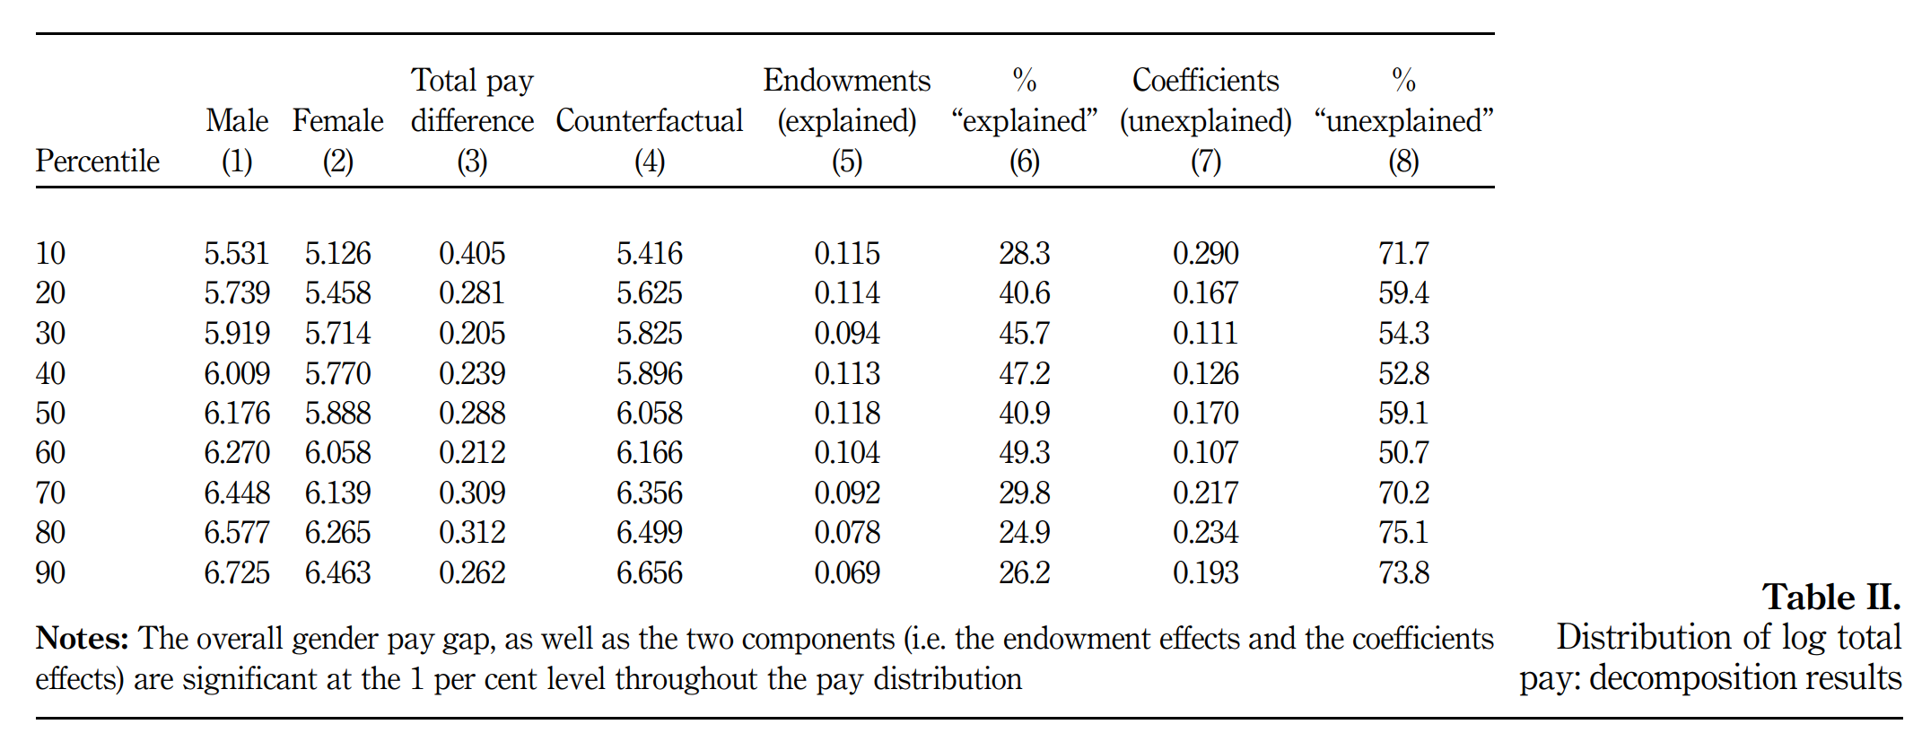Source (table and caption): Xiu and Gunderson (2014, 315)

Apparently, the unexplained portion of gender pay gap is higher at the extremes of the distribution, reaching 71.7% for the 10th percentile and 73.8% for the top 90th percentile than in the middle range, where remains below 60%.

The exploratory study of S. Liu (2013) provides additional insight to the glass ceiling analysis by introducing the perspective of interviewed Chinese female managers. Based on their stories, the author puts forward the following factors unobserved in empirical studies: 1. Social: socially accepted behavior of men and women and the attitudes toward women; 2. Organizational: male-dominated organizational culture, perceptions of role congruence regarding leadership, and HR practices; 3. Individual: career aspirations of women and women’s beliefs about glass ceilings (Table 1 in S. Liu 2013, 484). One common motive among those factors is that the work environment holds certain expectations toward women related more to social life rather than to professional activity. Sometimes, those expectations were conflicting with other cultural norms or were even internally inconsistent. Depending on the adopted criteria, those factors can be classified as unobservable qualifications or discrimination. Probably, it is a combination of both with an emphasis on the latter.

*3.2. Enterprise Ownership*

Another essential element of the labor market gender inequality analysis is the comparison of sectors categorized by ownership. In the PRC, the public sector consists of government organizations and state-owned enterprises (SOEs), and the private sector consists of Town and Village Enterprises (TVEs), foreign-owned enterprises, and privately-owned firms, and self-employment. With the economic reforms that started after 1978, there has been a tremendous growth in wages for both genders and across all sectors. However, the possibility of wage-setting independently of state policy has resulted in the emergence of pay gaps between men and women. Empirical studies on the topic have shown that the gap may result from both efficiency-enhancing and from efficiency-worsening practices, i.e. both from setting wage equal to the average product of labor and from gender discrimination.

Source (graph and caption): United Nations System in China (2014, 23)

Ma (2018)’s comprehensive study of gender wage gap in urban China during the 2000s in the context of ownership sector segmentation features the evidence of gender wage gap variability dependent on sector. For both years included in the research, 2002 and 2013, the gap was higher in the private sector than in the public sector (Ma 2018, 787). Moreover, the increase in the gap over time has also been higher for the private sector (Ma 2018, 787). The following table attached to the study illustrates the details of this phenomenon:

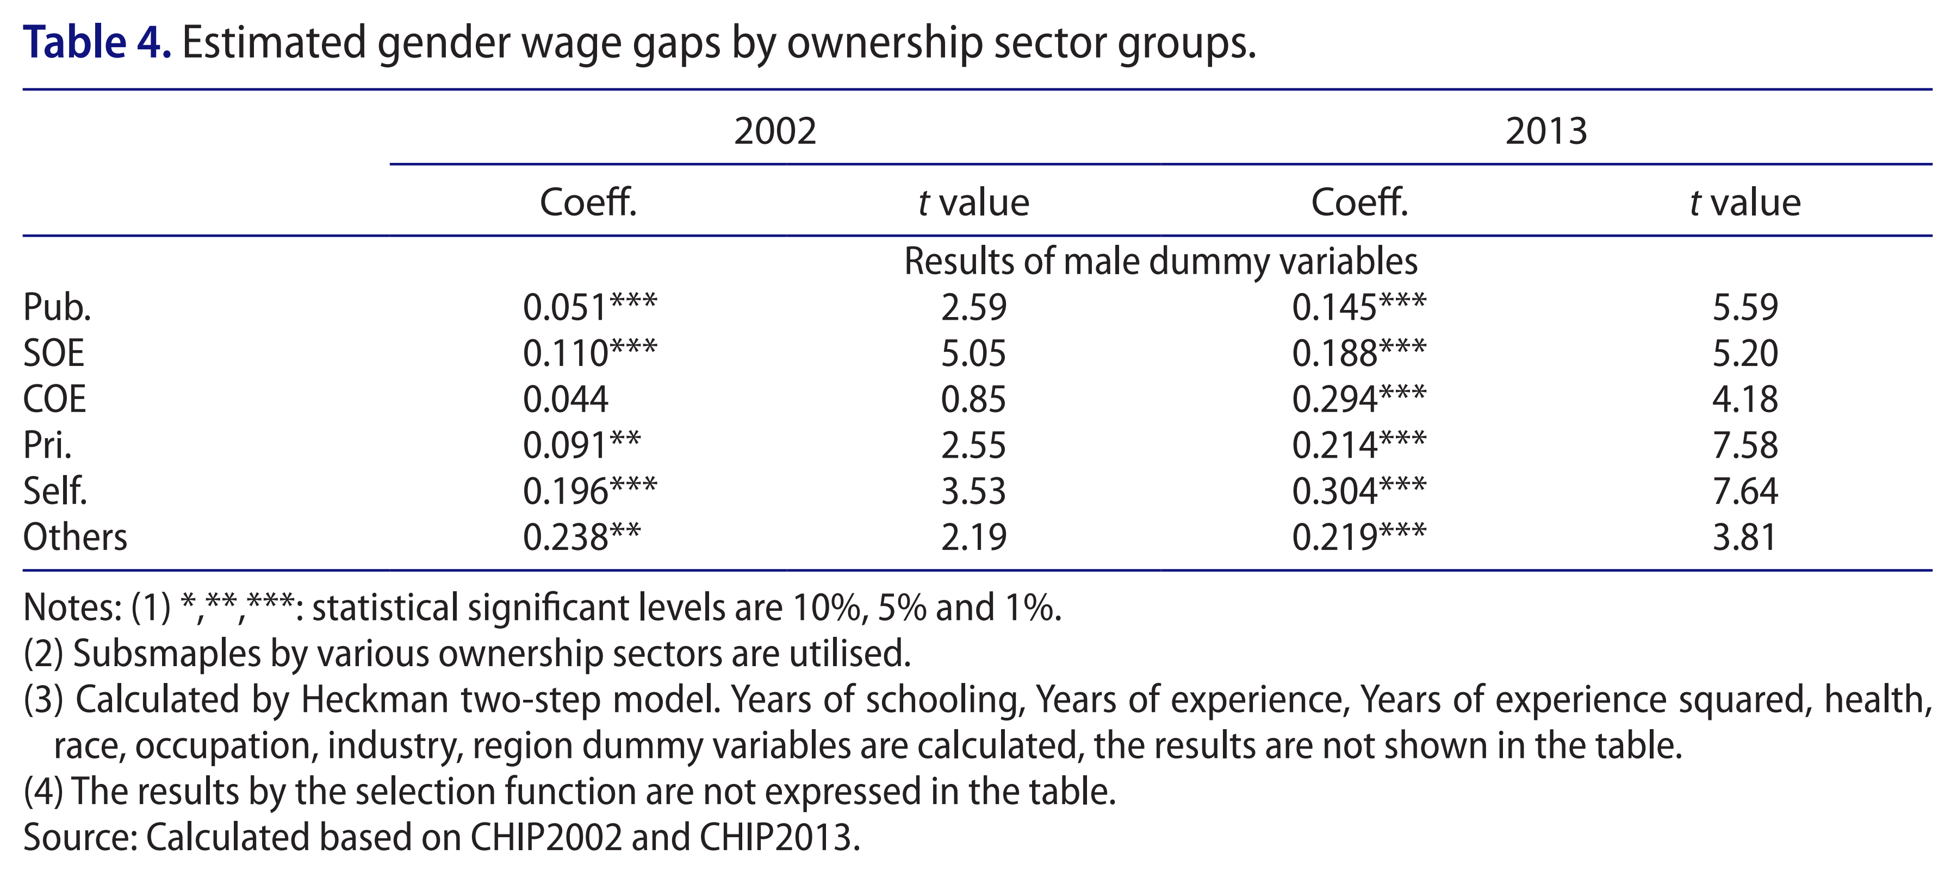Source (table and caption): Ma (2018, 788). Note: “COEs” denotes “collectively-owned enterprises,” elsewhere called the TVEs.

An interesting fact the table shows is that self-employment had the largest gender wage gap in both periods. Certainly, this cannot be a result of discrimination. Most likely, self-employed women took up less profitable economic activity than self-employed men. However, Ma’s (2018) study does not address that problem but examines other individual characteristics for women working in each sector.

That is, the author further conducts an infra-industry scrutiny on whether those gaps can be explained by individual variables related to schooling, age, health, race, marital status, and region. After controlling for those, she concludes that women faced discrimination in the private sector but were favored in the public sector (Ma 2018, 793). However, it is also possible that along with discrimination, additional, unobservable individual qualifications contributed to unexplained gender wage gap, as discussed in the final paragraph of the previous section.

Rickne (2012), in turn, finds that the generally narrower gender pay gap in the public sector overshadows two opposite effects. She finds that unskilled women experienced greater wage disadvantages relative to men in the SOEs and foreign invested companies, and smaller in the private sector (Rickne 2012, 326). The skilled women, in turn, had a wage advantage over men in the public sector. Next, the author discusses the wage-productivity ratio for female workers. Less educated women were overcompensated in all types of companies. For private and foreign-owned firms, the author explains that light industry employers preferred docility, obedience, and easiness to control characterizing women workers (Rickne 2012, 323). Highly educated women, in turn, received pays corresponding to their average productivity in most companies, excluding the SOEs and mixed-ownership ones (Rickne 2012, 323).

Source (graph and caption): Rickne (2012, 324)

Therefore, there is a possible tension between Ma (2018), who represents a somewhat more common opinion that gender discrimination, especially in private companies, has increased since the economic reform and Rickne (2012), who does not find such evidence and presents outcomes more favorable to the private sector. The difference may come from a different focus (industry vs. whole economy) or method (productivity functions vs. regressions with control variables).

*3.3. Rural-Urban Divide*

Rural-urban inequality has been one of the principal sources of inequality in the PRC over the last decades. However, there seems to be not enough discussion of gender pay inequality in the context of the rural-urban divide, and most recent publications focus on urban settings. To provide some outline on this problem, I have decided to include the findings from a master’s thesis by Gu (2017) a South Dakota State University student.

Based on 2011 The China Health and Nutrition Survey (CHNS) data, Gu (2017) notes that women had equal and higher education than men in rural and urban areas, respectively (Gu 2017, 35). However, the difference was relatively small, with merely 0.4 more years of education for urban women and 0.3 more years of education for women overall (Gu 2017, 26). At the same time, the author found a gender pay gap of -12.2% in urban division and -24.9% in rural division, indicating a 12.7 pp difference (Gu 2017, 34). It would be interesting to investigate what caused that difference. A conjectured explanation is women may have a smaller productivity in the on-farm employment or that gender discrimination may be higher in the rural environments.

*3.4. Globalization*

Globalization inevitably leads to higher economic growth, which is to the benefit of the society as a whole. However, a key criticism of that phenomenon is the emergence of winners and losers of global trade, or an increase in economic inequality. One of the lines of division is gender, since the adaptations of the labor market toward new conditions may have both advantageous and adverse effects on women’s wage, employment, and labor force participation.

Chen et al. (2013) report that one of the main benefits of the PRC’s integration to the global economy are decreased gender wage gaps and emergent workplaces. They find that foreign participation and export orientation not only eliminated gender discrimination but also contributed to higher female employment as well as to lower gender wage gap in a given region and industry (Chen et al. 2013). This is both due to increased competition, which raises the cost of discrimination, and due to higher employment of women in foreign and exporting firms (Chen et al. 2013). An important distinction to make is that this overall improvement took place despite increased gender wage gaps in foreign and exporting firms (Chen et al. 2013, 265). Nonetheless, the authors identify that the gap reflects productivity difference rather than discrimination (Chen et al. 2013, 265). The authors portray the emerging manufacturing jobs as conducive to women’s economic wellbeing (Chen et al. 2013, 265). Overall, they emphasize that the unskilled female workers benefit from the connection of local labor market to the global economic system (Chen et al. 2013, 265).

The abovementioned study was conducted using a intra-industry approach and fits into a general consensus on the positive effects of globalization on the situation of women in the labor market. However, Sauré and Zoabi (2014) present a new method challenging the foregoing belief. They argue that, in fact, international trade in capital-rich industrial countries may result in a drop in female labor force participation and women’s relative wages (Sauré and Zoabi, 2014, 24). They analyze that, with the expansion of female intensive sector, male intensive sector shrinks, and male labor reallocates to the former sector, decreasing capital-labor ratio there (Sauré and Zoabi, 2014, 31). Relying on the assumption of a relatively strong complementarity between capital and female labor, the authors conclude that the marginal productivity of women drops more than that of men—widening the gender wage gap and reducing female labor force participation (Sauré and Zoabi, 2014, 31). Further research on that topic could apply Sauré and Zoabi’s (2014) method to confirm or disprove Chen’s (2013) findings.

4. Individual-Level Factors of the PRC’s Labor Market Gender Inequality

*4.1 Education*

One possible explanation of the gender pay difference is the disadvantage that women face due to their lower education level attainment. Lower education level means lower qualifications, and thus a direct disadvantage through the market mechanism. This affects wages, employment, and female labor force participation. Therefore, it is important to start with the question of whether the educational opportunities of men and women in the PRC differ and, if yes, how. The answer to that will be followed by an analysis of how additional education changes the labor status and opportunities of each gender.

*4.1.1. Gender and Education Opportunities*

The gap in average schooling years of men and women narrowed from 1.9 years (7.4 years for men, 5.5 years for women) in 1990 to 1.3 years (8.3 years for men, 7.0 years for women) in 2000, and 0.8 year (9.2 years for men, 8.4 years for women) in 2010 (United Nations 2014).[1]

Lee (2012) argues that a large contributor to the gender equality in the predominantly patriarchal society of China has been the controversial one-child policy. Her study’s outcomes show that only children benefited from better education opportunities as compared with other children; the effect was larger on girls than on boys (Lee 2012, 51). Girls not only had exclusive access to a portion of household resources that would otherwise have had to be split with preference given to male offspring, but also avoided potential submission to their brothers (Lee 2012, 51). This is backed by empirical results: urban and rural girls with brother(s) received 0.20 and 0.62 fewer average years of education, respectively (Lee 2012, 51). However, there was no significant difference between only-child boys and only-child girls in terms of years of schooling (Lee 2012, 51).

*4.1.2. Education Level and Labor Opportunities*

Q. Liu (2012) finds that higher education significantly increases the probability of employment, with even higher returns for women (Q. Liu 2012, 28). Considering the time perspective, the importance of education for participation and employment has increased for both genders, also even more for women (Q. Liu 2012, 19). The study of Chi and Li (2014) confirms that observation and illustrates it with the following results:

Source (table and caption): Chi and Li (2014)

Interestingly, however, primary education has had a generally negative effect on employment, with a stronger impact again on women.

As far as the wage gaps are concerned, they decrease with the level of education (Hughes and Maurer‐Fazio 2002b 152). Hughes and Maurer-Fazio (2002b) show surprising evidence of low to even negative returns to education in men’s case (Hughes and Maurer-Fazio 2002b, 150). This fact may have various underlying phenomena. For example, women may make a better use of their education or men can better take advantage of the years spent working instead of learning.

Benefits from education vary by sector, especially at the levels below university. According to Ma (2018), education level increased the chance of getting a job in a public organization (Ma, 2018, 792). The same was true for the private sector. In both cases, statistical significance increased from 2002 to 2013 (Table 5a and 5b in Ma, 2018, 790-791). In terms of the impact of education on wages, Maurer-Fazio and Hughes (2002a) found that education at levels lower than university generally did not matter for women in the joint venture sector (Maurer-Fazio and Hughes 2002a, 21). For the SOEs, only vocational senior school and university levels were significant for wages (Table A2 in Maurer-Fazio and Hughes 2002a, 44). In turn, the impact of education was higher for the collective sector, where each level of education higher than junior middle school had a positive return on earnings (Maurer-Fazio and Hughes 2002a, 21-22).

*4.2. Marital Status and Children*

Marital status and the number of children are further factors explaining wage disparities. Neither do they determine one’s aptitude to work nor clearly indicate one’s individual characteristics, but they turn out to be a statistically significant and therefore reflect interesting preference patterns among Chinese employers.

Hughes and Maurer-Fazio (2002b, 147) find that for married individuals, the smallest gap was found in state enterprises, where women earned 87.9% of what men earned, and the highest gap was found in joint enterprises, where women earned 74.1% of what men earned (Table 5 in Hughes and Maurer‐Fazio 2002b, 147). In the case of single individuals, the smallest gap was also for state enterprises, where women earned 95.3% of what men earned, and the largest gap was found in collective enterprises, where women earned 89% of what men earned (Table 6 in Hughes and Maurer‐Fazio 2002b, 147).

In 2002, the authors found that, unlike in most other developed countries, marital status did not influence female labor force participation or the attachment of Chinese women, according to 1992 data (Hughes and Maurer‐Fazio 2002b, 146). However, this pattern has changed dramatically over time. In 2005 the authors, the authors present new evidence contradictory to their previous findings: “by 1990, marital status had a strongly significant effect” of 8.9% higher probability for a married woman to participate in the labor force (Maurer-Fazio, Hughes, and Zhang 2005, 11). By 2000, a turn in the pattern has taken place, with the new effect of -1.2 percent probability for married urban women to participate in the labor force (Maurer-Fazio, Hughes, and Zhang 2005, 11).

Q. Liu’s (2012) study confirms that marital status mattered in female labor force participation in 1995 and 2002 (Table 4 in Q. Liu 2012, 26). Also, in general, labor force participation for those years was higher for married men and women and lower for single people (Q. Liu, 2012, 25). The effect of marriage on employment is also positive and statistically significant for men; however, it is not statistically significant for women (Table 5 in Q. Liu 2012, 27).

The same study allows to answer the question of the importance of children on labor force participation and employment (Tables 4 and 5 in Q. Liu 2012, 27). The statistical significance of the effect of having children has decreased for labor force participation and has increased for employment. However, the effects have always been small, with at most 3.5% of higher probability of employment for men in 2002. In the same year, there was a very small but significant positive effect of an additional child at the age between 7 and 18 on female employment.

*4.3. Party Membership*

Although the available literature does not describe in detail the influence of the communist party membership on the different situation of men and women in the labor market, this factor seems to be significant and worth elaborating in future research. Q. Liu (2012) verifies that communist party membership increases the likelihood of labor force participation and employment; she notes that this effect has expanded over time for both genders (Q. Liu 2012; 19, 27). Nonetheless, the genders differ by magnitude of the effect; there was a gap between 2.5% unemployment rate for female CCP members 14.0% for other women (Q. Liu 2012; 25). Xiu and Gunderson (2014, 313) analyze the member-nonmember gap in terms of income distribution and find that the low-paid women were most affected by the difference (Xiu and Gunderson, 2014, 321). They also note that a higher proportion of men were party members (Xiu and Gunderson, 2014, 313). From this fact it follows that women were penalized more than men for their smaller interest in politics, civil engagement, or support for the state ideology.

5. Gender Discrimination and the PRC’s Labor Market Gender Inequality

The most pressing question of the discussion on gender pay inequality is whether the phenomenon is a result of gender discrimination or of other factors. In terms of measurement, the commonly used Blinder-Oaxaca decomposition model defines gender discrimination as the difference in wages that is unexplained by individual characteristics and other factors. Surprisingly, the unexplained factors happen to constitute most of the gender wage gap. Nevertheless, establishing whether discrimination really accounts for most of the gender pay inequality is very complicated and requires further research.

Using nationally representative micro data from the Chinese Household Income Project (CHIP) surveys, Q. Liu (2012) found that male-female differentials in employment and labor force participation cannot be explained by individual characteristics such as age, education, and marital status (Q. Liu 2012, 32); in fact, coefficient effects (potential discrimination) constitute as much as 90% of participation and 80% of employment differentials.

The scope of the problem does not seem to be the same across economy sectors. Rickne (2012) argues that negative discrimination is not a valid explanation of wage differences between men and women working for industrial companies. In contrast, they come from the differences in the contribution to the value added (Rickne 2012, 309). That study was conducted using firm-level data, what allowed to compare wage with the marginal productivity of labor (Rickne 2012, 308). What is more, women with lower levels of education earned relatively more given to their own contribution (Rickne 2012, 326). In addition, “more recently established light industrial and foreign-owned” firms preferred to employ young women. (Rickne 2012, 326). She concludes with a finding that the gender wage gap in industry is, in fact, relatively smaller than in other large economies (Rickne 2012, 326). Therefore, Rickne’s (2012) industrial sector results pose a serious challenge for many researchers who attribute most of the gender pay gap to discrimination. A counterargument would be that though industry is a sector adding up to almost a half of the Chinese GDP, gender discrimination could still be a real problem in agriculture and services. Nonetheless, her findings challenge the common consensus on the scale of gender discrimination in the PRC, and thus urge further research on that topic.

The changes resulting from progressing globalization also help better understand the sources of gender discrimination and inequality. According to Chen et al. (2013), significant gender discrimination exists predominantly in private non-exporting companies (Chen et al. 2013). Perhaps this fact is a consequence of cultural factors combined with limited exposure to the global standards and practices. International companies are more likely to consider gender discrimination unethical and uneconomic.

While there were gender wage gaps in foreign firms and domestic exporting firms, they result from productivity differences rather than discrimination. The author suggests that those differences were associated with low-tech and low-skilled tasks women do in those companies (Chen et al. 2013). Hence, one could conclude that although women already have equal access to education overall, they do not always receive the type of training that would reduce income disparities. However, this fact should not overshadow the overall ameliorating effect of globalization on both discrimination and inequality.

6. Conclusion

Market-oriented policies have allowed previously impossible firm-level price setting, including wage-setting. This landmark advancement has greatly contributed to growth by improving efficiency. However, efficiency sometimes entails inequality. In addition to that, the prejudices of some employers may translate to lower wages for certain groups of employees such as women (despite a resulting *decrease* in efficiency). The distinction between those two phenomena is a crucial question to researchers and policymakers. This motive guides the discussion of different structural and individual circumstances jointly contributing to the current labor market situation of Chinese women.

The degree and sources of gender inequality depend on the income level. It is important to notice that the gender pay gap changes with income were not very large. However, women at different distribution levels were impacted by inequality to various degrees. In some sense, high-income level women were more impacted by gender inequality, since their pay relative to that of men decreased despite their improvement in personal qualifications. Those women therefore experience “glass ceilings” explained inter alia by lesser work experience and lower likelihood of being managers or leaders (Xiu and Gunderson 2014, 322). However, the gender pay gap of very-low-income women was higher, reflecting their lower qualifications and returns to those (Xiu and Gunderson 2014, 315). They experienced “sticky floors” coming mainly from their occupations, lower communist party participation, and more household responsibilities (Xiu and Gunderson 2014, 322).

Another important predictor of gender inequality is the firm ownership. In general, the public sector seems to be less characterized by gender inequality than the private sector. Some scholars, such as Ma (2018) attribute that difference to a higher discrimination in the private sector. Other, including Rickne (2012), believe that the phenomenon is more complex, taking into account the skill level: in the industrial companies of the public sector, low-skilled women were disadvantaged relative to men, and high-skilled women were advantaged relative to men (Rickne 2012, 322-323). In addition, female industrial workers tend to be, in fact, overcompensated (Rickne 2012, 323).

In the globalized China, there have been more opportunities for women, which has contributed to their higher employment and labor force participation. More importantly, international competition counteracted gender discrimination, and even reduced the gender wage gap, although foreign-owned and exporting firms only improved in the former regard. That said, there is still a need to verify those outcomes employing more sophisticated research methods.

Considering the existing rural-urban divide in the PRC, labor market gender inequality should also be analyzed in that context. Although there is not much research done on that recently, a simple regression based on the 2011 HCNS data unveiled that the gender pay gap is higher for rural areas, possibly reflecting a larger problem discrimination there (Gu 2017). Then, it is important to note that while the present paper recognized the difference between rural and urban conditions, it relied more on city-based research. Another significant limitation of this paper is that it skipped the discussion of how employment and gender pay gap change depending on occupation, and how occupational segregation contributes to that. Instead, the discussion focused on broader structural-level elements of the PRC’s economy.

Among individual-level determinants of gender inequality, education is probably the most prominent one. Education attainment inequality in the PRC has been pretty small over the last few decades, with the gender schooling difference now averaging less than a year. It has decreased inter alia thanks to the controversial one-child policy. Educated women now possess competitive qualifications and enter positions previously reserved for men. It is well-established that higher education increases the chance for women to become employed and earn higher wages. However, the situation is more vague for lower education; it also depends on the economic sector.

Marital status also proved very important, since the wage gaps were largely smaller for single women than for married women. The effect of marriage on entering the labor force has shifted from a relatively large and positive one to a relatively small and negative one—depending on the study, it need not be statistically significant. The effect of having a child has also been not very clear, currently settling at a significant but small positive coefficient for females with adolescent children.

Somewhat unappreciated influence of communist party membership on employment and labor force participation turns out to be strong, especially for women from the bottom of the income distribution. While other factors such as age, region, race, health, and happiness level also affect individual were statistically significant and fairly important determinants of women’s situation in the labor market, they needed to be skipped due to the narrow scope of this paper, which focused on variables related more to social than to “natural” conditions.

Finally, the articles presented in this paper show that large-scale gender discrimination is most likely a fact. Even though it is difficult to empirically distinguish it from other unobservable deficiencies of female labor, is it unlikely that those deficiencies would account for most of the gender pay gap after controlling for the most important elements of human capital. However, not all gender inequality should be attributed to discrimination. It is the case that some women workers exhibit lower productivity, and it is well-documented for industrial companies. There is no easy solution to those problems. Gender discrimination could be eliminated by promoting a mindset change in companies, while lower productivity could be ameliorated by education better tailored to job tasks or a more efficient allocation of female labor, perhaps taking the advantage of international trade.

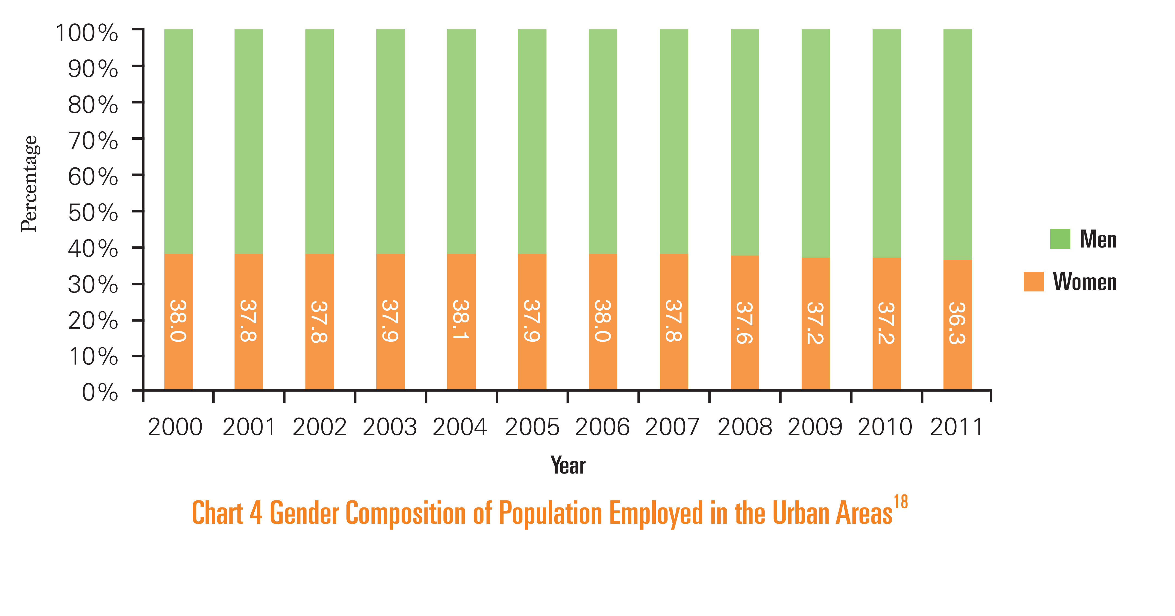**Appendix**

Source: United Nations System in China (2014, 17)

Source: United Nations System in China (2014, 14)

Source: World Bank (2006, 17)

**References**

Chen, Zhihong, Ying Ge, Huiwen Lai, and Chi Wan. 2013. “Globalization and Gender Wage Inequality in China.” *World Development* 44 (April): 256–66. https://doi.org/10.1016/j.worlddev.2012.11.007.

Chi, Wei, and Bo Li. 2014. “Trends in China’s Gender Employment and Pay Gap: Estimating Gender Pay Gaps with Employment Selection.” *Journal of Comparative Economics* 42 (3): 708–25. https://doi.org/10.1016/j.jce.2013.06.008.

Gu, Wei, "Explaining the Gender Wage Gap in Rural and Urban China" (2017). *Theses and Dissertations*. 1204.  
http://openprairie.sdstate.edu/etd/1204

Lee, Jong-Wha, and Dainn Wie. 2017. “Wage Structure and Gender Earnings Differentials in China and India.” *World Development* 97 (September): 313–29. https://doi.org/10.1016/j.worlddev.2017.04.016.

Lee, Ming-Hsuan. 2012. “The One-Child Policy and Gender Equality in Education in China: Evidence from Household Data.” *Journal of Family and Economic Issues* 33 (1): 41–52. https://doi.org/10.1007/s10834-011-9277-9.

Liu, Qian. 2012. “Unemployment and Labor Force Participation in Urban China.” *China Economic Review* 23 (1): 18–33. https://doi.org/10.1016/j.chieco.2011.07.008.

Liu, Shimin. 2013. “A Few Good Women at the Top: The China Case.” *Business Horizons* 56 (4): 483–90. https://doi.org/10.1016/j.bushor.2013.04.002.

Ma, Xinxin. 2018. “Ownership Sector Segmentation and the Gender Wage Gap in Urban China during the 2000s.” *Post-Communist Economies*, June, 1–30. https://doi.org/10.1080/14631377.2018.1458476.

Maurer-Fazio, Margaret, and James Hughes. 2002a. “The Effects of Market Liberalization on the Relative Earnings of Chinese Women,” *William Davidson Institute*. Working Paper Number 460.

Maurer-Fazio, Margaret, and James Hughes 2002b. Effects Of Marriage, Education, And Occupation On The Female/Male Wage Gap In China. *Pacific Economic Review, 7 (1): 137-156.* https://doi.org/10.1111/1468-0106.00156

Maurer-Fazio, Margaret, James W. Hughes, and Dandan Zhang. 2005. “Economic Reform and Changing Patterns of Labor Force Participation in Urban and Rural China.” *SSRN Electronic Journal*. https://doi.org/10.2139/ssrn.904002.

Rickne, Johanna. 2012. “Gender And Work Compensation In China’s Industrial Sector.” *Review of Income and Wealth* 58 (2): 307–29. https://doi.org/10.1111/j.1475-4991.2011.00489.x.

Sauré, Philip, and Hosny Zoabi. 2014. “International Trade, the Gender Wage Gap and Female Labor Force Participation.” *Journal of Development Economics* 111 (November): 17–33. https://doi.org/10.1016/j.jdeveco.2014.07.003.

Xiu, Lin, and Morley Gunderson. 2014. “Glass Ceiling or Sticky Floor? Quantile Regression Decomposition of the Gender Pay Gap in China.” *International Journal of Manpower* 35 (3): 306–26. https://doi.org/10.1108/IJM-01-2012-0017.

United Nations System in China. 2014. “Gender Equality in China's Economic Transformation.”

World Bank. 2016. “Gender Gaps in China: Facts and Figures.”

1. Indirect quote from United Nations System in China, “Gender Equality in China's Economic Transformation,” (October 2014). The original document is not available anymore. Data from 1990, 2000 and 2010 Population Census of People’s Republic of China,, cited from Women and Men in China: Facts and Data 2012, 2012, edited by the Department of Social, Science and Technology, and Cultural Statistics of the National Bureau of Statistics of China, Beijing: Pp. 66.)