TEST REPORT
ALS REFERENCE NUMBER: ATT/ELN/17/0001-paB
FOR company name
75/37 moo11
klong nueng, klong luang
pathumthani 12120 thailand

……………………………………………
WARUNEE MANEESUWAN
LABORATORY MANAGER

Particle Analysis According to ISO 16232:

Date sample received: |  | 24 November 2017
Date analysed: |  | 24 November 2017
Date test completed: |  | 28 November 2017
Result:
ALS Reference no.: |  | ELN-00001-PAB
Part description: |  | BOSCH SUB Battery
Lot No.: |  | Lot B
Test Result: |  | TEST FAILED
Evaluation of Particles:
 |  |  | ¹Cleanliness Class: II
 | Size rang, (µm) |  | Maximum quantity per part | Result quantity per part
Particle | 25 - 50 |  | Not to evaluate | Not to evaluate
Particle | 50 - 100 |  | 1,000 | 38.9
Particle | 100 - 150 |  | 140 | 7.8
Particle | 150 - 200 |  | 30 | 2.3
Particle | 200 - 300 |  | 7 | 1.7
Particle | 300 - 400 |  | 1 | 0.2
Particle | 400 - 600 |  | 0.1 | 0.1
Particle | 600 - 800 |  | 0.03 | 0.0
Particle | 800 - 1000 |  | 0.0 | 0.1
Particle | X > 1000 |  | 0.0 | 0.0
Fiber | X > 600 |  | Not to evaluate | Not to evaluate
Remark: ¹The specification provided by customer.

Largest Metallic Particle: | X | 194.6 micron
Largest Non-metallic Particle: | X | 929.1 micron

Cleanliness analysis according ISO 16232:
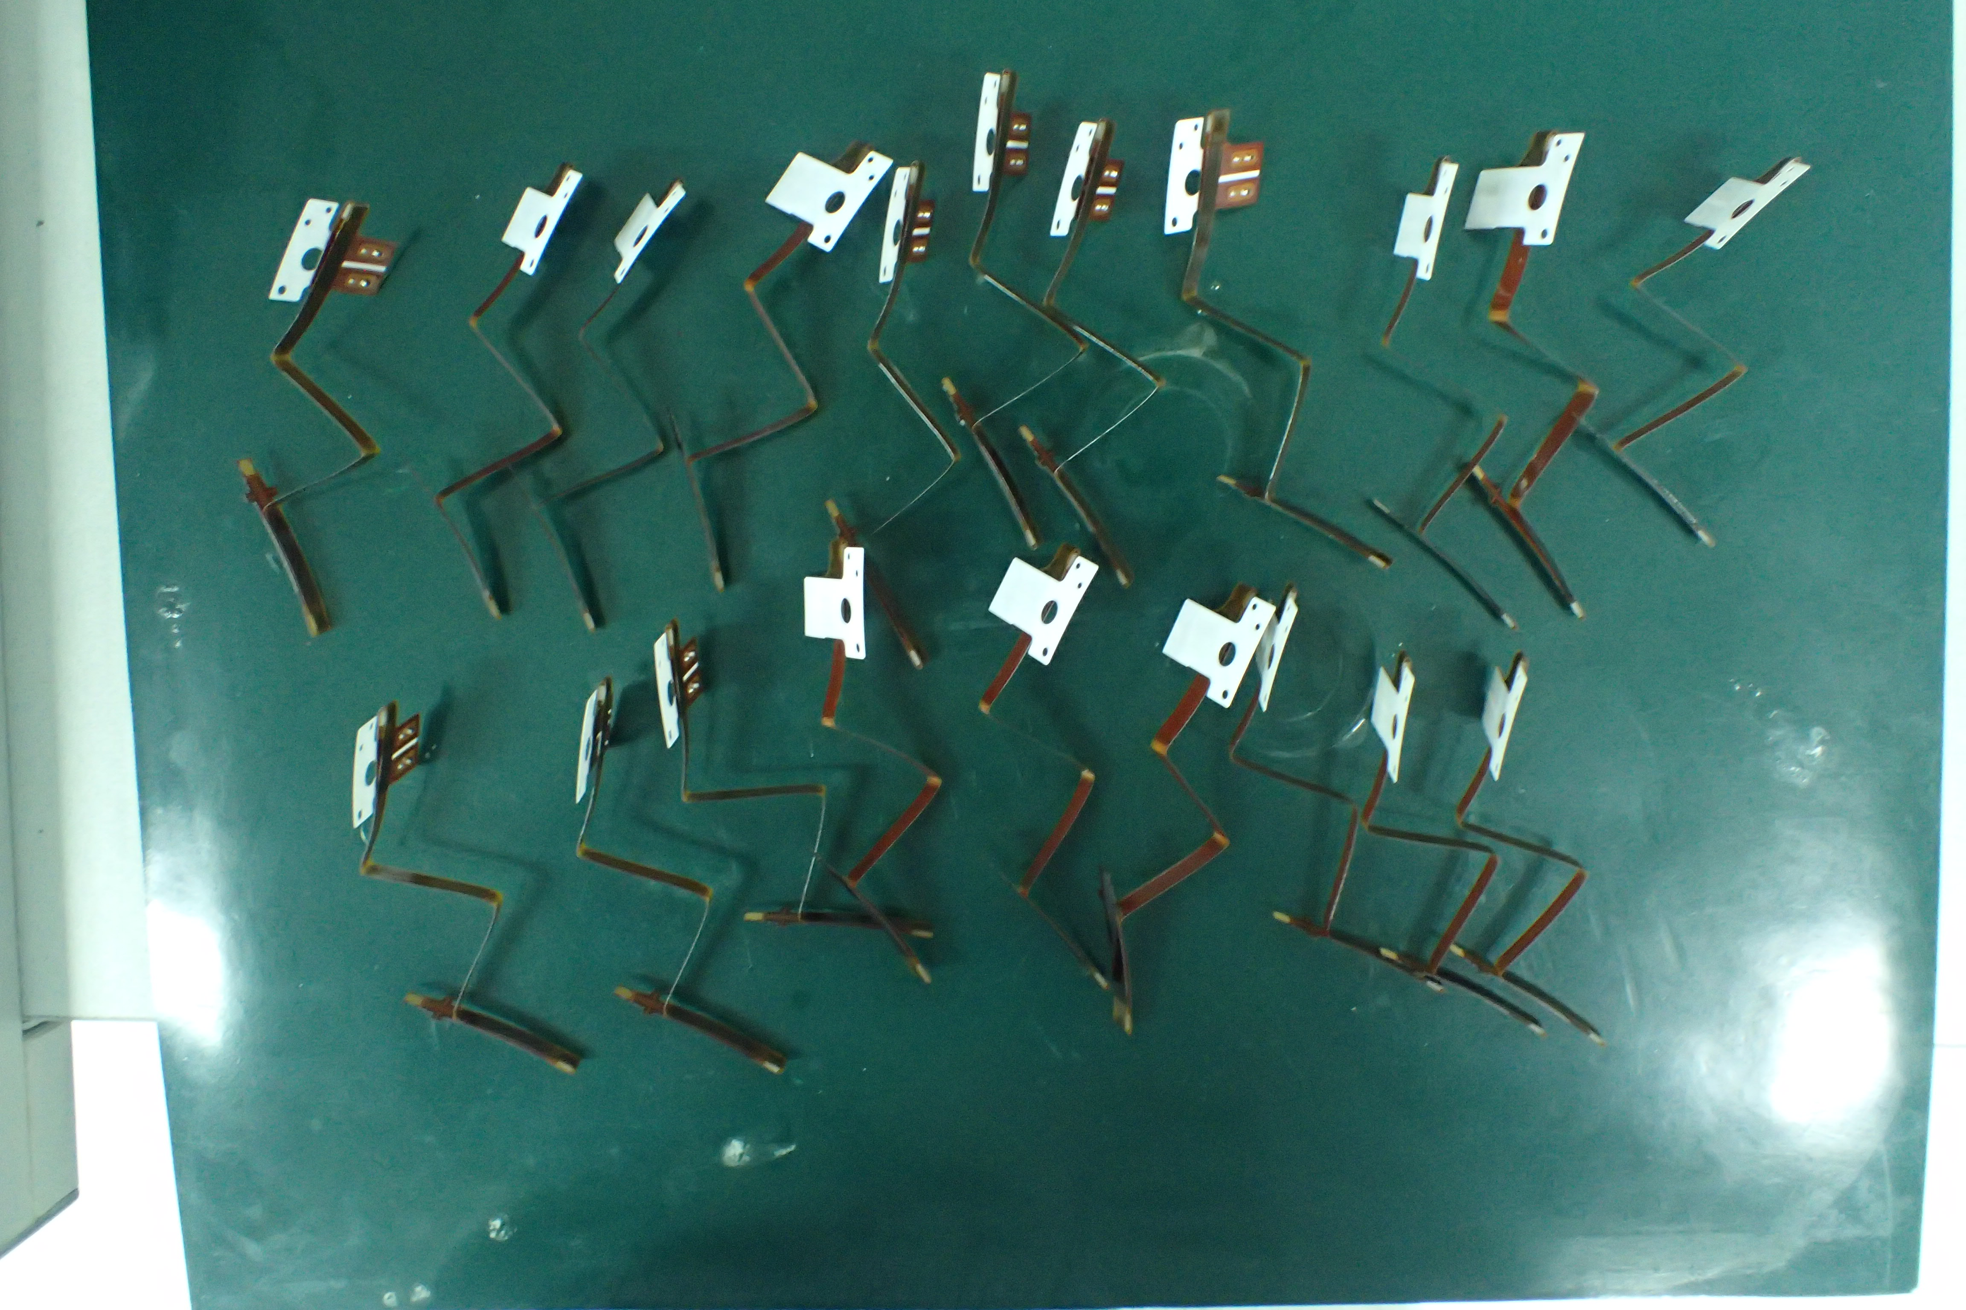
 |  |  | ALS Reference no.: |  |  |  | ATT/ELN/17/0001-PAB
 |  |  | Part description: |  |  |  | BOSCH SUB Battery
 |  |  | Lot No.: |  |  |  | Lot B
 |  |  | Date analysed: |  |  |  | 27 November 2017
 |  |  | Date test completed: |  |  |  | 28 November 2017
Description of process and extraction:
Extraction Procedure: | ªIn-house method refers to ISO16232
Analysis Environment: | Controlled laboratory, (class ISO14644-1: class 5)
Extraction method: | Extraction medium: |  |  | 2% Triton x-100
 | Spraying / Rewash Q’ty: |  |  | 2500 mL / 1000 mL
 | Wetted surface per component: |  |  | 20 cm²
 | Total tested size: |  |  | 20 pieces
Type of method: | [ ] Agitation acc.to ISO16232-2
 | [ / ] Pressure Rinse (medium pressure) acc.to ISO16232-3
 | Pressure Tank: 4 bar |  |  |  |  | Volume Flow: 1000mL/min
 | Nozzle shape: Flat-jet nozzle |  |  |  |  | Distance from component: Max. 15 cm.
 | [ ] Ultrasonic acc.to ISO16232-4
Filtration method: | [ / ] Vacuum pressure
 | [ ] Cascade filtration
Analysis Membrane used: | 47mm Dia., Nylon 5 µm MFPD
Type of drying: | [ / ] Oven |  |  | Temperature 80°C, 1 hour
 | [ / ] Desiccator |  |  | 24°C/33%RH, 24 hours
Mass of Contaminant: |  | Gravimetric analysis acc.to ISO16232-6
Particle sizing / counting / determination: |  | [ / ] by Optical Microscope acc.to ISO16232-7
 |  | Pixel scaling |  |  | 1.43 µm/pixel
 |  | Camera resolution |  |  | 1936 x 1460 pixel
 |  | [ ] by SEM/EDX acc.to ISO16232-8

Cleanliness analysis according ISO 16232:

Gravimetry:
Membrane filter weight: | Blank | Component
Before filtration (mg): | 90.1 | 83.0
After filtration (mg): | 90.4 | 88.8
Residue weight (mg): | 0.3 | 0.8

Microscopic Analysis
Particle Size  (μm) | Particles  on the membrane |  | Particles  per component |  | Particles referring  to 1000cm²
Particle Size  (μm) | ¹Total | Metallic | ¹Total | Metallic | ¹Total | Metallic
25 ≤ X < 50 | Not to evaluate | Not to evaluate | Not to evaluate | Not to evaluate | Not to evaluate | Not to evaluate
50 ≤ X < 100 | 777 | 19 | 38.9 | 1.0 | 1943 | 48
100 ≤ X < 150 | 155 | 10 | 7.8 | 0.5 | 388 | 25
150 ≤ X < 200 | 46 | 2 | 2.3 | 0.1 | 115 | 5
200 ≤ X < 300 | 34 | 0 | 1.7 | 0.0 | 85 | 0
300 ≤ X < 400 | 3 | 0 | 0.2 | 0.0 | 8 | 0
400 ≤ X < 600 | 1 | 0 | 0.1 | 0.0 | 3 | 0
600 ≤ X < 800 | 0 | 0 | 0.0 | 0.0 | 0 | 0
800 ≤ X < 1000 | 1 | 0 | 0.1 | 0.0 | 3 | 0
1000 ≤ X | 0 | 0 | 0.0 | 0.0 | 0 | 0
Remark: ¹Metallic + Non-metallic particles without fibers.
²Fibers defined as Non-metallic, Length/Width > 10.

Attachment I

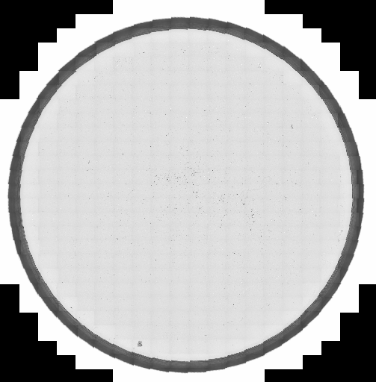

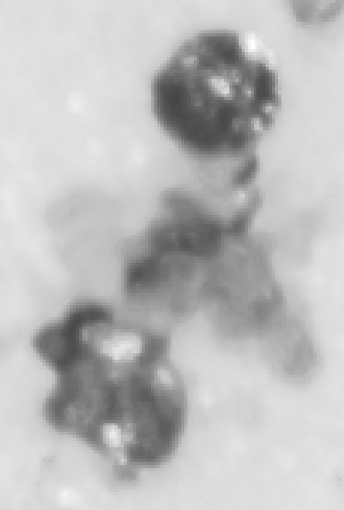 | 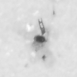
Largest Non-metallic particle | Largest Metallic particle

Attachment II

Double Analysis:
Table 1: Result of 3 Double Inspections of “BOSCH SUB Battery”.
 | No.1  (refer to ELN-0631-WB) | No.2  (refer to ELN-0632-WB) | No.3  (refer to ELN-0633-WB)
C1 | 102 | 227 | 43
C2 | 56 | 53 | 16
0.3 * (C1+C2) | 47 | 84 | 18
Double analysis result  (C2 ≤ 0.3 * (C1+C2)) | FAIL | PASS | PASS

