**Multiscale Modeling – 1st Report**

Paweł Król

1. **Intro**

Using Cellular Automata methods application for grain growth simulation of steel microstructure has been implemented. Application contains different tools that allow to adjust simulation process in order to achieve desired results. This report contains presentation of user interface and simulation effects comparison against real steel microstructures.

1. **Technology used**

Program has been implemented using *Java* programming language. The choice has been dictated by possibility of running application on different systems, without any special or additional tools and code. Development has been carried out on two different machines each with different operating system installed: Windows and Linux. Chosen language has allowed to set up environment and work on a project painlessly using those two machines.

Next technology decision was to select a library for graphical user interface. With *Java* choice boils down to two options, using good old *Swing* or newer *JavaFX* libraries. Decision has been made in the favor of the latter one, because of the cross platform layout designer and layouts being defined separately in special *XML* files (*\*.fxml* extension). Overall the architecture of *JavaFX* is more flexible in use which allowed to develop better quality code.

To have more control over implementing new features, to share and backup code, version control system has been used. For being reliable, secure, well known and popular - GIT system, with <http://github.com> as a remote service, has been chosen for this requirement.

1. **User Interface**

Main view of the application consists of top menu (1) with options: *File* and *Tools*, controls toolbar (2), generated structure view (3) and at the very bottom - status bar (4).

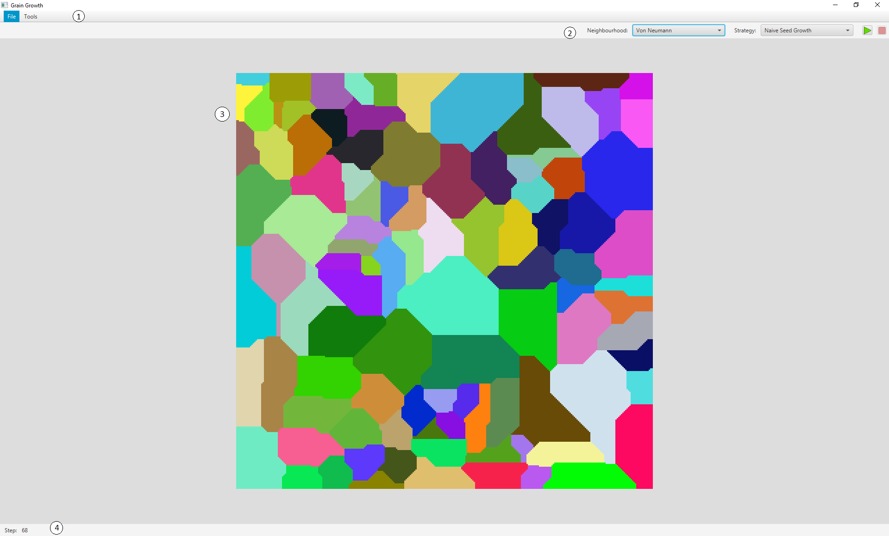

Drawing 1 Main application view

1. **Top menu**

In this part of the user interface one can find two sub menus: *File* and *Tools*. First one, presented on drawing number 2, contains following options: *New, Export, Import, Options* and *Quit.*

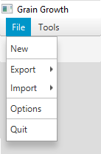

Drawing 2 Top menu *File* option

First option opens new dialog (Drawing 3) which allows to create a new simulation process (new grid). One may enter width and height of the new grid, there is also an option called *Cyclic* which, if checked, tells program to create a grid with cyclical boundaries.

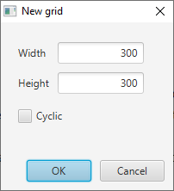

Drawing 3 New simulation dialog

With options *Export* and *Import* come sub menus *Text* and *Bitmap* which give opportunity to export or import grid either in text or bitmap format. Second to last option called *Options*  opens a new dialog (Drawing 4) with entrance box for simulation step delay. Last option closes application.

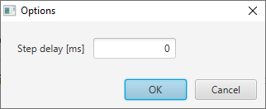

Drawing 4 Options dialog

Using *Tools* sub menu (Drawing 5) user is presented with following options: *Seed, Inclusion* and *Grain selector* which contains following submenus: *Manual, Random* and *All*.

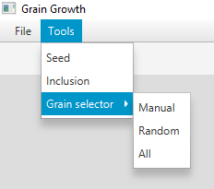

Drawing 5 Tools menu

*Seed* option creates dialog (Drawing 6) which is a control panel for grid seeder tool. User may enter number of seeds that will be randomly placed into grid.

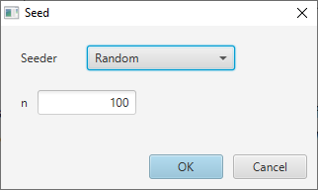

Drawing 6 Seeder dialog

*Inclusion* creates dialog (Drawing 7) for Inclusion tool, containing inclusion type select dropdown, amount of inclusions and radius/size input boxes.

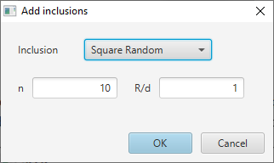

Drawing 7 Inclusion tool dialog

*Grain selector* is an option for invoking grain selection tool. Sub menus allow to select type of grain selection. If manual is clicked (Drawing 8), user can pick grains with cursor (mouse) and finish action by clicking done button (see section about status bar). *Random* on the other hand opens dialog using which user can enter amount of randomly selected grains.

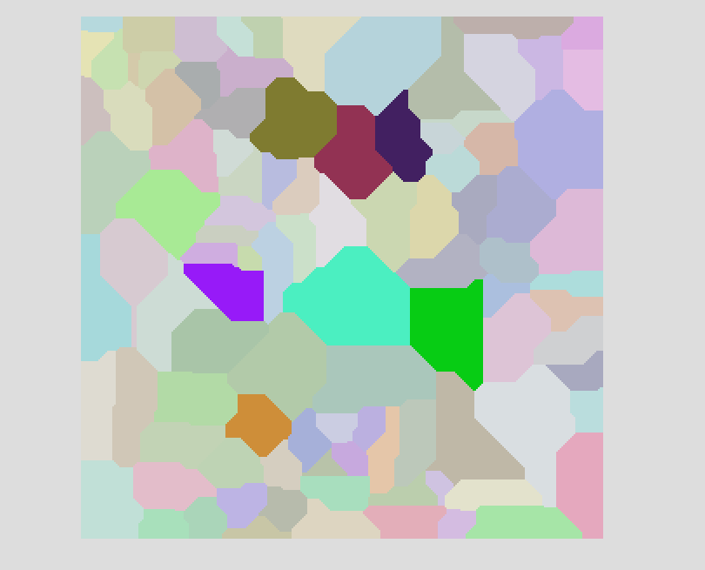

Drawing 8 Manually selected grains

After grain selection process, sequence of dialogs with different actions is displayed (Drawing 9 and Drawing 10).

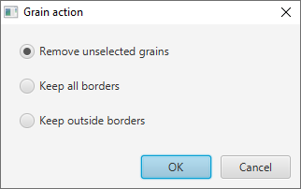

Drawing Grain action dialog

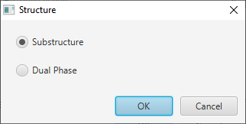

Drawing Structure type select

1. **Controls toolbar**

This part of the interface contains dropdowns for neighborhood and strategy, and buttons for starting and stopping (pausing) simulation as well (Drawing 11).



Drawing 11 Main control toolbar

1. **Structure view**

Here (Drawing 12) one can see the simulation effects. This component renders each frame of simulation process, and current state of the grid. It also serves as a place for user interaction when selecting grains manually.

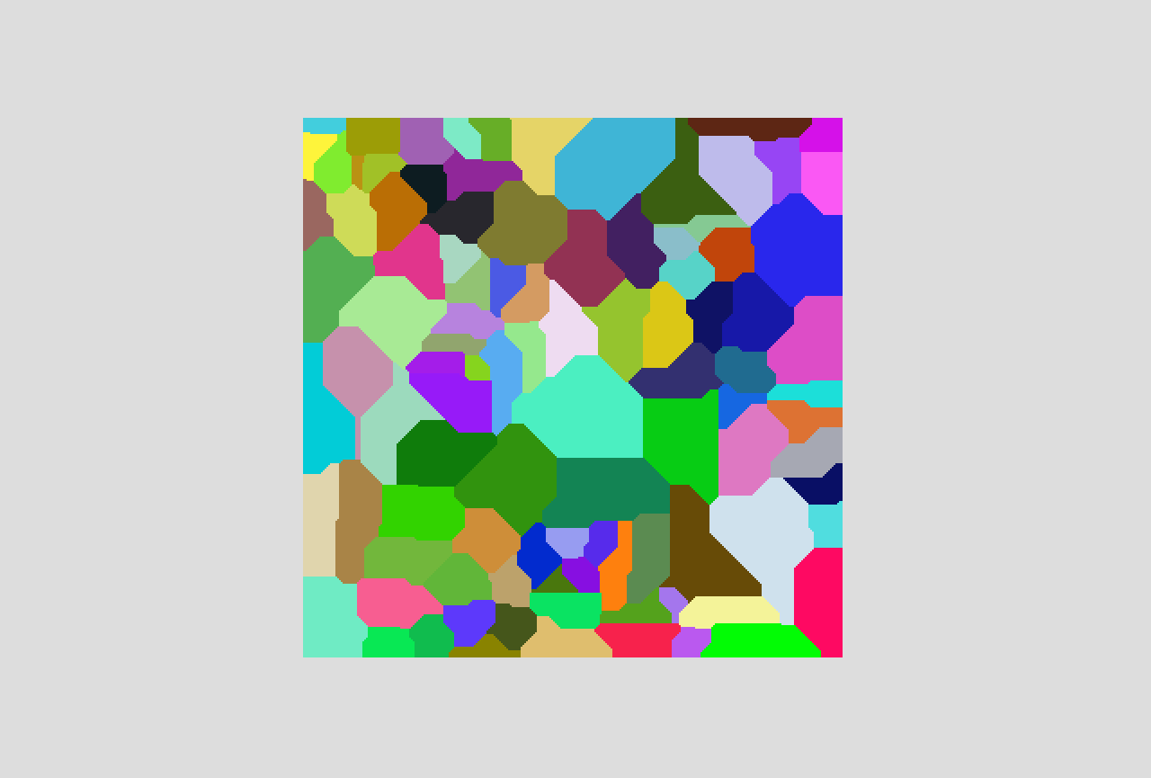

Drawing 12 Structure view

1. **Status bar**

Status bar (Drawing 13) has been placed at the bottom of the whole window. On the left side it contains information about current step of the simulation on the right side *Done* button is displayed when some manual actions are invoked (such as manual grain selection).



Drawing Status bar

1. **Simulation effects comparison**

First example presents stainless steel, with original microstructure (left) compared to generated by simulation with Von Neumann neighborhood (right). One may notice that simulation is a bit more “squary” but this is the nature of Cellular Automata, although with proper tuning it may be less visible. Effects of the simulation are satisfactory.

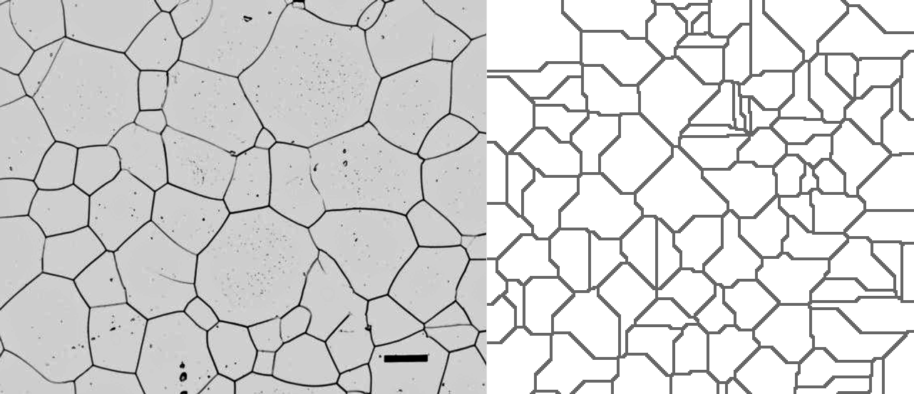

Example 1 Stainless steel, original (left) and simulated (right) structure comparison

Second example represents microstructure of an austenitic Mn steel, solution annealed and aged to precipitate a pearlitic phase on the grain boundaries. With original microstructure on the left and simulated (Von Neumann) on the right, one can notice that the process of recreating grain growth effects in that case can be quite reliable.

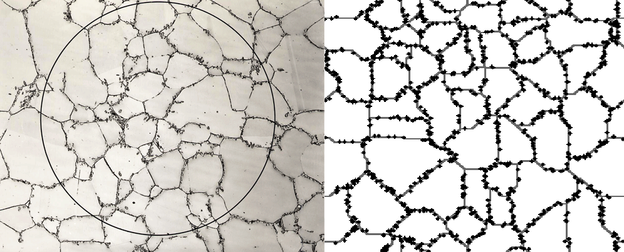

Example 2 Resemblance of inclusion simulation effect (right) to real structure (left)

Third example represents dual-phase carbon steel intercritically annealed at 775 °C. Effect of simulation (right) for this particualar example may differ from the original image (left). The reason for that is there are many factors that affect the outcome, but some of the characteristics can be deduced, i.e. one may find two phases in both images (simulation: gray and colorful, colorful is treated as one phase).

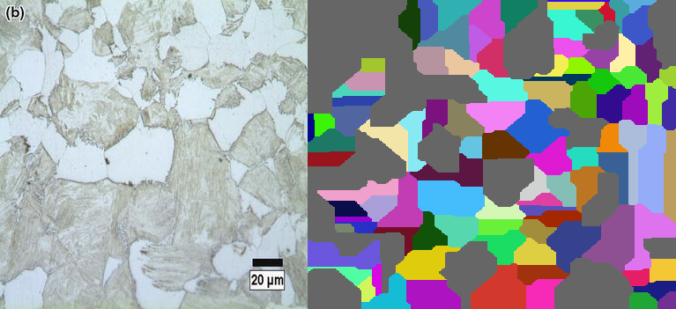

Example 3 Dual chase steel simulation effect (right) with real structure (left) comparison

Last (fourth) example presents a microstructure of Duplex stainless steel, which would not be possible (or at least very hard) to generate with implemented program.

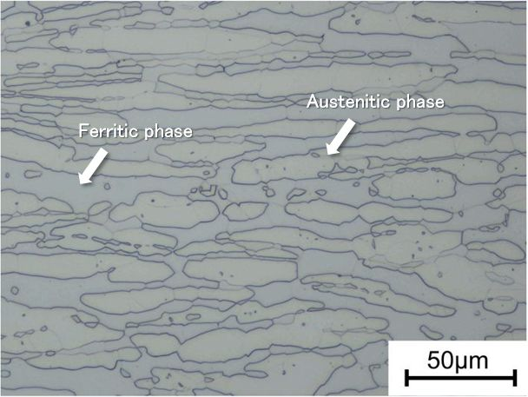

Example 4 Structure that cannot be simulated with presented software

1. **Summary**

Implemented application can be useful in simulating some of the microstructures of steels. Some generated microstructures are very similar to the original ones. Good experience and a ground knowledge of the metal structures may be helpful in generating plausible effects, as a result of a number of different tools and ways that simulation can be directed to. There are also limitations to the effect that can be achieved, structures can be found that presented software cannot simulate. Of course codebase is open to any changes, so implementing new functionalities or just adjusting present ones, may allow to generate new effects of simulations.

Used resources:

<https://vacaero.com/wp-content/uploads/2012/11/fig1-r-lg-1.gif>

<https://vacaero.com/information-resources/metallography-with-george-vander-voort/1137-introduction-to-stereological-principles.html>

<http://www.amse.org.cn/article/2014/1006-7191-27-2-279.html>

<http://www.kobelco-welding.jp/education-center/technical-highlight/vol18.html>