**Multiscale Modeling – 2nd Report**

Paweł Król

1. **Intro**

Monte Carlo methods can also be used in simulating metal microstructure growth and behavior. During the second part of the classes initial program has been extended by those techniques. Key feature for this part of the application is recrystallization process reproduction determined by cell energy distribution.

**2. New Interface components**

New interface components have been implemented, such as energy distribution view, recrystallization options and energy distribution options. Latter allows to select nucleation type and location.

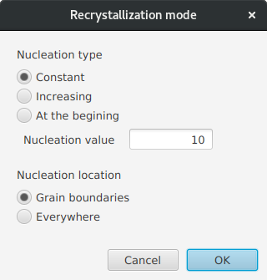  
Drawing 1 Recrystallization interface

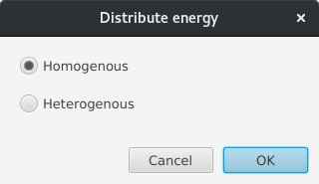  
Drawing 2 Energy distribution options

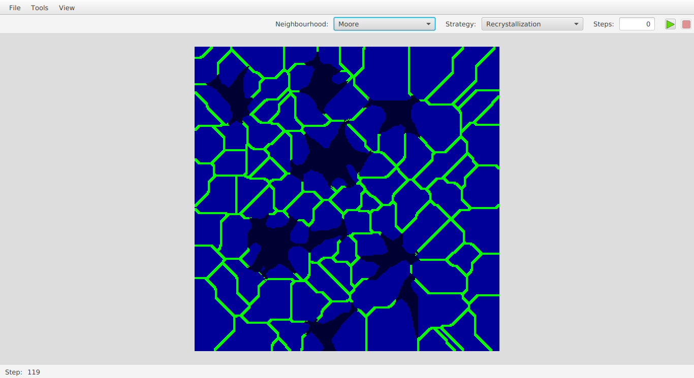

Drawing 3 Cell energy distribution during recrystallization process

Drawing 4 Energy distribution view for whole grid

On energy distribution grid, each cell is painted with color corresponding to the cell energy level. If energy is higher the color is more intense (lighter).

**3. Simulation effects comparison**

First example that can be seen on drawing no. 1, represents real recrystallized dual phase steel alongside simulation effect. One can notice that the simulation effect is quite plausible and can be a first proof that simulation has been implemented properly.

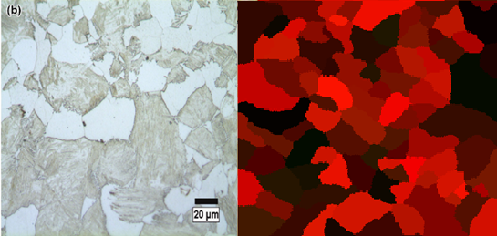

Drawing 4 Structure of recrystallized dual phase steel, original (left) and simulated (right) - comparison

Second example is placed on two drawings (drawing 2 and 3). On first image the progress of the implemented simulation is shown. Second image (drawing 3) represents structure of austenite in the low-carbon steel, but what is more important the recrystallization along grain borders can be seen. Comparing those two mentioned drawings, similarity can be found in the process of recrystallization – new grains are replacing old ones.

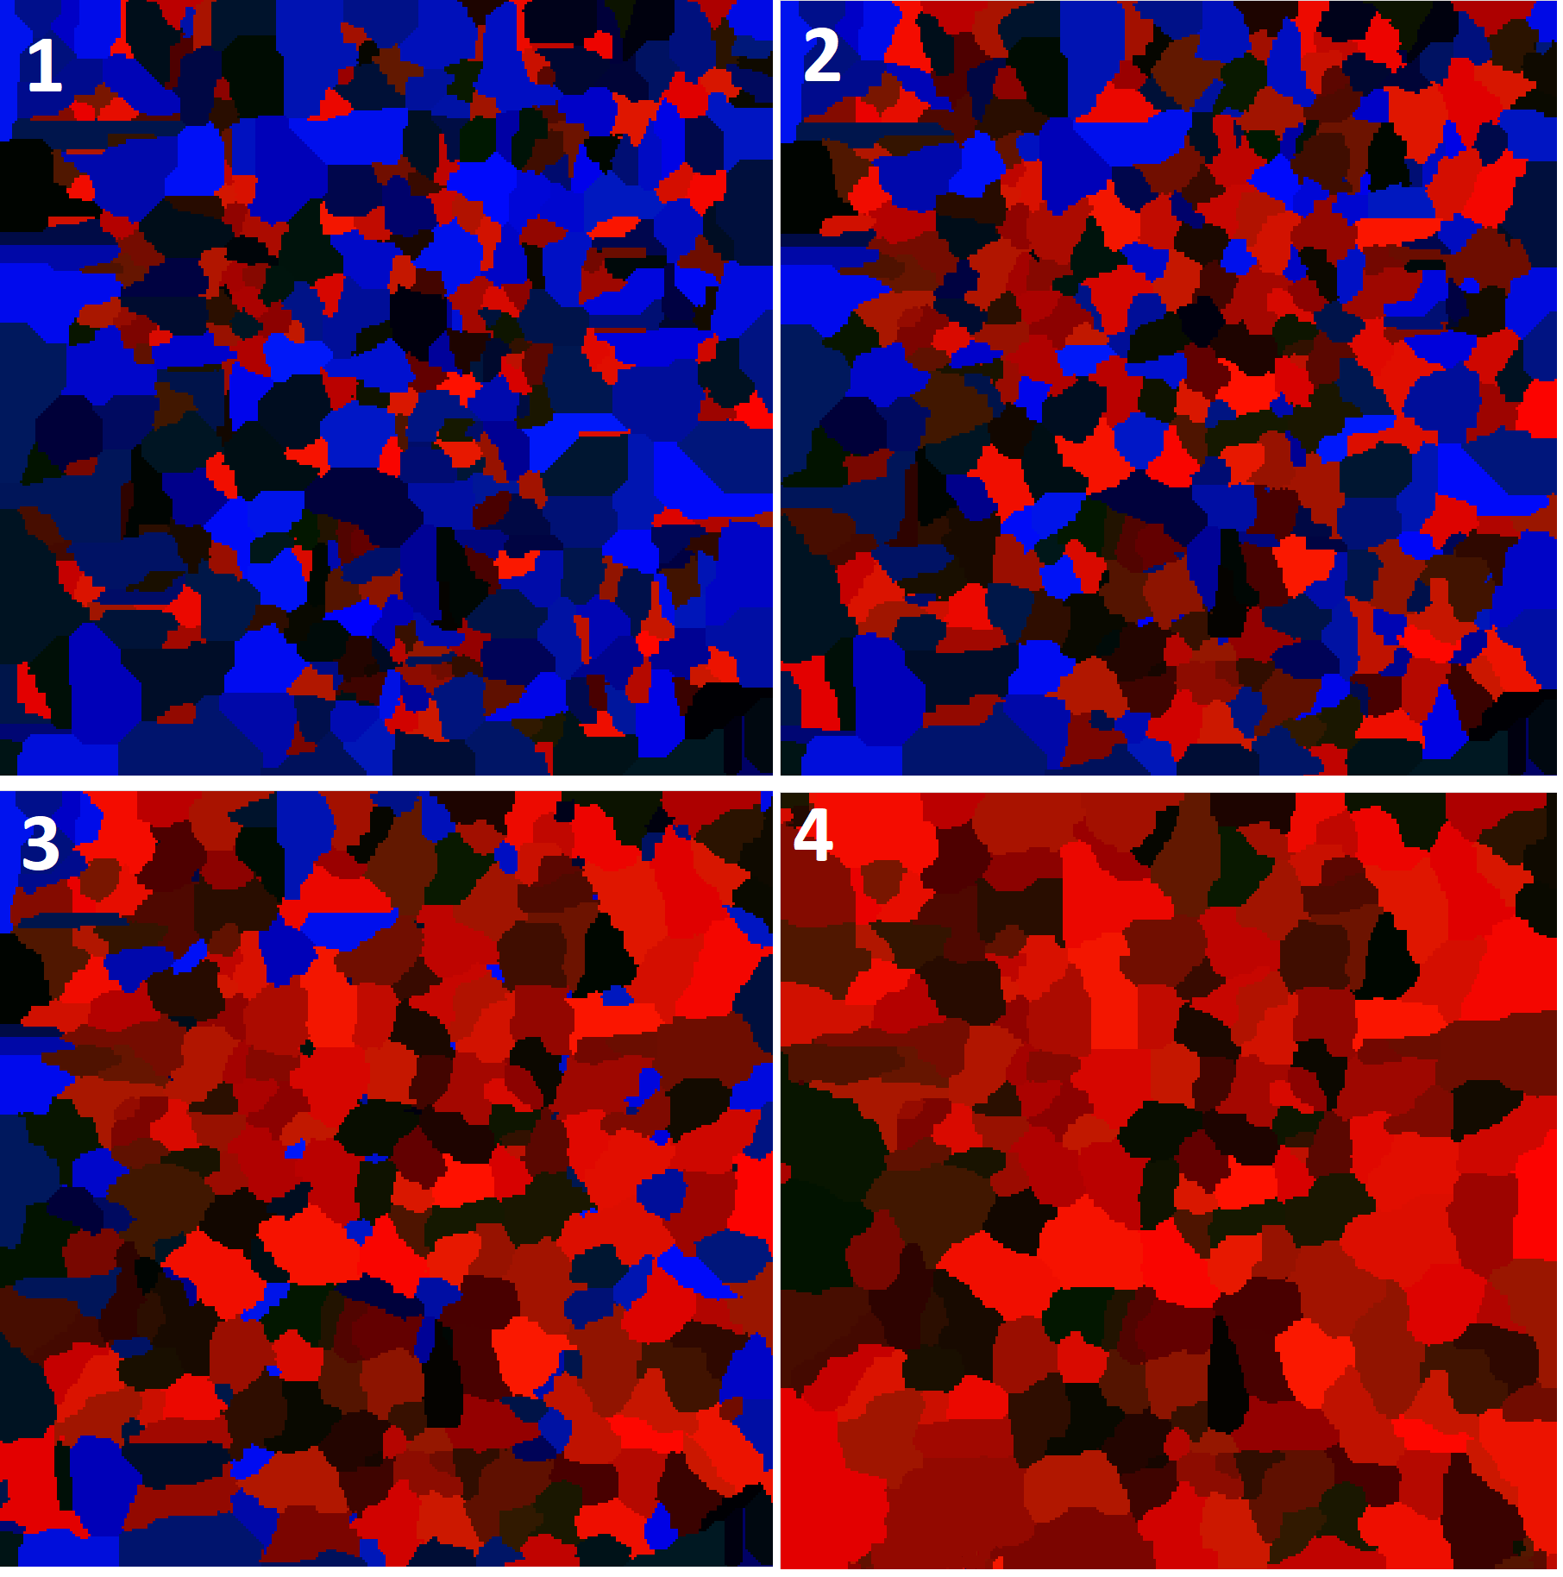

Drawing 5 Progress of recrystallization simulation with energy and nucleons distributed on initial grain boundaries

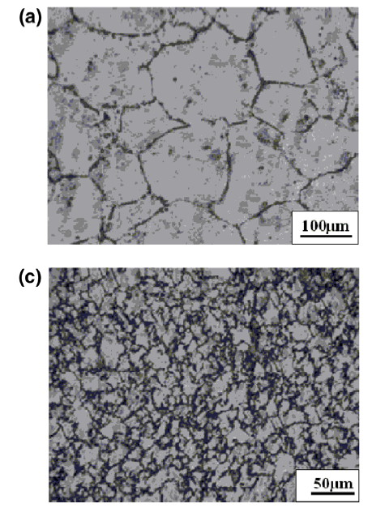

Drawing 6 Recrystallization of austenite in the low-carbon steel

**4. Summary**

Cellular automata are very flexible for extensions and improvements. By extending models (like cell) one can assign convenient parameters to some of the simulation elements that can be used to create more complicated simulations. In this case model of the cell has been extended by energy parameter which allowed to introduce recrystallization process simulation.

Using Monte Carlo techniques it was also possible to simulate a process of metal structure recrystallization with very plausible effects. The most noticeable drawback of this approach is that from the nature MC methods are based on the random selection which can cause a significant decrease in execution time.

Used resources:

<http://www.amse.org.cn/article/2016/1006-7191/1006-7191-29-12-1127.shtml>

<http://www.amse.org.cn/article/2016/1006-7191/1006-7191-29-12-1127/img_33.png>

<https://www.researchgate.net/figure/Microstructures-of-dual-phase-carbon-steel-intercritically-annealed-at-775-C-a-fibrous_fig3_272966423>