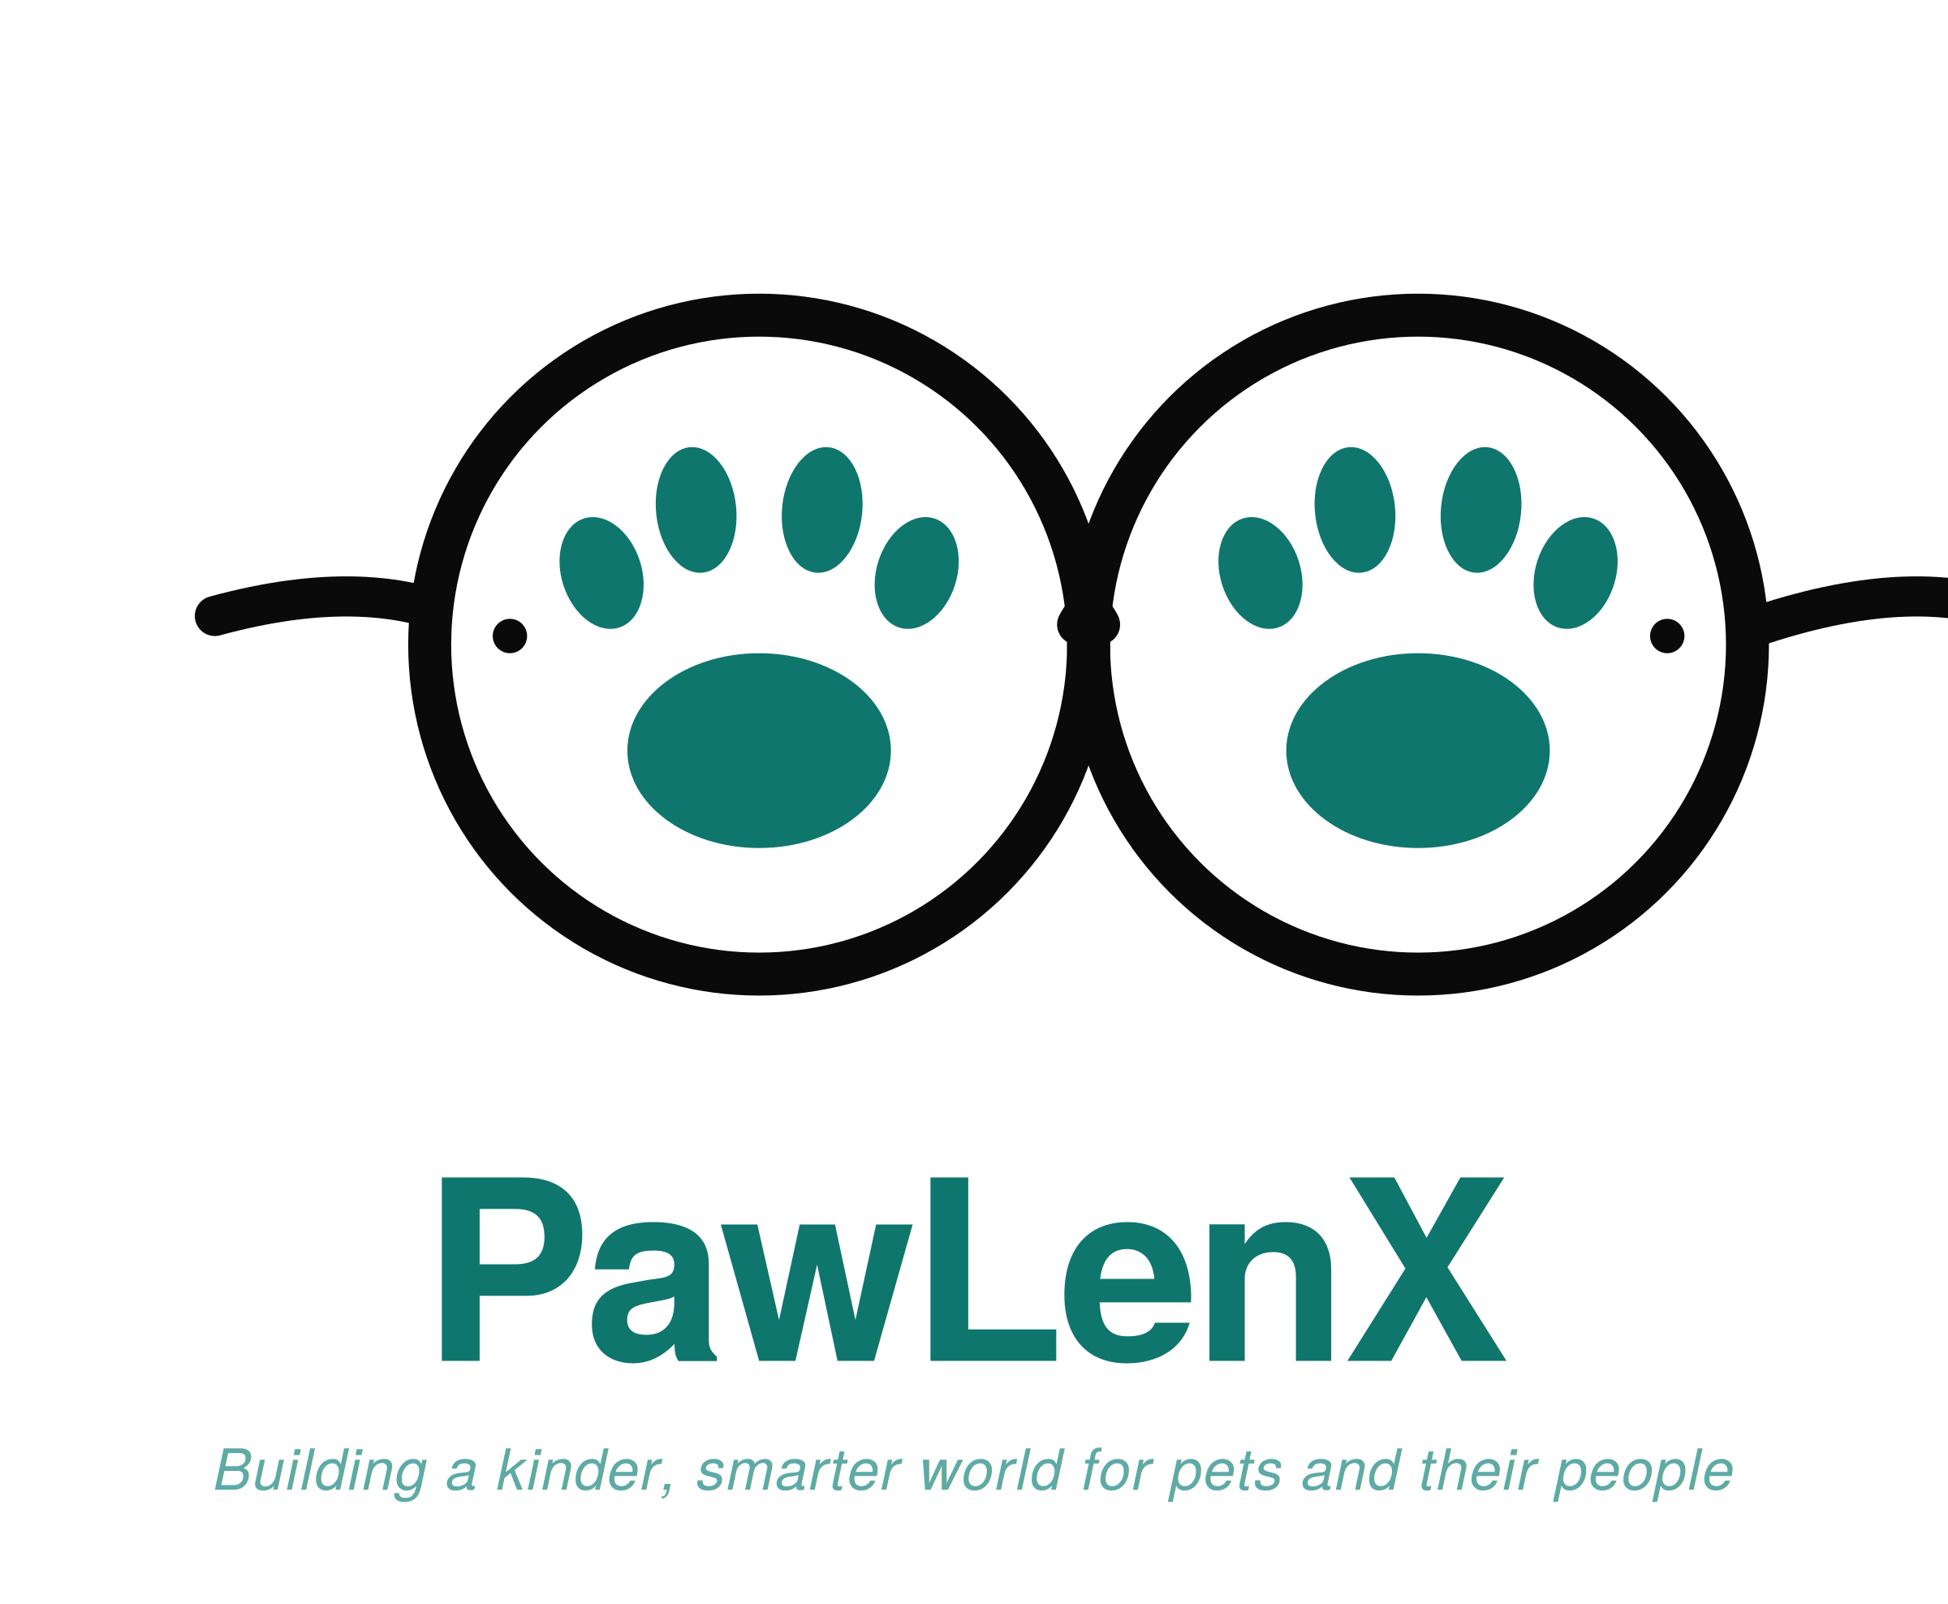

Brand Guide
Version 1.0 / May 2026
PawLenX, Inc.
Compiled by the Board of Directors

🐾 PawLenX, Inc.
Building a kinder, smarter world for pets and their people Document: Brand Guide v1.0
Audience: Internal team and approved partners

A Note Before You Begin
This guide is a living manual for the visual and verbal identity of PawLenX, Inc. It captures what the company looks like, how it sounds, and the small rules that keep both of those things consistent as our team and our product line grow.
The audience for this document is anyone who creates work in the PawLenX name. That includes our UI/UX designer, our marketing manager, our engineers when they build interfaces, our product team when they design packaging, and any external partner who agrees to follow our visual standards. Reading this guide should answer most questions about what is on-brand and what is not. The rest can be sent to the company's brand custodian, whose contact information appears at the close of this document.
Two principles shape every page that follows. The first is that consistency is a form of care. When our typography, our colors, and our tone of voice are predictable across every surface, customers feel that they are dealing with one steady company rather than five disconnected ones. The second principle is that warmth is not the enemy of professionalism. Pet care is, at its heart, a relationship between a family and an animal. Our brand should sound like a trusted friend who happens to be highly trained, not a clinical instrument with no pulse.

Section 1: Who We Are
PawLenX is a global (beyond US and Nigeria) pet care technology company. Our mission is to give every pet owner the clarity they need to recognize what is right, and what is wrong, in their animal's life. We do this through three products that share a single promise.
At the core of the company sits PawLenX AI, the subscription assistant that answers a pet owner's questions in real time on topics ranging from companionship and health to research and nutrition, among others. Pet TV is our streaming library of original, educational short films. Rounding out the trio, PawLenX Products is our forthcoming branded line of pet toys, training kits, and accessories.
The name is built from two parts. Paw stands for pet. LenX is a stylized form of lens, chosen because a lens is the instrument through which clear vision becomes possible. Read together, the name reveals its purpose: a lens for your paw, a clear way of seeing what is right or wrong about your pets from a broader view.

Our Values
Five values guide our decisions, whether the choice in front of us is a new feature, a hiring call, or the wording of a single sentence in the app.
Clarity. We make the complicated understandable. A pet owner in a moment of worry should never feel that the answer they need is hidden behind jargon.
Kindness. We assume the best of every owner who comes to us. People who love their pets sometimes make mistakes, and our job is to teach without scolding.
Rigor. We treat veterinary information with the seriousness it deserves. When we are uncertain, we say so, and we recommend a licensed professional.
Joy. Pets bring joy into homes. Our brand should feel like part of that joy, not a sterile companion to it.
Trust. We earn it slowly and protect it carefully. Trust is the currency we cannot replace once spent.

Brand Personality
If PawLenX were a person at a dinner table, that person would be the family veterinarian who is also a close friend. Warm, observant, occasionally funny, and absolutely reliable in a small emergency. Someone who can speak about a sick rabbit with the same care they would bring to a child's fever.

Section 2: Brand Voice and Tone
Voice is the steady character of how we sound. Tone is the calibration we apply to that voice for a given situation. A friend who is funny at lunch is calmer at a funeral, but it is the same friend.

How We Sound
Our copy is direct. The most important sentence comes first. We do not bury the answer under three paragraphs of throat-clearing.
The words we choose are plain. We pick the simpler word when it serves the meaning. Help beats assist. Use beats employ. The exception is veterinary terminology, where precision matters and the right name for a condition is worth teaching.
A warm register runs through everything we write. We address the reader as a real person, not a customer profile. When a question shows worry, we acknowledge the worry before we answer the question.
Honesty is non-negotiable. If a topic is beyond our scope, we say so and point to the right professional.
Trend words and hype have no place in our copy. Pet owners do not buy hype. They buy results and reassurance.

Tone Calibration
Educational content (Pet TV captions, app explainers): curious, patient, never condescending. Think of a knowledgeable friend explaining a topic over coffee.
Emergency content (urgent health prompts inside the app): clear, calm, brief. Lead with the action the owner must take. Save context for after the crisis has passed.
Marketing content (social posts, ads): observational, gently humorous, never at the pet's expense. We celebrate the silly things pets do without mocking them.
Customer service content (replies, support emails): patient, accountable, specific. When something has gone wrong, we acknowledge the wrong before we offer the fix.

Vocabulary We Embrace
Care, watch, learn, notice, see clearly, alongside, family, companion, healthy, safe, gentle, steady.

Language We Avoid
Disrupt, revolutionize, hack, perfect, ultimate, best-in-class, must-have, fur baby. The phrase pet parent is acceptable in casual contexts but should not appear in formal copy.

Section 3: The Logo System (Note that we do not currently have a final logo.)

Our Primary Mark—Temporary Template: Meyene will build the final logo.
The PawLenX mark is a pair of eyeglasses with a paw print inside each lens. Eyeglasses symbolize examination, the careful act of looking. Paws symbolize the subject of that examination, the animals in our care. Read together, the mark communicates our core promise: a way of seeing what is right or wrong about your pets from a broader view.
Two frame geometries and three-color palettes have been developed. Six logo variants are the result. The canonical mark for Version 1.0 of the brand is the round-frame variant in Healthcare Teal. All other variants are approved for specific contexts named below. Any further variation, including custom palettes and custom frame shapes, requires written approval from the Board of Directors.
The Canonical Mark

Round frames, Healthcare Teal. The default lockup for all standard surfaces.
All Six Existing Variants
The complete logo suite is shown below. Detailed usage rules for each variant follow on the next pages.
  Round / Healthcare Teal | 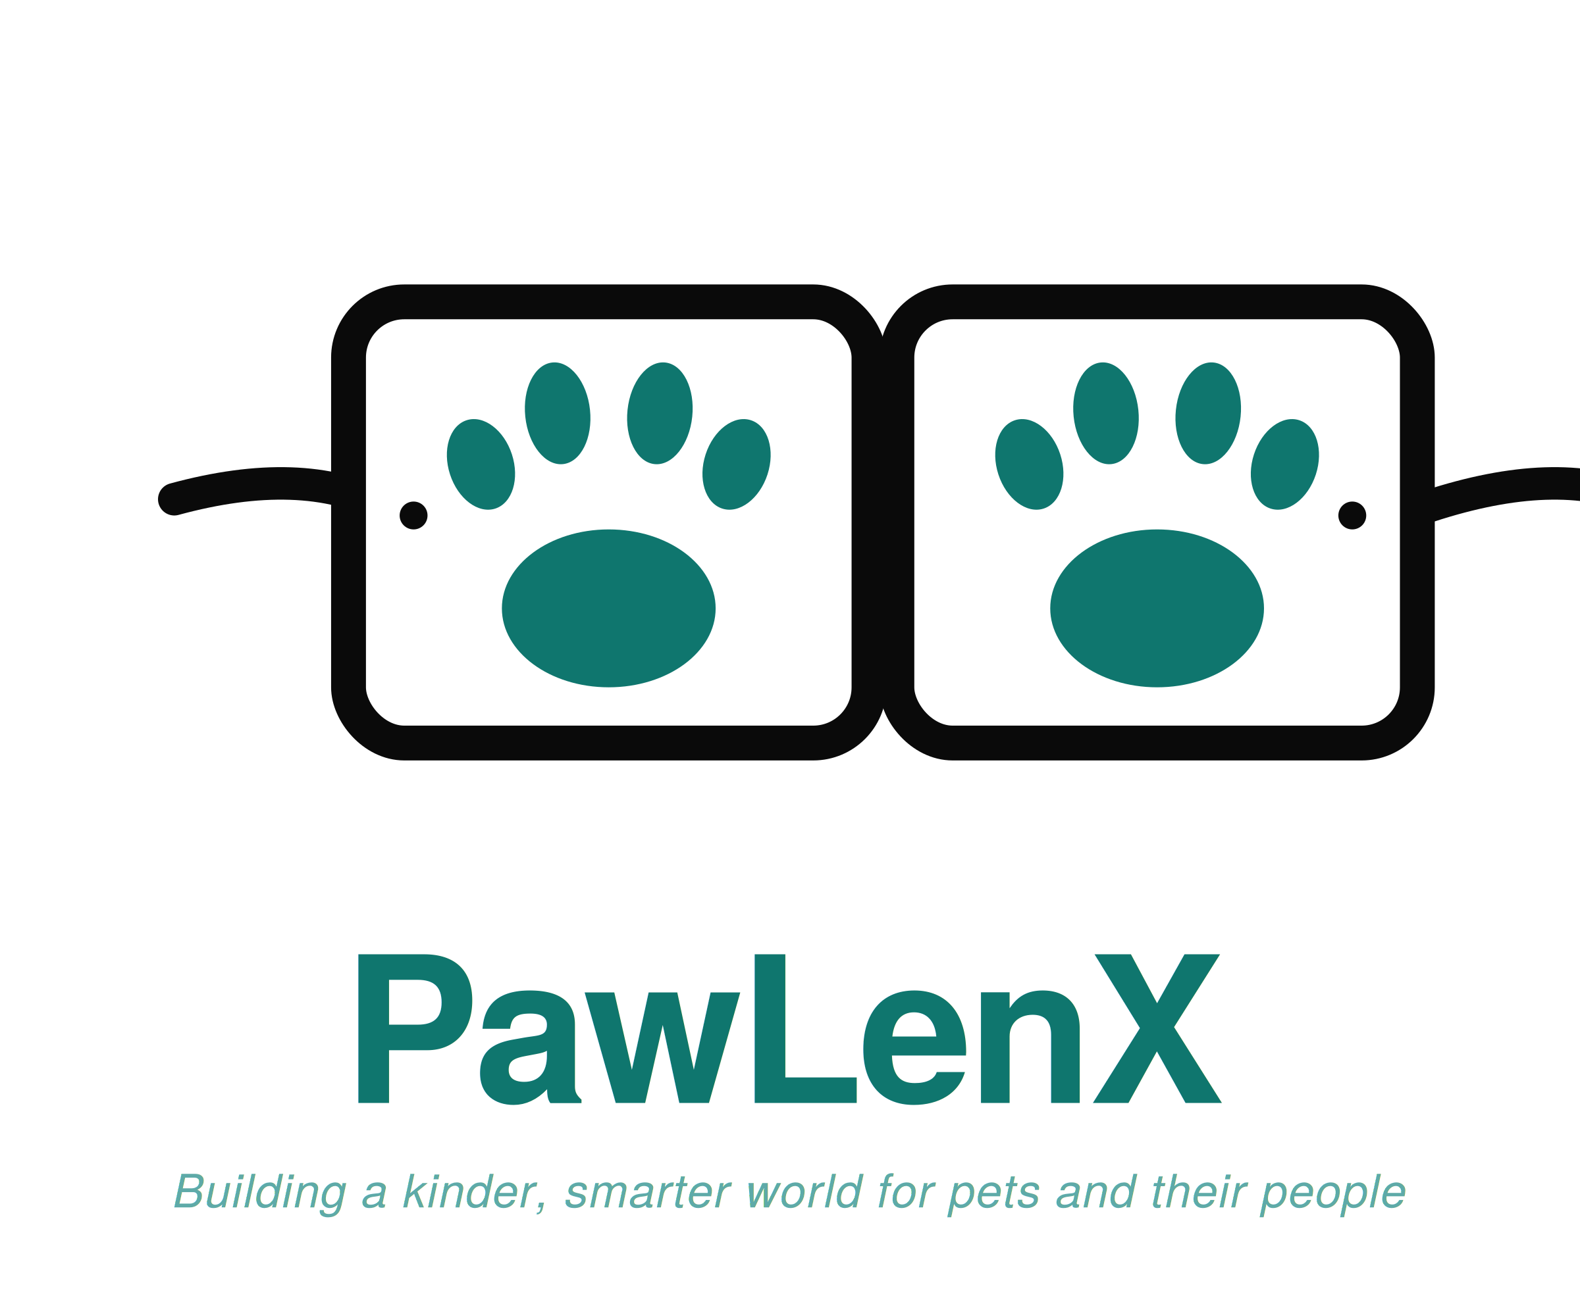  Rectangular / Healthcare Teal
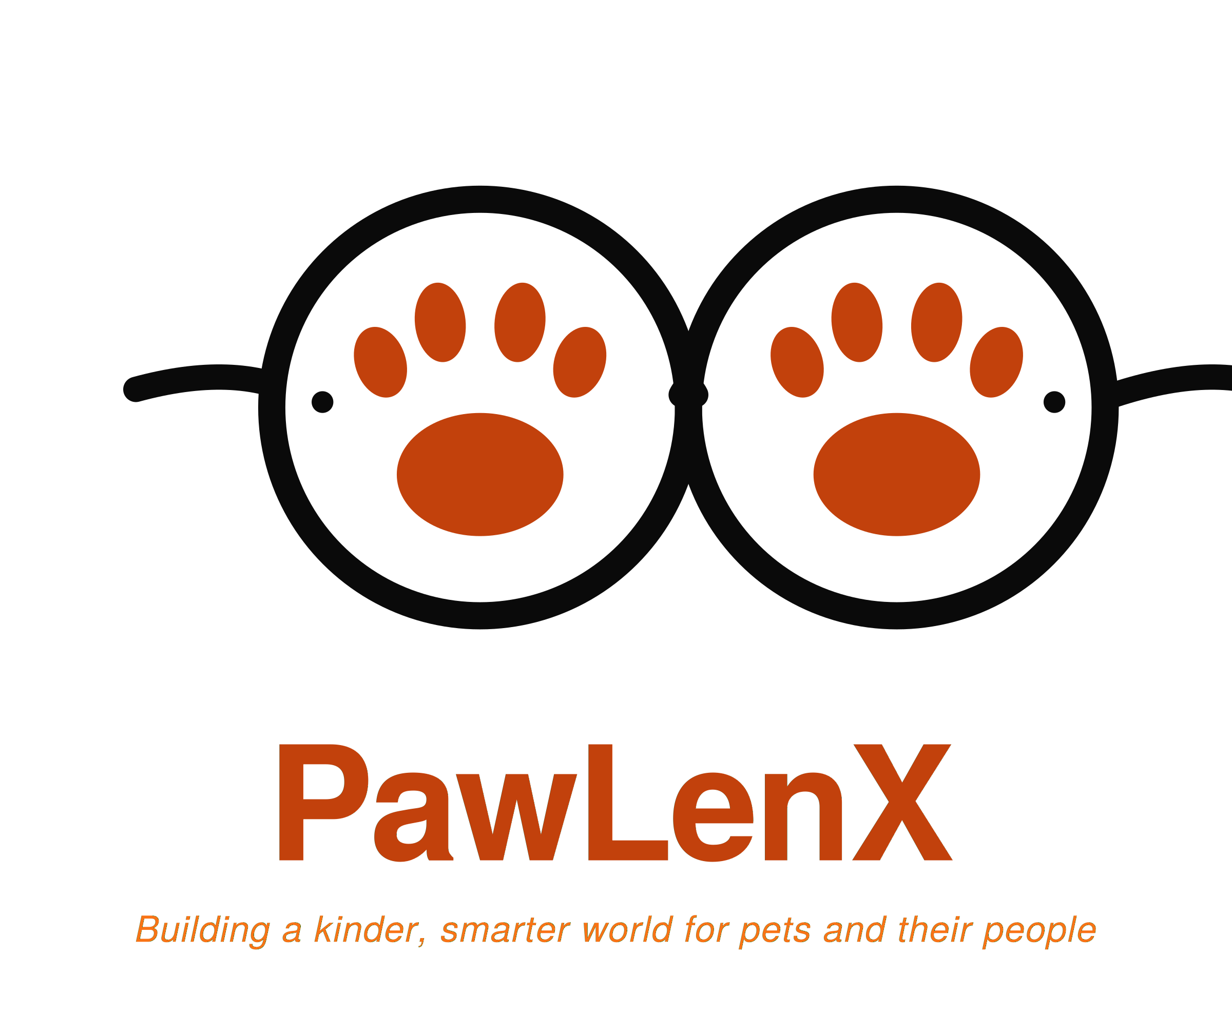  Round / Warm Earth | 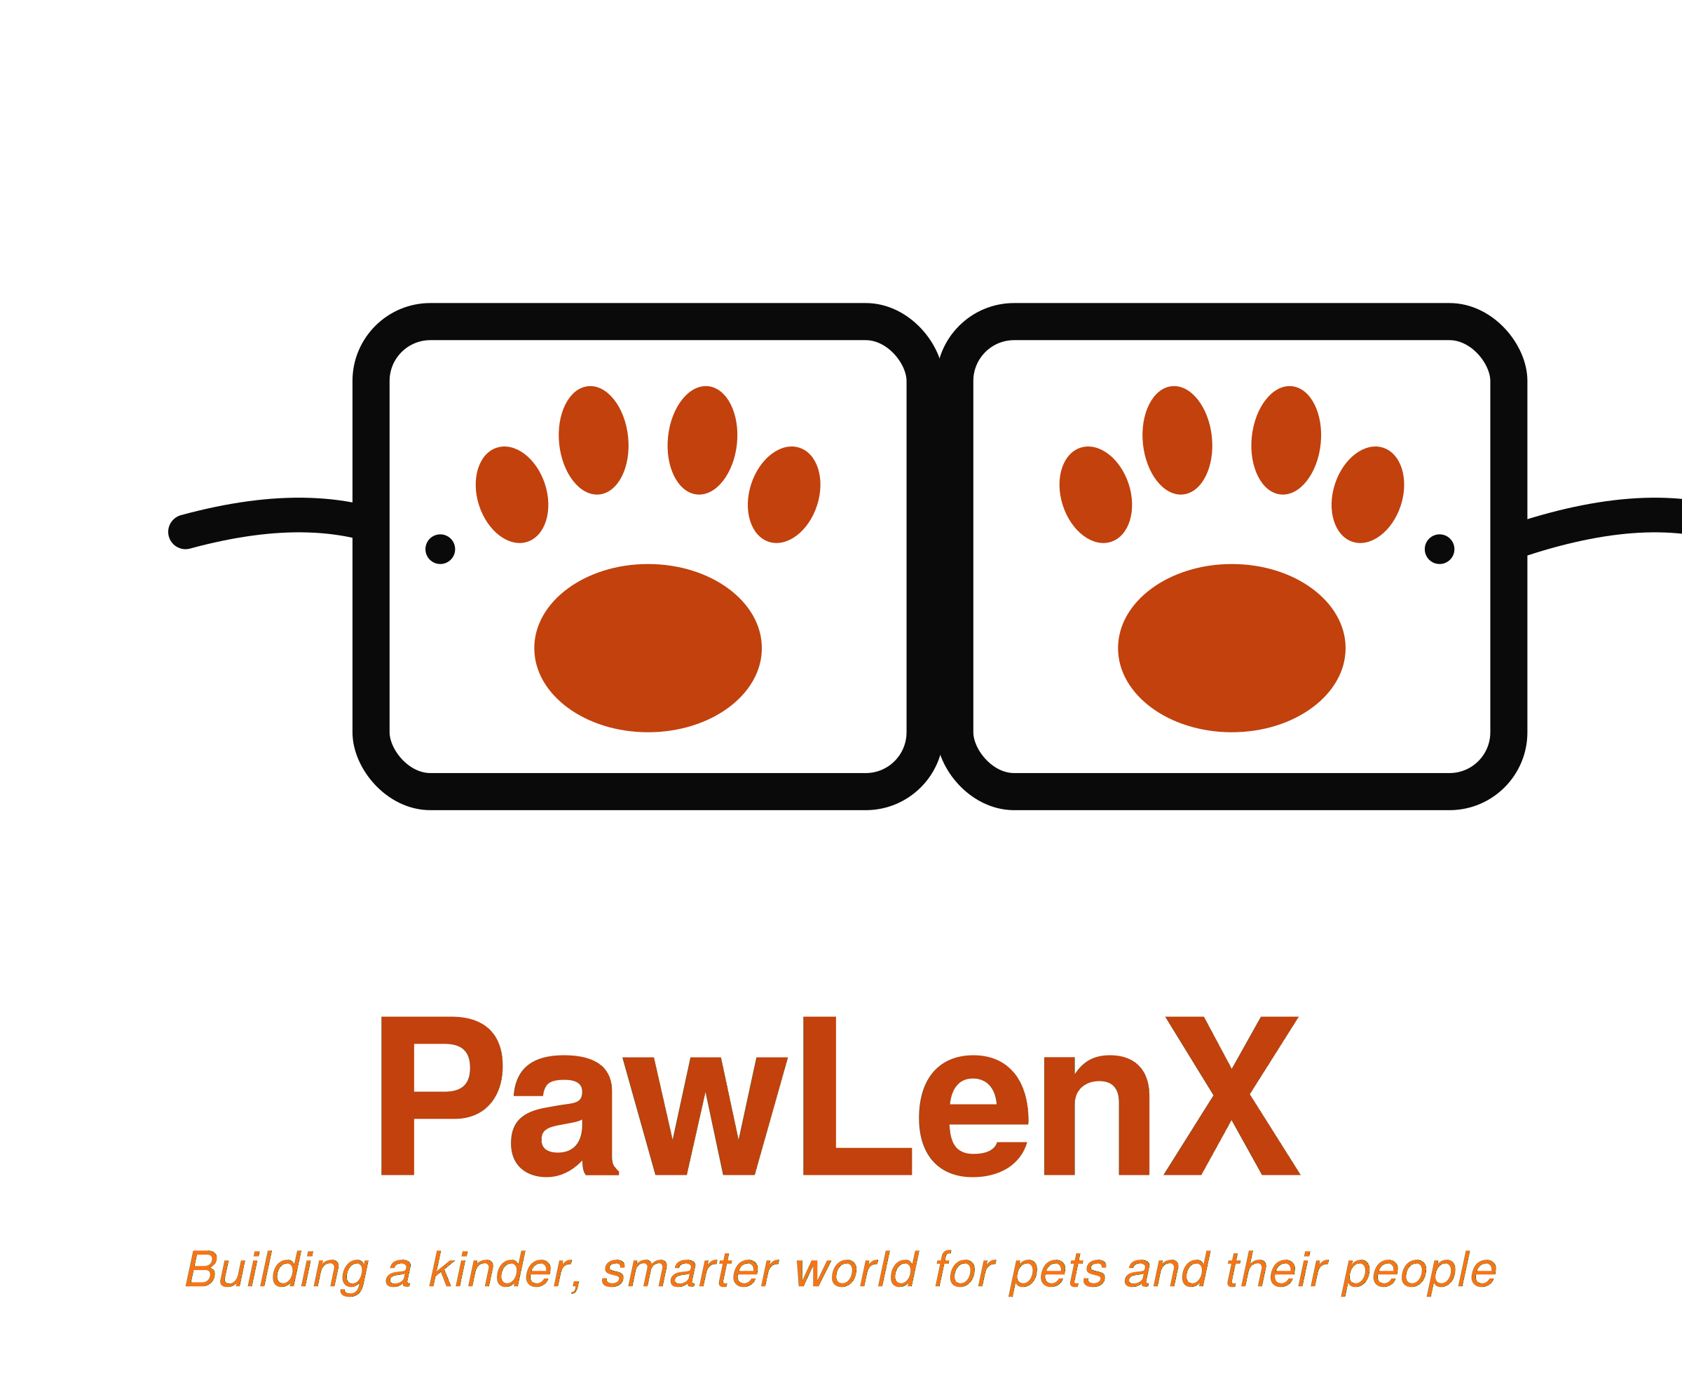  Rectangular / Warm Earth
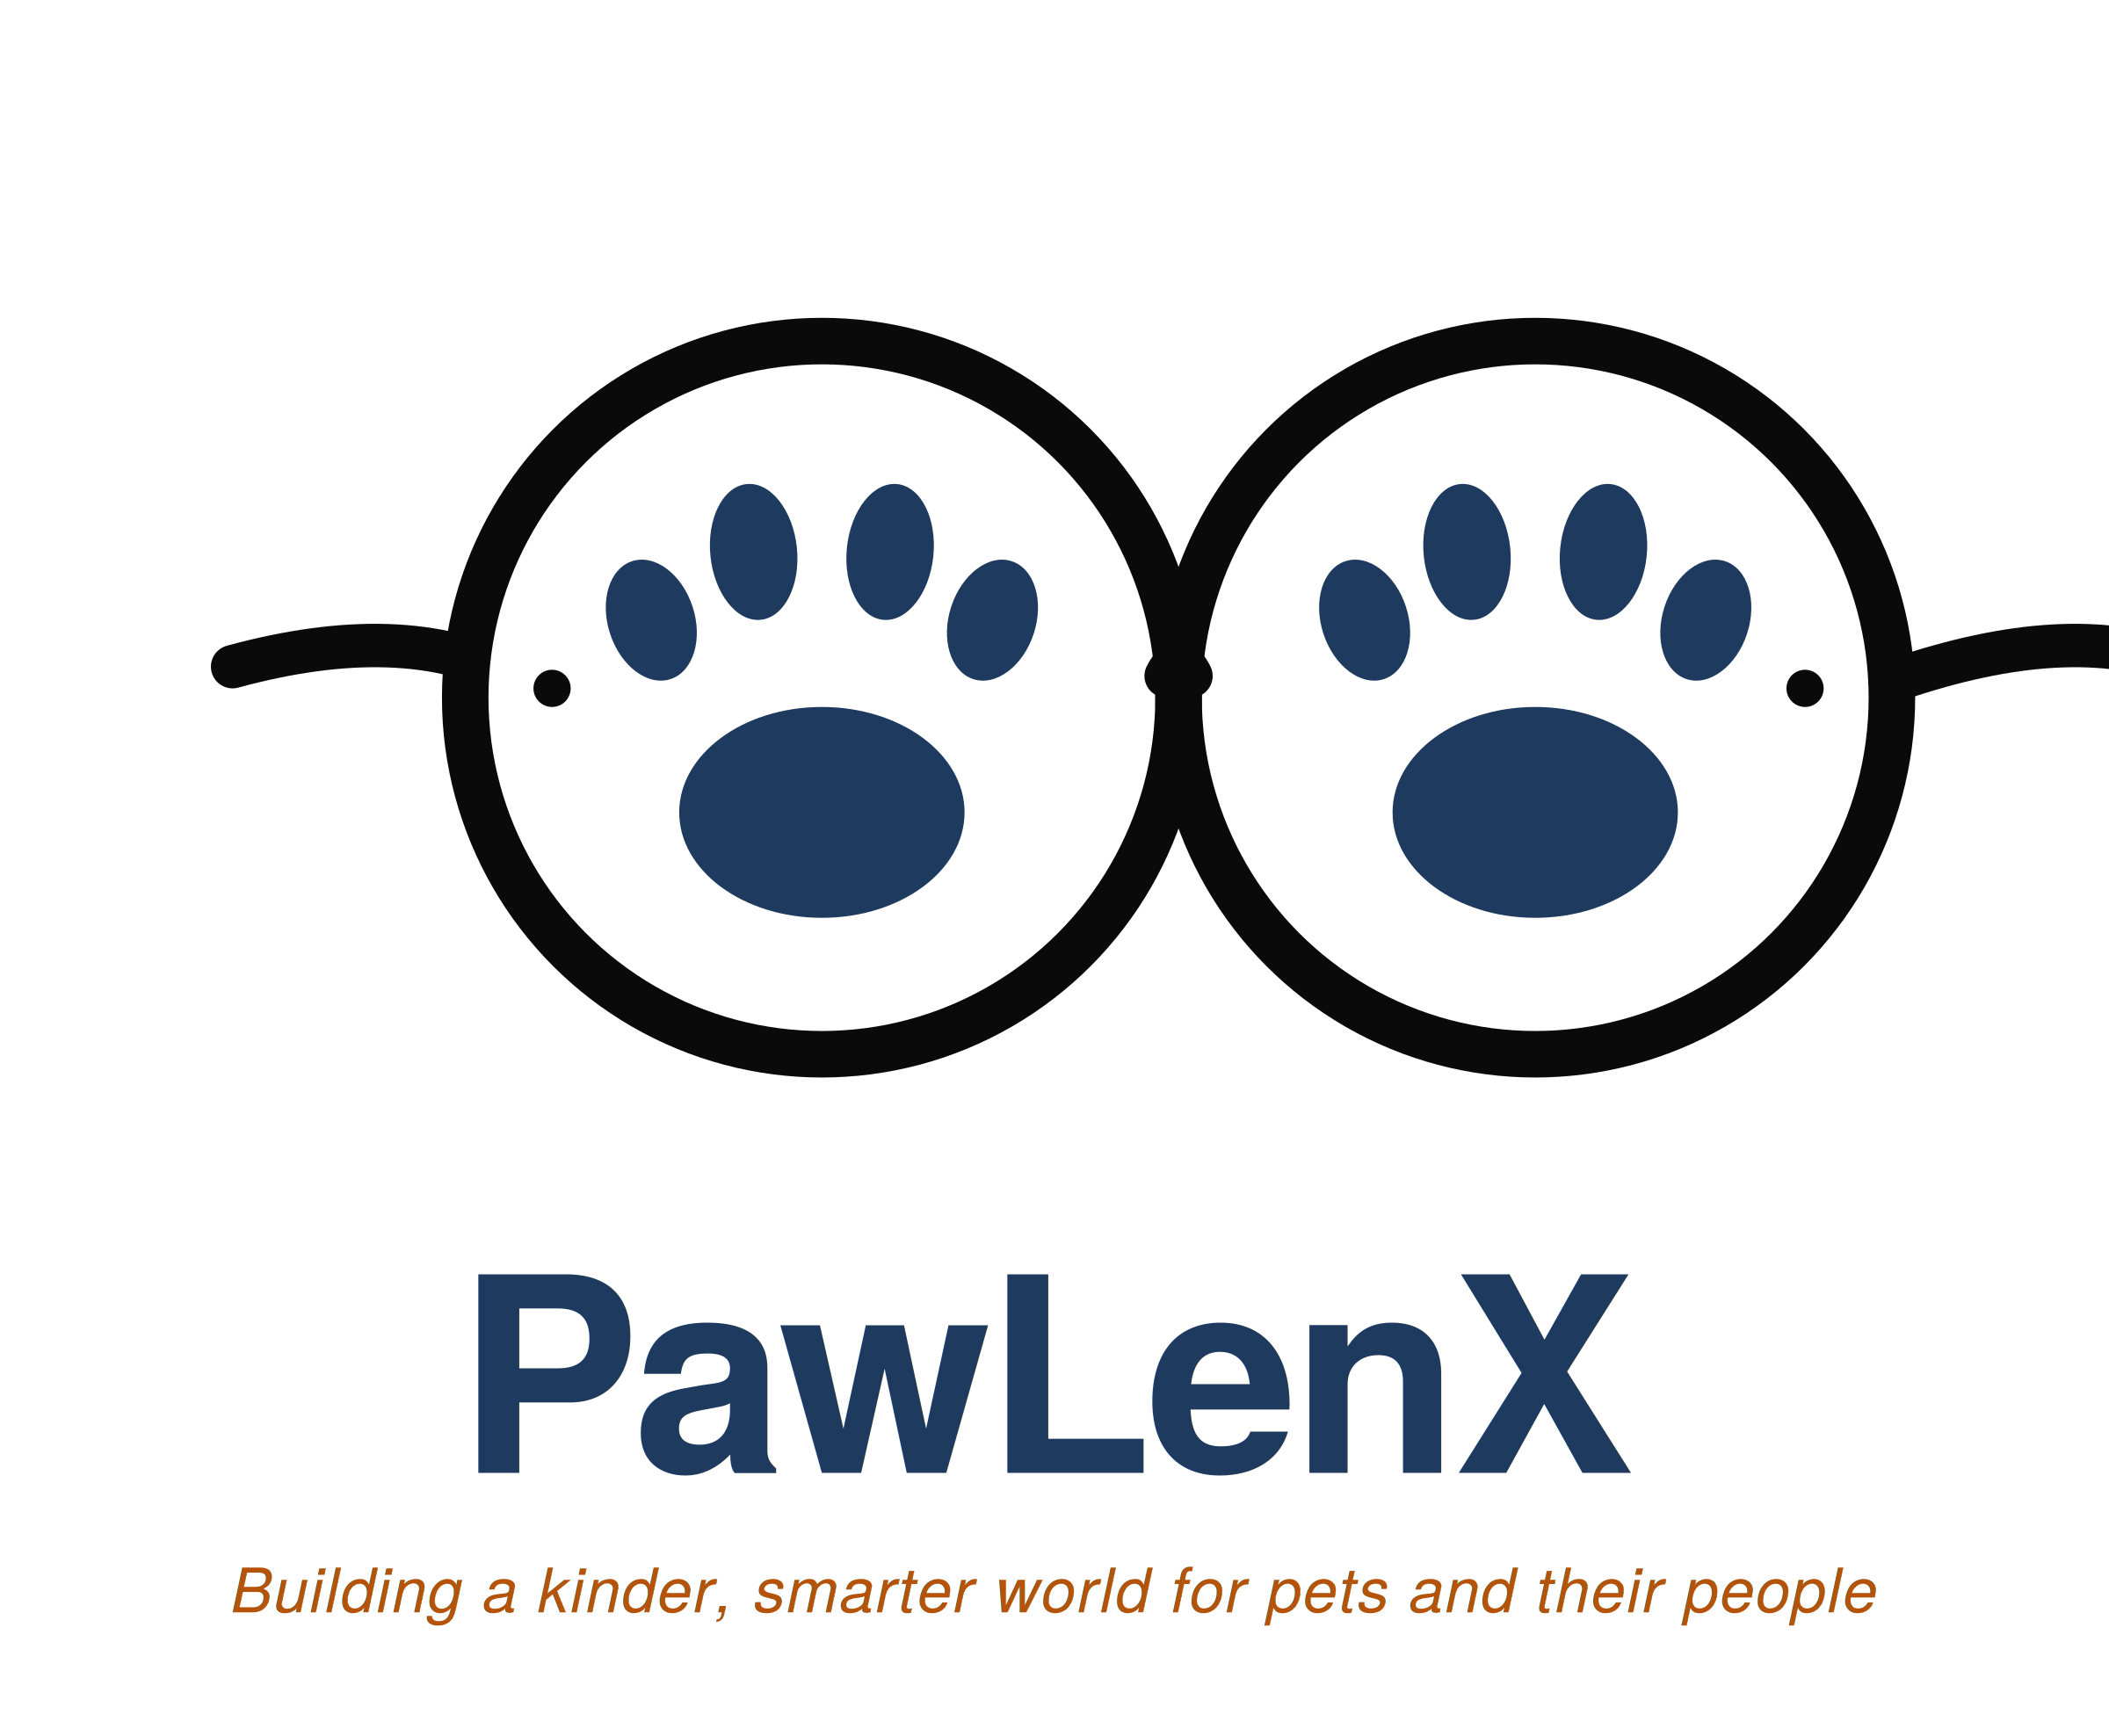  Round / Royal Trust | 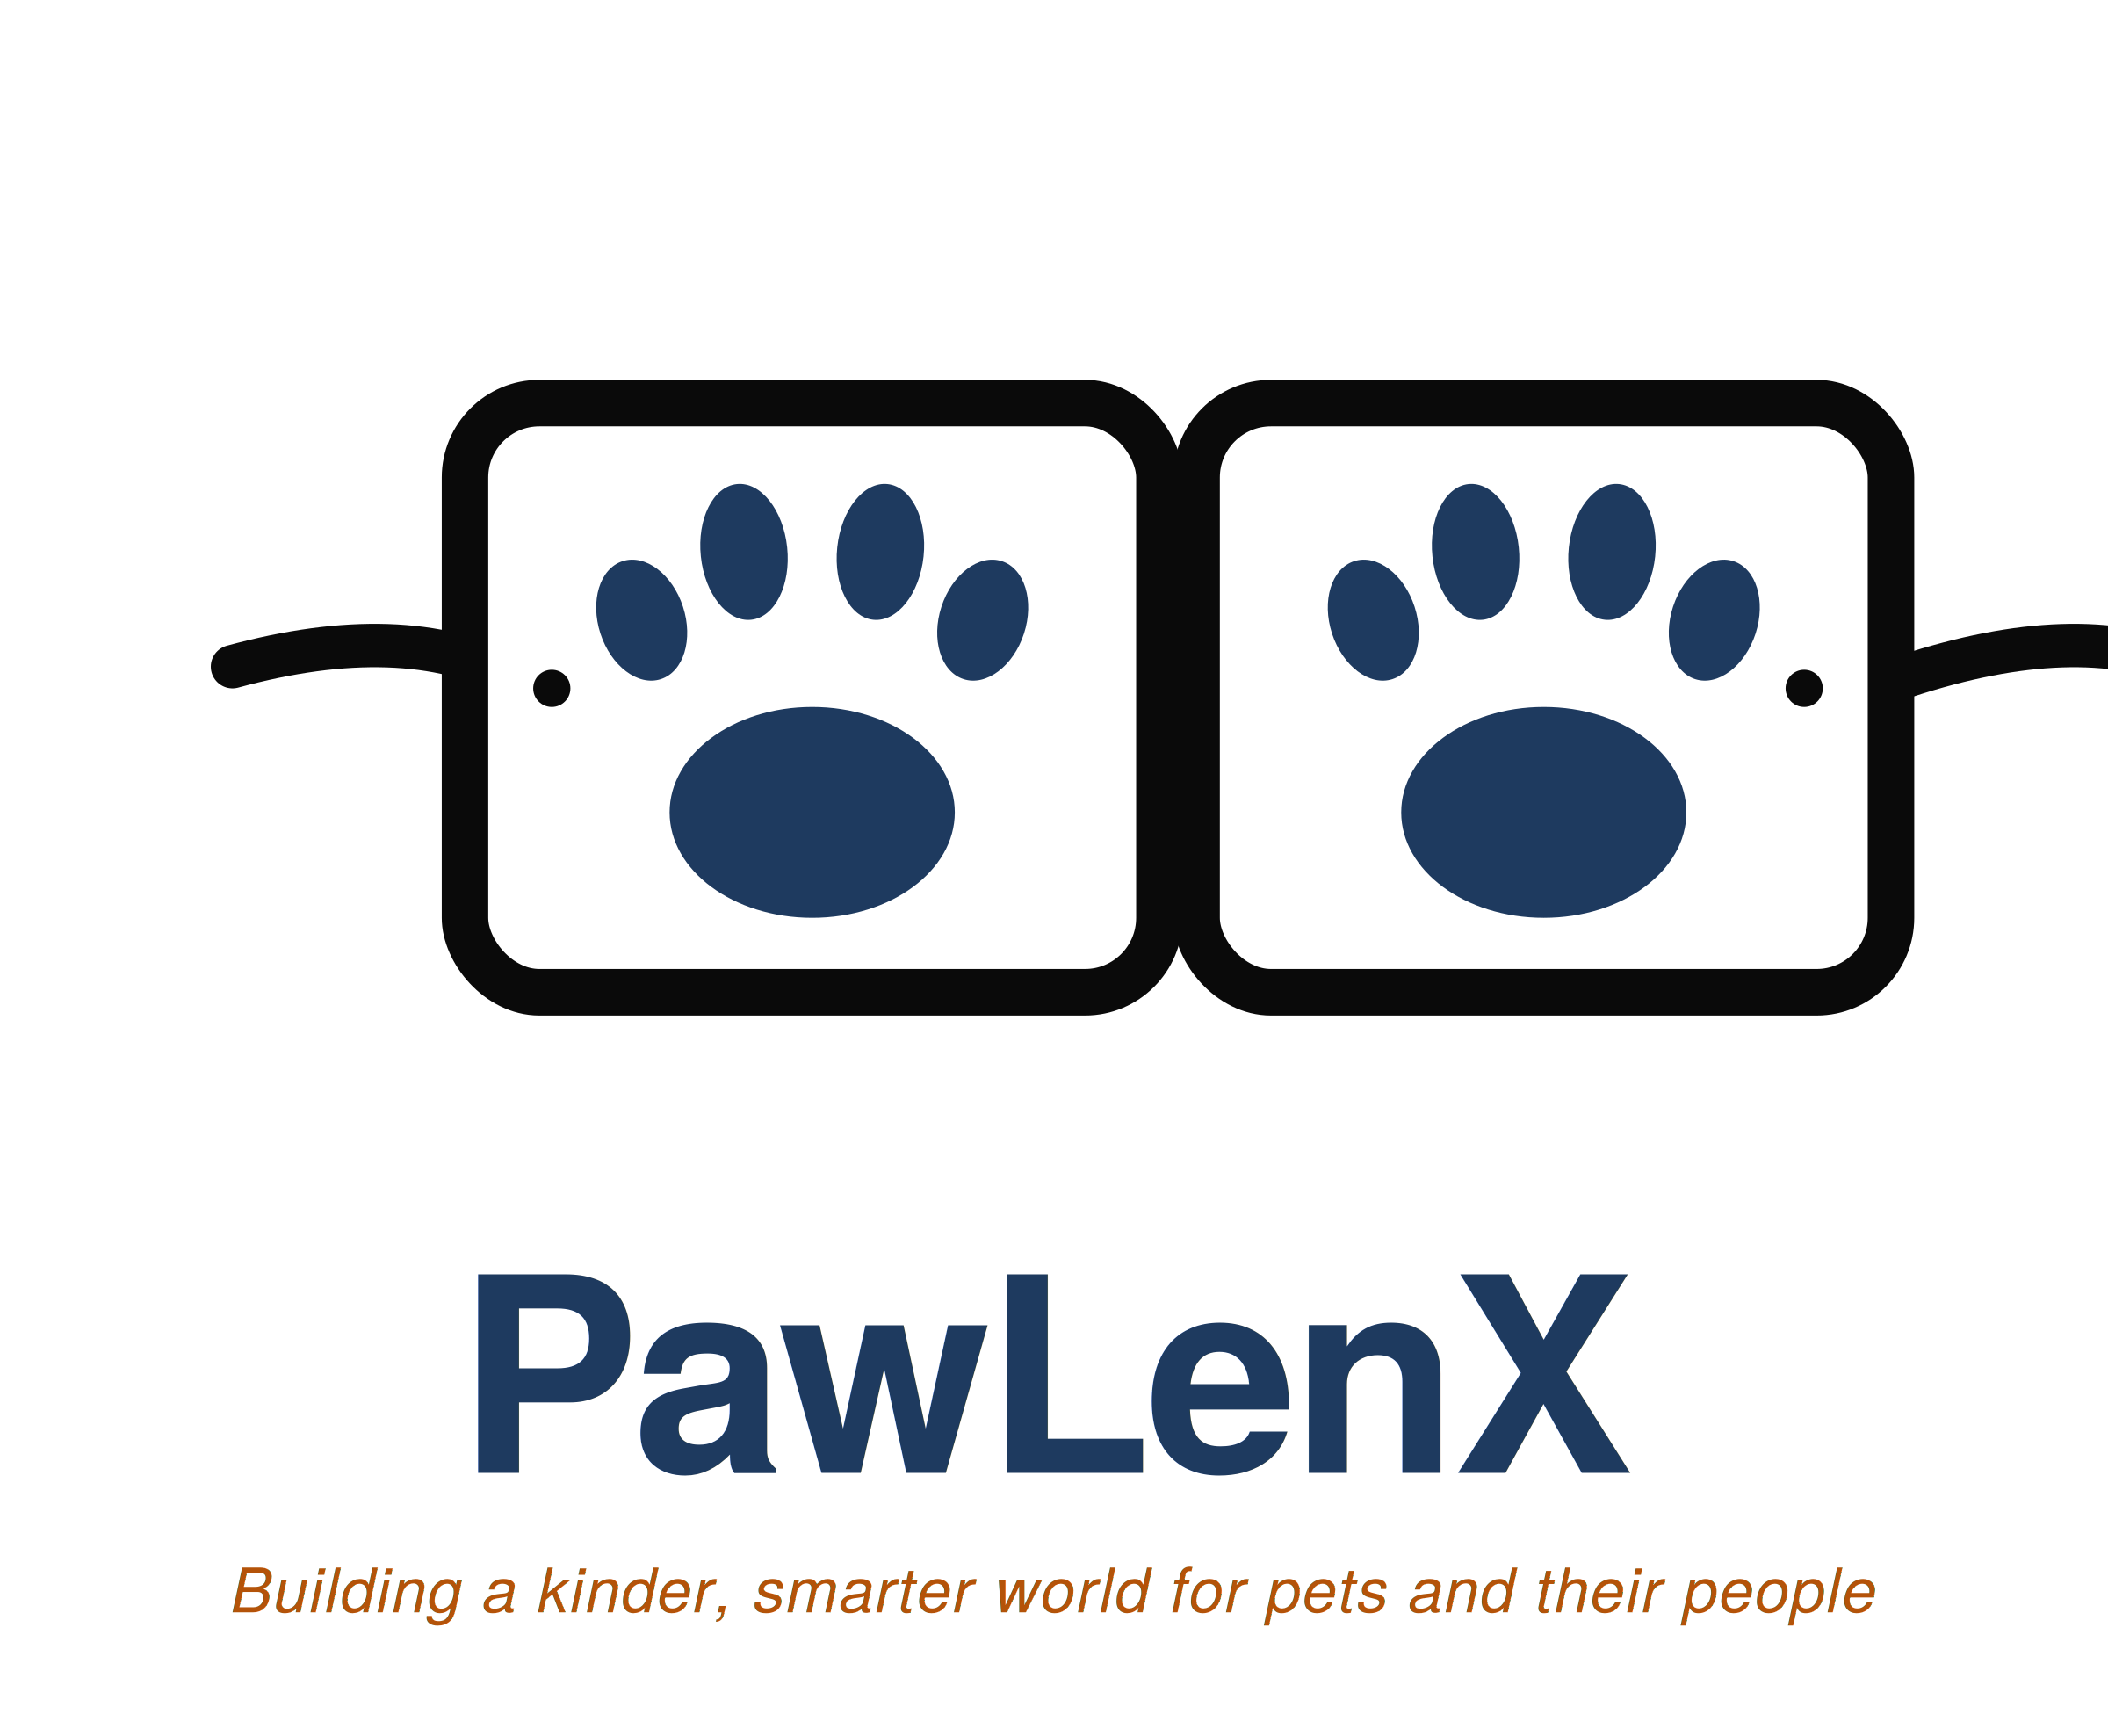  Rectangular / Royal Trust
When to Use Each Variant
Default applications use the Round Healthcare Teal mark. It appears on the website, the app, business cards, letterhead, social profiles, and any standard surface where no other variant has been explicitly approved.
Rectangular variants belong on product packaging and printed merchandise where a more defined, contained shape sits better alongside product photography. Both palette options are available in rectangular form.
The Warm Earth palette is approved for the PawLenX Products line of pet toys and accessories, where a tactile, earthen feel suits the physical product context. It may also appear in seasonal marketing for autumn campaigns.
Royal Trust applies to premium subscription marketing, investor materials, and any premium product line that the company may introduce in future. This palette signals heritage and authority.
For all primary digital and corporate surfaces, the Healthcare Teal palette is the default choice.
Logo File Formats
SVG files are the source of truth. Choose SVG whenever the surface supports it, including web pages, modern email signatures, and design files in Figma or Sketch.
PNG files are for raster surfaces that do not support SVG. Use PNG for social media uploads, embedded logos in slides, and any platform that requires a fixed pixel image. The PNG files have been produced at 2,400 pixels wide, large enough for print up to A3 size at 200 dots per inch.
PDF files are for print production. Send the PDF version to printers for business cards, packaging, and any vendor producing physical materials.
Clear Space
The logo needs room to breathe. The minimum clear space around the mark equals the height of the wordmark itself. No other element, including other text, graphic decoration, or competing logos, may sit closer than this distance.
Minimum Size
A full lockup, including the mark, the wordmark, and the tagline, must not be reproduced smaller than 120 pixels wide on screen or 1.25 inches wide in print. Below this size, the tagline becomes illegible. For smaller applications such as favicons, app icons, and social profile photos, request a mark-only variant from the brand custodian.
What Not to Do
Several treatments break the integrity of the logo and are forbidden across all surfaces.
Stretching or squashing the logo is not permitted. The proportions are fixed.
Rotation is also forbidden. The mark sits horizontal at all times.
Recoloring outside the three approved palettes is prohibited. Individual colors must not be pulled out of one palette and applied to another.
Placement on busy or low-contrast backgrounds creates a different kind of damage. If the chosen background does not provide a contrast ratio of at least 4.5 to 1 against the mark, change the background or request a monochrome variant.
Removing the tagline from the full lockup is prohibited unless the approved mark-only variant is being used.
Decorative effects such as drop shadows, glows, outlines, or texture overlays are not permitted under any circumstances.
Redrawing the paws, the lenses, or the wordmark is also forbidden. If a custom application requires modification, request a new variant from the brand custodian.

Section 4: Color System
PawLenX operates with three approved palettes: one primary and two extended. Each palette consists of three colors, all of which are documented in the formats most often requested by designers and printers.
One color, Brand Black, is shared across all three palettes as the structural anchor for logo frames and high-contrast text. Its values are specified here once: HEX #0A0A0A, RGB 10, 10, 10, and CMYK 0, 0, 0, 96. Each palette listed below carries Brand Black as its third color without restating the values.

Primary Palette: Healthcare Teal
The Healthcare Teal palette is the default identity for the company. It appears on the website, in the app, on corporate documents, and across all digital marketing unless a specific context calls for an extended palette.
 | Brand Teal  Primary brand color | HEX  #0F766E | RGB  15, 118, 110  CMYK  87, 0, 7, 54
 | Soft Teal  Accents, hover states | HEX  #5EAAA8 | RGB  94, 170, 168  CMYK  45, 0, 1, 33
 | Brand Black  Logo frames, body text | HEX  #0A0A0A | RGB  10, 10, 10  CMYK  0, 0, 0, 96
Brand Black completes this palette, with values specified at the top of the section.

Extended Palette One: Warm Earth
This palette is approved for product packaging on the PawLenX Products line and for seasonal autumn marketing.
 | Terracotta  Primary in this palette | HEX  #C2410C | RGB  194, 65, 12  CMYK  0, 67, 94, 24
 | Sunset Orange  Accent, warmth | HEX  #F97316 | RGB  249, 115, 22  CMYK  0, 54, 91, 2
 | Brand Black  Logo frames, body text | HEX  #0A0A0A | RGB  10, 10, 10  CMYK  0, 0, 0, 96
The third color is again Brand Black, drawn from the shared anchor above.

Extended Palette Two: Royal Trust
This palette is held back for premium product lines, investor materials, and the marketing of premium subscription tiers.
 | Heritage Navy  Primary in this palette | HEX  #1E3A5F | RGB  30, 58, 95  CMYK  68, 39, 0, 63
 | Burnished Gold  Premium accent | HEX  #B45309 | RGB  180, 83, 9  CMYK  0, 54, 95, 29
 | Brand Black  Logo frames, body text | HEX  #0A0A0A | RGB  10, 10, 10  CMYK  0, 0, 0, 96
Brand Black anchors this palette as well, using the same values declared earlier.

Supporting Neutrals
Across all three palettes, four neutrals carry the supporting work of the brand: backgrounds, body text, table dividers, and disabled states.
 | Paper White  Primary backgrounds, lens fills | HEX  #FFFFFF | RGB  255, 255, 255  CMYK  0, 0, 0, 0
 | Soft Cream  Secondary backgrounds | HEX  #FAFAFA | RGB  250, 250, 250  CMYK  0, 0, 0, 2
 | Grey 500  Body text, captions | HEX  #6B7280 | RGB  107, 114, 128  CMYK  16, 11, 0, 50
 | Grey 200  Dividers, disabled states | HEX  #E5E7EB | RGB  229, 231, 235  CMYK  3, 2, 0, 8

Color Usage Proportions
A simple rule of thumb keeps the brand visually steady across very different surfaces. In any composition, aim for sixty percent neutrals, thirty percent primary palette color, and ten percent accent palette color. A landing page, for example, sits on white or cream, carries headers and key buttons in Brand Teal, and uses Soft Teal for hover states and secondary callouts. This proportion prevents the strong palette colors from overwhelming the reader.

Accessibility Notes
All three palettes have been checked for contrast against white and against Brand Black. Brand Teal placed on white yields a 5.86 contrast ratio, passing WCAG AA for normal text. Heritage Navy reaches 10.7 when set on white, clearing the higher AAA threshold. Terracotta sits at 5.46 against white, also clearing AA.
Body copy inside our digital products should use Grey 500 on white (a 5.74 ratio, AA-compliant) or Brand Black on white (19.9, AAA-compliant). Soft Teal must never carry text on a white background. Its contrast ratio of 2.65 fails accessibility standards, which is why Soft Teal stays in the role of background, fill, and decorative accent only.

Section 5: Typography
A brand's typography is the voice of the brand made visible. PawLenX uses a single primary sans-serif typeface, paired with a single serif for editorial moments, and a monospace family for code and technical content.

Primary Typeface: Inter
Inter is a contemporary sans-serif designed for clarity at every size. It is available free of charge through Google Fonts, supports the full range of African and European diacritics needed for Yoruba, Igbo, and other Nigerian languages, and ships in a wide range of weights.
All interface text, marketing copy, document headings, and body content should be set in Inter. Six weights are sanctioned for brand use: Regular (400), Medium (500), Semibold (600), Bold (700), and the italic versions of Regular and Medium.

Editorial Typeface: Source Serif
Source Serif serves editorial moments where a softer, more literary feel is desired. Use it for pull quotes inside long-form Pet TV essays, for ceremonial titles on annual reports, and sparingly elsewhere. Source Serif should not appear in standard interface copy or marketing collateral.

Monospace Typeface: JetBrains Mono
JetBrains Mono is for code blocks, technical documentation, and anywhere a fixed-width font is needed. It appears inside developer-facing materials and in technical sections of the website.

Type Hierarchy
The following sizes and weights apply to most surfaces. Adjust proportionally for screens larger or smaller than 1440 pixels.
For display titles, set Inter Bold between 48 and 72 points, with letter-spacing tightened to negative two percent. These titles carry hero sections and page openings.
Major section headers, designated Heading 1 in our document hierarchy, run at Inter Bold, 32 points. Subsection headers (Heading 2) drop to Inter Semibold at 24 points, while callouts and minor section breaks (Heading 3) sit at the same weight at 18 points.
Opening paragraphs and emphasized prose appear at Inter Regular, 18 points. Standard reading text sits one step smaller, at 16 points in the same weight. Image captions and metadata drop further to 13 points, also in Inter Regular.
Line height for body copy should sit at 1.6, generous enough to support comfortable reading on screens and in print. Tighter line heights of 1.2 to 1.3 work well for headings.

Section 6: Imagery, Illustration, and Iconography

Photography Style
Imagery for the brand should feel like documentary, not advertisement. Pets appear in their natural environments, not posed against studio backdrops. Humans in the frame are caught in real moments of care: brushing, feeding, examining, playing.
Lighting is soft and natural where possible. We avoid the harsh ring-light look common in pet content on social media. The composition leaves space for the animal's whole face and body language to be read clearly.
Pets of all common species, breeds, and sizes are welcome in our imagery. Our content must represent the species we serve, including the less photographed ones such as snakes, lizards, fish, ants, and the smaller bird species.

Illustration Style for AI Videos
The PawLenX short films use a flat, gently stylized illustration approach when AI-generated scenes are needed. The palette pulls from Healthcare Teal. Backgrounds are simple, with one or two focal elements per frame. Pet anatomy must be drawn correctly, even when stylized. A bearded dragon must have the right number of toes, and the head shape of a python must match its species.

Iconography
Icons in the app and on the website should be drawn in a single style across the product. The recommended style is rounded outline, two-pixel stroke, with all corners rounded. This style sits comfortably with the round-frame logo and reads clearly at small sizes.
Avoid mixing icon styles. Filled icons in some places and outline icons in others on the same screen will read as inconsistent. Drawing from multiple icon libraries inside a single product creates the same problem.

Section 7: Applications

Business Cards
PawLenX business cards measure 3.5 inches by 2 inches, printed double-sided on uncoated 350 gsm card stock. The front carries the round, Healthcare Teal logo centered, with the holder's name, title, and contact information below. On the reverse, Brand Teal fills the surface as a full bleed, with the tagline reversed out in white.

Email Signature
Signatures follow a fixed template: name in Inter Semibold, title in Inter Regular, then phone, email, and the website on separate lines. The horizontal logo lockup sits below, sized to 180 pixels wide. No quotes, no decorative banners, no animated images.

Social Media Profiles
Profile images on social media use the mark-only logo variant, centered on a white or Brand Teal background depending on the platform's aesthetic. Cover images carry the full lockup on a Brand Teal field, with the tagline visible.

Product Packaging
Packaging for the PawLenX Products line uses the rectangular logo variant in the Warm Earth palette. The frame style matches the boxed nature of physical product packaging, and the warmer palette differentiates the products from the digital surfaces where Healthcare Teal dominates.

App and Web
The app and website lead with the round Healthcare Teal logo in the top-left corner of every screen, sized to a consistent forty pixels of height. Brand Teal appears as the primary action color on buttons, links, and key interactive states. Soft Teal is used for hover states and selected items.

Section 8: Common Mistakes to Avoid
Pulling the logo apart and using only the paw or only the eyeglasses as a standalone graphic. The two halves work together. Neither half works alone.
Using the logo on photography without checking contrast. A teal logo on a dark photograph disappears.
Mixing palettes within a single document. Choose one palette per piece of communication and hold to it.
Adding the company name or tagline as separate text next to the logo. The wordmark and tagline are part of the logo. Do not duplicate them.
Translating the tagline into other languages without approval. Tagline translation requires careful editorial work and must be approved by the brand custodian before publication.
Inventing new palette colors for one-off projects. The three approved palettes cover every brand context. Any addition requires board-level approval.

Section 9: Brand Custodian and Approvals
The brand custodian for PawLenX is the Board of Directors but currently supervised by Chief Research and Development Officer, Dr. Olu Arigbede and Chief Technical Officer, Dr. Tomi Shodipe. All questions about brand usage, all requests for new variants, and all approvals for partner or vendor brand use should be directed to these offices.
Every approved logo file, color reference, and template named in this guide lives in the company's brand asset library, hosted on the shared drive. Access is granted by the CHRO, Dr. Olakunle Ajayi.
This guide will be reviewed every six months. Changes will be communicated to the team in writing, and the version number on the cover will be incremented at each revision.

Closing Note
A brand is not a logo. A brand is the sum of every promise the company has kept and every detail it has cared about. The pages above are a tool to help us keep those promises consistently. When in doubt about a brand decision, the right question is not whether the guide allows the choice, but whether the choice would make our customers trust us more, or less. If the answer leans toward more, the choice is probably correct. When it leans toward less, that decision deserves a second look.

Prepared by:
Drs. Olu Arigbede & Tom Shodipe
For
PawLenX, Inc.

