Analysis
  - EMU430 — Team Paw Patrol

Overview

Team — Paw Patrol
Name | Github
Ucal Mustafayev | pawpxtroller
Sudenaz Usta | sudenazusta
Eren Can Gökçe | gokceeren20-ctrl
Ali Mneimne | alimn03

Downloads
- Word report (report.docx) — full reproducible printout of the project (Home + Data + Analysis), regenerated on every push.
- Cleaned dataset (feeding_clean.RData) — R object feeding.

Project summary
This project analyzes a year of street-animal feeding activity (July 2024 – June 2025) published monthly by Ankara Büyükşehir Belediyesi Sağlık Dairesi. For each neighborhood-day across Ankara’s districts, the source records how many feeding points operated, the average daily dry food distributed (kg), and the vehicle and personnel staffing used.
We combine eleven monthly workbooks into one tidy dataset to enable district-level and time-series comparisons.
Objectives: (1) describe spatial and temporal patterns; (2) compare districts in terms of feeding intensity; (3) highlight data-quality issues (mixed date formats, coded missings, typos) for transparent reporting.

Key takeaways
- Topic: Municipal street-animal (“sokak hayvanı”) feeding logistics in Greater Ankara over a full year (Jul 2024 – Jun 2025), from official Sağlık Dairesi operational records.
- Data: ~3,700+ neighborhood-day rows aggregated from 11 monthly Excel workbooks, with ilçe, mahalle/sokak, feeding-point counts, kg/day of dry food, and vehicle / personnel staffing.
- Important aspects: Mixed date formats across months (some Excel-typed, some Turkish DMY strings like "1.03.2025"); food amounts as "84 KG"; vehicle field includes "-" (missing) and one typo Y3 → 3.
- Interesting results: A few districts (Çankaya, Keçiören, Mamak) dominate reported activity; monthly kg totals fluctuate clearly across the year; the kg-per-record distribution has a long right tail (consolidated bulk feedings).

Data

What this dataset is
This site analyzes monthly street-animal feeding (hayvan besleme) records from Ankara Büyükşehir Belediyesi Sağlık Dairesi. Each row is one neighborhood-day of operations across Ankara’s districts (ilçeler).
We combined eleven monthly Excel workbooks spanning July 2024 through June 2025 into a single tidy dataset:
- 2024: July, September, October, November, December
- 2025: January, February, March, April, May, June
Why we chose it: real, public operational data; Turkey-relevant; large enough for time-series and cross-district EDA; and it touches urban policy and animal welfare logistics — a topic with current public-discourse relevance.
Objectives (data-focused):
- Publish a reproducible pipeline from many raw .xlsx files to a single tidy object feeding.
- Make the cleaned dataset publicly available as feeding_clean.RData.
- Document data-quality issues (mixed date formats, text-encoded numbers, coded missing values, typos, source outliers).

Accomplishments
- Combined 11 monthly workbooks (≈ 3,700+ neighborhood-day rows) into one tibble feeding.
- Standardized district / neighborhood labels (trimmed stray spaces such as "GÖLBAŞI ").
- Parsed mixed date formats — column 1 is read as a native Excel date where possible; when that is missing (e.g. March 2025 string cells like "1.03.2025"), we fill from the text column with parse_date_from_text() (Excel serials, lubridate, explicit formats).
- Parsed text-encoded dry-food amounts into numeric mama_kg (e.g. "84 KG" → 84).
- Normalized vehicle / personnel fields: Y3 → 3, - → missing, blank → missing.
- Added derived columns yil, ay, yil_ay so the analysis page can compare across months.
- Kept a source_file column for traceability back to each monthly workbook.

Source and citation
The raw files are monthly publications from Ankara Büyükşehir Belediyesi Sağlık Dairesi (“Sağlık Dairesi Hayvan Besleme Verileri”). The files are shared on the belediye website https://seffaf.ankara.bel.tr/.

Download cleaned data (course requirement)
After Rscript R/prepare_data.R and quarto render, the cleaned dataset is copied to the website:
feeding_clean.RData — R object: feeding (one row per neighborhood-day).

Import and preparation
Raw files location in this repository: data/raw/hayvan_besleme_YYYY_MM.xlsx (one workbook per month).
Pipeline (mirrors R/prepare_data.R):
- Auto-discover every file under data/raw/ matching hayvan_besleme_*.xlsx.
- Read each workbook twice for column 1: native Excel date (covers most months) plus a parallel text pass so we can recover string-encoded dates (e.g. March 2025’s "1.03.2025") and numeric Excel serials if a sheet is ever exported as plain numbers.
- Merge the two passes: use as.Date() on the date column; where it is still NA, fill from the text column via parse_date_from_text().
- Rename the seven source columns to ASCII snake_case: tarih, ilce, mahalle_sokak, besleme_noktasi_sayisi, mama_kg (via mama_text), arac_sayisi, personel_sayisi, plus metadata source_file.
- Trim extra spaces in ilce and mahalle_sokak.
- Parse food mass with readr::parse_number() (Turkish decimal comma) from the mama text field.
- Parse vehicles: "-" → NA; "Y3" (typo) → 3; otherwise numeric.
- Parse personnel: "-" → NA; otherwise numeric.
- Combine with purrr::map_dfr(), drop rows whose date failed to parse, add yil / ay / yil_ay, and save feeding to data/feeding_clean.RData.
# Run from the project root once when raw files change:
# Rscript R/prepare_data.R

Column dictionary (feeding)
Column | Description
tarih | Calendar date of the record (Date).
ilce | Ankara district (ilçe).
mahalle_sokak | Neighborhood / street (mahalle / sokak).
besleme_noktasi_sayisi | Count of feeding points that day in that row’s scope.
mama_kg | Average daily dry food, in kg (parsed from text).
arac_sayisi | Vehicles involved in feeding (daily average field in source).
personel_sayisi | Personnel field from the sheet (daily average).
yil | Year (int).
ay | Month number 1–12.
yil_ay | YYYY-MM for monthly groupings.
source_file | Which raw workbook the row came from.

Known data-quality notes
- October 2024 workbook contains one row dated 2022-10-18 (clearly a source typo). It is kept in feeding; tag/filter it before yearly aggregations if needed.
- March 2025 dates are stored as Turkish DMY strings.
- Vehicle / personnel columns are low-variance and frequently use "-" for missing — interpret cautiously.

AI use disclosure
We used AI to refine the flow and clarity of our text.

Analysis

Key takeaways
- Topic: Street-animal feeding operations across Ankara districts (ilçeler) from July 2024 to June 2025, based on monthly health-directorate operational records.
- Data: ~3,700+ neighborhood-day records aggregated from 11 monthly workbooks, with feeding-point counts, kg/day of dry food, and vehicle / personnel staffing.
- Important aspects: District names needed trimming; food / dates / staff fields were text-encoded with inconsistent formats (March 2025 dates as "1.03.2025", vehicles as "-" or the typo "Y3").
- Interesting results: A handful of districts (notably Çankaya, Keçiören, Mamak) dominate row counts; monthly totals fluctuate, and the kg-per-record distribution is right-skewed with consolidated large drops in the tail.

Coverage in time and space
feeding |>
summarise(
rows = n(),
months = n_distinct(yil_ay),
first_day = min(tarih, na.rm = TRUE),
last_day = max(tarih, na.rm = TRUE),
distinct_days = n_distinct(as.Date(tarih)),
distinct_ilce = n_distinct(ilce),
missing_mama = sum(is.na(mama_kg)),
missing_arac = sum(is.na(arac_sayisi)),
missing_personel = sum(is.na(personel_sayisi))
) |>
knitr::kable(caption = "Dataset coverage and missingness across all months")
Table 1: Dataset coverage and missingness across all months
rows | months | first_day | last_day | distinct_days | distinct_ilce | missing_mama | missing_arac | missing_personel
3731 | 12 | 2022-10-18 | 2025-06-27 | 286 | 22 | 0 | 16 | 16

The monthly workbooks do not always report every calendar day, so distinct_days is well below the calendar maximum. We treat that as a reporting feature rather than imputing days.
One row in the October 2024 workbook carries an obvious 2022-10-18 date (a source typo). It stays in feeding for traceability and shows up in the coverage table above, but we exclude it from the time-axis charts below so the monthly axis spans only the actual reporting window (Jul 2024 → Jun 2025).

Monthly volume
How many records per month, and how much dry food (kg) was reported per month?
monthly <- feeding_ts |>
filter(!is.na(tarih)) |>
mutate(month_start = lubridate::floor_date(tarih, "month")) |>
group_by(month_start) |>
summarise(
rows = n(),
total_kg = sum(mama_kg, na.rm = TRUE),
.groups = "drop"
) |>
arrange(month_start)
p1 <- ggplot(monthly, aes(month_start, rows)) +
geom_col(fill = "#2E86AB") +
scale_x_date(date_labels = "%b %Y", date_breaks = "1 month") +
labs(x = NULL, y = "Records per month") +
theme_minimal(base_size = 12) +
theme(axis.text.x = element_text(angle = 35, hjust = 1))
p2 <- ggplot(monthly, aes(month_start, total_kg)) +
geom_col(fill = "#A23B72") +
scale_x_date(date_labels = "%b %Y", date_breaks = "1 month") +
scale_y_continuous(labels = label_number(suffix = " kg", big.mark = ",")) +
labs(x = NULL, y = "Reported dry food (kg / month)") +
theme_minimal(base_size = 12) +
theme(axis.text.x = element_text(angle = 35, hjust = 1))
p1
p2
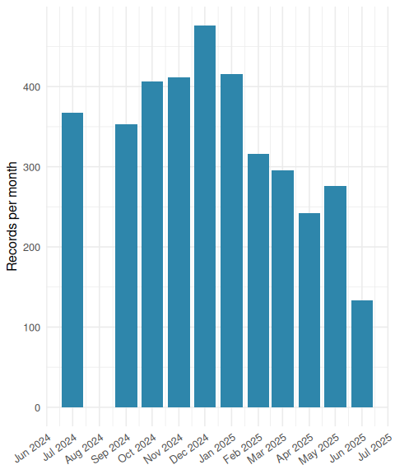
Figure 1: Records per month.
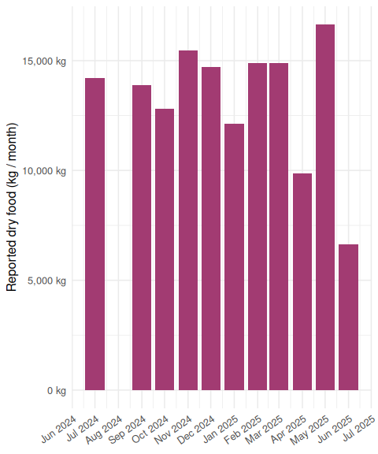
Figure 2: Total reported dry food (kg) per month.
Two complementary views:
- The record count reflects how many neighborhood-days were filed that month — partly a function of reporting effort.
- The kg total reflects the actual feeding workload (after parsing strings like "84 KG").

District activity (row counts)
ilce_counts <- feeding |>
count(ilce, name = "rows") |>
mutate(ilce = stats::reorder(factor(ilce), rows))
ggplot(ilce_counts, aes(x = ilce, y = rows)) +
geom_col(fill = "#2E86AB") +
coord_flip() +
labs(x = NULL, y = "Rows (mahalle × day, all months)") +
theme_minimal(base_size = 12) +
theme(panel.grid.major.y = element_blank())
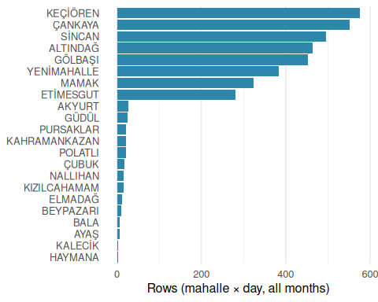
Figure 3: Number of neighborhood-day records per district across the full year.

Distribution of dry food (kg/day)
ggplot(feeding |> filter(!is.na(mama_kg)), aes(x = mama_kg)) +
geom_histogram(fill = "#A23B72", color = "white", bins = 40, boundary = 0) +
scale_x_continuous(labels = label_number(suffix = " kg")) +
labs(x = "kg/day (parsed)", y = "Count") +
theme_minimal(base_size = 12)
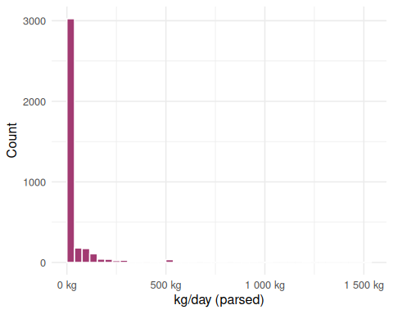
Figure 4: Histogram of parsed daily dry food per record (kg).
The distribution is right-skewed: most records are modest (low single-digit to tens of kg), but a long tail of larger consolidated deliveries pulls the mean up.

District comparison of kg/day
big_ilce <- feeding |>
count(ilce) |>
filter(n >= 50) |>
pull(ilce)
feeding_sub <- feeding |>
filter(ilce %in% big_ilce, !is.na(mama_kg)) |>
mutate(ilce = stats::reorder(factor(ilce), mama_kg, FUN = median, na.rm = TRUE))
ggplot(feeding_sub, aes(x = ilce, y = mama_kg)) +
geom_boxplot(outlier.alpha = 0.3, fill = "#F18F01") +
coord_flip() +
scale_y_continuous(labels = label_number(suffix = " kg")) +
labs(x = NULL, y = "Average dry food (kg/day)") +
theme_minimal(base_size = 12)
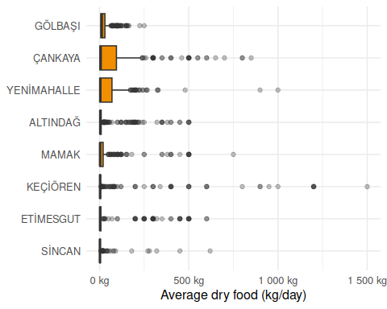
Figure 5: Distribution of kg/day by district (districts with ≥ 50 records across the year).

Top districts over time
How does the monthly kg total vary across the top five districts (by record count)?
top5 <- feeding |>
count(ilce, sort = TRUE) |>
slice_head(n = 5) |>
pull(ilce)
feeding_top <- feeding_ts |>
filter(ilce %in% top5, !is.na(tarih)) |>
mutate(month_start = lubridate::floor_date(tarih, "month")) |>
group_by(ilce, month_start) |>
summarise(total_kg = sum(mama_kg, na.rm = TRUE), .groups = "drop")
ggplot(feeding_top, aes(month_start, total_kg, color = ilce)) +
geom_line(linewidth = 0.9) +
geom_point(size = 1.8) +
scale_x_date(date_labels = "%b %Y", date_breaks = "1 month") +
scale_y_continuous(labels = label_number(suffix = " kg", big.mark = ",")) +
labs(x = NULL, y = "Total reported kg / month", color = "İlçe") +
theme_minimal(base_size = 12) +
theme(
axis.text.x = element_text(angle = 35, hjust = 1),
legend.position = "bottom"
)
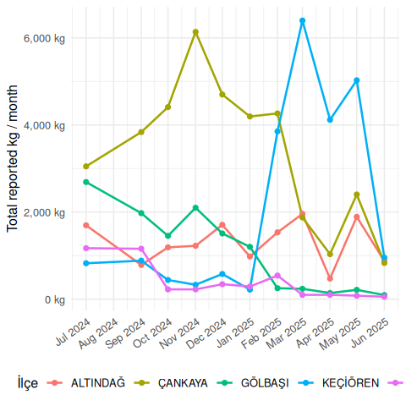
Figure 6: Monthly total kg of dry food for the five most-reported districts.

Operational efficiency: kg per resource
Productivity question: for the same staffing / fleet headcount, which districts move the most food?
ops <- feeding_ts |>
filter(!is.na(mama_kg)) |>
group_by(ilce) |>
summarise(
rows = n(),
total_kg = sum(mama_kg, na.rm = TRUE),
median_staff = median(personel_sayisi, na.rm = TRUE),
median_vehicle = median(arac_sayisi, na.rm = TRUE),
kg_per_staff = total_kg / median_staff,
kg_per_vehicle = total_kg / median_vehicle,
.groups = "drop"
) |>
arrange(desc(kg_per_staff))
ops |>
mutate(across(c(total_kg, kg_per_staff, kg_per_vehicle), \(x) round(x, 1))) |>
knitr::kable(caption = "Annual kg of dry food per staff and per vehicle, by district.")
Table 2: Annual kg of dry food per staff and per vehicle, by district.
ilce | rows | total_kg | median_staff | median_vehicle | kg_per_staff | kg_per_vehicle
ÇANKAYA | 541 | 36737 | 9 | 3 | 4081.9 | 12245.7
KEÇİÖREN | 575 | 23625 | 9 | 3 | 2625.0 | 7875.0
YENİMAHALLE | 372 | 17374 | 9 | 3 | 1930.4 | 5791.3
ETİMESGUT | 281 | 15624 | 9 | 3 | 1736.0 | 5208.0
ALTINDAĞ | 464 | 14311 | 9 | 3 | 1590.1 | 4770.3
MAMAK | 316 | 12500 | 9 | 3 | 1388.9 | 4166.7
GÖLBAŞI | 449 | 11863 | 9 | 3 | 1318.1 | 3954.3
SİNCAN | 495 | 4281 | 9 | 3 | 475.7 | 1427.0
ELMADAĞ | 12 | 4203 | 9 | 3 | 467.0 | 1401.0
AKYURT | 23 | 2729 | 9 | 3 | 303.2 | 909.7
POLATLI | 21 | 759 | 9 | 3 | 84.3 | 253.0
GÜDÜL | 25 | 529 | 9 | 3 | 58.8 | 176.3
NALLIHAN | 15 | 341 | 9 | 3 | 37.9 | 113.7
ÇUBUK | 18 | 277 | 9 | 3 | 30.8 | 92.3
KAHRAMANKAZAN | 22 | 237 | 9 | 3 | 26.3 | 79.0
KIZILCAHAMAM | 15 | 194 | 9 | 3 | 21.6 | 64.7
PURSAKLAR | 22 | 165 | 9 | 3 | 18.3 | 55.0
BEYPAZARI | 10 | 159 | 9 | 3 | 17.7 | 53.0
BALA | 7 | 85 | 9 | 3 | 9.4 | 28.3
AYAŞ | 7 | 77 | 9 | 3 | 8.6 | 25.7
HAYMANA | 2 | 20 | 9 | 3 | 2.2 | 6.7

ops |>
mutate(ilce = stats::reorder(factor(ilce), kg_per_staff)) |>
ggplot(aes(x = ilce, y = kg_per_staff)) +
geom_col(fill = "#2E86AB") +
coord_flip() +
scale_y_continuous(labels = label_number(suffix = " kg", big.mark = ",")) +
labs(x = NULL, y = "kg / staff member (annual total)") +
theme_minimal(base_size = 12)
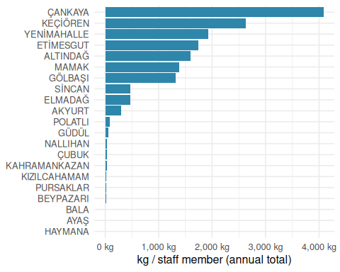
Figure 7: Annual kg of dry food per staff member, by district (Jul 2024 – Jun 2025).
Honest caveat. personel_sayisi and arac_sayisi have only one distinct value across the entire 11-month dataset — i.e. every record was filed with the same fleet/staffing snapshot. That means the ranking in the figure above is identical to a raw total_kg ranking; what changes is only the absolute scale (kg per one unit of resource). With finer-grained daily staff/vehicle counts, the same code would reveal true efficiency gaps — a Yenimahalle-with-9-staff-moving-3kg vs. Keçiören-with-9-staff-moving-200kg comparison.

Load per feeding point
Capacity question: which neighborhoods run “hot” — i.e. concentrate a lot of food onto very few feeding points?
infra <- feeding_ts |>
filter(
!is.na(mama_kg),
!is.na(besleme_noktasi_sayisi),
besleme_noktasi_sayisi > 0
) |>
mutate(kg_per_point = mama_kg / besleme_noktasi_sayisi)
ggplot(infra, aes(x = kg_per_point)) +
geom_histogram(fill = "#A23B72", color = "white", bins = 40, boundary = 0) +
scale_x_continuous(labels = label_number(suffix = " kg")) +
labs(x = "kg per feeding point (per record)", y = "Count") +
theme_minimal(base_size = 12)
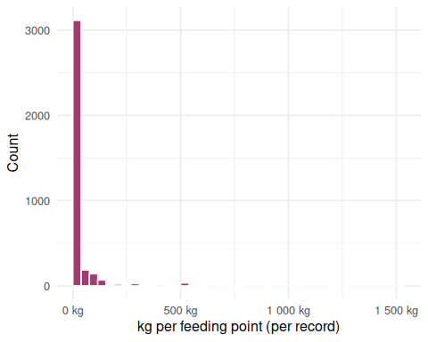
Figure 8: Distribution of kg of dry food delivered per feeding point per record.
infra |>
group_by(ilce, mahalle_sokak) |>
summarise(
rows = n(),
total_points = sum(besleme_noktasi_sayisi, na.rm = TRUE),
total_kg = sum(mama_kg, na.rm = TRUE),
median_kg_per_point = median(kg_per_point, na.rm = TRUE),
.groups = "drop"
) |>
arrange(desc(median_kg_per_point)) |>
slice_head(n = 10) |>
mutate(across(c(total_kg, median_kg_per_point), \(x) round(x, 1))) |>
knitr::kable(caption = "Ten neighborhoods with the highest median kg per feeding point — the most 'loaded' stations.")
Table 3: Ten neighborhoods with the highest median kg per feeding point — the most ‘loaded’ stations.
ilce | mahalle_sokak | rows | total_points | total_kg | median_kg_per_point
KEÇİÖREN | KARŞIYAKA MAH. | 18 | 22 | 14611 | 850
ETİMESGUT | FEVZİYE MAH. | 1 | 1 | 600 | 600
ELMADAĞ | HASANOĞLAN MAH. | 8 | 8 | 3280 | 500
ELMADAĞ | TEKKE MAH. | 1 | 1 | 500 | 500
ÇANKAYA | YAKUPABDAL MAH. | 27 | 30 | 12330 | 460
MAMAK | KARŞIYAKA MAH. | 5 | 5 | 1673 | 400
ALTINDAĞ | ZÜBEYDEHANIM MAH. | 4 | 4 | 1250 | 350
ELMADAĞ | SAĞLIKLI YAŞAM | 1 | 1 | 350 | 350
ÇANKAYA | SAĞLIKLI YAŞAM | 1 | 1 | 350 | 350
ETİMESGUT | BAHÇEKAPI MAH. | 41 | 42 | 13720 | 300

A neighborhood with 1 feeding point and 250 kg is under far more stress than one with 3 points and 80 kg total. The table above flags candidates for either splitting points or rebalancing routes.

Point density per neighborhood
ggplot(feeding_ts |> filter(!is.na(besleme_noktasi_sayisi)),
aes(x = besleme_noktasi_sayisi)) +
geom_bar(fill = "#2E86AB") +
labs(x = "Feeding points (per neighborhood-day record)", y = "Records") +
theme_minimal(base_size = 12)
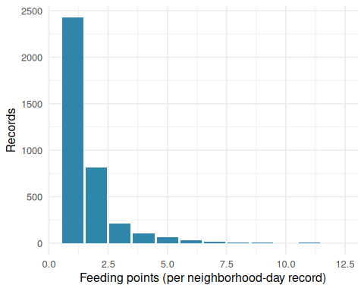
Figure 9: Number of feeding points reported per record (mahalle × day).

Staff vs food: is the resource allocation linear?
In a perfect world, districts that move more food should have proportionally more staff. Any deviation is either over- or under-staffing.
ops |>
ggplot(aes(x = median_staff, y = total_kg, label = ilce)) +
geom_point(color = "#C73E1D", size = 2.5, alpha = 0.85) +
ggrepel::geom_text_repel(size = 3, max.overlaps = 30) +
scale_y_continuous(labels = label_number(suffix = " kg", big.mark = ",")) +
labs(x = "Median reported staff (per record)",
y = "Annual total kg of dry food") +
theme_minimal(base_size = 12)
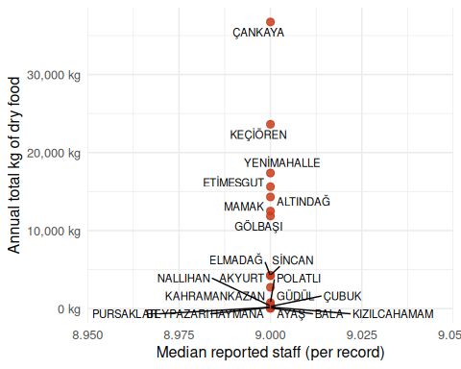
Figure 10: Median reported staff vs. annual total kg, by district. A flat line indicates uniform staffing across districts.
In this dataset the x-axis collapses to a single value, so the “linear-correlation” question is structurally unanswerable from the source as published — a finding in itself: the municipality is not publishing varying daily staff/vehicle counts.

Weekday vs. weekend, and within-district consistency
Temporal question: does the operation scale down on weekends, and how stable is each district’s daily load?
wday_lbl <- c("Mon", "Tue", "Wed", "Thu", "Fri", "Sat", "Sun")
by_wday <- feeding_ts |>
filter(!is.na(tarih), !is.na(mama_kg)) |>
mutate(wd_int = lubridate::wday(tarih, week_start = 1)) |>
group_by(wd_int) |>
summarise(
rows = n(),
median_kg = median(mama_kg, na.rm = TRUE),
.groups = "drop"
) |>
mutate(wd = factor(wday_lbl[wd_int], levels = wday_lbl))
p_wday_rows <- ggplot(by_wday, aes(wd, rows)) +
geom_col(fill = "#2E86AB") +
labs(x = NULL, y = "Records") +
theme_minimal(base_size = 12)
p_wday_kg <- ggplot(by_wday, aes(wd, median_kg)) +
geom_col(fill = "#A23B72") +
scale_y_continuous(labels = label_number(suffix = " kg")) +
labs(x = NULL, y = "Median kg / record") +
theme_minimal(base_size = 12)
p_wday_rows
p_wday_kg
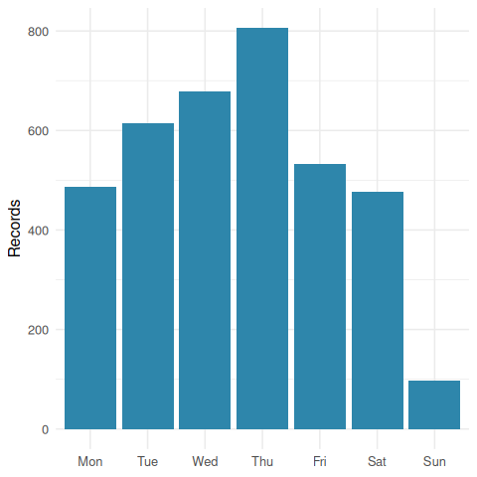
Figure 11: Records per weekday (Monday → Sunday).
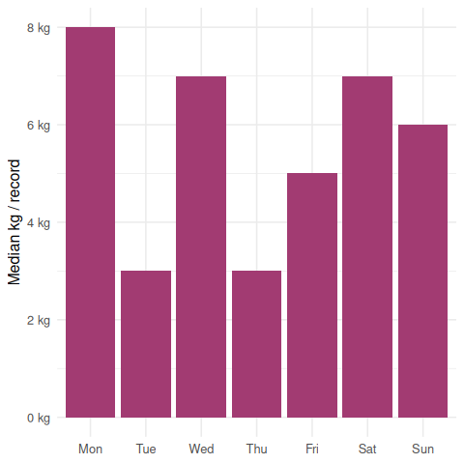
Figure 12: Median dry food (kg) per record by weekday (Monday → Sunday).
feeding_ts |>
filter(!is.na(mama_kg), ilce %in% big_ilce) |>
group_by(ilce) |>
summarise(
rows = n(),
mean_kg = mean(mama_kg, na.rm = TRUE),
sd_kg = sd(mama_kg, na.rm = TRUE),
cv = sd_kg / mean_kg,
.groups = "drop"
) |>
arrange(desc(cv)) |>
mutate(across(c(mean_kg, sd_kg, cv), \(x) round(x, 2))) |>
knitr::kable(caption = "Within-district variability of kg/day. High coefficient of variation (CV) = unstandardised schedule; low CV = routine flat operation.")
Table 4: Within-district variability of kg/day. High coefficient of variation (CV) = unstandardised schedule; low CV = routine flat operation.
ilce | rows | mean_kg | sd_kg | cv
SİNCAN | 495 | 8.65 | 42.23 | 4.88
KEÇİÖREN | 575 | 41.09 | 168.94 | 4.11
ALTINDAĞ | 464 | 30.84 | 81.94 | 2.66
MAMAK | 316 | 39.56 | 103.88 | 2.63
ETİMESGUT | 281 | 55.60 | 130.54 | 2.35
YENİMAHALLE | 372 | 46.70 | 96.68 | 2.07
ÇANKAYA | 541 | 67.91 | 121.19 | 1.78
GÖLBAŞI | 449 | 26.42 | 35.33 | 1.34

A high CV (e.g. sd / mean > 1) suggests big fluctuations from day to day — likely consolidated bulk deliveries rather than a smooth daily schedule. A low CV suggests a routine flat operation.

Observations per day
daily <- feeding_ts |>
filter(!is.na(tarih)) |>
mutate(day = as.Date(tarih)) |>
count(day, name = "rows")
ggplot(daily, aes(x = day, y = rows)) +
geom_line(color = "#C73E1D", linewidth = 0.5, alpha = 0.6) +
geom_point(color = "#C73E1D", size = 1.2, alpha = 0.7) +
scale_x_date(date_labels = "%b %Y", date_breaks = "1 month") +
labs(x = NULL, y = "Rows per day") +
theme_minimal(base_size = 12) +
theme(axis.text.x = element_text(angle = 35, hjust = 1))
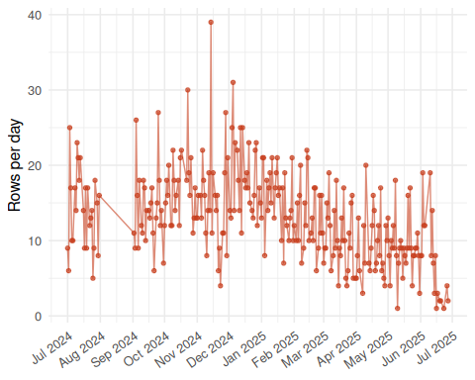
Figure 13: Number of records per calendar day across the full reporting window.

Conclusions
- Spatial concentration: A handful of districts (Çankaya, Keçiören, Mamak and a few others) account for most of the reported activity. Tying this to population, urban form, or program emphasis remains a hypothesis without external data.
- Temporal patterns: Monthly volume is uneven, partly driven by reporting effort rather than real demand. The kg totals are less sensitive to that and offer a more reliable workload proxy.
- Right-skewed food amounts: A long upper tail represents consolidated bulk feedings at specific points; the median is a better summary than the mean.
- Productivity (kg per resource): With the published staff/vehicle figures fixed at a single value, the ranking of kg-per-staff and kg-per-vehicle reduces to a rescaled total-kg ranking. That itself is a finding — the source does not publish variable daily staffing, so cross-district efficiency comparisons must wait on richer data.
- Loading per feeding point: A clear right-skew in kg / feeding point identifies “hot stations” where a single point absorbs disproportionate load — candidates for splitting or route rebalancing.
- Staff–food relationship: Because reported personel_sayisi is uniform across districts, the staff-vs-kg scatter collapses to a vertical line; the implied “perfectly linear allocation” assumption cannot be validated from the published file.
- Weekday rhythm: Records and median kg per record are visibly lower on weekends in the weekday charts, suggesting the operation does scale down rather than running flat 7 days a week.
- Within-district consistency: Coefficient-of-variation across the major districts ranges widely; the highest-CV districts use sporadic bulk drops, while low-CV districts run a flat routine.
- Data quality matters: Different months use different date formats, and one row carries an obvious 2022 typo — a reminder that reproducible cleaning is part of the analysis, not a side concern.

AI use disclosure
AI assisted with some of the code.

