

AMHERST HIRED WALKIE-TALKIE RADIOS

Hytera RD-985 Duplex Repeater Instructions

SETTING UP AND USING THE REPEATER

General Principles

- Aim to place the repeater at the geographical centre of the area you want to cover.
- The repeater must be kept indoors out of exposure to the elements (the repeater is NOT waterproof).
- The antennae should be placed outside, as high as possible, with minimum interruption to line of sight for intended radio users.
- The repeater operates on one channel at a time.
Repeater channels 1-4 correspond to radio channels 13-16 respectively.
Repeater channel 1=radio channel 13, repeater 2=radio 14, etc.
- The repeater has a built-in speaker for monitoring transmissions.

Installation

- If you have 2 x antennae, join them with the T-Harness and consider them a single antenna.
- Install the antenna as high as connecting cable will allow.
The supplied mounting clip allows for easy attachment to scaffold or similar tube (spanner required).
- Place Repeater and power supply (PSU) in a secure, dry location within range of intended antenna location.
- Attach the antenna to socket on the back of the repeater using supplied extension cable. The connecter features a twist-lock mechanism.
- Connect PSU to repeater.
- Switch PSU to ‘off’, then connect PSU to mains power.

Usage

- Switch PSU to ‘on’.
- Select desired repeater channel using Channel selector buttons (“1” on Fig 1).
- Adjust in-built speaker volume using Volume Control knob (“2” on Fig 1).

Fig 1

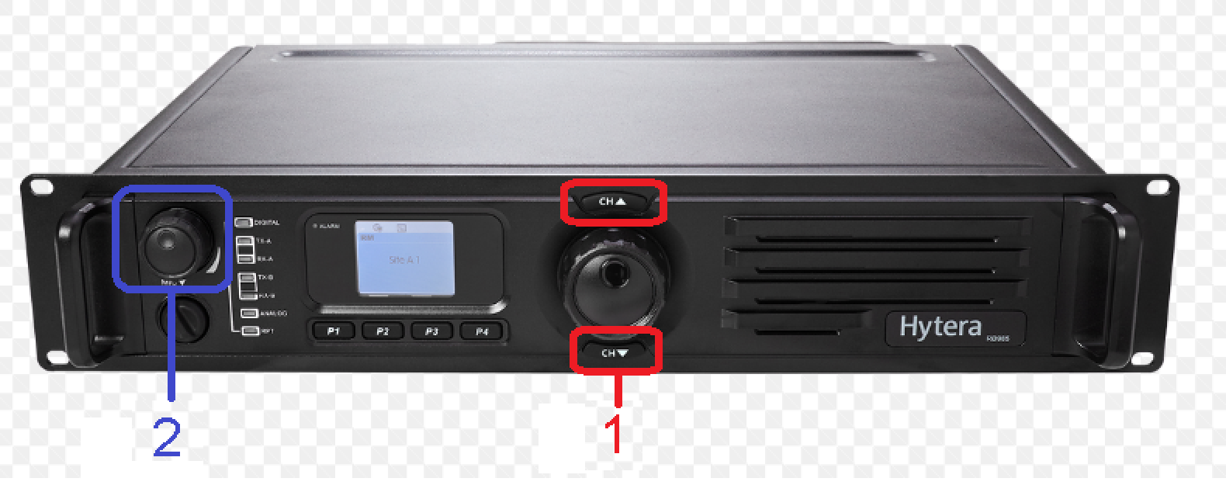

AMHERST HIRED WALKIE-TALKIE RADIOS

Hytera RD-985 Duplex Repeater Instructions

REPEATER CONTENTS CHECKLIST:
1x Hytera digital repeater in flight-case
1x Antenna
1x Antenna mounting clip
1x Antenna connection cable
1x Power Supply (12v output connected)
1x IEC ‘Kettle’ Lead
1x laminated instruction sheet

MISSING AND FAULTY ITEMS
- We check all equipment before despatching.
- In the unlikely event that any equipment is missing or faulty please contact us immediately upon receipt – we may be able to send replacements.
- Returns with undeclared missing and/or faulty equipment will incur charges.
- If any equipment develops a fault while you are using it, please let us know - whether you feel the damage or problem was your fault or not.
- Mark the faulty item with a Post-It or similar label so that we know what is wrong when we get the equipment back.

RETURNING THE REPEATER
- Switch the PSU off.
- Disconnect all cables.
- Reattach covers to repeater flight-case.
- Dismount antenna.
- Repackage all equipment as it was supplied, making sure that everything fits securely into the boxes so that it can’t bash about during transit. Use above checklist to ensure nothing is missing.
- Note down how things went on the “Hire Checklist & Return Sheet”– did the radios work as you expected? Note any faulty items and any problems that you encountered.
- It is very important that you include the “Hire Checklist & Return Sheet” because this tells us who these radios have been returned from and enables us to close the hire.

Also include this instruction sheet. They cost us money to print and laminate.

Amherst Enterprises Limited
70 Kingsgate Road
LONDON NW6 4TE Tel: 020 7328 9792

If you are arranging your own courier please use a trackable, signed-for service with appropriate insurance - all equipment remains your responsibility until received by our staff.

