

Walkie Talkie Radio Fact Sheet

Entel DX485 digital walkie-talkie | 
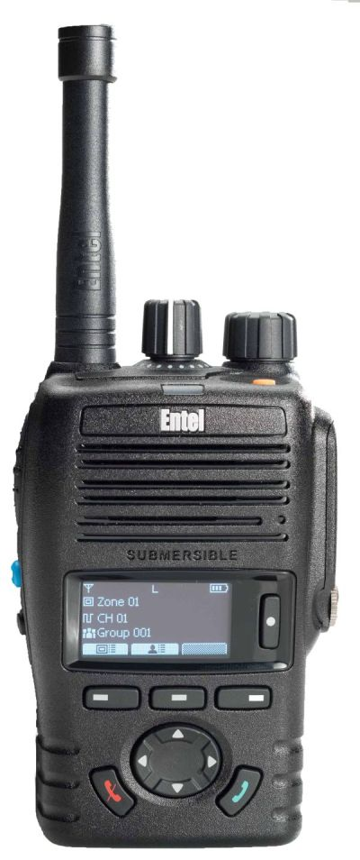 | - General purpose digital/analogue walkie-talkie – full power (4w UHF)  - OLED high-visibility display to show battery life, battery condition, signal strength, channel information and more  - Ultra-clear digital audio sound  - Ofcom licence needed in the UK  - Size 97mm x 62mm x 48mm excluding. antenna  - Antenna length 170mm, or 70mm “stubby”  - Weight 275g inc. battery  - Battery 2000mAh Li-Ion high capacity  - Rotary on/off/volume knob & rotary channel selector, plus additional programmable keys  - IP68 – waterproof to 2 metres  - 64 programmable channels, 8 zones  - Emergency button with siren sound & remote sending  - Low battery alert & battery gauge & battery usage count display  - Integral belt clip  - Robust Entel audio connector  - Comes with battery and drop-in desk charger unit  - Price £199 + VAT each, or £189 + VAT each if 5 or more radios are bought together
Amherst Two Way Radio Centre, 70 Kingsgate Road, London NW6 4TE

Tel: 020 7328 9792 Fax: 020 7209 2704

Email: radios@amherst.co.uk Web: www.walkie-talkie-radio.co.uk

Dated 28th March 2020 E. & O.E.

