

TESUNHO SIM CARD RADIOS
HOW TO CHANGE “GROUPS”

If you have hired some of our Tesunho SIM card radios, and you have asked us to configure more than one user “group” (groups on these radios are like channels on conventional walkie-talkies) then you need to know how to

TESUNHO TH289

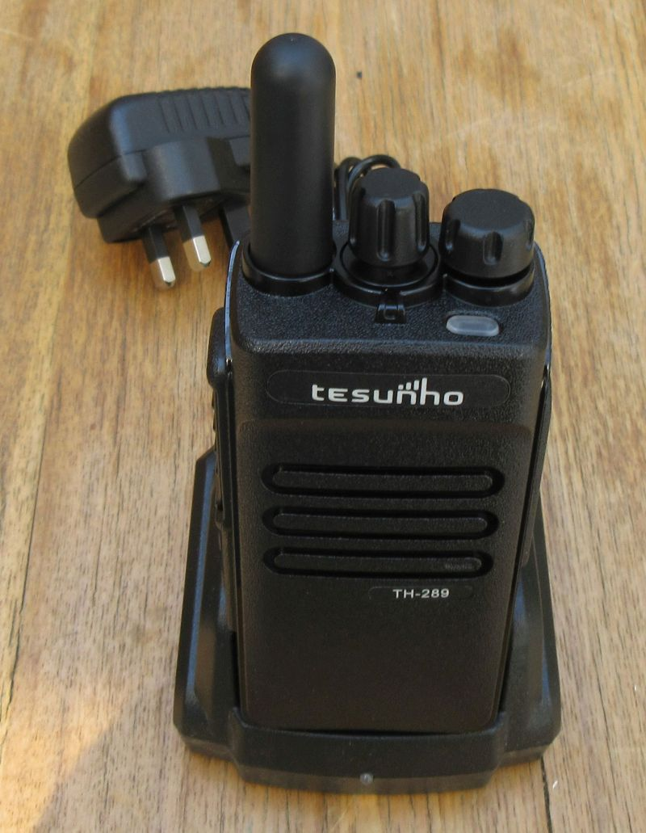
Use the upper small button on the side to enter “choose group” mode.

Then use the rotary control on the top of the radio, next to the volume control to step between the groups.

The radio will say the name of each group.

When you get to the group you want to be in, press the PTT (Push To Talk) button and the radio will then join that group.

TESUNHO TH388

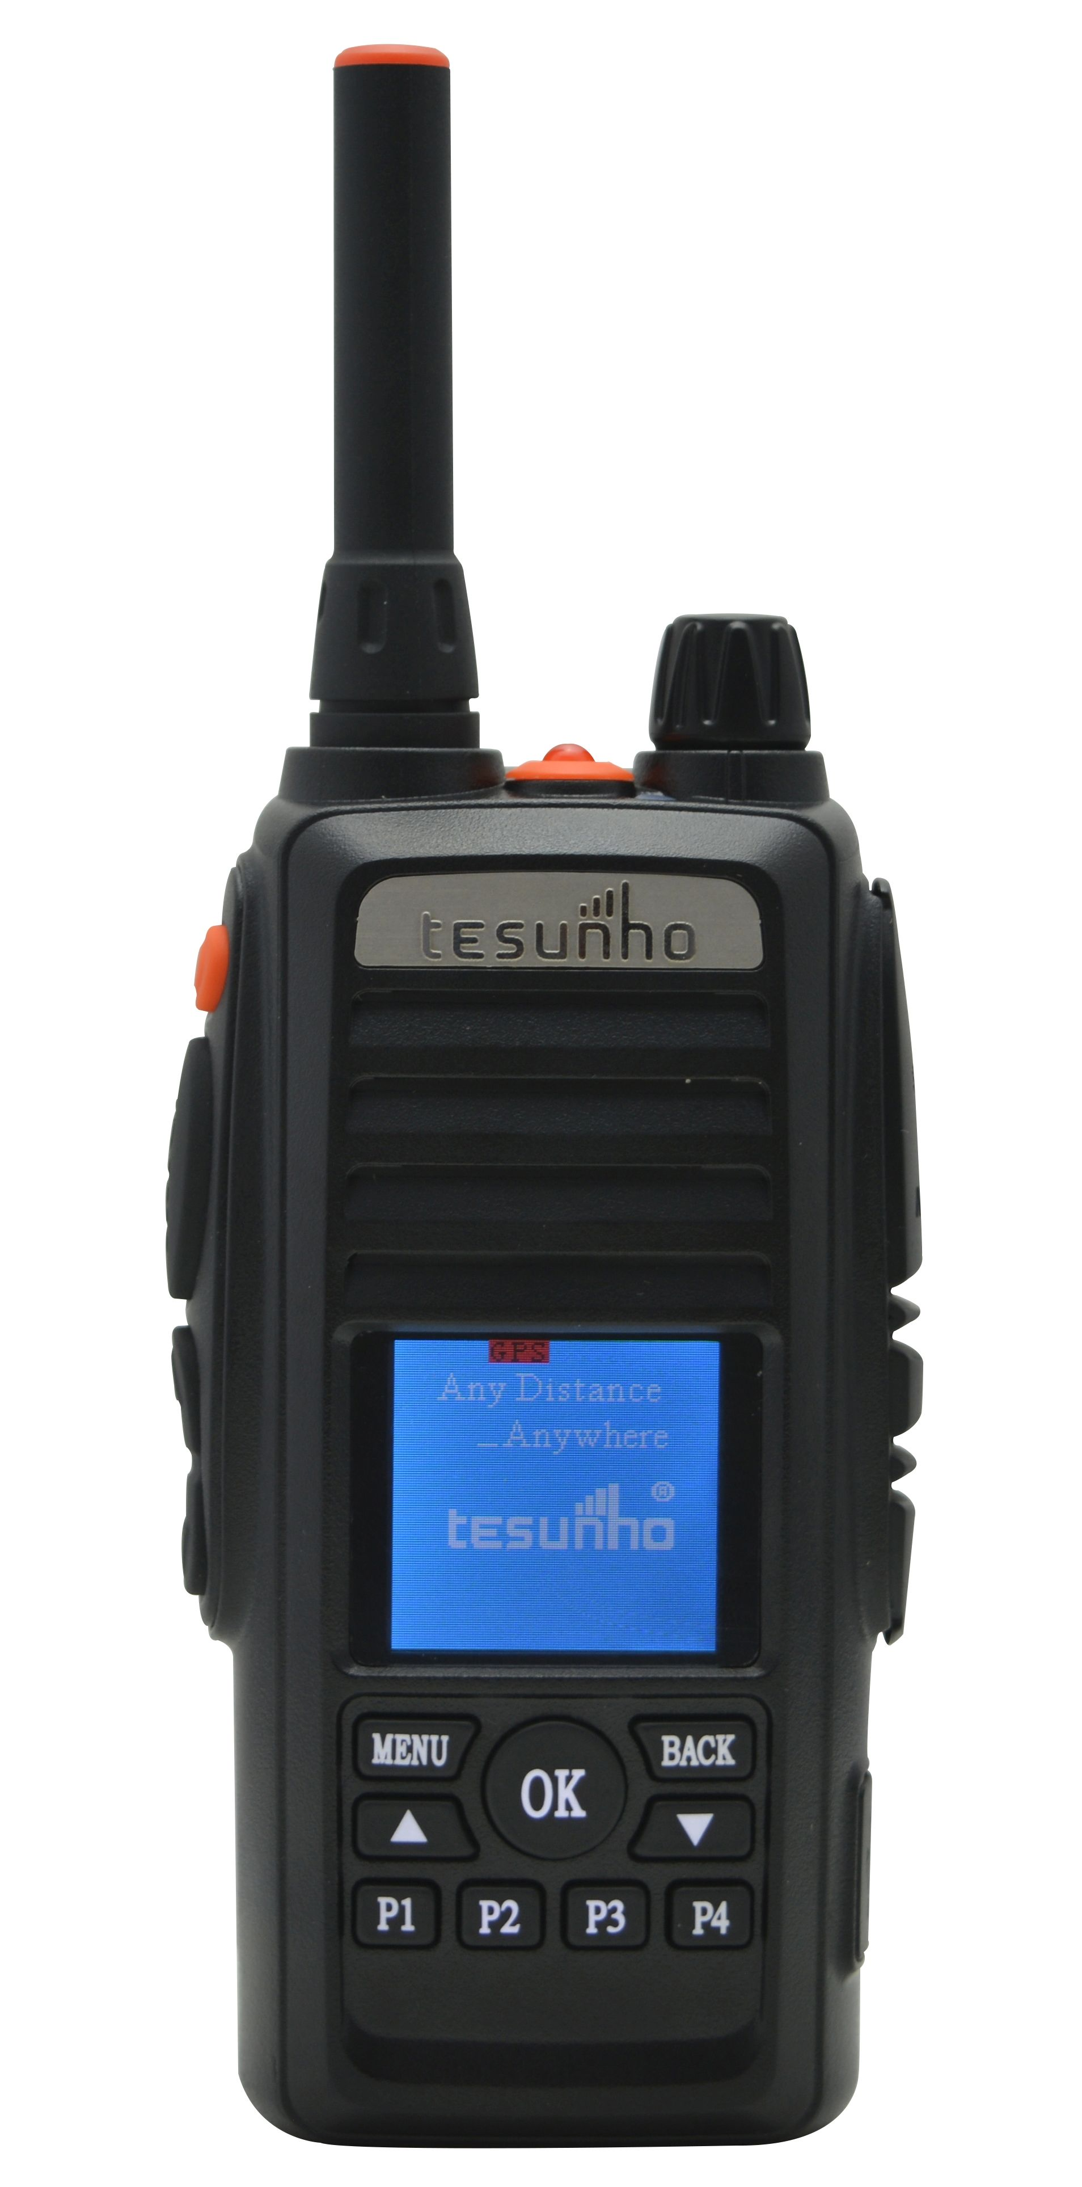
Use the MENU button and the “Choose Group” option to change groups, using the LED display on the screen.

