

AMHERST - HIRED METAL-DETECTOR “WANDS”

UNPACKING THE “WANDS”

Open the box(es) supplied carefully, so you can re-use them to return the equipment later. Tell us if anything is missing or damaged. Keep all the packaging for returning the equipment.

USING THE METAL-DETECTING WANDS
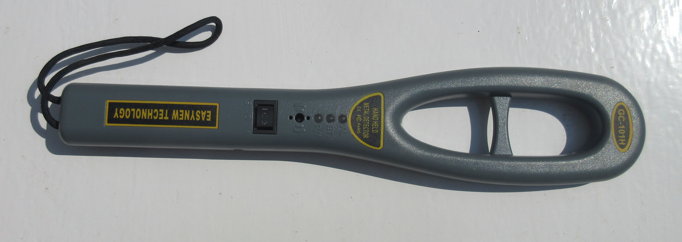

The “wand” has a power switch with 3 positions.

In the central position the “wand” is off.

Press the switch down to the left (marked “I”) to switch it on in the standard “beep” mode, where the wand sounds a beep when metal is detected.

Press the switch down to the right (marked “II”) to switch it on in “vibrate” mode, where the wand handle vibrates when metal is detected.

This “vibrate” mode is useful where a high ambient noise level means that the “beep” wouldn’t be audible, or where you want to be discreet, and not have the electronic “beep” sounding.

To use the “wand”, make sure that it is turned on, and then run it SLOWLY over the subject’s person, almost in contact with their clothing.
Focus on the subjects clothing pockets, and anywhere else where a weapon could be concealed.

The wand has a detection range of only about 5cms ( or about 2 inches), so make sure that you do not hold it too far away to detect concealed metal objects. The wand should almost touch the clothing as you scan the subject.

The user should familiarise themselves with the “wands” use and limitations, by first trying it out on themselves or a colleage, to get a “feel” for how well it will detect metal objects and at what range, before using it “for real”.

The “wand” will either beep or vibrate whenever it detects metal objects. At this point, the user should ask the subject to remove and display the metal objects from their pockets.

INSERTING & REMOVING THE RECHARGEABLE BATTERY

The “wands” use a small 9 volt “PP3” battery, of the same type often used for smoke alarms etc. We provide rechargeable batteries with the wands.
It is very easy for the switches to get switched to the “on” positions by accident in transit, so sometimes we will send the wands out without their rechargeable batteries installed.

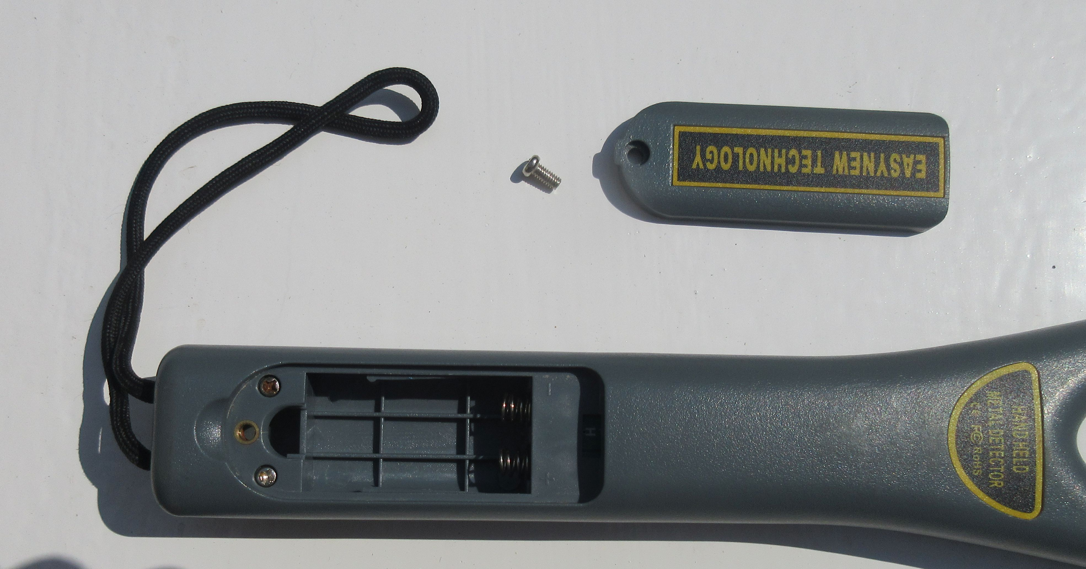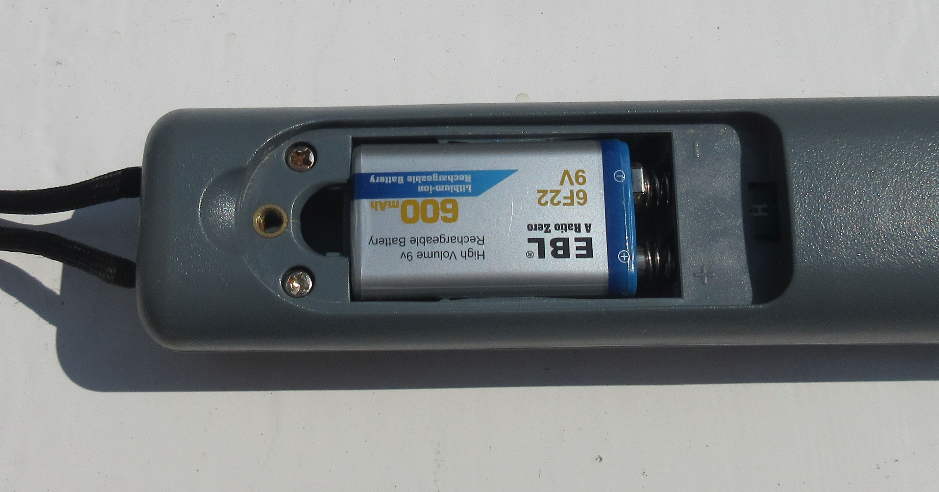

Use a small cross-head screwdriver to remove the battery cover and then you can insert and remove the battery.
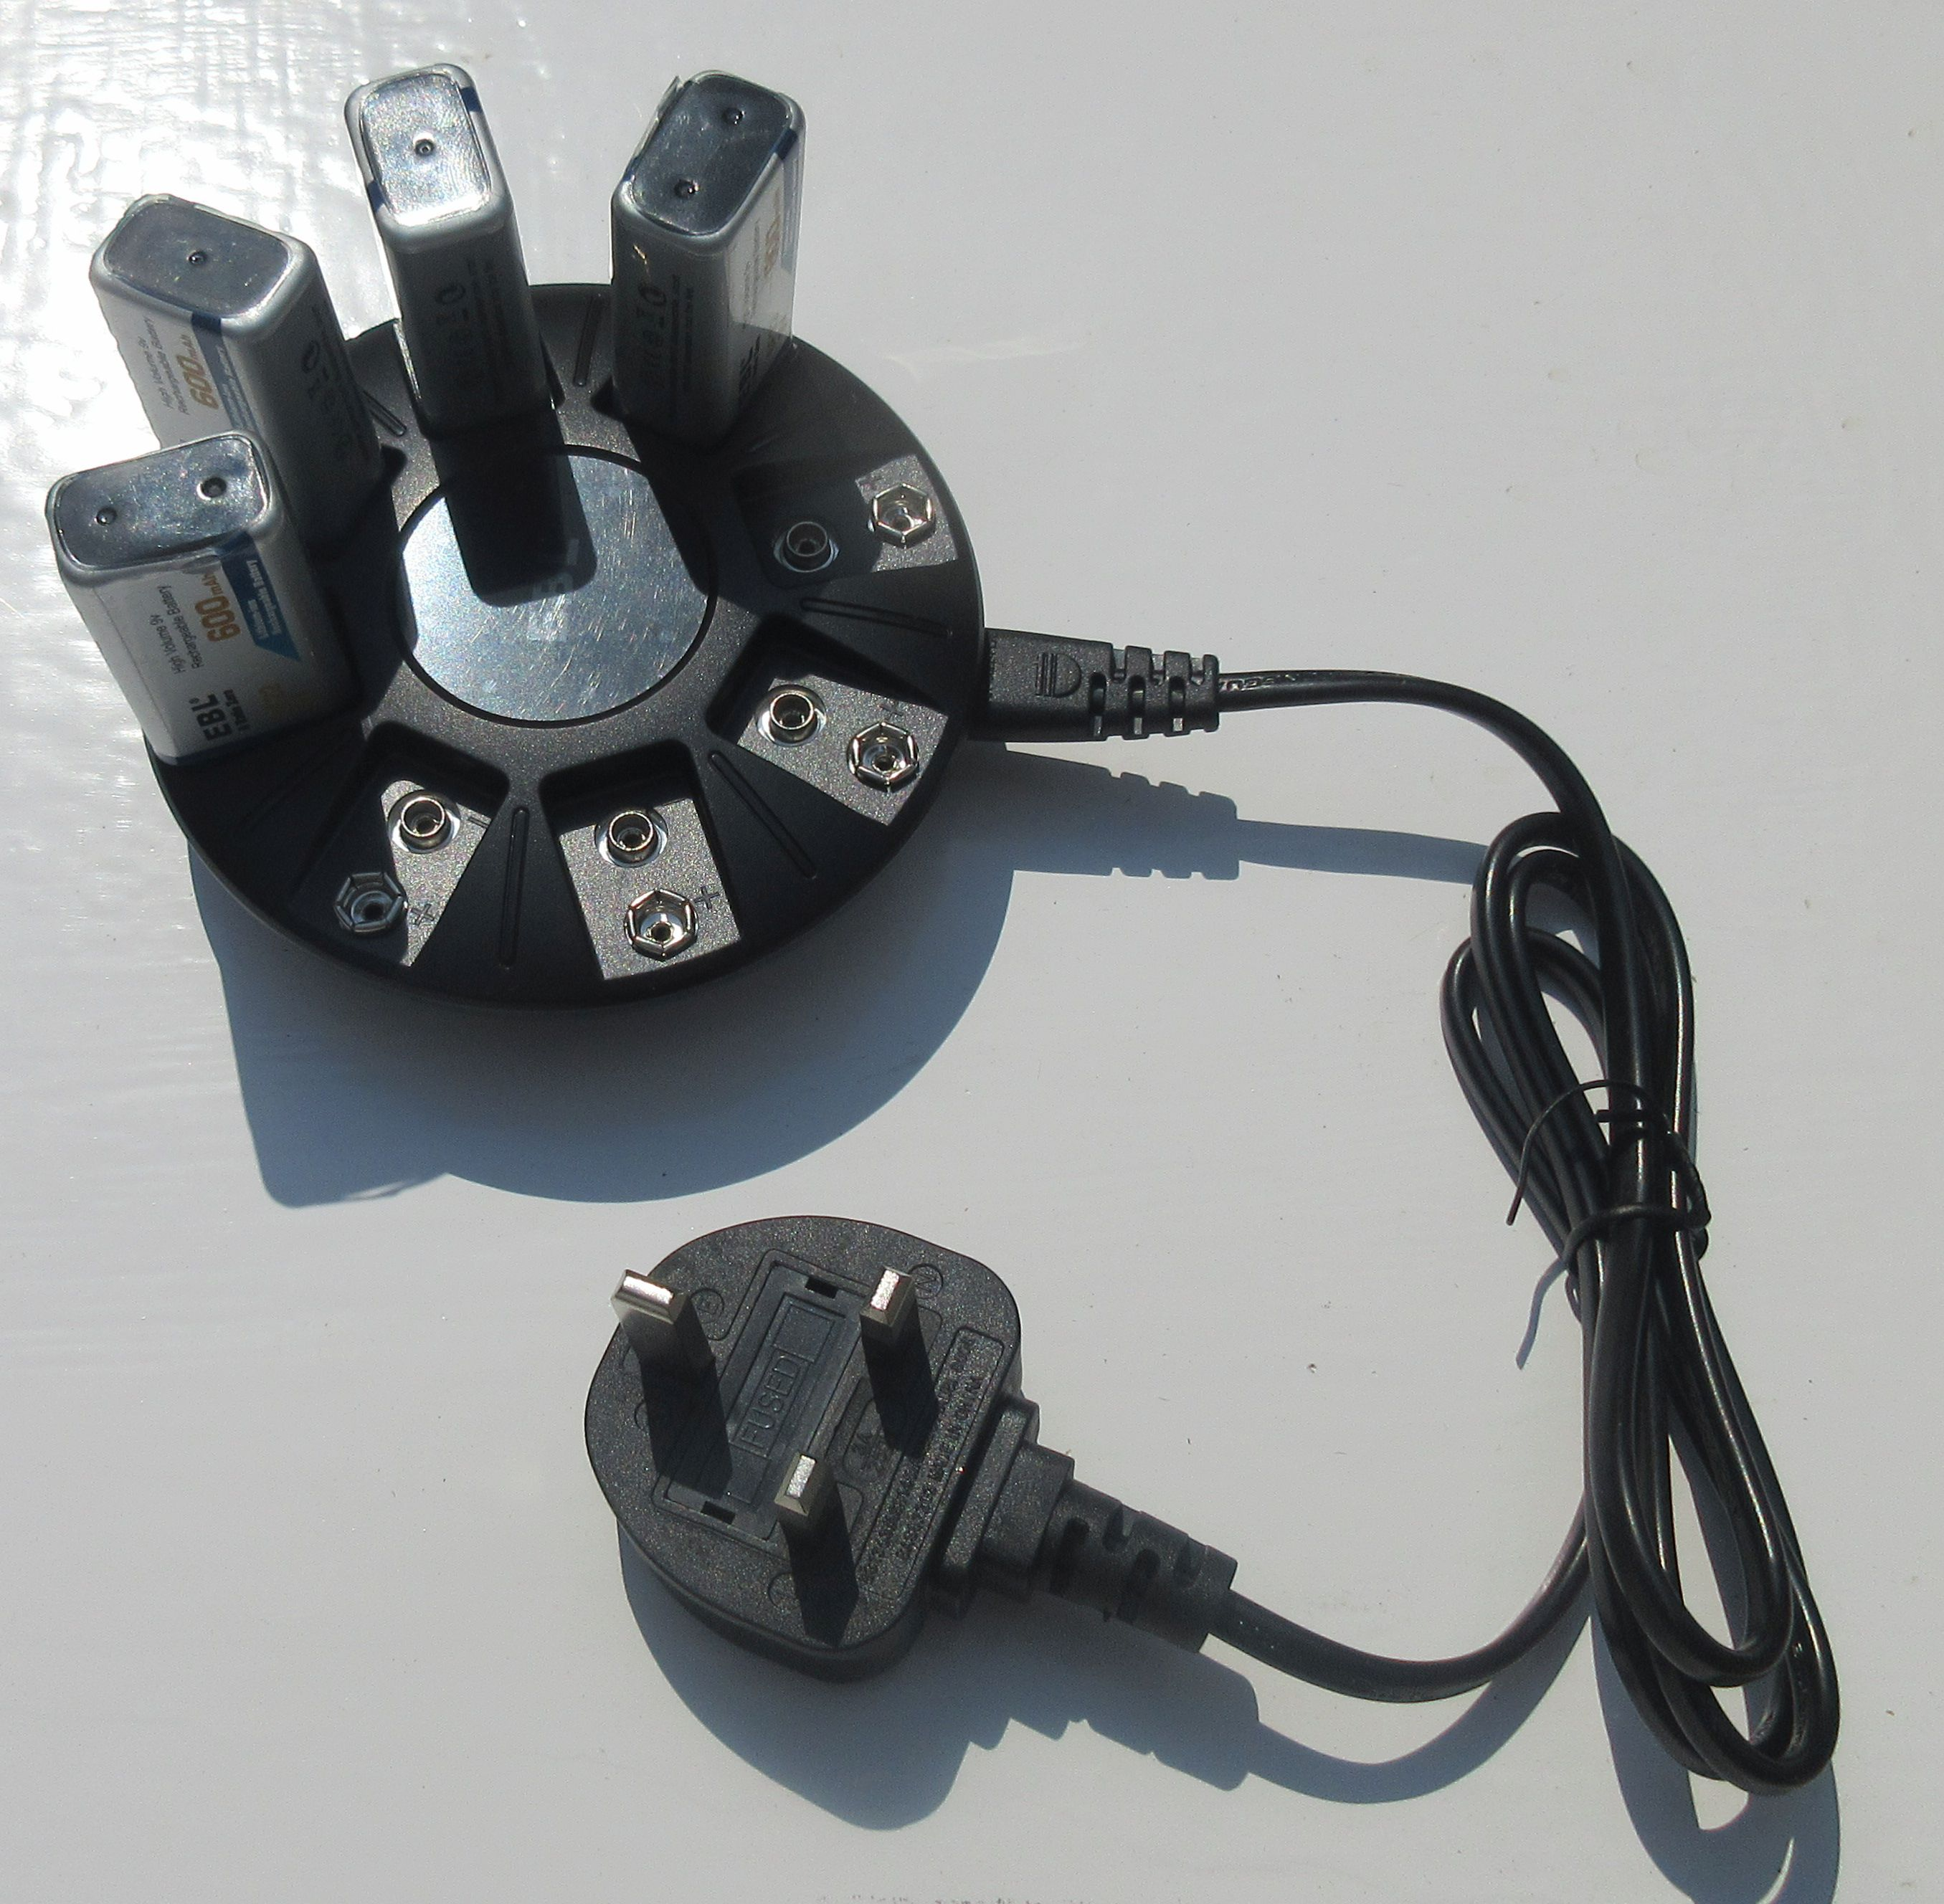
We can provide spare rechargeable batteries and multi-chargers if required.

If you are using the wands over several days, it is a good idea to put the rechargeable batteries on charge between the periods when you are using them, to make sure that the batteries do not run out in use.

Please do not throw away our re-chargeable batteries – they cost around £5 each, and you will have to pay for replacements if they are not returned.

RETURNING THE WANDS - FOLLOW THIS CHECKLIST PLEASE

Switch all the wands off. It worries and annoys the postmen & couriers if the parcels emit a loud beeping sound, when a box full of wands all “detect” the metal in the surrounding wands.

Remove the batteries to prevent this from happening.

Be aware that you will have to pay us for any of our equipment that is not returned to us.

Also include this instruction sheet. Then pack them up securely, and send or bring them back to us at:

Amherst Enterprises Limited
70 Kingsgate Road
LONDON NW6 4TE Tel: 020 7328 9792

Please use a “trackable” or “signed-for” delivery service with appropriate insurance. The wands and associated items remain your responsibility until we get them back to our office.

