**Link to Invision Prototype**

https://projects.invisionapp.com/prototype/ck0udh7lz0030we0178ca3nly/play

**1. Executive Summary**

Bun Bun Bake Shop is a bakery that allows customers to purchase home-made bakeries online. The overall goal is to design and prototype a website for Bun Bun Bake Shop. I created seven screens and corresponding user flow that allows a complete purchase. The key takeaway from my design and prototype are: (1) designers should keep a big picture in mind while being attentive to details; (2) designers should frequently refer to Nielsen’s usability heuristics when designing for interactions.

**2. Design Goals**

(i) The expected users are: old customers who visited Bun Bun Bake Shop before and new customers browsing for bakery to order online.

(ii) My major consideration when designing the prototypes are:

* *Usability has the highest priority*  
  As my TA showed us some quick prototypes from other sections, I saw some groups primarily focused on creating engaging visuals. I try to not be critical, but I believe aesthetics could be sacrificed if it hinders usability. I reminded myself throughout the design process that if there is a component that looks pretty but does not contribute to the overall efficacy, or even gets in the way, I should dump it without hesitation.
* *Deliberate considerations should be made when designing interactive components*  
  Usually there are plenty of alternatives that could satisfy a particular goal, e.g., confirmation on items to be purchased. A designer can simply display the item quantity or allow greater flexibility by letting users re-select the quantity, if they regret their previous decision in the last minute. Prototyping the entire service have a lot of similar decisive points that a designer should put themselves into others’ shoes when deciding what direction to go down.
* *The visual system should match users’ expectation of a bakery*

Although visual elements are not of highest priority, they still contribute greatly to the overall experience. A consistent visual system, though it could be naïve at this point, should be created for the website that conveys the feeling of a bakery. I therefore used primarily dark brown for headings and interactive components like buttons, tabs, links; and gray for supplemental information display. I also made some line graphics for the brand, which resonate with the tone of “Bun Bun Bake Shop”.

(iii) The motivations that drives my designs are that: (1) First of all, the interactions do not have to be avant-garde, a traditional shopping website user flow probably works best because customers are familiar with the common standards set by Amazon, Ebay, etc. Having a sense of familiarity prevents lots of potential usability problems; (2) Secondly, I do not want to show off by complicating a small bakery’s website, so I only included necessary interactions such as view products, add products to shopping cart, checkout, etc; (3) Thirdly, I believe allowing for a second thought is critical for a shopping experience, so I added interactions for users to recall, and if necessary, regret.

**3. Site Map**

(i) A simpler structure is as follow:

* HOME
  + ABOUT
    - OUR STORY
  + MENU
  + CART
    - CHECKOUT
  + CONTACT
    - STORE LOCATION

(ii) The map with screenshots and interactions

(Note that for simplicity, I did not include the repetitive interaction lines for universal elements)

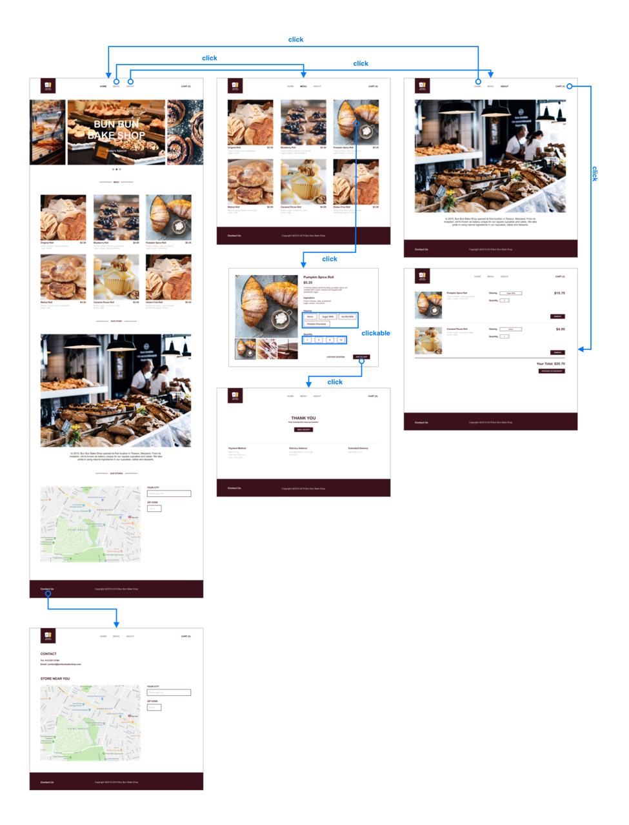

(iii) **An Invision Prototype Screenshot**

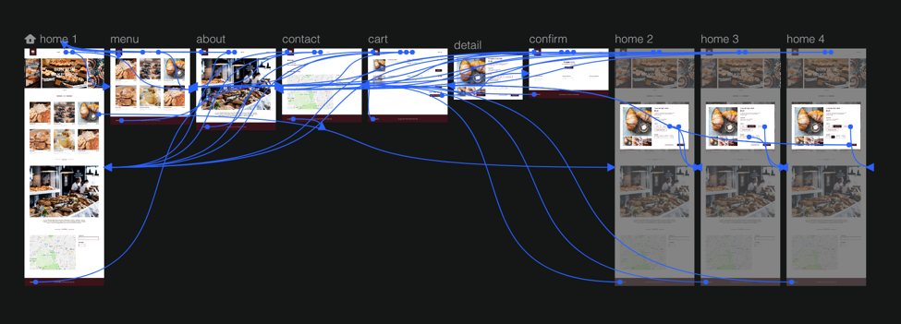

**4. Tasks**

1. Browse products
2. Select item and add to cart   
   (NOTE: please do so from home page not menu page! It should’ve been the same process but it’s just too much extra work to copy paste the whole background again and add the interactions. You’ll know what I mean when going to the prototype.)
3. View contacts, brand stories, etc.