Insert Name

AB Paxtor Garcia

Change Date

Table of Contents

# How to install Proteus

Shoutout to Sam for figuring it out

## Download Visual Studio Community

Not VS code (we are trying to make that one work too)

[Download Link](https://visualstudio.microsoft.com/vs/community/)

## Download CMAKE

[Download Link](https://cmake.org/download/)

**Make Sure to Allow Path**

## Clone that repo

the proteus repo obv

In whatever CLI terminal you like (Git, ZSH, bash, CMD, Powershell) - Run the following command

```  
git clone https://github.com/csun-tavlab/proteus.git   
```

## Do the repo commands from proteus repo

CLI Pro’s

cd /path/to/proteus  
ls  
mkdir build  
ls  
cd build  
cmake ..

Visual Studio Method

If there is an error, go through Visual Studio:

* Open Local Folder for proteus repo
* In *View* in the Ribbon, open a terminal mkdir build ls cd build cmake ..

## Visual Studio Community Config

### Building Proteus

1. Open Visual Studio
2. Open a local folder, choose the “build” folder from proteus
3. On the file view (right side of Visual Studio), do the following
   * Rigt click ALL_BUILD.vcxproj
   * Click *BUILD Project* or equivalent
   * Wait 10 decades for proteus to get ready
4. There should be a “proteus.sln” created

### Using proteus

This is still in Visual Studio

1. Open that “proteus.sln”
2. Expand the proteus sub folder
   * Right click “proteus” folder
   * Set “proteus” folder as the startup project

* 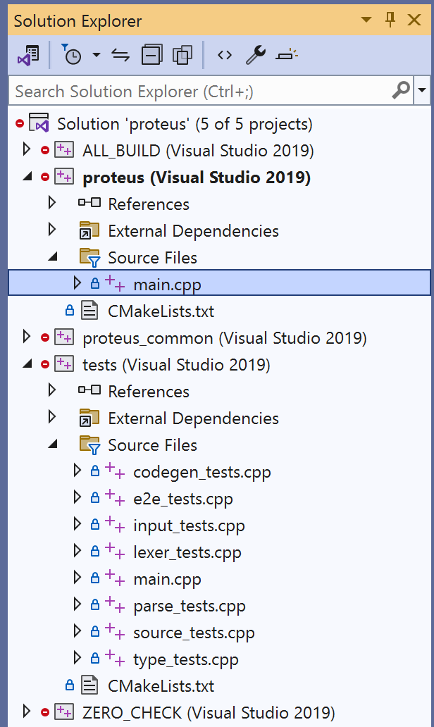
* image

1. Just hit that Local Windows Debugger whilst main.cpp is open
2. A terminal should open with the following lines

* The Proteus language compiler  
   Usage:  
   proteus [OPTION...] INPUT [OUTPUT]  
    
   -h, --help Print this message  
   --logfile arg Output compilation messages to this file instead of  
   stderr  
   --loglevel arg Set the log level (accepts: error, warning, info,  
   debug) (default: info)  
   -d, --debug Same as --loglevel=debug  
   --noprefix Don't emit prefixes in generated code  
   --trace Add trace messages to generated code  
   -i, --input arg Input file  
   -o, --output arg Output file  
    
   C:\Users\abpax\Desktop\Git\proteus\build\Release\proteus.exe (process 6656) exited with code 0.  
   To automatically close the console when debugging stops, enable Tools->Options->Debugging->Automatically close the console when debugging stops.  
   Press any key to close this window . . .

### Changing main file to run

#### TESTS!

Sam got this one

So, instead of setting “proteus” as the main startup folder, do “tests”

It will run tests

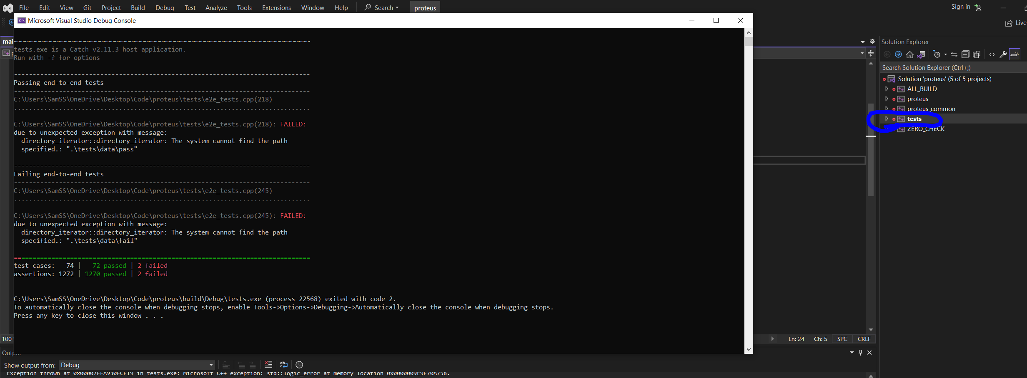

image