Household Corkboard/Calendar
Group 5

Thomas Bakaysa
Scotty Roberts
Brandon Sanchez
Pax Leslie
Chyler Jones

System Vision Document

It is difficult to manage a household and keep track of everything that needs to be done. Some people like to use whiteboards, planners, sticky notes, or loose pieces of paper to try to keep track of the tasks they need to complete. The use of all these things can lead to a lack of accountability and can be inefficient as you may forget tasks and where you wrote them down. Lastly, using the typical ways to manage your tasks does not provide any incentive to complete them, which makes it feel like more of a chore and can make you less likely to do it.

Business Benefits:

A centralized household corkboard/calendar addresses the problems described by offering a solution that centralizes all of your tasks, to-do lists, and important events. Providing incentives to complete your goals by adding a point leaderboard can make tasks feel like less of a chore, which can reduce conflict between family members/roommates and increase your effort or willingness to get things done.

Additionally, users are encouraged to interact and engage with the application through personalization. Actions and reactions will reflect custom personalization options to showcase individual flair through the use of accumulated points.

- How this idea differs from competitors:
  - Cozi: We will have a point system and leaderboard across the household.
  - OurHome: We focus on the entire household that can be used for families or roommate environments, not just gamifying chores for kids.
  - AnyList: Our app will be more of a house management system that can include organized/shared shopping lists, as well as have a point system that AnyList lacks.
  - Tody/Sweepy: Our concept is much more broad than gamifying cleaning tasks as we will have different types of posts as well as a centralized corkboard for households.
  - Flatastic: We will have a point system and leaderboard across the household. Expense/bill tracking can be possible in our concept, but it is not the main focus.
  - Overall: We will prioritize a visually appealing and interactive application that incentivizes engagement from all members of the household rather than the minimalist and calendar-like approach the other applications use.

System Capabilities:

- User Login: using email/phone number to create an account with unique display name
- There will be different user types in a household. The base household account member will have full access to features and will be able to create, edit, and interact with posts. An administrator account will be a higher level user group that can add or remove household members, assign points to tasks, and prevent cheating.

- Interactive Posts: Users can create different types of posts(to-do lists, sticky notes, grocery lists, etc) that can be created and deleted. Users can choose whether to share the post with the household or only put it on their personal calendar. When a task is completed, it will be marked as done.

- Point System: points will be assigned to each task which will be awarded when a task is completed. The amount of points each type of task gets can be determined by the household administrator. We will keep track of points each user tallies and create a leaderboard within the household that will reset every week.

- Messaging: Users within the same household will be able to communicate with each other

Requirements

Functional
- Create Accounts
  - Users can create household
  - Users can designate different types of accounts for the household
- Delete Accounts
  - Household admins can delete accounts
  - Household admins can delete households
- Authentication
  - Validate household logins via MFA
  - The system must be accessible via external networks (4G/5G)
- Create a post
  - Users can add posts to dashboard
  - Users can add an event from their personal calendar to the group board
- Delete a post
  - Users can delete posts their own posts from the dashboard
  - Admins can delete any post
- Interact with posts
  - Users can mark individual lines in a list post
  - Users can mark chore posts as completed
  - Users can mark a post as “positive” and “negative”
- Message a user
  - Users can direct message other users as well as message a centralized group chat
- Reset Points
  - Household admin can reset the points when needed
- Redeem Points
  - Users can redeem points within the points tab

Non-Functional
- Security requirements
  - Encrypted information
  - Households stay private
- Operational requirements
  - System will operate in an android environment
  - Server will live in a BeagleBone
  - Database will live on a free online hosting service
- Performance
  - Load and display household in a timely manner (3 seconds)
  - Will update household data periodically (30 seconds)
- Cultural and Political
  - No cultural and political requirements
- Usability
  - Ease of use as a priority

Use Case Diagram
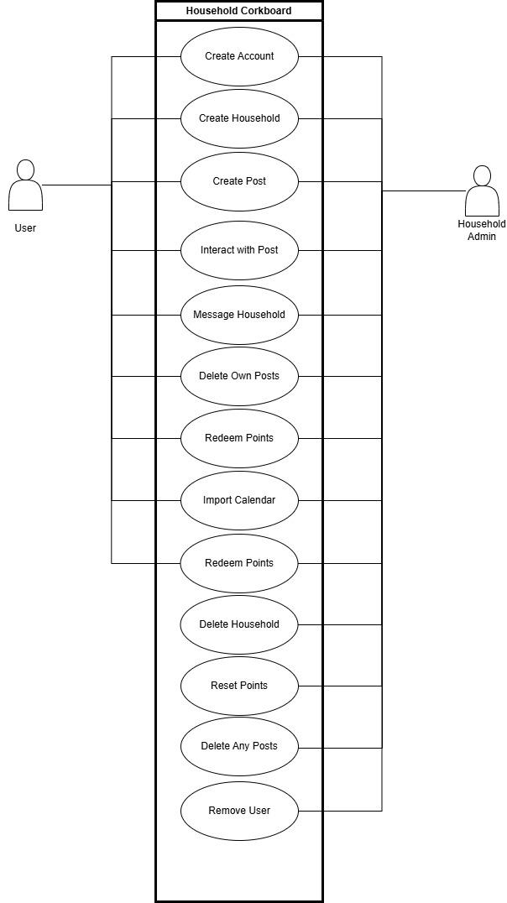

Use Cases
Use Case | Brief Use Case Description
Create Account | User/actor enters new customer account data, and the system assigns account number, creates a customer record, and creates an account record.
Create Household | Regular users can create a household, which will automatically set them as an Admin for that household. From here the Admin can create / add users to the household.
Create Post | Users can add posts or events to the household dashboard.
Interact With Post | Users can engage with posts by marking items on lists, completing chores, etc.
Message Household | Users can send messages in the household group chat that is created with the creation of the household.
Delete Own Posts | Be able to remove your own post
Redeem Points | Users can use points earned to redeem certain rewards
Remove User | Admins can remove users from a household.
Delete Household | Household admin has the ability to delete the household corkboard.
Edit Points | Household Admin has the ability to edit the points of the household
Delete Any Posts | Household Admin has the ability to delete any posts made to the dashboard

Full use cases are attached as a separate document.

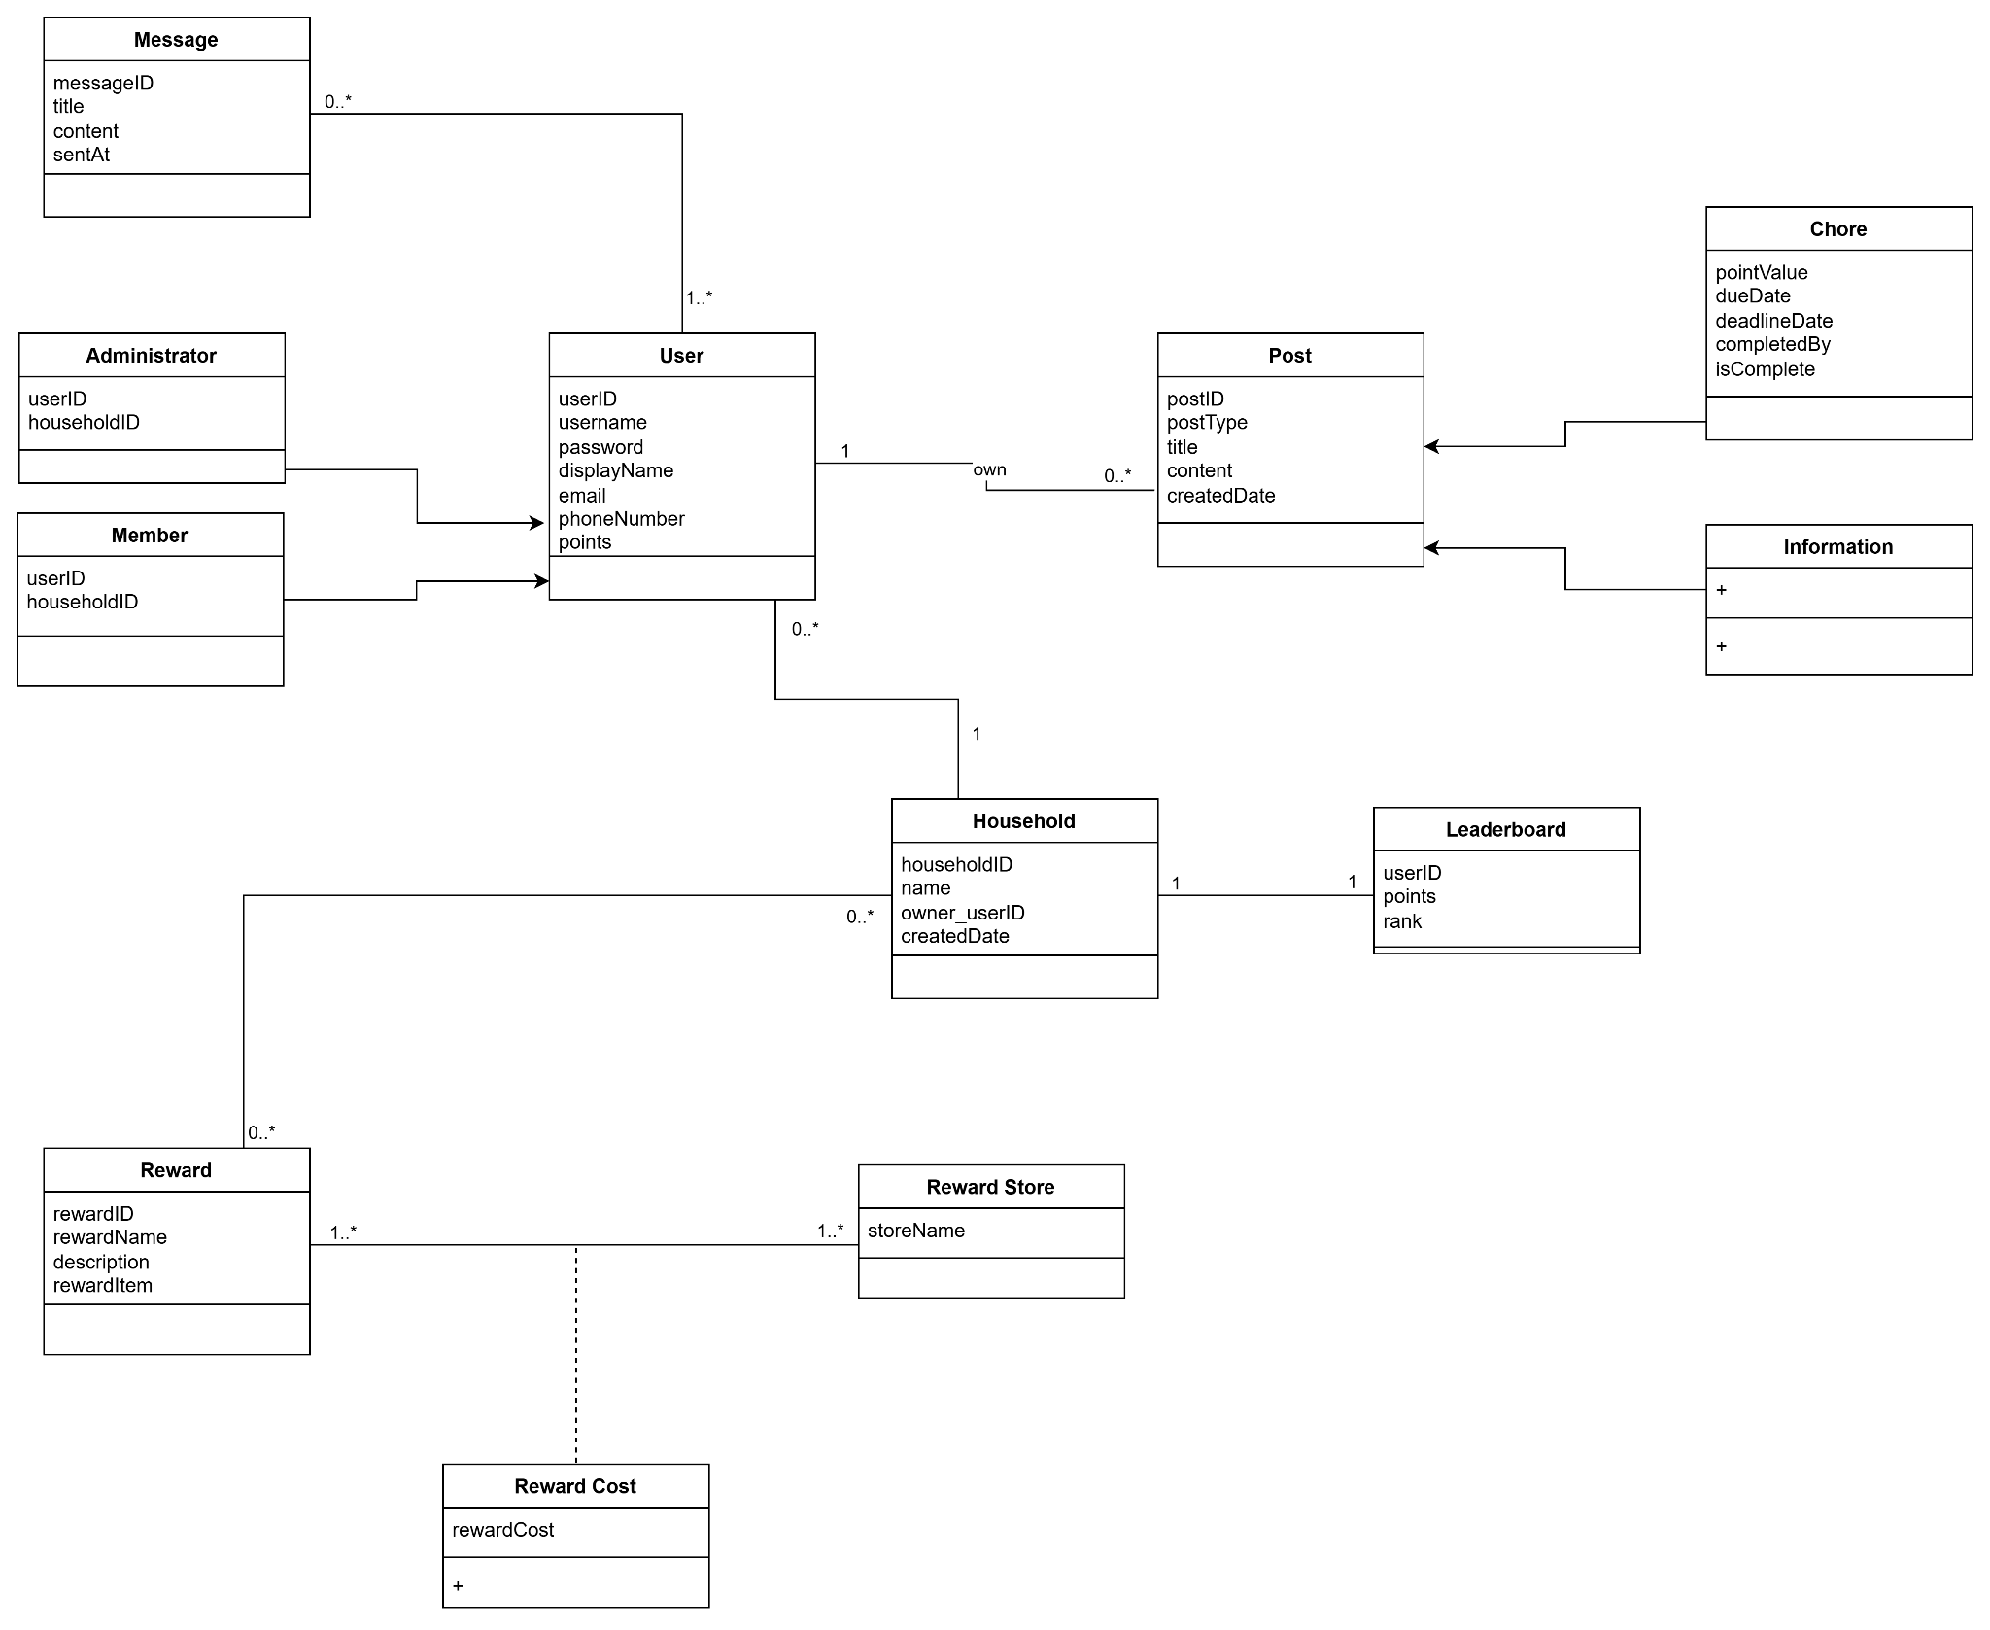

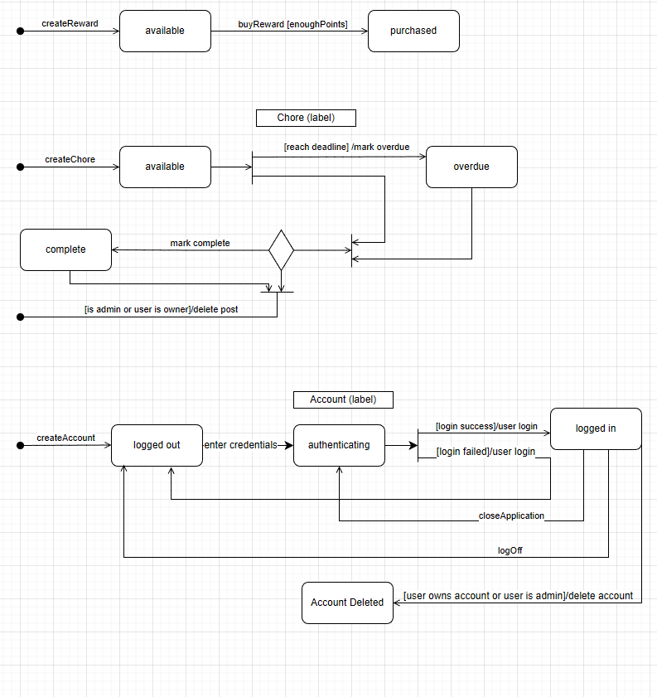

Database Schema
Table | Attributes
User | user_id(PK): UUID  email: VARCHAR(255)  phone: VARCHAR(20)  name: VARCHAR(100)  display_name: VARCHAR(100)
Household | household_id(PK): UUID  name: VARCHAR(255)  owner_user_id(FK): UUID
Household Members | member_id(PK): UUID  user_id(FK): UUID  household_id(FK): UUID  role: VARCHAR(20)  weekly_points: INT
Posts | post_id(PK): UUID  author_id(FK): UUID  type: VARCHAR(20)  title: VARCHAR(255)  body: TEXT  point_value: INT  status: VARCHAR(20)  created_at: DATE  due_at: DATE
Messages | message_id(PK): UUID  from_user_id(FK): UUID  household_id(FK): UUID  Content: TEXT  sent_at: DATE
Rewards | reward_id(PK): UUID  household_id(FK): UUID  cost: INT

